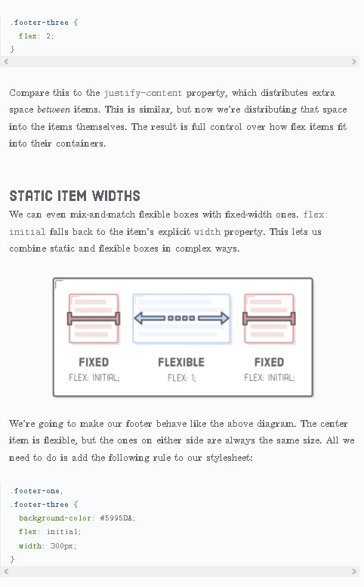I think this is a mistake because the property of footer-two is not set to one in the static item widths. Maybe that was something the teacher wanted us to figure out by ourselves but I don’t think that is the case because there was no other examples where you need to figure things out by yourself in the lectures I chose to do for this assignment.

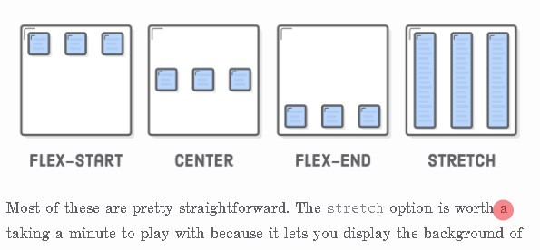Furthermore, I feel like the content on this website is not as engaging as the content on Free Code Camp because it lacks the little tasks you need to complete before moving forward with the lecture. I found one spelling mistake and I have marked it with red on the screen shot bellow.

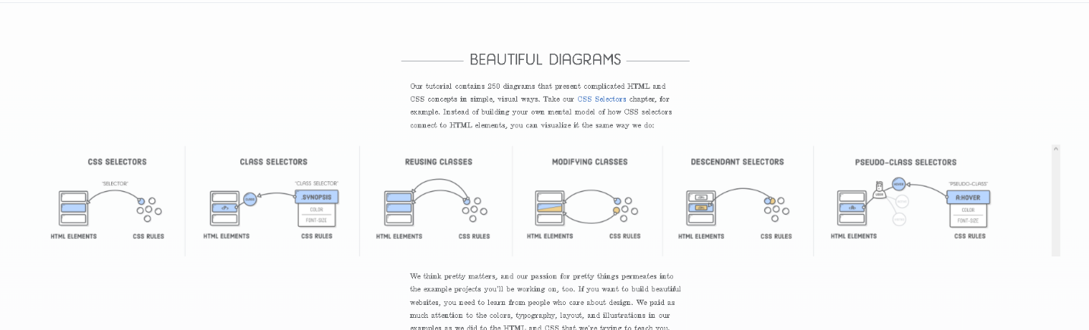Overall design of the website was beautiful. I would like to see a dark mode for the website because after extended periods of looking at a white background my eyes start to hurt. One of the positive sides of this website is that it lets you do a project while following instructions, but the bad thing about it is that you are already given the solution to every problem and if you don’t understand some things copying the code will not help you learn it. The writer does provide a lot of visual explanations about the subject with pictures similar to the one above. I think that this website is better than free code camp if it is used as a reference website because it is a little bit harder to look something up on free code camp. But MDN web docs is a lot more in depth with all its topics than any of these sites, but I feel the content on that site is not that beginner friendly compared to the first two. I would like to see more content covered by this person or people because all they have at the moment is HTML and CSS.

This part on the front page of the website is not responsive and I think it is a screenshot because the scrollbar on the right is not my browsers scrollbar. To be able to see this I had to zoom out to 80%.