when we say body recomposition, we are referring to a reduction in body fat percentage alongside an increase in lean body mass (more specifically, muscle mass). In both women and men, this is most commonly achieved under four circumstances:

1. NEW LIFTERS (BEGINNERS): As we discussed above, the body is most primed for growth when weight training is still a new stimulus. To fuel the speedy muscle building process, the body can “easily” tap into body fat stores to yield impressive recomposition.

2. DETRAINED LIFTERS (DETRAINEES): The detrained lifter is anyone who has lifted for a significant period of time, built a significant amount of muscle but then stopped training due to injury, lack of motivation or some other impediment to regular lifting. Similar to the new trainee, the detrainee is able to build a lot of muscle very quickly, making recomposition common. We will revisit this phenomenon later when we discuss muscle memory.

3. OBESE INDIVIDUALS: Because obese individuals have a very large energy reserve (bodyfat), it’s simple enough for them to eat in a caloric deficit and still have plenty of stored energy to fuel the muscle building process. As a result, when obese individuals train, it’s common for them to build muscle and lose fat at the same time.

4. ANABOLIC STEROID USERS: Using anabolic steroids puts you in a similar camp to the new trainee and the detrainee in that it allows most people to build relatively large amounts of muscle mass very quickly. Again, to fuel that speedy muscle building process, the body can tap into body fat stores, resulting in impressive recomposition.

MANDATORY TOOLS TO MEASURE AND TRACK BODY COMPOSITION

1. WEIGHT SCALE

For consistency purposes, we recommend tracking your body weight for four-seven days per week at the same time of day for consistency purposes. Weigh as soon as you wake up, after using the bathroom and before drinking any water or eating any food. Using those four-seven body weight measurements, you will tabulate a weekly average. You will then compare that weekly average to future weekly averages to determine whether your weight is trending up or down over time.

1. MEASURING TAPE

When taking body part measurements, measure at the largest site on the muscle. For the Legs-Thighs, Biceps, Triceps and Calves, be sure to record both a left and a right measurement. This will allow you to track any asymmetry and thereby modify your training to correct for imbalances. Similar to the scale, realize that body part measurements are not a perfect science. For example, as you lose fat, many of these measurements may actually decrease, despite a gain in muscle to the area (if you happen to lose more fat from the area than you added muscle to the area). As such, you should use this information to compliment the weight and waist measurements. When losing body fat, waist circumference is the one area that seems to change the most and even if you’re adding muscle to your abdominals, it will not drastically change the size of your waist. For all intents and purposes, a reduction in waist circumference is a very good indicator of fat loss. To avoid fluctuations due to water retention, we suggest taking waist circumference measurements one to two times per month, on the same days each month. The other body part measurements can be taken once every one to three months when assessing muscular progress on specific areas or weak points.

1. CAMERA (PROGRESS PHOTOS)

We recommend taking progress photos one to four times monthly.

Follow the suggestions below to ensure you take the most accurate and useful progress photos possible:

A) Use the same environment/location (ideally using natural light from a window or doorway); B) Shoot at the same time of the day (preferably fasted on an empty stomach);

C) Shoot on the same day of the week;

D) Use the same angle for each picture. Set up your camera in the same spot, at the same height;

E) Use a self-timer or record a video and take screen shots, and

F) Include your full body in several different poses. Include front, back and side pics. If you can perform mandatory bodybuilding poses, they are ideal for assessing muscular detail and balance.

4. FOOD SCALE

It is essential that you track your calorie, protein, fat and carbohydrate intake from all foods you eat. For the sake of convenience, we recommend tracking your food intake through mobile apps like MyFitnessPal.

A calorie is simply a unit of energy. And “energy balance” simply refers to the relationship between energy coming in and energy going out. Over a specific time scale, energy balance is said to be positive if you are storing more calories than you are burning. Generally speaking, this means you are in a caloric surplus and should gain weight. Conversely, energy balance is said to be negative if you are burning more calories than you are storing. In this case, you are in a caloric deficit and should lose weight. Again, for the most part, bigger caloric surpluses will lead to faster weight gain and bigger caloric deficits will lead to faster weight loss.

Put simply, the energy balance equation in relation to calories and weight loss looks like this: WEIGHT CHANGE = CALORIES IN – CALORIES OUT

It’s also common to see people misapply the logic of the energy balance equation. For example, many folks will just assume that an anabolic process like building muscle can’t happen concurrently with a catabolic process like losing fat. Because fat tissue and muscle tissue are separate systems, it’s perfectly possible to lose a significant amount of fat due to the caloric deficit, while still building muscle from the progressive training stimulus (and sufficient protein).

For the sake of being as precise as possible, it’s worth noting that fat and muscle tissues have different energy densities. Because muscle is made up mostly of water, it has much less stored energy than fat does. One kilogram (~2.2 pounds) of muscle contains 1,800 calories while one kilogram of fat has 9,400 calories.

Let’s run the net energy balance math on the example above, assuming you were to lose 20 pounds (9.1kg) of fat while gaining 5 pounds (2.3kg) of muscle over a full year: 9.1 KILOGRAMS OF FAT LOST = 85,540 CALORIES LOST 2.3 KILOGRAMS OF MUSCLE GAINED = 4,140 CALORIES GAINED NET ENERGY BALANCE = ENERGY GAINED – ENERGY EXPENDED = -81,400 CALORIES In other words, in order to achieve this body recomposition, you must have been in a 81,400 calorie deficit over the course of the year. Since there are 365 days in a year, that would amount to: 81,400 yearly calorie deficit / 365 days = a 223 calorie deficit per day

Weight change = calories in – calories out. The ‘calories in’ part of this equation is very straightforward: you eat food - and that pretty much covers that segment. The ‘calories out’ aspect is much more complex and requires further explanation to understand how each of these two factors influence body recomposition.

Total daily energy expenditure (TDEE): the total number of calories you burn each day. It is sometimes referred to as your net metabolic rate. Three key factors determine the number of calories we burn each day:

1. Basal Metabolic Rate (BMR) - how many calories your body burns per day in order to perform all of its basic metabolic functions and maintain its body mass at rest. If you sat on the couch all day long and did nothing but breathe, this would be roughly the number of calories you’d burn. Since your BMR comprises such a large portion of your total daily energy outflow, it is worthwhile to determine roughly how many calories it contributes to the total daily burn. For those of you who like math and objective numbers, we recommend using the Mifflin St. Jeor formula (below) to calculate your BMR. As you can see, this formula takes four variables into consideration: gender, age, height and weight. However, there are additional variables that are not, and can not be accounted for. This is one reason why this formula is very good, but not perfect.

BMR = 10 x weight(kg) + 6.25 x height(cm) - 5 x age(y) + 5 (man)

BMR = 10 x weight(kg) + 6.25 x height(cm) - 5 x age(y) - 161 (woman)

1. Physical Activity Level - how many calories you burn by “moving around”. For most people, daily physical activity makes up 20-35 percent of total caloric expenditure. These values can be lower if you are more sedentary or higher if you’re more active than average. It’s worth highlighting that this component of metabolism is not limited to the number of calories you burn while formally exercising (lifting weights and cardio). It includes the calories burned from all of your daily activities, including typing at your desk, bringing groceries to the car and singing in the shower. The calories burned from these non-exercise activities make up NEAT: Non-Exercise Activity Thermogenesis. Interestingly enough, when in a caloric deficit for an extended period of time, your body senses the decline in food intake and automatically decreases energy expenditure by downregulating NEAT. This can result in something as simple as fidgeting less, but can also present as severe fatigue if you diet for too hard or too long
2. Thermic Effect of Food - amount of energy expended by breaking down and processing food for use and storage. Simply put, your body burns calories as it digests, absorbs, transports and stores food that you eat. Just as each macronutrient (carbohydrates, fats or proteins) provides us with a different number of calories, they also require different amounts of energy to digest, absorb, and utilize. Because of this, each macronutrient has a different thermic effect.

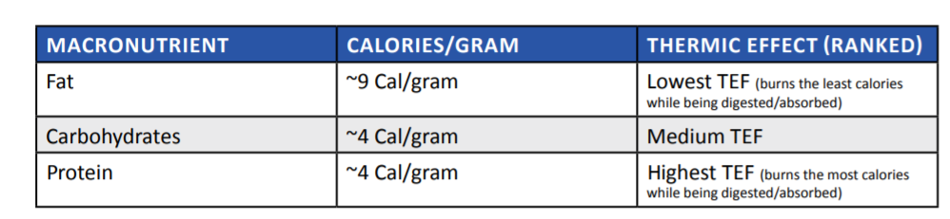

Protein is the most thermogenic macronutrient. This means eating a higher protein diet will result in more calories burned because it requires more energy to digest and absorb that protein. This is one of the many reasons why high protein diets typically result in greater fat loss and better improvements in body composition, even when caloric intakes are equated. This fact serves as another example of why the expression “a calorie is a calorie” fails to capture the more complex and nuanced ways in which each of the different macronutrients are handled by our bodies.

To illustrate, let’s compare complex carbohydrates and simple carbohydrates. Complex carbohydrates are primarily made up of long chains of carbs (polysaccharides) that need to be digested and broken down into smaller molecules (disaccharides, monosaccharides) before being used for energy. On the other hand, most simple carbohydrates are already in a usable form and do not need to be digested per se. They simply need to be absorbed and can be utilized for energy or stored right away. For example, 200 grams of sweet potato and 43 grams of Gatorade will both deliver roughly 40 grams of carbohydrates. However, the thermic effect of these two foods are quite different. Your body will expend more energy digesting and absorbing the carbohydrates from the sweet potato than it will the Gatorade. This isn’t to say that one of these carbohydrate sources is good and the other is bad, but rather that they may be more and less suitable in certain contexts.

CALORIE INTAKE: HOW MANY CALORIES SHOULD I EAT?

Depends on three factors:

1. YOUR PRIMARY GOAL

Obviously, the goal with body recomposition is to build muscle AND lose fat (not to pick one or the other). However, it is still important to pick what goal is more important to you. The reason we insist on choosing a primary goal is that it will contribute to the determination of how many calories you should eat. If your primary goal is to lose fat, we recommend a moderate caloric deficit, whereas if you mostly want to build muscle, then a moderate caloric surplus is best suited for your goal. If both objectives are equally important, eating at caloric maintenance is our suggestion for you.

2. CURRENT BODY COMPOSITION

Defining Body Composition:

For our purposes here, we will split body composition into three categories:

Low Bodyfat: 8-12% bodyfat for men, 18-22% for women

Moderate Bodyfat: 12-18% bodyfat for men, 22-28% for women

High Bodyfat: 18-20+% bodyfat for men, 28-30%+ for women

As a general rule of thumb, we suggest that for those with a lean physique, the best way for you to transform your physique and achieve body recomp is to enter a caloric surplus. If an already lean individual was to enter a caloric deficit, or even stay at maintenance, he or she would inhibit the ability to build muscle at an appropriate rate. This could end up in the person not making any significant progress with either muscle gain or fat loss. On the other end of the spectrum, if you’re currently at a higher body fat percentage, entering a caloric surplus would be detrimental to your goal of recomping since it will stunt fat loss. In this case, a caloric deficit will ensure that fat loss occurs as the progressive resistance training and adequate protein intake facilitate muscle growth. As a third scenario, some of you may fall in between these two body fat categorizations into a sort of moderate body fat classification. In this case, we recommend staying closer to maintenance calories, with the goal of losing fat and building muscle being on roughly even footing. In this case, you can also default to your primary goal determinant to decide whether you should stay at true maintenance, or enter a slight surplus, or a slight deficit.

3. TRAINING EXPERIENCE

The more training experience you have, the closer you will be to your natural genetic limitation for muscle mass and consequently, it will be more difficult for you to gain lean mass. Conversely, someone who is still relatively new to weight training will be able to gain muscle mass much faster. This is important to keep in mind because it implies that beginners can use larger surpluses to build muscle without accruing excessive fat mass. In other words, the more advanced you are, the more likely it is that large caloric surpluses will lead to fat gain rather than muscle gain (since you will be more resistant to muscle gain). For the purposes of this section, we will define beginner, intermediate and advanced as follows:

• BEGINNER - Making progressive overload gains on a week to week basis and significant visual changes month to month (usually 0-2 years of lifting).

• INTERMEDIATE - Able to progressively overload on a month to month basis. Physique progress is evident every couple of months (usually 2-5 years of lifting).

• ADVANCED - Takes multiple months or even years to see visual progress and ability to overload lifts is much more difficult (usually 5+ years of serious lifting).

As an example, consider someone with only six months of lifting experience whose primary goal is to build muscle (let’s assume they are already pretty lean). Because their body is so primed for muscle growth, a relatively large (25 percent) caloric surplus will return much more lean gains than a 25 percent caloric surplus would for an advanced trainee. So, assuming their caloric maintenance (calories needed to maintain weight) is 2500 calories, a 25 percent caloric surplus would be: 2,500 calories (maintenance) + 25 percent = 3,125 calories for recomp. Compare this with someone with five years of lifting experience. Because they are much closer to their genetic muscular ceiling, a large caloric surplus will yield more fat gain than muscle gain - not ideal for someone with a body recomp goal. Assuming they also have the primary goal of building muscle, in this case, we would recommend a smaller (~10 percent) caloric surplus: 2,500 calories (maintenance) + 10 percent = 2,750 calories for recomp. On the other hand, your training age will not directly impact how big your deficit should be since one’s ability to lose fat is not diminished with increased training experience. For the most part, beginners and veterans to the weight room will not differ in their ability to lose fat. For this reason, experience level only impacts the recommended size of a caloric surplus, not a caloric deficit.

1. OTHER FACTORS

BIOFEEDBACK - Throughout the process of recomping, it is important to pay attention to biofeedback (your recovery and hunger). If your training volume or intensity is higher than normal for example, it may be necessary to increase your caloric intake during this period of increased training demands. Also, sometimes an amplified training stimulus will result in an increased appetite, perhaps as a signal that you require more nutrients to fuel proper recovery. While you should be cautious with using your appetite to dictate your calorie intake (since your appetite generally doesn’t care about your goals), paying attention to this biofeedback can provide useful information when it comes to adjusting calorie intake.

THE DETRAINEE. Body recomposition is extremely common for those who previously resistance trained, built a lot of muscle, but later stopped resistance training for an extended period of time and ended up losing muscle as a result. This phenomenon of “muscle memory.” Basically, it’s much easier to build muscle back than it was to build that muscle from scratch. When we weight train and cause muscle fibers to grow in size (hypertrophy), we also increase the number of nuclei (myonuclei) in the muscle. You can think of myonuclei as the control center of the muscle fiber. Even though the muscle fiber itself loses size (atrophy) when we skip the gym for too long, these control centers (myonuclei) are never lost. As soon as we get back to training again, myonuclei that were built months or years ago can now start cranking out commands to ramp up the production of new muscle much faster than if you had never trained in the past.

While it will depend on the other factors we have just outlined (Does the detrainee have a specific primary goal? Are they starting at a high or low bodyfat?), eating at caloric maintenance is often a safe starting point to begin losing fat and building muscle for the detrainee. In many respects, the detrainee can be treated more like a beginner in the sense that they are often able to achieve impressive recomposition in a relatively short time frame.

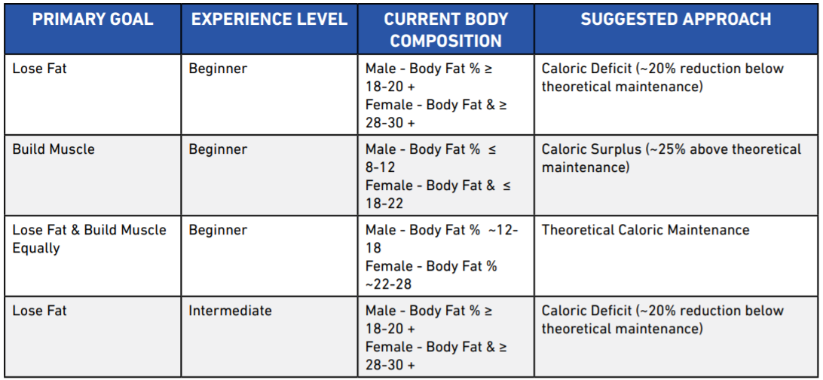

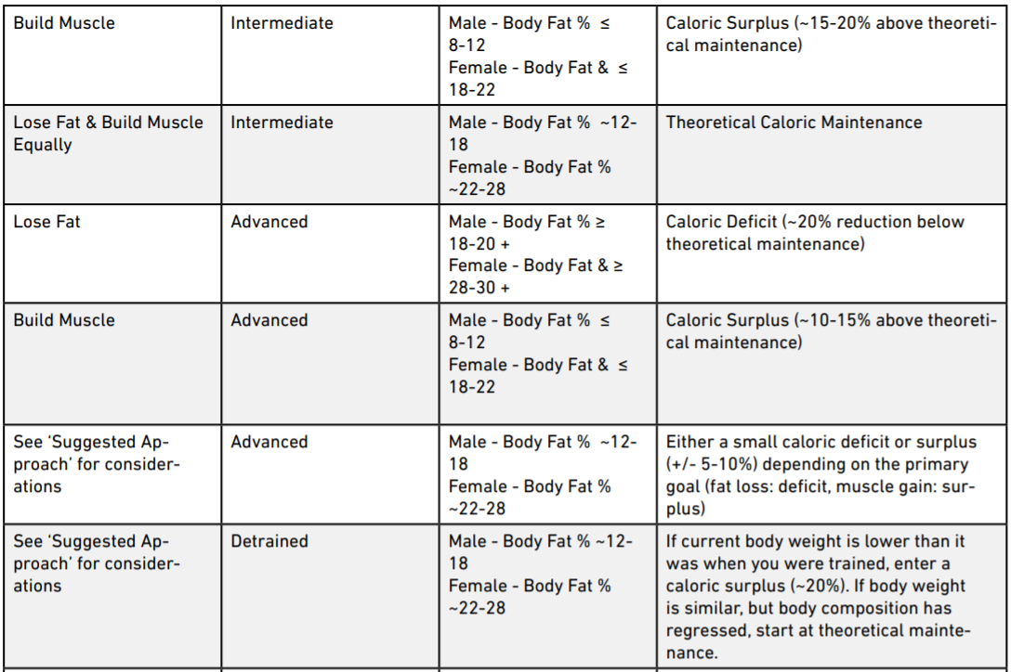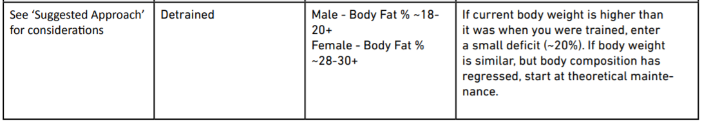

EXCEPTIONS TO THE TABLE ABOVE

If most of the following points apply, you may be a genetic freak. You may want to increase the recommended calorie surplus by 5-10 percent.

• You have a large frame: Broad shoulders, thick wrists and ankles.

• You have muscular parents and/or multiple muscular relatives.

• You are generally gifted at sports.

• You have noticed you can build muscle quickly.

• Men only: You have a high 2D:4D ratio (your ring finger is significantly longer than your index finger)

If you are currently well above 25 percent body fat for men or 35 percent for women, it may be wise for you to enter a larger caloric deficit in the range of 20-30 percent.

ESTIMATING THEORETICAL MAINTENANCE

The goal is to simply determine how many calories you need to eat per day to maintain your current weight. Maintenance calories should not be thought of as a fixed number, but rather as a moving target that will change based on your changing body composition, NEAT levels and various other metabolic factors. Two ways to estimate this value:

1.USING A FORMULA

Calculate BMR using the Mifflin St. Jeor formula and account for activity levels using the table below:

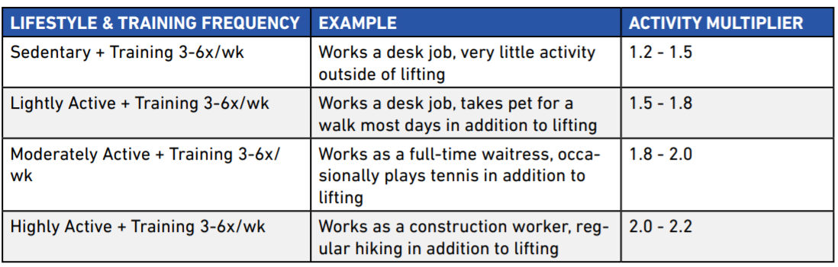

2. USING A GUESS-AND-CHECK METHOD.

1. Track your bodyweight and caloric intake every day for two weeks

2. Determine the average values for week one and week two.

3. Determine the average weight gained or lost from week one to week two.

4. Determine maintenance based off weight change.

a. If you maintained weight from week one to week two, then whatever your average caloric intake was can be set as your maintenance calories.

b. If you lost weight from week one to week two:

i. Assuming you need about a 500 calorie deficit per day to lose one pound of weight, you can determine maintenance by figuring out how much of a deficit you were in.

EXAMPLE 1: If you ate 3,000 calories per day on average and lost one pound from week one to week two, then your maintenance would be (3,000 + 500 calories = 3,500 calories).

EXAMPLE 2: If you ate 2,000 calories per day on average and lost 0.4 pounds from the first week to the second, then your maintenance would be (2,000 + 0.4 x 500 calories = 2,000+ 200 calories = 2,200 calories).

c. If you gained weight from week one to week two:

i. Assuming you need about a 500 calorie surplus per day to gain one pound of weight, you can determine maintenance by figuring out how much of a surplus you were in.

EXAMPLE 1: If you ate 3,000 calories per day on average and gained one pound from the first week to the second, then your maintenance would be (3,000 - 500 calories = 2,500 calories).

EXAMPLE 2: If you ate 2,600 calories per day on average and gained 0.4 pounds from week to week, then your maintenance would be (2,600 - 0.4 x 500 calories = 2,600 - 200 calories = 2,400 calories).

The benefit of using the formula-based approach is that you can figure out your maintenance calorie intake right away. The downside of using a generic calculation is that it may not be truly fine-tuned to your individual situation. The benefit of using the guess-and-check method is that you are basing your estimation off your body’s actual response to food intake. The downside of using guess-and-check is that it takes at least two weeks to get a decent idea of what your maintenance is, which can be a drag if you are eager to get started right away.

CARB/CALORIE CYCLING AND REFEEDS

A refeed is a 24 hour period during which caloric intake is increased (normally through increased carb intake). Generally, refeeds are employed in dieters for four main reasons:

1. To acutely improve training performance (which is often impeded on low calorie/carb intakes);

2. To provide a mental break from the monotony of a fat loss diet;

3. To acutely reverse some of the negative hormonal adaptations associated with low caloric intakes and low body fat percentages, such as reduced leptin; and

4. To improve adherence to the diet.

Two options, depending on your specific goals and circumstances:

1. A LINEAR APPROACH (NO REFEEDS OR CARB CYCLING)

A linear approach to daily caloric intake means that you will eat the same caloric intake and the same macros every day without refeeds, high carb days or calorie cycling. This approach would be most appropriate for anyone with the primary goal of building muscle and in a caloric surplus. When in a caloric surplus, it is of relatively less importance to vary your carbohydrate intake throughout the week. Since there is already an excess of nutrients to fuel performance, the diet should not be mentally strenuous and there should be no negative hormonal adaptations to reverse. Additionally, for some individuals, establishing consistent daily habits and building trust in your ability to follow through each and every day will be better achieved by simply hitting a set target for a given period of time. If there is a particular event or special occasion that will make hitting your macronutrient targets more difficult, you can simply account for the increase in calorie intake by making a conscious effort to be more active that day (or in the coming few days), or by doing your best to estimate the nutritional content of the meal without stressing or obsessing over the specifics.

2. LOGICAL CARB CYCLING (NON-LINEAR CARB INTAKE)

For those who are either in a deficit, or at caloric maintenance and are seeking to optimize every area of their diet, we are suggesting a “logical carb cycling” approach. For those with more limited calories to spare, partitioning more of your energy intake on days that you train is a tool to prioritize the timing of nutrients around the workout. It should be pretty intuitive: you will allocate more carbohydrates on days that you train, which will fuel your training better and may compound over time to yield greater results. This would imply that on days you are resting from the gym, you would eat slightly less carbohydrate (and slightly less calories overall). As a simple rule of thumb for those taking the non-linear route, we recommend reducing total daily carb intake by to approximately 20 percent on non-training days. You may also utilize this logical carb cycling approach by increasing your calories (primarily via carbs) on a day your caloric expenditure is abnormally high. For example, if you normally weight train 5x per week but happen to play two hours of basketball on top of your normal exercise regimen, you can adjust for that increased calorie expenditure by taking a refeed. If your physical activity is significantly higher than your norm, you can consider increasing carb intake by approximately 20 percent for that day.

THE “SKINNY FAT” DILEMMA

A skinny fat male has more than 20 percent body fat with low muscularity and a skinny fat female has more than 35 percent body fat with low muscularity. If this label does fit, a bulking approach may be tempting because you would like to look more muscular. However, a bulking phase will most often lead to an even fatter appearance and exacerbate the potential health concerns associated with having a higher body fat percentage. People who are skinny fat (despite their normal body weight) have an increased risk of developing metabolic syndrome. They also tend to have insulin-resistance, excess visceral fat, high blood triglycerides, elevated blood pressure and may be at a greater risk for developing cardiovascular disease. For this reason, we generally advise against a caloric surplus for skinny fat individuals. Likewise, while an aggressive cutting approach may improve health outcomes by lowering body fat levels, it will also most likely result in an even skinnier appearance. This is why we believe body recomposition to be the ideal route for someone who is indeed skinny fat.

Path recommendation:

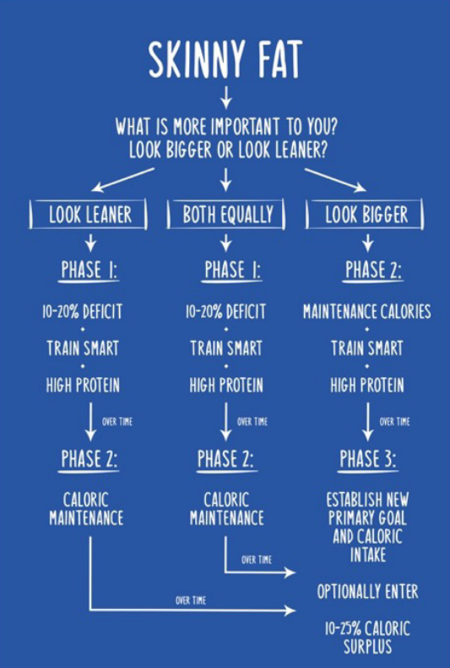

Example of a skinny-fat individual who prioritized looking leaner first:

PHASE 1: LOWER BODY FAT PERCENTAGE (~10-20% CALORIC DEFICIT)

As mentioned above, assuming the primary goal is to look leaner, we suggest a 10-20 percent deficit to start off your recomposition phase. Even if you would like to achieve both goals equally, it may be well-advised to put your overall health at the forefront. Also, prioritizing being leaner will allow measures like insulin sensitivity to improve, which can actually benefit body recomposition over the long run by improving nutrient partitioning. Of course, we do not recommend that you remain in a calorie deficit indefinitely, as this will eventually impede your muscle building potential. Once you have lost a significant amount of body fat, seen significant reductions in your waist circumference and leaner progress photos, we recommend transitioning out of a calorie deficit and into Phase 2: Caloric Maintenance. For context, it would be appropriate to begin the transition from Phase 1 to Phase 2 after going from approximately 20 percent body fat to approximately 15 percent as a male or from about 35 percent body fat to around 28 percent as a female. Generally, Phase 1 can last anywhere from two to six months, depending on the extent of fat loss required.

PHASE 2: GAIN LEAN MASS AND LOWER BODY FAT PERCENTAGE (~CALORIC MAINTENANCE) Now that you have achieved a lower body fat percentage, it is time to transition to caloric maintenance so that muscle can be built at a faster rate. This may require recalculation of your current caloric needs based on your new body weight, body composition and activity level as covered earlier in this chapter. By decreasing your fat mass in Phase 1, you will now be more insulin sensitive and can begin to shift your macronutrient ratios as well. For now, we generally recommend increasing your carbohydrate intake and decreasing your fat intake as you get leaner and more muscular. For example, if you were consuming 35 percent of your total calories from fat in Phase 1, you may now reduce fat intake to make up 25-30 percent of total calories in Phase 2. This shift should lead to improved training performance, better pumps in the gym and increased muscle fullness. Phase 2 would involve taking the male who got down to approximately 15 percent body fat in Phase 1, down even further to 10-12 percent (as muscle mass gain naturally lowers body fat percentage). For the female that ended Phase 1 at about 28 percent, she may get down to 20-25 percent body fat in Phase 2. Generally, Phase 2 can take anywhere from 1-12 months depending on the individual’s needs and goals. For example, you may only need a few months at caloric maintenance before you are ready to prioritize building muscle and enter Phase 3. On the other hand, it is fine to stay in Phase 2 for an extended period of time if you would prefer to continue recomping by gradually losing fat and building muscle, without prioritizing one over the other. It is common however, for people to notice their physique making the greatest progress when shifting from a fat loss-focused phase to a muscle building phase. A proper shift to Phase 3 can result in just about pure muscle gain, in a near absence of any fat gain. You are now primed to make the most impressive visual progress by shifting into Phase 3: a moderate caloric surplus

PHASE 3: ESTABLISH NEW PRIMARY GOALS (~10-25% CALORIC SURPLUS) At this point, you have prioritized fat loss in Phase 1, lowered your body fat percentage while increasing muscle mass more substantially in Phase 2 and may now be ready to prioritize a faster rate of muscle gain by entering a caloric surplus. Just as with Phase 2, this may require recalculation of your current caloric needs as laid out earlier in this chapter. Also, since your body fat percentage continued to decrease during Phase 2, insulin sensitivity has continued to improve and macronutrient ratios can be further adjusted to include more carbohydrates with less fats (but never allowing fats to drop below 20 percent of your total calories). At this point, we recommend gradually increasing your total calorie intake up to around 10-25 percent. If you are more concerned with staying leaner and avoiding fat gain, we recommend sticking to slower calorie increases and a smaller overall caloric surplus (closer to 10 percent). If you are more concerned with building muscle and are comfortable with adding some fat, we recommend going with faster calorie increases and a larger overall caloric surplus (closer to 25 percent). Generally, Phase 3 can last anywhere from 2-12 months, depending on the individual’s needs and goals. After Phase 3, it is simply a matter of continuing to periodically reassess progress using the we’ve talked about at the beginning and updating your calorie and macronutrient needs based on your changing goals.

MACRONUTRIENTS

There are three key macronutrients which make up the calories we consume in food. The prefix MACRO refers to the nutrients our bodies use in BIG amounts to function properly (on the scale of grams). These macros are protein, carbs and fats.

MICRONUTRIENTS

Micronutrients, on the other hand, are nutrients like vitamins and minerals that our bodies use in small amounts (on the scale of milligrams).

THE SIX MICRONUTRIENT COMMANDMENTS:

1. Aim for at least three or four servings of green vegetables per day.

• Examples of one serving: Typically “1 cup” counts as a serving of vegetables. 1 cup of broccoli (more specifically: 100g raw), or ~10 broccoli florets; 100g raw spinach (~3 & ⅓ cups raw, or ½ cup cooked), or ½ cup asparagus (~65g or 6 spears).

2. Aim for at least two servings of fruit per day.

• Examples of one serving: one kiwi or one banana (typically 80-150g raw weight depending on fruit source).

3. Try to regularly eat a variety of fruits and vegetables of different colours and rotate food sources.

4. Consume fatty fish once or twice per week (otherwise, consider fish oil supplements.

5. Eat a varied, balanced diet. If eliminating grains, dairy or meat, consider supplementation of vitamin B12, vitamin D, omega-3 fatty acids, iodine, iron, calcium, and zinc under the guidance of a medical professional.

6. Generally, stick to a whole food, minimally-processed, nutrient-dense diet.

HOW MUCH PROTEIN SHOULD WE EAT FOR RECOMP?

Protein is the most essential macronutrient when it comes to repairing and building muscle. We also know that protein is the most thermogenic macronutrient, meaning it leads to more caloric expenditure than carbs or fats. In addition, protein tends to be the most satiating macronutrient, meaning you will feel fuller for a given number of calories consumed. Since there is no consensus in the scientific literature about the amount of protein we need to eat for maximum gains, we think it is far better to have too much protein than too little. If you consume too little, you could be leaving potential gains on the table and missing out on fat loss, just because you didn’t want to eat an extra chicken breast or protein shake. In this sense, we think of having a high protein intake as a sort of anabolic insurance. It covers you in a similar way as car insurance in that you may not necessarily need it, but it’s a good idea to have it just in case. For the record, since we are advocating for a high protein diet, it’s worth noting that a high protein diet is very safe and the current literature has consistently shown no negative side effects of very high protein diets on blood lipids, liver, bone or kidney function. We also believe that just like people of different starting body fat percentages will require different calorie intakes, they will also require different protein intakes. How much protein YOU need to eat, depends not only on your bodyweight, but also on your body fat. So it isn’t quite as simple as just recommending a single target for everyone.

OUR SLIDING MODEL FOR PROTEIN INTAKE

There is direct evidence that increasing protein intake leads to body recomposition. Several studies have shown that very high protein intakes (protein overfeeding) leads to body recomposition by either reducing fat mass, increasing lean mass, or both.

The higher your body fat percentage, the less likely you are to lose muscle in a calorie deficit because your body has so much fat to use for fuel. On the other hand, the leaner you are, the more likely you are to lose muscle in a calorie deficit because there is more limited fat for fuel. Therefore, we propose that the leaner you are, the more protein you need to eat to preserve (or gain) muscle mass. This is why we recommend a sliding protein target ranging between 1.2 - 1.6 grams per pound of lean body mass. This sliding scale takes into consideration your current body composition. The leaner you are, the closer you will want to be to the 1.6 grams per pound figure. The more body fat you have, the closer you will want to be to the 1.2 grams per pound figure.

LOW FAT? LOW CARB? OR NEITHER?

Both carbs and fats play an important role in fueling training performance and driving positive body composition change. To keep things simple, fats are essential for survival and carbohydrates are not. This means that we must consume dietary fat, whereas our metabolism can adapt to a complete absence of carbohydrate intake by shifting the primary energy source to ketone bodies (molecules produced from fatty acids by the liver - ketogenesis - that are readily transported into tissues outside the liver to be oxidized for energy). Still, just because we can survive without carbs does not imply that eliminating them from the diet is the most effective route to body recomp. Many people fear that “eating fat will make them fat.” Of course, dietary fat serves many purposes in the human body apart from being stored as adipose tissue, including regulating many metabolic processes, playing a large role in hormonal production, and enabling our bodies to absorb and utilize certain vitamins (A, D, E, & K).

HOW MUCH FAT SHOULD WE EAT FOR RECOMP?

We generally advise that 20-35 percent of your total calories come from dietary fat. By ensuring you never drop your fats below 20 percent of total calories, you reduce your risk of becoming deficient in fat soluble vitamins and experiencing negative hormonal side effects such as reduced testosterone. There is a strong relationship between body fat percentage and insulin sensitivity. The higher your body fat percentage, the lower your insulin sensitivity. Thus, the higher your starting body fat percentage is, the lower your carbohydrate intake should be. Therefore, we suggest those with higher levels of body fat stay toward the higher end of our recommended range of 20-35 percent of total calories. Moreover, you should take your activity levels into consideration when determining how much of your caloric intake should come from fats. Those that are more active would benefit from a lower fat intake, as they can more easily utilize carbohydrates for energy, while those with less active lifestyles would be better off with a higher fat and lower carb intake. Once you determine your dietary fat and protein intake, you fill in the remaining calories of your daily goal from carbohydrates.

HOW MUCH CARBOHYDRATE SHOULD WE EAT FOR RECOMP?

Carbohydrates are our bodies’ preferred energy source as they are utilized most efficiently. Moreover, carbohydrates are a great tool for improving training performance, as plenty of research has shown that extreme carbohydrate restriction can negatively impact strength training. A strong relationship between body fat percentage and insulin resistance has been demonstrated in the scientific literature. This implies that those who carry more body fat have a decreased ability to utilize carbohydrates efficiently. Thus, they should reduce their total carbohydrate intake and consume a larger percentage of calories from fat. This relationship is why we suggest those of you with higher body fat levels consume fewer carbs and more fats, while those of you who are leaner and have less body fat should consume more carbs and less fat.

STEP-BY-STEP GUIDE FOR SETTING UP RECOMP MACROS:

• Step 1: Weigh yourself and calculate your body fat % (via BIA, Skin Calipers, DEXA, or guesstimation)

• Step 2. Calculate LBM: Bodyweight x (0.XX as % of lean mass) i.e. if you weigh 170lbs at 15% bodyfat, you have 85% lean mass. Your LBM would be: 170lbs x 0.85 = 144.5lbs LBM

• Step 3: Estimate your Basal Metabolic Rate (BMR) using the according to Mifflin St. Jeor Formula or (more roughly) bodyweight(lbs) x 10.

• Step 4: Apply the appropriate activity multiplier to determine your theoretical maintenance calories. Alternatively, use a 2 week guess-and-check method to determine maintenance calories.

• Step 5: Determine whether you should be in a caloric surplus, caloric deficit or at maintenance to drive body recomposition. Apply the surplus/deficit to your theoretical maintenance to determine your recomp calorie intake. (Important step!)

• Step 6: Set up your protein intake by multiplying your LBM by 1.2-1.6 (closer to 1.6 the leaner you are).

• Step 7: Determine what percentage of calories should come from fat (20-35%). Closer to 20 percent the leaner you are.

• Step 8: Calculate your fat intake by multiplying your recomp calorie intake by the percentage in Step 7 and dividing by 9. (9 calories per gram of fat)

• Step 9: Calculate your “remaining calories” by subtracting the calories from protein (protein intake x 4) and the calories from fat (fat intake x 9).

• Step 10: Calculate your carb intake from the “remaining calories” by dividing by 4. (4 calories per gram of carbs)

1. PROTEIN QUALITY: WHAT FOOD SOURCES ARE MOST ANABOLIC?

Protein quality is typically defined based on its amino acid profile. Generally speaking, complete proteins are food sources which provide you with all of the nine essential amino acids. Muscle protein synthesis (MPS) requires that all nine essential amino acids be present, since skeletal muscle protein is itself made up of these nine essential amino acids.

The amino acids:

\* = Branch Chain Amino Acids (BCAAs) \*\* = Leucine: the key BCAA for MPS

VEGAN CONSIDERATIONS FOR PROTEIN SOURCES

Consuming foods with a full spectrum of EAAs may present a challenge to some vegans. Generally speaking, it can be more difficult for vegans to reach our recommended intake of total protein per day and the quality of protein (based on amino acid profile) from vegan sources is typically lower when compared to animal products. One potential solution vegans use to overcome the quality problem is to pair two or more incomplete protein sources to create a complete meal. A common pairing of two incomplete food sources to create a complete meal would be rice and beans (lentils). Unfortunately, this strategy still poses a slight problem: the total quantity of amino acids are still generally much lower from vegan protein sources. Fortunately, in recent years, many supplement companies have made large strides in improving high quality vegan protein powders with a full spectrum of essential amino acids. We therefore strongly recommend supplementing with a vegan protein blend that uses rice and pea protein as their primary sources. Apart from supplementing a rice and pea protein blend, BCAA supplementation is worth considering for vegans to maximize the protein synthetic response of each meal. Since any complete protein-containing meal will contain all three BCAAs by default, we would not say supplementation is required, but may assist in making the most of each meal, especially if it is naturally lower in total BCAA content. We suggest that vegans consuming meals naturally low in leucine can optionally consume an additional five grams of BCAAs (2:1:1 ratio) via supplementation with meals (most importantly pre/postworkout) to maximize the muscle protein synthetic response.

DO BCAAS ACTUALLY MATTER?

Yes, and no. Every time you eat a meal, you have an opportunity to maximize MPS and over time, your muscle building potential. Since leucine is responsible for triggering MPS, if you’re consuming food sources that are low in BCAAs (especially leucine), you are leaving potential gains on the table. Generally speaking, the more leucine in a meal the more MPS will be elevated, up to a point. This means that consuming protein sources higher in leucine (such as whey or other animal sources) will increase MPS more. It also means that, assuming you have two meals of equal leucine content, the meal with more total protein will increase MPS more. However, there is a limit to how much you can crank MPS up. While BCAAs do play an important role in getting the muscle building process started, we cannot simply consume BCAAs on their own and expect to build new muscle. For this reason, we recommend consuming foods high in BCAAs and EAAs and, except for in the case of some vegan exceptions, recommend against BCAA supplementation.

SUGGESTED PROTEIN SOURCES

Below are a list of high quality, protein rich foods that we recommend including in your diet regularly. These foods were selected based on the completeness of their amino acid profile and total leucine content.

* Whey Protein
* Eggs
* Egg Whites
* Meat (Chicken, Beef, Pork, Turkey, Elk, Game, etc)
* Fish (all kinds)
* Dairy (i.e. yogurt, cheese)
* Vegan Protein Powder (Rice + Pea Blends)
* Soy Protein Isolate
* Seaweed, Spirulina

2. PROTEIN DISTRIBUTION: HOW SHOULD WE SPACE OUT OUR PROTEIN THROUGHOUT THE DAY?

HOW MUCH PROTEIN CAN WE ABSORB IN ONE MEAL?

The amount of protein needed to recover from an intense leg day is likely more than what is needed after a quick arm-pump. So how much protein you can utilize in a single meal seems to depend on the type of training you do, with higher volume sessions involving more total muscle, utilizing more protein per meal. How much protein you need per meal also depends on how much total muscle mass you have. For example, a 120 pound female will require less total daily protein than a 180 pound male, but will also be able to utilize less protein per meal for building new muscle. In summary, the more muscle you train in a workout and the more total muscle you have, the more protein you should be able to utilize per meal.

HOW MUCH PROTEIN SHOULD WE EAT PER MEAL?

As mentioned previously, while we need a full spectrum of essential amino acids in order to actually build new muscle tissue, the branch chain amino acid leucine is the primary trigger (key) for sparking new muscle growth (MPS). If we are going to answer the question of how much protein we should eat per meal, it is important therefore to know how much leucine we should eat per meal. Luckily for us, one of the world’s most renowned protein researchers - Dr. Stuart Phillips - has discovered what that leucine threshold in humans seems to be. Dr. Phillips reported that 0.045 grams of leucine per kilogram of body weight per meal is the amount needed to optimize MPS. However, calculating the leucine content of every meal would be annoying and impractical, so the best approach would be to evenly distribute the total protein goal per day across the number of meals.

HOW MANY MEALS SHOULD I EAT PER DAY?

Of course, simply reaching your total daily protein target is still the most important thing, but may not be enough to maximize results. Theoretically speaking, since there is a maximum threshold for upregulating MPS in one feeding, increasing the frequency of feedings (up to a point) should enhance muscle building capabilities. That’s exactly what the science has showed us in a particular study. To maximize the anabolic response of each meal, we suggest splitting your total protein intake across 4 to 6 high-protein meals per day, spaced by roughly 3-5 hours between meals (besides your overnight fast, when you’re sleeping (i.e. 6-9 hours)). Note that “meals” can also include protein shakes/meal replacements.

3. PROTEIN TIMING: WHEN ARE THE IMPORTANT TIMES TO EAT PROTEIN?