when we say body recomposition, we are referring to a reduction in body fat percentage alongside an increase in lean body mass (more specifically, muscle mass). In both women and men, this is most commonly achieved under four circumstances:

1. NEW LIFTERS (BEGINNERS): As we discussed above, the body is most primed for growth when weight training is still a new stimulus. To fuel the speedy muscle building process, the body can “easily” tap into body fat stores to yield impressive recomposition.

2. DETRAINED LIFTERS (DETRAINEES): The detrained lifter is anyone who has lifted for a significant period of time, built a significant amount of muscle but then stopped training due to injury, lack of motivation or some other impediment to regular lifting. Similar to the new trainee, the detrainee is able to build a lot of muscle very quickly, making recomposition common. We will revisit this phenomenon later when we discuss muscle memory.

3. OBESE INDIVIDUALS: Because obese individuals have a very large energy reserve (bodyfat), it’s simple enough for them to eat in a caloric deficit and still have plenty of stored energy to fuel the muscle building process. As a result, when obese individuals train, it’s common for them to build muscle and lose fat at the same time.

4. ANABOLIC STEROID USERS: Using anabolic steroids puts you in a similar camp to the new trainee and the detrainee in that it allows most people to build relatively large amounts of muscle mass very quickly. Again, to fuel that speedy muscle building process, the body can tap into body fat stores, resulting in impressive recomposition.

MANDATORY TOOLS TO MEASURE AND TRACK BODY COMPOSITION

1. WEIGHT SCALE

For consistency purposes, we recommend tracking your body weight for four-seven days per week at the same time of day for consistency purposes. Weigh as soon as you wake up, after using the bathroom and before drinking any water or eating any food. Using those four-seven body weight measurements, you will tabulate a weekly average. You will then compare that weekly average to future weekly averages to determine whether your weight is trending up or down over time.

1. MEASURING TAPE

When taking body part measurements, measure at the largest site on the muscle. For the Legs-Thighs, Biceps, Triceps and Calves, be sure to record both a left and a right measurement. This will allow you to track any asymmetry and thereby modify your training to correct for imbalances. Similar to the scale, realize that body part measurements are not a perfect science. For example, as you lose fat, many of these measurements may actually decrease, despite a gain in muscle to the area (if you happen to lose more fat from the area than you added muscle to the area). As such, you should use this information to compliment the weight and waist measurements. When losing body fat, waist circumference is the one area that seems to change the most and even if you’re adding muscle to your abdominals, it will not drastically change the size of your waist. For all intents and purposes, a reduction in waist circumference is a very good indicator of fat loss. To avoid fluctuations due to water retention, we suggest taking waist circumference measurements one to two times per month, on the same days each month. The other body part measurements can be taken once every one to three months when assessing muscular progress on specific areas or weak points.

1. CAMERA (PROGRESS PHOTOS)

We recommend taking progress photos one to four times monthly.

Follow the suggestions below to ensure you take the most accurate and useful progress photos possible:

A) Use the same environment/location (ideally using natural light from a window or doorway); B) Shoot at the same time of the day (preferably fasted on an empty stomach);

C) Shoot on the same day of the week;

D) Use the same angle for each picture. Set up your camera in the same spot, at the same height;

E) Use a self-timer or record a video and take screen shots, and

F) Include your full body in several different poses. Include front, back and side pics. If you can perform mandatory bodybuilding poses, they are ideal for assessing muscular detail and balance.

4. FOOD SCALE

It is essential that you track your calorie, protein, fat and carbohydrate intake from all foods you eat. For the sake of convenience, we recommend tracking your food intake through mobile apps like MyFitnessPal.

A calorie is simply a unit of energy. And “energy balance” simply refers to the relationship between energy coming in and energy going out. Over a specific time scale, energy balance is said to be positive if you are storing more calories than you are burning. Generally speaking, this means you are in a caloric surplus and should gain weight. Conversely, energy balance is said to be negative if you are burning more calories than you are storing. In this case, you are in a caloric deficit and should lose weight. Again, for the most part, bigger caloric surpluses will lead to faster weight gain and bigger caloric deficits will lead to faster weight loss.

Put simply, the energy balance equation in relation to calories and weight loss looks like this: WEIGHT CHANGE = CALORIES IN – CALORIES OUT

It’s also common to see people misapply the logic of the energy balance equation. For example, many folks will just assume that an anabolic process like building muscle can’t happen concurrently with a catabolic process like losing fat. Because fat tissue and muscle tissue are separate systems, it’s perfectly possible to lose a significant amount of fat due to the caloric deficit, while still building muscle from the progressive training stimulus (and sufficient protein).

For the sake of being as precise as possible, it’s worth noting that fat and muscle tissues have different energy densities. Because muscle is made up mostly of water, it has much less stored energy than fat does. One kilogram (~2.2 pounds) of muscle contains 1,800 calories while one kilogram of fat has 9,400 calories.

Let’s run the net energy balance math on the example above, assuming you were to lose 20 pounds (9.1kg) of fat while gaining 5 pounds (2.3kg) of muscle over a full year: 9.1 KILOGRAMS OF FAT LOST = 85,540 CALORIES LOST 2.3 KILOGRAMS OF MUSCLE GAINED = 4,140 CALORIES GAINED NET ENERGY BALANCE = ENERGY GAINED – ENERGY EXPENDED = -81,400 CALORIES In other words, in order to achieve this body recomposition, you must have been in a 81,400 calorie deficit over the course of the year. Since there are 365 days in a year, that would amount to: 81,400 yearly calorie deficit / 365 days = a 223 calorie deficit per day

Weight change = calories in – calories out. The ‘calories in’ part of this equation is very straightforward: you eat food - and that pretty much covers that segment. The ‘calories out’ aspect is much more complex and requires further explanation to understand how each of these two factors influence body recomposition.

Total daily energy expenditure (TDEE): the total number of calories you burn each day. It is sometimes referred to as your net metabolic rate. Three key factors determine the number of calories we burn each day:

1. Basal Metabolic Rate (BMR) - how many calories your body burns per day in order to perform all of its basic metabolic functions and maintain its body mass at rest. If you sat on the couch all day long and did nothing but breathe, this would be roughly the number of calories you’d burn. Since your BMR comprises such a large portion of your total daily energy outflow, it is worthwhile to determine roughly how many calories it contributes to the total daily burn. For those of you who like math and objective numbers, we recommend using the Mifflin St. Jeor formula (below) to calculate your BMR. As you can see, this formula takes four variables into consideration: gender, age, height and weight. However, there are additional variables that are not, and can not be accounted for. This is one reason why this formula is very good, but not perfect.

BMR = 10 x weight(kg) + 6.25 x height(cm) - 5 x age(y) + 5 (man)

BMR = 10 x weight(kg) + 6.25 x height(cm) - 5 x age(y) - 161 (woman)

1. Physical Activity Level - how many calories you burn by “moving around”. For most people, daily physical activity makes up 20-35 percent of total caloric expenditure. These values can be lower if you are more sedentary or higher if you’re more active than average. It’s worth highlighting that this component of metabolism is not limited to the number of calories you burn while formally exercising (lifting weights and cardio). It includes the calories burned from all of your daily activities, including typing at your desk, bringing groceries to the car and singing in the shower. The calories burned from these non-exercise activities make up NEAT: Non-Exercise Activity Thermogenesis. Interestingly enough, when in a caloric deficit for an extended period of time, your body senses the decline in food intake and automatically decreases energy expenditure by downregulating NEAT. This can result in something as simple as fidgeting less, but can also present as severe fatigue if you diet for too hard or too long
2. Thermic Effect of Food - amount of energy expended by breaking down and processing food for use and storage. Simply put, your body burns calories as it digests, absorbs, transports and stores food that you eat. Just as each macronutrient (carbohydrates, fats or proteins) provides us with a different number of calories, they also require different amounts of energy to digest, absorb, and utilize. Because of this, each macronutrient has a different thermic effect.

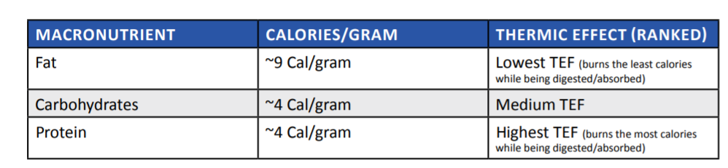

Protein is the most thermogenic macronutrient. This means eating a higher protein diet will result in more calories burned because it requires more energy to digest and absorb that protein. This is one of the many reasons why high protein diets typically result in greater fat loss and better improvements in body composition, even when caloric intakes are equated. This fact serves as another example of why the expression “a calorie is a calorie” fails to capture the more complex and nuanced ways in which each of the different macronutrients are handled by our bodies.

To illustrate, let’s compare complex carbohydrates and simple carbohydrates. Complex carbohydrates are primarily made up of long chains of carbs (polysaccharides) that need to be digested and broken down into smaller molecules (disaccharides, monosaccharides) before being used for energy. On the other hand, most simple carbohydrates are already in a usable form and do not need to be digested per se. They simply need to be absorbed and can be utilized for energy or stored right away. For example, 200 grams of sweet potato and 43 grams of Gatorade will both deliver roughly 40 grams of carbohydrates. However, the thermic effect of these two foods are quite different. Your body will expend more energy digesting and absorbing the carbohydrates from the sweet potato than it will the Gatorade. This isn’t to say that one of these carbohydrate sources is good and the other is bad, but rather that they may be more and less suitable in certain contexts.

CALORIE INTAKE: HOW MANY CALORIES SHOULD I EAT?

Depends on three factors:

1. YOUR PRIMARY GOAL

Obviously, the goal with body recomposition is to build muscle AND lose fat (not to pick one or the other). However, it is still important to pick what goal is more important to you. The reason we insist on choosing a primary goal is that it will contribute to the determination of how many calories you should eat. If your primary goal is to lose fat, we recommend a moderate caloric deficit, whereas if you mostly want to build muscle, then a moderate caloric surplus is best suited for your goal. If both objectives are equally important, eating at caloric maintenance is our suggestion for you.

2. CURRENT BODY COMPOSITION

Defining Body Composition:

For our purposes here, we will split body composition into three categories:

Low Bodyfat: 8-12% bodyfat for men, 18-22% for women

Moderate Bodyfat: 12-18% bodyfat for men, 22-28% for women

High Bodyfat: 18-20+% bodyfat for men, 28-30%+ for women

As a general rule of thumb, we suggest that for those with a lean physique, the best way for you to transform your physique and achieve body recomp is to enter a caloric surplus. If an already lean individual was to enter a caloric deficit, or even stay at maintenance, he or she would inhibit the ability to build muscle at an appropriate rate. This could end up in the person not making any significant progress with either muscle gain or fat loss. On the other end of the spectrum, if you’re currently at a higher body fat percentage, entering a caloric surplus would be detrimental to your goal of recomping since it will stunt fat loss. In this case, a caloric deficit will ensure that fat loss occurs as the progressive resistance training and adequate protein intake facilitate muscle growth. As a third scenario, some of you may fall in between these two body fat categorizations into a sort of moderate body fat classification. In this case, we recommend staying closer to maintenance calories, with the goal of losing fat and building muscle being on roughly even footing. In this case, you can also default to your primary goal determinant to decide whether you should stay at true maintenance, or enter a slight surplus, or a slight deficit.

3. TRAINING EXPERIENCE

The more training experience you have, the closer you will be to your natural genetic limitation for muscle mass and consequently, it will be more difficult for you to gain lean mass. Conversely, someone who is still relatively new to weight training will be able to gain muscle mass much faster. This is important to keep in mind because it implies that beginners can use larger surpluses to build muscle without accruing excessive fat mass. In other words, the more advanced you are, the more likely it is that large caloric surpluses will lead to fat gain rather than muscle gain (since you will be more resistant to muscle gain). For the purposes of this section, we will define beginner, intermediate and advanced as follows:

• BEGINNER - Making progressive overload gains on a week to week basis and significant visual changes month to month (usually 0-2 years of lifting).

• INTERMEDIATE - Able to progressively overload on a month to month basis. Physique progress is evident every couple of months (usually 2-5 years of lifting).

• ADVANCED - Takes multiple months or even years to see visual progress and ability to overload lifts is much more difficult (usually 5+ years of serious lifting).

As an example, consider someone with only six months of lifting experience whose primary goal is to build muscle (let’s assume they are already pretty lean). Because their body is so primed for muscle growth, a relatively large (25 percent) caloric surplus will return much more lean gains than a 25 percent caloric surplus would for an advanced trainee. So, assuming their caloric maintenance (calories needed to maintain weight) is 2500 calories, a 25 percent caloric surplus would be: 2,500 calories (maintenance) + 25 percent = 3,125 calories for recomp. Compare this with someone with five years of lifting experience. Because they are much closer to their genetic muscular ceiling, a large caloric surplus will yield more fat gain than muscle gain - not ideal for someone with a body recomp goal. Assuming they also have the primary goal of building muscle, in this case, we would recommend a smaller (~10 percent) caloric surplus: 2,500 calories (maintenance) + 10 percent = 2,750 calories for recomp. On the other hand, your training age will not directly impact how big your deficit should be since one’s ability to lose fat is not diminished with increased training experience. For the most part, beginners and veterans to the weight room will not differ in their ability to lose fat. For this reason, experience level only impacts the recommended size of a caloric surplus, not a caloric deficit.

1. OTHER FACTORS

BIOFEEDBACK - Throughout the process of recomping, it is important to pay attention to biofeedback (your recovery and hunger). If your training volume or intensity is higher than normal for example, it may be necessary to increase your caloric intake during this period of increased training demands. Also, sometimes an amplified training stimulus will result in an increased appetite, perhaps as a signal that you require more nutrients to fuel proper recovery. While you should be cautious with using your appetite to dictate your calorie intake (since your appetite generally doesn’t care about your goals), paying attention to this biofeedback can provide useful information when it comes to adjusting calorie intake.

THE DETRAINEE. Body recomposition is extremely common for those who previously resistance trained, built a lot of muscle, but later stopped resistance training for an extended period of time and ended up losing muscle as a result. This phenomenon of “muscle memory.” Basically, it’s much easier to build muscle back than it was to build that muscle from scratch. When we weight train and cause muscle fibers to grow in size (hypertrophy), we also increase the number of nuclei (myonuclei) in the muscle. You can think of myonuclei as the control center of the muscle fiber. Even though the muscle fiber itself loses size (atrophy) when we skip the gym for too long, these control centers (myonuclei) are never lost. As soon as we get back to training again, myonuclei that were built months or years ago can now start cranking out commands to ramp up the production of new muscle much faster than if you had never trained in the past.

While it will depend on the other factors we have just outlined (Does the detrainee have a specific primary goal? Are they starting at a high or low bodyfat?), eating at caloric maintenance is often a safe starting point to begin losing fat and building muscle for the detrainee. In many respects, the detrainee can be treated more like a beginner in the sense that they are often able to achieve impressive recomposition in a relatively short time frame.

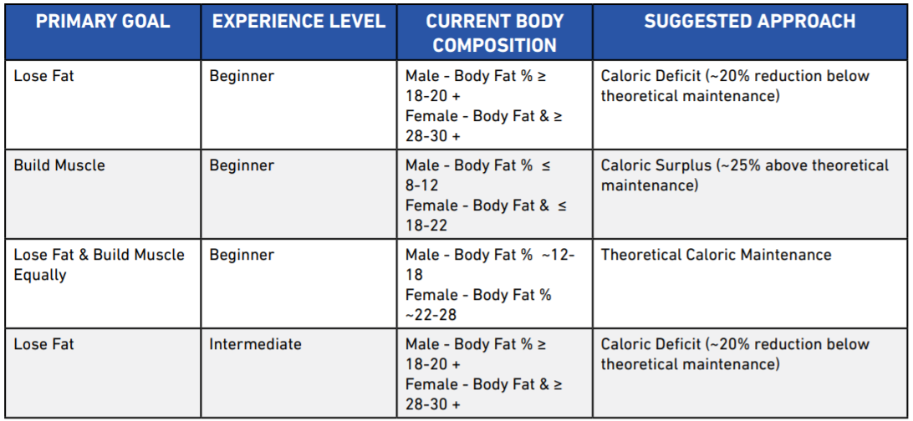

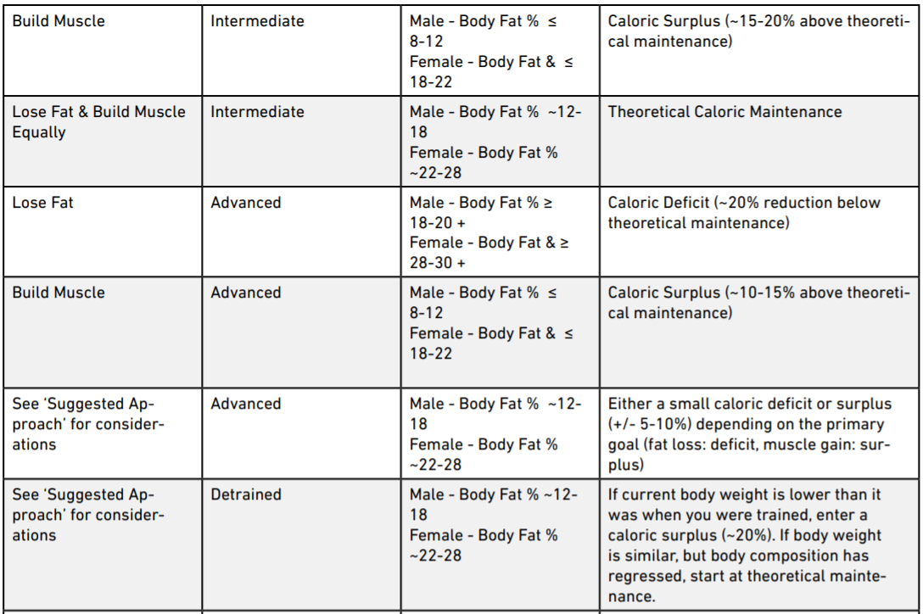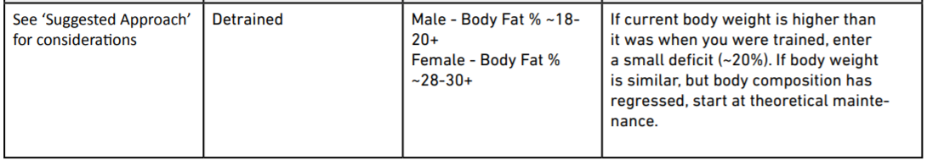

EXCEPTIONS TO THE TABLE ABOVE

If most of the following points apply, you may be a genetic freak. You may want to increase the recommended calorie surplus by 5-10 percent.

• You have a large frame: Broad shoulders, thick wrists and ankles.

• You have muscular parents and/or multiple muscular relatives.

• You are generally gifted at sports.

• You have noticed you can build muscle quickly.

• Men only: You have a high 2D:4D ratio (your ring finger is significantly longer than your index finger)

If you are currently well above 25 percent body fat for men or 35 percent for women, it may be wise for you to enter a larger caloric deficit in the range of 20-30 percent.

ESTIMATING THEORETICAL MAINTENANCE

The goal is to simply determine how many calories you need to eat per day to maintain your current weight. Maintenance calories should not be thought of as a fixed number, but rather as a moving target that will change based on your changing body composition, NEAT levels and various other metabolic factors. Two ways to estimate this value:

1.USING A FORMULA

Calculate BMR using the Mifflin St. Jeor formula and account for activity levels using the table below:

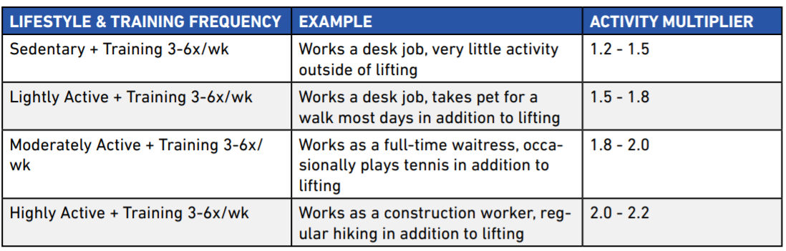

2. USING A GUESS-AND-CHECK METHOD.

1. Track your bodyweight and caloric intake every day for two weeks

2. Determine the average values for week one and week two.

3. Determine the average weight gained or lost from week one to week two.

4. Determine maintenance based off weight change.

a. If you maintained weight from week one to week two, then whatever your average caloric intake was can be set as your maintenance calories.

b. If you lost weight from week one to week two:

i. Assuming you need about a 500 calorie deficit per day to lose one pound of weight, you can determine maintenance by figuring out how much of a deficit you were in.

EXAMPLE 1: If you ate 3,000 calories per day on average and lost one pound from week one to week two, then your maintenance would be (3,000 + 500 calories = 3,500 calories).

EXAMPLE 2: If you ate 2,000 calories per day on average and lost 0.4 pounds from the first week to the second, then your maintenance would be (2,000 + 0.4 x 500 calories = 2,000+ 200 calories = 2,200 calories).

c. If you gained weight from week one to week two:

i. Assuming you need about a 500 calorie surplus per day to gain one pound of weight, you can determine maintenance by figuring out how much of a surplus you were in.

EXAMPLE 1: If you ate 3,000 calories per day on average and gained one pound from the first week to the second, then your maintenance would be (3,000 - 500 calories = 2,500 calories).

EXAMPLE 2: If you ate 2,600 calories per day on average and gained 0.4 pounds from week to week, then your maintenance would be (2,600 - 0.4 x 500 calories = 2,600 - 200 calories = 2,400 calories).

The benefit of using the formula-based approach is that you can figure out your maintenance calorie intake right away. The downside of using a generic calculation is that it may not be truly fine-tuned to your individual situation. The benefit of using the guess-and-check method is that you are basing your estimation off your body’s actual response to food intake. The downside of using guess-and-check is that it takes at least two weeks to get a decent idea of what your maintenance is, which can be a drag if you are eager to get started right away.

CARB/CALORIE CYCLING AND REFEEDS

A refeed is a 24 hour period during which caloric intake is increased (normally through increased carb intake). Generally, refeeds are employed in dieters for four main reasons:

1. To acutely improve training performance (which is often impeded on low calorie/carb intakes);

2. To provide a mental break from the monotony of a fat loss diet;

3. To acutely reverse some of the negative hormonal adaptations associated with low caloric intakes and low body fat percentages, such as reduced leptin; and

4. To improve adherence to the diet.

Two options, depending on your specific goals and circumstances:

1. A LINEAR APPROACH (NO REFEEDS OR CARB CYCLING)

A linear approach to daily caloric intake means that you will eat the same caloric intake and the same macros every day without refeeds, high carb days or calorie cycling. This approach would be most appropriate for anyone with the primary goal of building muscle and in a caloric surplus. When in a caloric surplus, it is of relatively less importance to vary your carbohydrate intake throughout the week. Since there is already an excess of nutrients to fuel performance, the diet should not be mentally strenuous and there should be no negative hormonal adaptations to reverse. Additionally, for some individuals, establishing consistent daily habits and building trust in your ability to follow through each and every day will be better achieved by simply hitting a set target for a given period of time. If there is a particular event or special occasion that will make hitting your macronutrient targets more difficult, you can simply account for the increase in calorie intake by making a conscious effort to be more active that day (or in the coming few days), or by doing your best to estimate the nutritional content of the meal without stressing or obsessing over the specifics.

2. LOGICAL CARB CYCLING (NON-LINEAR CARB INTAKE)

For those who are either in a deficit, or at caloric maintenance and are seeking to optimize every area of their diet, we are suggesting a “logical carb cycling” approach. For those with more limited calories to spare, partitioning more of your energy intake on days that you train is a tool to prioritize the timing of nutrients around the workout. It should be pretty intuitive: you will allocate more carbohydrates on days that you train, which will fuel your training better and may compound over time to yield greater results. This would imply that on days you are resting from the gym, you would eat slightly less carbohydrate (and slightly less calories overall). As a simple rule of thumb for those taking the non-linear route, we recommend reducing total daily carb intake by to approximately 20 percent on non-training days. You may also utilize this logical carb cycling approach by increasing your calories (primarily via carbs) on a day your caloric expenditure is abnormally high. For example, if you normally weight train 5x per week but happen to play two hours of basketball on top of your normal exercise regimen, you can adjust for that increased calorie expenditure by taking a refeed. If your physical activity is significantly higher than your norm, you can consider increasing carb intake by approximately 20 percent for that day.

THE “SKINNY FAT” DILEMMA

A skinny fat male has more than 20 percent body fat with low muscularity and a skinny fat female has more than 35 percent body fat with low muscularity. If this label does fit, a bulking approach may be tempting because you would like to look more muscular. However, a bulking phase will most often lead to an even fatter appearance and exacerbate the potential health concerns associated with having a higher body fat percentage. People who are skinny fat (despite their normal body weight) have an increased risk of developing metabolic syndrome. They also tend to have insulin-resistance, excess visceral fat, high blood triglycerides, elevated blood pressure and may be at a greater risk for developing cardiovascular disease. For this reason, we generally advise against a caloric surplus for skinny fat individuals. Likewise, while an aggressive cutting approach may improve health outcomes by lowering body fat levels, it will also most likely result in an even skinnier appearance. This is why we believe body recomposition to be the ideal route for someone who is indeed skinny fat.

Path recommendation:

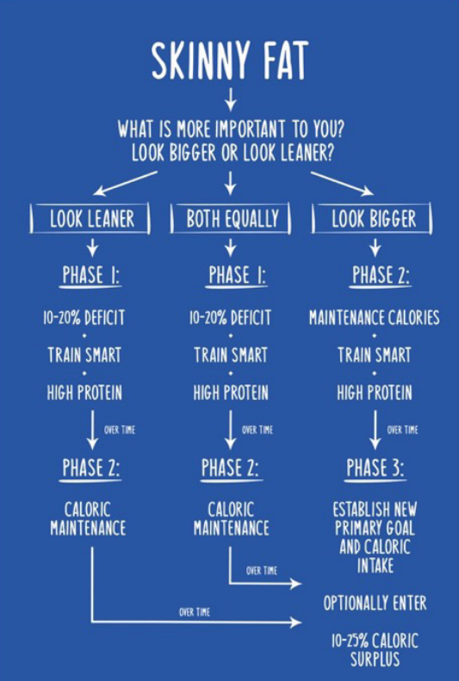

Example of a skinny-fat individual who prioritized looking leaner first:

PHASE 1: LOWER BODY FAT PERCENTAGE (~10-20% CALORIC DEFICIT)

As mentioned above, assuming the primary goal is to look leaner, we suggest a 10-20 percent deficit to start off your recomposition phase. Even if you would like to achieve both goals equally, it may be well-advised to put your overall health at the forefront. Also, prioritizing being leaner will allow measures like insulin sensitivity to improve, which can actually benefit body recomposition over the long run by improving nutrient partitioning. Of course, we do not recommend that you remain in a calorie deficit indefinitely, as this will eventually impede your muscle building potential. Once you have lost a significant amount of body fat, seen significant reductions in your waist circumference and leaner progress photos, we recommend transitioning out of a calorie deficit and into Phase 2: Caloric Maintenance. For context, it would be appropriate to begin the transition from Phase 1 to Phase 2 after going from approximately 20 percent body fat to approximately 15 percent as a male or from about 35 percent body fat to around 28 percent as a female. Generally, Phase 1 can last anywhere from two to six months, depending on the extent of fat loss required.

PHASE 2: GAIN LEAN MASS AND LOWER BODY FAT PERCENTAGE (~CALORIC MAINTENANCE) Now that you have achieved a lower body fat percentage, it is time to transition to caloric maintenance so that muscle can be built at a faster rate. This may require recalculation of your current caloric needs based on your new body weight, body composition and activity level as covered earlier in this chapter. By decreasing your fat mass in Phase 1, you will now be more insulin sensitive and can begin to shift your macronutrient ratios as well. For now, we generally recommend increasing your carbohydrate intake and decreasing your fat intake as you get leaner and more muscular. For example, if you were consuming 35 percent of your total calories from fat in Phase 1, you may now reduce fat intake to make up 25-30 percent of total calories in Phase 2. This shift should lead to improved training performance, better pumps in the gym and increased muscle fullness. Phase 2 would involve taking the male who got down to approximately 15 percent body fat in Phase 1, down even further to 10-12 percent (as muscle mass gain naturally lowers body fat percentage). For the female that ended Phase 1 at about 28 percent, she may get down to 20-25 percent body fat in Phase 2. Generally, Phase 2 can take anywhere from 1-12 months depending on the individual’s needs and goals. For example, you may only need a few months at caloric maintenance before you are ready to prioritize building muscle and enter Phase 3. On the other hand, it is fine to stay in Phase 2 for an extended period of time if you would prefer to continue recomping by gradually losing fat and building muscle, without prioritizing one over the other. It is common however, for people to notice their physique making the greatest progress when shifting from a fat loss-focused phase to a muscle building phase. A proper shift to Phase 3 can result in just about pure muscle gain, in a near absence of any fat gain. You are now primed to make the most impressive visual progress by shifting into Phase 3: a moderate caloric surplus

PHASE 3: ESTABLISH NEW PRIMARY GOALS (~10-25% CALORIC SURPLUS) At this point, you have prioritized fat loss in Phase 1, lowered your body fat percentage while increasing muscle mass more substantially in Phase 2 and may now be ready to prioritize a faster rate of muscle gain by entering a caloric surplus. Just as with Phase 2, this may require recalculation of your current caloric needs as laid out earlier in this chapter. Also, since your body fat percentage continued to decrease during Phase 2, insulin sensitivity has continued to improve and macronutrient ratios can be further adjusted to include more carbohydrates with less fats (but never allowing fats to drop below 20 percent of your total calories). At this point, we recommend gradually increasing your total calorie intake up to around 10-25 percent. If you are more concerned with staying leaner and avoiding fat gain, we recommend sticking to slower calorie increases and a smaller overall caloric surplus (closer to 10 percent). If you are more concerned with building muscle and are comfortable with adding some fat, we recommend going with faster calorie increases and a larger overall caloric surplus (closer to 25 percent). Generally, Phase 3 can last anywhere from 2-12 months, depending on the individual’s needs and goals. After Phase 3, it is simply a matter of continuing to periodically reassess progress using the we’ve talked about at the beginning and updating your calorie and macronutrient needs based on your changing goals.

MACRONUTRIENTS

There are three key macronutrients which make up the calories we consume in food. The prefix MACRO refers to the nutrients our bodies use in BIG amounts to function properly (on the scale of grams). These macros are protein, carbs and fats.

MICRONUTRIENTS

Micronutrients, on the other hand, are nutrients like vitamins and minerals that our bodies use in small amounts (on the scale of milligrams).

THE SIX MICRONUTRIENT COMMANDMENTS:

1. Aim for at least three or four servings of green vegetables per day.

• Examples of one serving: Typically “1 cup” counts as a serving of vegetables. 1 cup of broccoli (more specifically: 100g raw), or ~10 broccoli florets; 100g raw spinach (~3 & ⅓ cups raw, or ½ cup cooked), or ½ cup asparagus (~65g or 6 spears).

2. Aim for at least two servings of fruit per day.

• Examples of one serving: one kiwi or one banana (typically 80-150g raw weight depending on fruit source).

3. Try to regularly eat a variety of fruits and vegetables of different colours and rotate food sources.

4. Consume fatty fish once or twice per week (otherwise, consider fish oil supplements.

5. Eat a varied, balanced diet. If eliminating grains, dairy or meat, consider supplementation of vitamin B12, vitamin D, omega-3 fatty acids, iodine, iron, calcium, and zinc under the guidance of a medical professional.

6. Generally, stick to a whole food, minimally-processed, nutrient-dense diet.

HOW MUCH PROTEIN SHOULD WE EAT FOR RECOMP?

Protein is the most essential macronutrient when it comes to repairing and building muscle. We also know that protein is the most thermogenic macronutrient, meaning it leads to more caloric expenditure than carbs or fats. In addition, protein tends to be the most satiating macronutrient, meaning you will feel fuller for a given number of calories consumed. Since there is no consensus in the scientific literature about the amount of protein we need to eat for maximum gains, we think it is far better to have too much protein than too little. If you consume too little, you could be leaving potential gains on the table and missing out on fat loss, just because you didn’t want to eat an extra chicken breast or protein shake. In this sense, we think of having a high protein intake as a sort of anabolic insurance. It covers you in a similar way as car insurance in that you may not necessarily need it, but it’s a good idea to have it just in case. For the record, since we are advocating for a high protein diet, it’s worth noting that a high protein diet is very safe and the current literature has consistently shown no negative side effects of very high protein diets on blood lipids, liver, bone or kidney function. We also believe that just like people of different starting body fat percentages will require different calorie intakes, they will also require different protein intakes. How much protein YOU need to eat, depends not only on your bodyweight, but also on your body fat. So it isn’t quite as simple as just recommending a single target for everyone.

OUR SLIDING MODEL FOR PROTEIN INTAKE

There is direct evidence that increasing protein intake leads to body recomposition. Several studies have shown that very high protein intakes (protein overfeeding) leads to body recomposition by either reducing fat mass, increasing lean mass, or both.

The higher your body fat percentage, the less likely you are to lose muscle in a calorie deficit because your body has so much fat to use for fuel. On the other hand, the leaner you are, the more likely you are to lose muscle in a calorie deficit because there is more limited fat for fuel. Therefore, we propose that the leaner you are, the more protein you need to eat to preserve (or gain) muscle mass. This is why we recommend a sliding protein target ranging between 1.2 - 1.6 grams per pound of lean body mass. This sliding scale takes into consideration your current body composition. The leaner you are, the closer you will want to be to the 1.6 grams per pound figure. The more body fat you have, the closer you will want to be to the 1.2 grams per pound figure.

LOW FAT? LOW CARB? OR NEITHER?

Both carbs and fats play an important role in fueling training performance and driving positive body composition change. To keep things simple, fats are essential for survival and carbohydrates are not. This means that we must consume dietary fat, whereas our metabolism can adapt to a complete absence of carbohydrate intake by shifting the primary energy source to ketone bodies (molecules produced from fatty acids by the liver - ketogenesis - that are readily transported into tissues outside the liver to be oxidized for energy). Still, just because we can survive without carbs does not imply that eliminating them from the diet is the most effective route to body recomp. Many people fear that “eating fat will make them fat.” Of course, dietary fat serves many purposes in the human body apart from being stored as adipose tissue, including regulating many metabolic processes, playing a large role in hormonal production, and enabling our bodies to absorb and utilize certain vitamins (A, D, E, & K).

HOW MUCH FAT SHOULD WE EAT FOR RECOMP?

We generally advise that 20-35 percent of your total calories come from dietary fat. By ensuring you never drop your fats below 20 percent of total calories, you reduce your risk of becoming deficient in fat soluble vitamins and experiencing negative hormonal side effects such as reduced testosterone. There is a strong relationship between body fat percentage and insulin sensitivity. The higher your body fat percentage, the lower your insulin sensitivity. Thus, the higher your starting body fat percentage is, the lower your carbohydrate intake should be. Therefore, we suggest those with higher levels of body fat stay toward the higher end of our recommended range of 20-35 percent of total calories. Moreover, you should take your activity levels into consideration when determining how much of your caloric intake should come from fats. Those that are more active would benefit from a lower fat intake, as they can more easily utilize carbohydrates for energy, while those with less active lifestyles would be better off with a higher fat and lower carb intake. Once you determine your dietary fat and protein intake, you fill in the remaining calories of your daily goal from carbohydrates.

HOW MUCH CARBOHYDRATE SHOULD WE EAT FOR RECOMP?

Carbohydrates are our bodies’ preferred energy source as they are utilized most efficiently. Moreover, carbohydrates are a great tool for improving training performance, as plenty of research has shown that extreme carbohydrate restriction can negatively impact strength training. A strong relationship between body fat percentage and insulin resistance has been demonstrated in the scientific literature. This implies that those who carry more body fat have a decreased ability to utilize carbohydrates efficiently. Thus, they should reduce their total carbohydrate intake and consume a larger percentage of calories from fat. This relationship is why we suggest those of you with higher body fat levels consume fewer carbs and more fats, while those of you who are leaner and have less body fat should consume more carbs and less fat.

STEP-BY-STEP GUIDE FOR SETTING UP RECOMP MACROS:

• Step 1: Weigh yourself and calculate your body fat % (via BIA, Skin Calipers, DEXA, or guesstimation)

• Step 2. Calculate LBM: Bodyweight x (0.XX as % of lean mass) i.e. if you weigh 170lbs at 15% bodyfat, you have 85% lean mass. Your LBM would be: 170lbs x 0.85 = 144.5lbs LBM

• Step 3: Estimate your Basal Metabolic Rate (BMR) using the according to Mifflin St. Jeor Formula or (more roughly) bodyweight(lbs) x 10.

• Step 4: Apply the appropriate activity multiplier to determine your theoretical maintenance calories. Alternatively, use a 2 week guess-and-check method to determine maintenance calories.

• Step 5: Determine whether you should be in a caloric surplus, caloric deficit or at maintenance to drive body recomposition. Apply the surplus/deficit to your theoretical maintenance to determine your recomp calorie intake. (Important step!)

• Step 6: Set up your protein intake by multiplying your LBM by 1.2-1.6 (closer to 1.6 the leaner you are).

• Step 7: Determine what percentage of calories should come from fat (20-35%). Closer to 20 percent the leaner you are.

• Step 8: Calculate your fat intake by multiplying your recomp calorie intake by the percentage in Step 7 and dividing by 9. (9 calories per gram of fat)

• Step 9: Calculate your “remaining calories” by subtracting the calories from protein (protein intake x 4) and the calories from fat (fat intake x 9).

• Step 10: Calculate your carb intake from the “remaining calories” by dividing by 4. (4 calories per gram of carbs)

1. PROTEIN QUALITY: WHAT FOOD SOURCES ARE MOST ANABOLIC?

Protein quality is typically defined based on its amino acid profile. Generally speaking, complete proteins are food sources which provide you with all of the nine essential amino acids. Muscle protein synthesis (MPS) requires that all nine essential amino acids be present, since skeletal muscle protein is itself made up of these nine essential amino acids.

The amino acids:

* = Branch Chain Amino Acids (BCAAs) ** = Leucine: the key BCAA for MPS

VEGAN CONSIDERATIONS FOR PROTEIN SOURCES

Consuming foods with a full spectrum of EAAs may present a challenge to some vegans. Generally speaking, it can be more difficult for vegans to reach our recommended intake of total protein per day and the quality of protein (based on amino acid profile) from vegan sources is typically lower when compared to animal products. One potential solution vegans use to overcome the quality problem is to pair two or more incomplete protein sources to create a complete meal. A common pairing of two incomplete food sources to create a complete meal would be rice and beans (lentils). Unfortunately, this strategy still poses a slight problem: the total quantity of amino acids are still generally much lower from vegan protein sources. Fortunately, in recent years, many supplement companies have made large strides in improving high quality vegan protein powders with a full spectrum of essential amino acids. We therefore strongly recommend supplementing with a vegan protein blend that uses rice and pea protein as their primary sources. Apart from supplementing a rice and pea protein blend, BCAA supplementation is worth considering for vegans to maximize the protein synthetic response of each meal. Since any complete protein-containing meal will contain all three BCAAs by default, we would not say supplementation is required, but may assist in making the most of each meal, especially if it is naturally lower in total BCAA content. We suggest that vegans consuming meals naturally low in leucine can optionally consume an additional five grams of BCAAs (2:1:1 ratio) via supplementation with meals (most importantly pre/postworkout) to maximize the muscle protein synthetic response.

DO BCAAS ACTUALLY MATTER?

Yes, and no. Every time you eat a meal, you have an opportunity to maximize MPS and over time, your muscle building potential. Since leucine is responsible for triggering MPS, if you’re consuming food sources that are low in BCAAs (especially leucine), you are leaving potential gains on the table. Generally speaking, the more leucine in a meal the more MPS will be elevated, up to a point. This means that consuming protein sources higher in leucine (such as whey or other animal sources) will increase MPS more. It also means that, assuming you have two meals of equal leucine content, the meal with more total protein will increase MPS more. However, there is a limit to how much you can crank MPS up. While BCAAs do play an important role in getting the muscle building process started, we cannot simply consume BCAAs on their own and expect to build new muscle. For this reason, we recommend consuming foods high in BCAAs and EAAs and, except for in the case of some vegan exceptions, recommend against BCAA supplementation.

SUGGESTED PROTEIN SOURCES

Below are a list of high quality, protein rich foods that we recommend including in your diet regularly. These foods were selected based on the completeness of their amino acid profile and total leucine content.

* Whey Protein
* Eggs
* Egg Whites
* Meat (Chicken, Beef, Pork, Turkey, Elk, Game, etc)
* Fish (all kinds)
* Dairy (i.e. yogurt, cheese)
* Vegan Protein Powder (Rice + Pea Blends)
* Soy Protein Isolate
* Seaweed, Spirulina

2. PROTEIN DISTRIBUTION: HOW SHOULD WE SPACE OUT OUR PROTEIN THROUGHOUT THE DAY?

HOW MUCH PROTEIN CAN WE ABSORB IN ONE MEAL?

The amount of protein needed to recover from an intense leg day is likely more than what is needed after a quick arm-pump. So how much protein you can utilize in a single meal seems to depend on the type of training you do, with higher volume sessions involving more total muscle, utilizing more protein per meal. How much protein you need per meal also depends on how much total muscle mass you have. For example, a 120 pound female will require less total daily protein than a 180 pound male, but will also be able to utilize less protein per meal for building new muscle. In summary, the more muscle you train in a workout and the more total muscle you have, the more protein you should be able to utilize per meal.

HOW MUCH PROTEIN SHOULD WE EAT PER MEAL?

As mentioned previously, while we need a full spectrum of essential amino acids in order to actually build new muscle tissue, the branch chain amino acid leucine is the primary trigger (key) for sparking new muscle growth (MPS). If we are going to answer the question of how much protein we should eat per meal, it is important therefore to know how much leucine we should eat per meal. Luckily for us, one of the world’s most renowned protein researchers - Dr. Stuart Phillips - has discovered what that leucine threshold in humans seems to be. Dr. Phillips reported that 0.045 grams of leucine per kilogram of body weight per meal is the amount needed to optimize MPS. However, calculating the leucine content of every meal would be annoying and impractical, so the best approach would be to evenly distribute the total protein goal per day across the number of meals.

HOW MANY MEALS SHOULD I EAT PER DAY?

Of course, simply reaching your total daily protein target is still the most important thing, but may not be enough to maximize results. Theoretically speaking, since there is a maximum threshold for upregulating MPS in one feeding, increasing the frequency of feedings (up to a point) should enhance muscle building capabilities. That’s exactly what the science has showed us in a particular study. To maximize the anabolic response of each meal, we suggest splitting your total protein intake across 4 to 6 high-protein meals per day, spaced by roughly 3-5 hours between meals (besides your overnight fast, when you’re sleeping (i.e. 6-9 hours)). Note that “meals” can also include protein shakes/meal replacements.

3. PROTEIN TIMING: WHEN ARE THE IMPORTANT TIMES TO EAT PROTEIN?

Physiologically speaking, different protein sources and food combinations will have different rates of digestion, which can impact when they are most ideally consumed. Different proteins have different digestion rates because of differences in the structure of the protein itself. Whey protein, for example, is digested very quickly, resulting in a rapid influx of amino acids into the bloodstream. For this reason, it has been heavily marketed as a post-workout supplement. On the other hand, casein (another protein found in milk) digests much more slowly, providing a slower, steady drip of amino acids into the bloodstream. For this reason, casein protein powders have been heavily marketed as a pre-bed protein source. Increasing the fiber and fat content of any meal will slow digestion rate. You can use these timing principles to your advantage when expecting to go longer durations without food (such as before bed or if you need to skip a meal). For example, you can extend the anabolic response of any meal by eating protein sources with slower digestion rates or by consuming meals that are higher in fat and/or fiber. For this reason, we recommend consuming both a high quality and high quantity of protein before bed so as to maximize your muscle building and recovery potential as you sleep. You can slow the digestion rate of the pre-bed meal by simply eating more protein, choosing a slower-digesting protein such as casein or steak and/or by adding a serving of vegetables or some fats before hitting the hay.

A NOTE ABOUT FAT

While fats are essential for survival and can positively impact your health in many ways, we think they have a relatively smaller role in optimizing body composition than protein and carbohydrates. Because fats, such as cholesterol, make up the building blocks for steroid hormones, dietary fat plays a crucial role in regulating natural levels of several anabolic hormones, including testosterone. A diet low in overall fat intake has also been shown to suppress testosterone levels and as a result may hinder the muscle building and fat loss process. Furthermore, omega-3 and omega-6 fatty acids are essential nutrients responsible for regulating several metabolic processes, including inflammation, which may have implications for recovery from training. For this reason, we recommend consuming one or two servings of fatty fish per week or consider fish oil supplementation. All fat-soluble vitamins also require dietary fat to facilitate absorption. Since deficiency in these vitamins can lead to health and recovery problems, it’s clear that eating sufficient dietary fat is central to proper health and performance. We also suggest that you limit and avoid trans-fats whenever possible because of their negative impact on heart health.

SUGGESTED FAT SOURCES

Below are a list of fat-rich foods that we recommend including in your diet regularly:

• salmon and other fatty fish (or fish oil supplements)

• whole eggs • seeds (flax, chia, etc.)

• nuts (walnuts, almonds, macadamia nuts, peanuts, etc.)

• nut butters (peanut butter, almond butter, etc.)

SOLVING THE MYSTERIES OF CARBOHYDRATES

Carbohydrates are a non-essential macronutrient. Unlike protein and certain fats, you can technically survive without eating any carbs for the rest of your life. Carbohydrates also do not have the same anabolic properties as protein, since they do not directly impact muscle protein synthesis. Despite this, carbohydrates still play a crucial role in the body recomposition process by fueling training performance, which will ultimately drive muscle growth. Different types of carbohydrates can also differentially impact things like hunger, digestion and mood state.

THE BEST CARB SOURCES FOR RECOMP

Before digging into the best carb sources for fueling training, it is important to understand the basic carbohydrate science from a structural standpoint so that we can all achieve a better understanding of our practical recommendations. All carbohydrates have a few things in common: They are all made up of carbon, hydrogen and oxygen atoms (hence the name Carb-OH-hydrates), they all hold about three grams of water per gram when stored as muscle glycogen and they all taste amazing (for the most part). Carbohydrates can also be categorized in several different ways. For our recomp purposes here, we will focus on two such categorizations: simple versus complex carbs and high glycemic versus low glycemic carbs.

SIMPLE VS COMPLEX CARBS

The phrase “simple carbs” implies exactly what it sounds like: They are the smallest and simplest types of carbohydrates. For the most part, they make up what we collectively call sugars. There are many different types of sugars. The simplest of all are the monosaccharides. The prefix mono means alone and saccharide is science-speak for sugar. There are only three of these sugars that exist on their own: glucose - our body’s primary energy source under normal circumstances, fructose - as found in fruit and galactose (the sugar type mostly found in milk products).

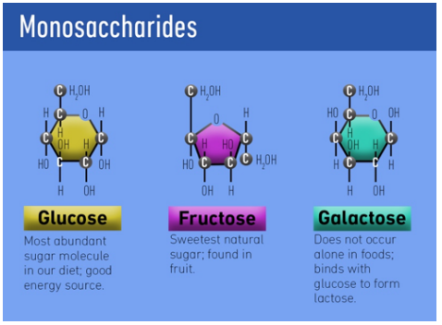

In certain foods, these monosaccharides link up with one another to form sugar pairs called di-saccharides. As you might guess from the di prefix, this involves two of the sugars above linking together to form a slightly bigger type of sugar. We still classify these sugar pairs as simple carbs.

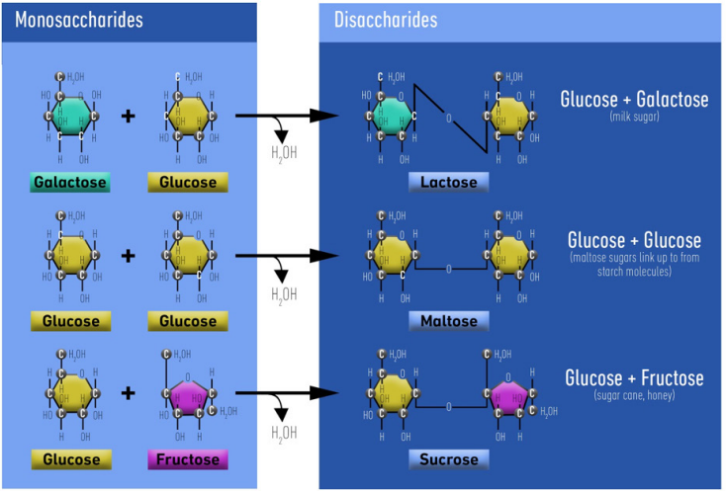

“Because simple carbs are so small, they can be absorbed very quickly and without significant digestion.”

Examples of simple carbs include: candy, table sugar, the sugar found in milk and the sugar found in fruit (although there are also complex carbs in fruit).

Complex carbs, on the other hand, are much bigger and bulkier. They are made up of chains of simple sugars linked together. These complex carbohydrate chains are referred to as polysaccharides (poly, referring to many and saccharide, indicating sugar).

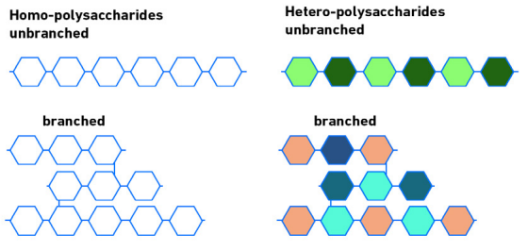

Because complex carbs are so large and often branched, they must be broken down (digested) into their smaller, simple components before they can be absorbed and used for energy. This has two important implications: Complex carbs are absorbed more slowly, over a longer time frame and complex carbs have a higher thermic effect (how many calories the body burns to break down that food). Examples of complex carbs include whole grains, vegetables, legumes, rice and pasta.

UNTANGLING FIBER

Some foods that are high in complex carbohydrates also contain fiber (a type of polysaccharide). Fiber is important to mention because it has profound impacts on gut functioning. From a recomposition perspective, foods higher in fiber will assist with regular bowel movements. This can help improve nutrient absorption and prevent inconsistent weigh ins, resulting in more accurate recomp tracking. Fiber also promotes a healthier gut in general. Insoluble fibers (found in whole grains, beans, potatoes and many fruits) are transformed into short chain fatty acids by our gut’s microbes, which confer a multitude of health benefits. Despite fiber having many health benefits, there can be too much of a good thing. Excessive fiber intake can lead to bloating, poor nutrient absorption and irregular bowel movements. For these reasons, we recommend keeping fiber intake between 25 and 75 grams per day. The higher your total carb intake, the higher your fiber intake should be. Use the figures below for approximate daily carb intake as a rough guideline for determining daily fiber intake.

<200g carb: ~25g fiber

200g carb: ~35g fiber

300g carb: ~45g fiber

400g carb: ~55g fiber

500g carb: ~65g fiber

600g carb: ~75g fiber

GLYCEMIC INDEX

The glycemic index has been the source of a lot of unnecessary dietary confusion. Many people seem to think that high-glycemic carbs are the “bad carbs“, destined to be stored as body fat the second they touch your tongue. Low-glycemic carbs on the other hand, are often referred to as the “good carbs,” hoarding all the health and performance benefits foods can offer. While there are important relevant differences between these carb types, we encourage you to avoid black and white thinking on this topic and recognize that both types can be useful depending on context. To keep it simple, the glycemic index (GI) is a measure of how much a given food impacts blood sugar levels on a scale of 1-100. The higher the number, the more eating that food will raise blood sugar.

It’s important to note that the values in the second table only apply when these carbs are eaten on their own. The glycemic response of a full meal depends not only on the carb source in the meal, but everything else on your plate. White rice, as an example, is considered a high-glycemic carb source on its own but can you think of the last time you ate a plate of white rice by itself? Chances are, you will be combining that white rice with a protein source, such as steak and (hopefully) a vegetable such as broccoli. Because the protein in the steak and the fiber in the broccoli will both require a large amount of digestion before they can be absorbed, the carbs from the rice will be absorbed much more slowly as well. As such, the blood sugar spike that would normally be high from eating white rice, will be significantly blunted. That is, the glycemic response of the meal will be much lower. At this point, you may be wondering if the glycemic index matters at all. We believe that the glycemic response of any given meal or food in isolation is not a primary driver of either muscle gain or fat loss (those titles belong to resistance training and energy balance). However, the glycemic index of different carbohydrates is worth considering for two reasons: energy levels and hunger.

1. ENERGY LEVELS

About a year ago, just before we started writing this book, I (Jeff) started noticing that every time I trained, I would feel weak and dizzy about half way through the workout. Sometimes, when you get to extremely low levels of body fat (usually below seven to eight percent for me), this happens simply as a result of low energy availability. But this was happening deep in winter, during a period of self-experimentation I called “bear mode.” Without getting into the details, I was definitely not short on total calories or body fat. Something else was definitely going on. It was actually after several phone calls with Chris, that I discovered the issue. I was skipping breakfast in the morning and then having a pre-workout meal that consisted only of extra lean ground chicken, white rice and salsa. Because this was my only meal prior to training, and there was minimal fat or fiber present to slow digestion down, my blood sugar was skyrocketing from the high glycemic white rice and then crashing mid-workout. After figuring out the problem, I did two things to fix it. First, I stopped skipping breakfast. In other words, I started eating two meals before training. I realize not everyone can do this because of scheduling concerns, but this allowed me to replenish any lost glycogen from the overnight fast to provide more sustained energy during the workout. I also switched to a lower glycemic carb source. Rather than having chicken and white rice, I switched to whole wheat bread and made a chicken sandwich instead. The main takeaway here is that something as simple and unsuspecting as the glycemic index of your carb sources can have an impact on your energy levels during your training session and at various time points throughout the day.

2. HUNGER

Another thing the glycemic index of a food can impact is hunger and satiety (how full you feel after eating). In 1999, Dr. Ludwig’s research group investigated the effects of glycemic index on hunger responses. The scientists had three groups of subjects consume a meal of similar caloric value. One group consumed a low-glycemic meal, one group a medium-glycemic meal, and the third, a high-glycemic meal. As expected, the high-glycemic group had the largest spike in insulin, followed by a blood sugar crash. They also demonstrated the greatest increase in adrenaline, which the authors attributed to the corresponding increase in hunger (perhaps due to mimicking a starvation response). After the meal, all three groups were given free access to food and as you might expect, the high-glycemic group ended up eating approximately 650 extra calories in their next meal compared to the other two groups! The implication for recomposition is that choosing low-glycemic carbohydrates for most of your meals will likely improve your adherence to the macronutrient targets by helping you feel more full after each meal.

SUGGESTED CARB SOURCES

We recommend an 80/20 rule when it comes to food selection: ensure about 80 percent of your carbs are coming from whole, minimally processed foods such as those below. The other 20 percent can be filled in with foods you personally enjoy or find convenient. CARB SOURCES LIST: Whole wheat bread, oatmeal, brown rice, long grain rice, all rice derivatives (i.e. cream of rice, rice crisp cereal, etc.) legumes (peas, beans, etc.), starchy vegetables (potatoes, carrots, corn), quinoa, bulgur (wheat derivatives), all fruit (kiwi, bananas, apples, oranges, etc.), all berries (raspberries, blueberries, blackberries, etc.), all fibrous vegetables (broccoli, spinach, kale, lettuce, etc.)

HOW MUCH SUGAR IS OKAY?

While foods like ice cream, cookies and sugary cereals are fine in moderation, we do recommend limiting them to a time when they are less likely to result in a crash during training. For example, it would be much more appropriate to consume these foods as part of a post-workout meal than a pre-workout meal. Furthermore, we suggest limiting total daily sugar intake to roughly 100 grams per day as a soft maximum. Of course, some of you with high caloric requirements will be fine exceeding this limit, and some of you with lower caloric intakes should rarely reach this amount if you are sticking to the 80/20 rule. Also, if the majority of your sugar intake is coming from fruit, you may exceed the 100 gram limit. We wanted to include this as a ballpark figure to be aware of, as opposed to a universal limit that can never be exceeded.

THE NUTRITION-WORKOUT LINK

WHEN DOES PERIWORKOUT NUTRITION MATTER?

1. BODY FAT PERCENTAGE

The first factor that will impact the importance of peri-workout nutrition is your current level of body fat. The higher your body fat, the more energy your body has in reserve (in adipose tissue as fat and in muscle tissue as glycogen), making the timing of nutrients around the workout less urgent. On the flip side, trainees with lower energy reserves (leaner individuals) would be wise to pay closer attention to their periworkout nutrition because they do not have an abundance of stored energy which increases the importance of optimizing energy utilization from food

2. TOTAL CALORIC INTAKE

How many calories you are eating in total also impacts the importance of nutrient timing around training. An individual with a lower caloric intake would be advised to allocate a reasonable portion of their nutrient intake around the training session so their performance and recovery is not further impeded by the lower overall energy intake. That isn’t to say those with a higher calorie target can ignore periworkout nutrition, but just that it is of relatively less importance for them.

3. TRAINING STYLE

Your specific style of training can also impact how much you should pay attention to nutrient timing. Let’s use a few examples to illustrate. A powerlifter training with heavy weights for low reps (1-6 reps) will likely not deplete as much carbohydrate during their training session as a traditional bodybuilder who trains with more moderate to high reps (6-20 reps) and high volume. This is because high intensity, low volume training will rely more heavily on the phosphocreatine (PCr) energy system (using creatine phosphate for fuel), whereas the moderate intensity, high volume training will rely more heavily on the glycolytic system (burning carbohydrates for fuel). Presumably, the bodybuilder in our example would deplete more glycogen during training and would stand to benefit more from timing carbohydrates around the workout. The total length of the workout and type of split you’re running can also come into play. For example, the nutrients depleted and calories expended during an intense two hour leg day will be significantly higher than a 45 minute shoulder and arm workout.

PRE-WORKOUT NUTRITION

In our opinion, THIS is the MOST important meal of the day for body recomposition. As such, we will give it the most attention. Optimizing the pre-workout meal will ensure that you are properly fueled to perform at your best and generate the ideal anabolic environment to maximize the muscle building process. As such, there are two primary purposes of the pre-workout meal: to fuel training and to create an anabolic environment for building muscle. Let’s start with fuelling the workout.

1. FUEL THE WORKOUT

The preworkout meal should consist of all three macronutrients and water. Because the right carbohydrates in the right quantity will be most effective for providing sustainable energy throughout the workout. What type of carbs should you eat pre-workout? Choosing lower glycemic carbohydrates will be more likely to keep blood glucose levels stable during training. For this reason, we recommend selecting carb sources on the lower end of the glycemic index and/or composing a meal that will induce a lower glycemic response (such as by adding a protein with some fiber and fats). A pre-workout meal consisting primarily of high glycemic carbs may cause blood glucose levels to dip below baseline, putting you in a hypoglycemic state. Similar to the case when I (Jeff) was eating plain chicken and white rice as a pre-workout meal, this hypoglycemic state can lead to weakness, light-headedness, dizziness, and will definitely negatively impact your training performance if it occurs. Low glycemic carbohydrates have also demonstrated higher amounts of fat oxidation and improved time-to-exhaustion. Despite being an acute response, making better pre-workout carb choices will clearly improve body composition by enhancing workout quality over time! We also recommend including carbohydrate sources that require the use of multiple carbohydrate transporters for absorption in your pre-workout meal. The three different monosaccharides (simple sugars) we discussed earlier (glucose, fructose and galactose)? Well, these three sugars each use different transporters to get them from the digestive tract into the bloodstream where they can be used for energy. The main reason why it’s smart to include carbohydrates that utilize multiple transporters is that they will provide a more sustainable and consistent energy source throughout a training session. In other words, if you simply consume one type of carbohydrate, you will only be able to utilize one transporter for absorption. If you consume two (or more) types of carbohydrates, you will be able to utilize several different transporters that funnel the carbs through at different rates. This will result in a much more efficient influx of carbohydrates in the bloodstream and a more sustainable supply of energy. With all of this information provided, we recommend that your pre-workout meal consist of starchy, low glycemic carbohydrates and a fruit source.

HOW MANY CARBS TO EAT PRE-WORKOUT

While there will be individual differences, generally speaking, we recommend hitting a minimum of one gram of carbohydrate per kilogram of body weight. Of course, depending on your total daily calorie and carb intake, you may be required to eat more or less than this amount. This however, is our soft minimum target for optimizing training performance. As mentioned previously, higher volume and longer duration training sessions generally require higher amounts of carbohydrates to fuel properly, so use discretion when adjusting the one gram per kilogram figure to fit your specific training needs. We also recommend consuming fiber in moderation in the pre-workout meal. To avoid interference with nutrient absorption and unnecessary bloating, fiber should be kept around 5-15 grams in the preworkout meal as a ballpark estimate. The further away your training session is, the more fiber you can get away with and even utilize as a tool in your favor. The sooner your training session is, the less fiber you should consume. For similar reasons, we recommend consuming a more moderate fat intake before training. While this will be individual, we recommend keeping fat intake no higher than 0-20 grams in the pre-workout meal. Individuals with higher overall caloric intakes may require higher fat intakes in the pre-workout meal. Also, the closer the pre-workout meal is to the training session itself, the lower fat it should contain to prevent digestion-training overlap.

2. CREATE AN ANABOLIC ENVIRONMENT DURING TRAINING

Consuming adequate protein in the pre-workout meal will stimulate the appropriate muscle protein synthetic machinery to crank up the anabolic dial during training. Based on information outlined previously, we recommend consuming approximately 0.45- 0.75 grams of protein per kilogram of bodyweight in the pre-workout meal, ideally coming from a complete protein source such as whey, meat, poultry or fish.

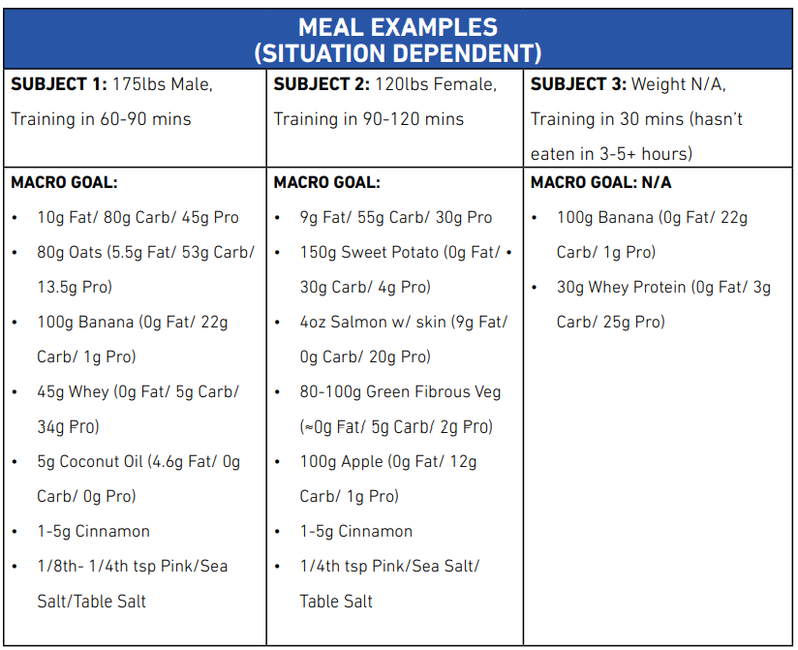

Generally, we suggest eating 30-120 minutes before training, depending on your schedule, preferences and what you find provides the best energy while lifting. The closer the meal is to the workout, the more you should focus on consuming faster digesting foods such as whey protein and a banana (which is lower in fiber than an apple). You may also reduce total carbohydrate intake when on a rushed schedule for faster energy availability and to avoid an overlap of digestion and training.

A few points to note concerning the examples above:

* All meals utilize multiple carb transporters
* All subjects lightly salted their meals to improve electrolyte balance. When eating meals high in potassium, salting the meal slightly more liberally is acceptable to optimize the sodium-potassium ratio
* All subjects added a serving of cinnamon to because it has been shown to decrease the glycemic response of the meal and help keep blood sugar levels stable.

THE IMPORTANCE OF HYDRATION

Research has shown that a mere three percent dehydration status can significantly decrease strength, total volume/reps and recovery between sets, all while increasing perceived exertion scores (the workout feels harder).

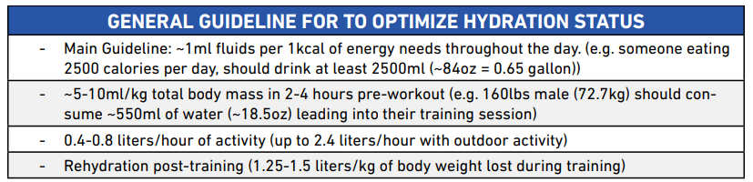

Perhaps the simplest way to assess hydration status is by noting the color of your urine. Urine that is more clear and less yellow is indicative of proper hydration. The goal is to keep your urine looking more like lemonade and less like apple juice.

INTRA-WORKOUT NUTRITION

The purpose of intra-workout nutrition (nutrients consumed during the training session) is to improve performance and prolong time to fatigue. Similar to the pre-workout meal, those who have lower energy reserves (less body fat and glycogen) will likely yield the greatest benefit from utilizing intra-workout nutrition. The value of an intra-workout meal will also depend on the volume and duration of your training. We generally recommend intra-workout nutrition under the circumstances listed below. If none of the following considerations apply, an intra-workout feeding is not needed at all.

• Your workouts are longer than 60 minutes.

• You train on an empty stomach (fasted).

• It has been three to five hours since your pre-workout meal

Assuming one of the three above considerations apply to you, providing your body with a fuel source such as glucose during training can help spare muscle glycogen and reduce muscle protein breakdown. It can also increase hyperemia, leading to better pumps in the gym. This will create more enjoyable training sessions and potentially improve the mind-muscle connection. Furthermore, while debate is ongoing in academic circles as to its specific role, muscle cell swelling has been proposed as a contributing factor for hypertrophy.

WHAT TO EAT INTRA-WORKOUT

We recommend that intra-workout nutrition come from liquid carbohydrates and optional liquid protein/amino acid supplements. Liquid sources are used for quick consumption and digestion and to prevent a full or bloated feeling while training.

HOW MUCH TO EAT INTRA-WORKOUT

Consuming too many carbohydrates or too much protein during training can lead to gastrointestinal discomfort and negatively impact training performance. The literature has shown that carbohydrate oxidation rates tend to plateau at 1-1.2 grams per minute, so consuming more than one gram of carbohydrate per minute of training would be unnecessary for fueling performance. We generally recommend 0.5 grams of carbs per minute of weight training, beginning about 30 minutes into the workout. For example, if training for 90 minutes, you would consume a total of 30 grams of carbs during the workout, starting 30 minutes in. For those of you in a caloric deficit, you may not want to waste calories on liquid sources for satiety purposes. In this case, we would simply recommend consuming a very minimal amount (5-10 grams) of carbohydrates intra-workout. In our experience, even five grams of carbohydrates can be sufficient for stabilizing blood glucose and turning a bad workout around. It may sound unbelievable, but there is also considerable data supporting the use of carbohydrate mouth rinsing (CHO-MR) as a way to improve performance in endurance activities such as cycling. The proposed mechanisms are likely neurologically mediated. Researchers have proposed that the presence of carbohydrates in the mouth can increase dopamine release which cannot only increase feelings of pleasure and motivation, but also increase motor output.

POST-WORKOUT NUTRITION

The primary goal is to begin the recovery process by stimulating muscle protein synthesis. To this end, we recommend consuming approximately 0.5 grams of protein per kilogram of bodyweight, ideally coming from a complete protein source.

The second objective is to replenish glycogen stores even if it is unlikely that they will be significantly depleted, assuming the pre and post workout guidelines have been followed. Glycogen replenishment becomes more important if you are training multiple times per day or if you train the same muscle group on consecutive days. Because rates of glycogen synthesis are highest within the first two hours following training, we recommend consuming 1-1.5 grams of carbohydrates per kilogram of bodyweight post-workout. This may also be a good time to include a high glycemic carb source, since they have been shown to optimize glycogen synthesis following training when compared to their counterpart.

CARDIO: TO-DO OR NOT-TO-DO

Remember that with the goal of body recomposition, we are trying to build muscle and lose fat. The muscle building component will be taken care of primarily through progressive resistance training and adequate protein intake. The fat loss component will come primarily through establishing a caloric deficit. Such a caloric deficit can be achieved by reducing your caloric intake, by increasing activity (including cardio) or through a combination of both.

• Your cardio plan should be tailored to your specific needs and goals

• In general, we recommend keeping cardio to an effective minimum for fat loss

• Low intensity steady state (LISS) cardio can be performed for up to 30-45 minutes 0-5x per week (depending on your lifestyle and primary goal)

• High intensity interval training (HIIT) should be used more sparingly at a maximum of 1-2 sessions per week

• Individuals with low levels of NEAT and fat loss goals can set a ballpark step goal to increase daily activity levels (for ex. ~8,000 steps per day)

SETTLING THE SUPPLEMENT DILEMMA

TIER 1

* **Protein powder** - daily consumption of high levels of protein from whole food sources can be challenging. Therefore, supplementing your diet with a high-quality protein powder is a convenient and effective way to help you reach your daily protein target.
* **Creatine -** significantly improves strength and power performance, enhances muscle hydration and increases muscle size. Creatine is produced naturally by the liver and is stored in our skeletal muscle as phosphocreatine. Phosphocreatine is a fuel predominantly used for short duration, high intensity work such as heavy weight training, sprinting, etc. It is recommended that anyone with muscle and strength building goals, supplement five grams of creatine monohydrate per day. Some data has suggested that creatine uptake is slightly enhanced when taken post-workout with carbohydrates and protein. In any case, the time of day you supplement with creatine is certainly much less important than simply being consistent with taking those five grams per day.
* **Caffeine** - good evidence supporting its use for cognitive function, increasing strength, prolonging fatigue, maximizing acute fat oxidation, sparing glycogen and much more. For those with the primary goal of fat loss or alertness, supplementing with a low dose may be beneficial before doing cardio (1-2mg/kg). If you’re looking to maximize strength performance, a much higher dose (3-6mg/kg) can be utilized up to two times per week. While this higher dose is recommended in the literature, it would be wise to assess your personal tolerance for the substance before jumping to this high of an intake. The more frequently you utilize high doses of caffeine for acute resistance training enhancements, the less effective it becomes and the faster you build a tolerance. Therefore, it may be wise to reserve caffeine supplementation for your heaviest and most demanding training sessions. Furthermore, excessive caffeine supplementation has been shown to decrease sleep quality.

TIER 2

* **Multivitamins** - research reveals that it is not always easy to get micronutrient requirements from food alone, especially for athletes and for those in a caloric deficit. As discusses earlier, being deficient in zinc, for example, may reduce testosterone levels and several other vitamins are important in regulating metabolic pathways linked to fat loss. Furthermore, there is a difference between an optimal and adequate micronutrient consumption. Many of the recommended daily allowances are based on amounts required to prevent diseases, not to optimize health.
* **Fish oil (essential fatty acids (EFA’S - EPA + DHA))** - these fatty acids are found in fish, seaweed, grass-fed meats, free-range egg yolk, flaxseed, walnuts, chia seeds and spinach, to name a few sources Research indicates that you should at least consume 0.3-0.5 grams of combine EPA+DHA per day and that multiple health markers are optimized when consuming anywhere from four to six grams per day. Deficiency in omega 3 fatty acids can lead to fatigue, poor cognition/memory, distributed mood/depression, increased risk of cardiovascular disease and several other negative symptoms.

IMPORTANCE OF SLEEP

Sleep study: Participants went on an eight week fat loss diet. The researchers split the subjects up into a “sleep restricted” group and a “normal sleep” group. All things were equal except the sleep restricted group slept one hour less than the other group, five nights per week. The sleep restricted group was allowed to sleep one more hour per night on the weekends to test if it was possible to catch up on lost sleep. The other group slept normally the entire time. Although there were no significant differences in total weight lost, there was an enormous difference in where that weight was lost from (that is, whether weight was lost from fat or muscle). For the subjects that slept normally, 83 percent of weight loss was lost as fat. For the subjects that were sleep restricted, this completely flipped: approximately 85 percent of weight loss was lost as fat-free mass! It was actually even worse than this for the sleep restricted group. In addition to the unfavorable body composition results, there was also a significant spike in ghrelin (a hormone responsible for ramping up hunger levels). So sleeping less will not only negatively impact your body recomposition goals in its own right, it will also make hitting your calorie and macro targets even more difficult by making you feel hungrier than usual.

WEIGHT TRAINING - THE DRIVING FORCE OF BODY RECOMPOSITION

PROGRESSIVE OVERLOAD IS KEY

Progressive overload is the gradual increase in the amount of stress placed on the body from exercise. In other words, if no greater stress is placed on the muscle over time, the muscle has no reason to grow in order to overcome that stress. Different ways to apply progressive overload:

1) increase load

2) increase repetitions with same load

3) increase sets

4) improve form

5) increase rep duration (such as by slowing the eccentric/negative)

VOLUME IS A DRIVER OF GROWTH

At the most basic level, training volume refers to the amount of work you are doing. While volume load is calculated in the scientific literature according to the formula, sets x reps x load, in practical training circles, it is usually approximated as the number of working sets (not including warm up sets) performed per session or per week. It has been suggested that there is a dose-response relationship between training volume and muscle hypertrophy, meaning more training volume tends to lead to more muscle growth. However, the literature is inconclusive as recent evidence suggests that more volume is not always better and how much you need depends on other training variables. As we will see, not all volume is created equal and how much volume you need to maximize growth may also depend on the body part you’re training. The muscles of the back, for example, may require higher training volumes than the biceps in order to maximize growth. However, as a general rule, based on our coaching experience and the body of scientific research, most trainees should be performing somewhere in the range of 10-20 sets per body part per week.

GENERAL VOLUME PRINCIPLES

• Your current training status and previous training experience will play a large role in determining how much volume you should perform.

• Generally, beginners should train with lower volumes than advanced trainees.

• We recommend starting with relatively low volumes at the beginning of a program and gradually increasing volume over time.

• Volume can be increased by adding working sets and/or by lifting more load (weight) and/or adding more reps per set.

• More isn’t always better! Adding too much volume can result in overtraining or injury and can be counterproductive to body recomposition.

• Increasing volume isn’t the only way to drive progress. We think it is better to underestimate your optimal volume initially and focus first on mastering variables like technique and effort before turning to increasing volume.

NOT ALL VOLUME IS CREATED EQUAL

As one final note on volume, we would like to remind you that not all volume is created equal. There is a much higher level of skill and effort required to perform some lifts than others. For example, one set of bench press will offer more hypertrophic bang for your buck than one set of pec deck. Likewise, performing four sets of squats will impose a higher local and systemic fatigue demand than four sets of leg press.

NOT ALL EXERCISES ARE CREATED EQUAL

It should be clear from the research above that including a variety of exercises is ideal for optimizing complete development of a muscle group. We also believe that some exercises are simply more effective at building muscle than others. Generally speaking, it is important to emphasize multi-joint, compound movements that utilize large amounts of muscle mass in any complete training program. This will not only improve general strength that can then be carried over to other exercises but will also make training more time-efficient (since a single compound exercise is able to activate a large degree of muscle mass). Below are some basic compound exercises we suggest including in your program:

• Legs: Squat variation, lunge, leg press, deadlift variation, hip thrust

• Back/biceps: Horizontal pull (row variation), vertical pull (pullup/pulldown)

• Chest/triceps: Horizontal press (dumbbell, barbell, machine)

• Shoulders: Vertical press (barbell, dumbbell)

TRAINING HARD

Not every set should be taken to failure, since consistently taking sets to complete fatigue can lead to overtraining and reduced overall volume, potentially hindering growth. As a general rule, we recommend leaving one to three reps in the tank on most compound exercises. Isolation exercises can be taken more routinely to failure without the same risk of fatigue accumulation, however, we still recommend reserving failure for the last set of any given exercise.

WHAT IS THE BEST REP RANGE FOR MUSCLE GROWTH?

As long as you are applying appropriate effort, with appropriate volume, research shows that you can achieve very similar levels of hypertrophy with low reps (heavy weight) and high reps (light weight). We still believe that there is a “practical hypertrophy zone” where the majority of working sets should come from. That practical rep zone is 6-15 reps. There are two main reasons why we believe this rep zone is preferable for the goal of building muscle. First, as you increase the rep count beyond 15 reps, you will begin to accumulate more metabolic fatigue, which can be very taxing, both psychologically and physiologically. As such, since you can achieve the same hypertrophy with lower reps, generally, we recommend reserving high rep work (15-25+ reps) for isolation exercises to be performed near the end of the workout. By the same token, sets with a rep count lower than six tend to run a higher risk of injury due to heavy loading and can make it more difficult to accumulate an appropriate amount of total training volume. This also doesn’t imply that there is no place for “pure strength work” (i.e. 15 rep sets). We suggest allocating approximately 75 percent of your weekly training volume to the 6-15 rep zone.

TRAINING FREQUENCY AND TRAINING SPLITS

It seems that as a whole, the scientific literature suggests that training each muscle twice per week is better than only training each muscle once per week. Whether or not frequencies higher than that are better, seems to depend on the individual.