ADAPTIVE NETWORK ROUTING & CONGESTION CONTROL

An end-to-end network simulation for adaptive routing and congestion control enhanced by Machine Learning.

SHREEJITH J (24BCE0625)
POOJA IYKKARATH SANTHOSH (24BAI0269)
HEMAL KAMINENI (24BCE0649)
ELDO JOHN GIBY (24BCE0387)
ANFY SONY (24BCE2799)
Abstract
This project develops a Python-first network simulation and analysis system that demonstrates the complete journey of data across the seven OSI layers while studying routing and congestion under changing network conditions. The system generates application data, performs encoding and session management, transports data using TCP or UDP, creates IP packets, adds MAC addressing and CRC-based error detection, and models bandwidth and transmission delay. A software network of configurable routers and links is used to simulate queueing, packet loss, delay and link failures. A machine-learning module learns from these network states to predict congestion and estimate route performance, allowing the system to choose better paths dynamically. The project combines Computer Networks laboratory concepts with machine-learning-based decision making and presents the results through a visual packet journey and performance dashboard.

Core idea
Generate → encapsulate → route → stress the network → predict → adapt → deliver → measure.
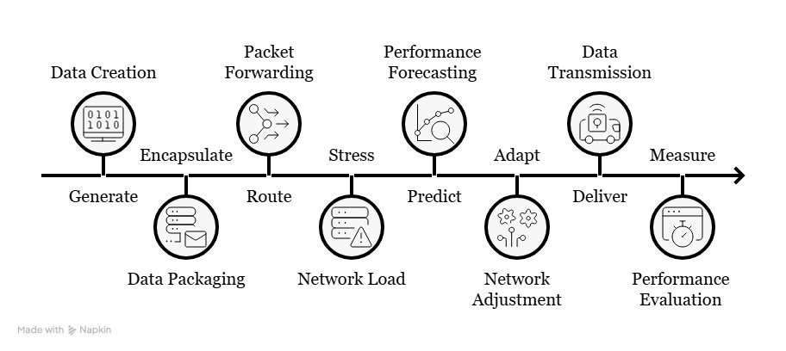
1. Project Concept
The project asks one practical question: how should a network adapt when its links, queues and traffic conditions change? A single packet is followed from the application layer to transmission and back to the receiver.
What the system demonstrates
- End-to-end communication across all seven OSI layers.
- Python TCP/UDP communication with session and transport behavior.
- Adaptive routing using live network metrics rather than a fixed path.
- Congestion creation, measurement and recovery inside the simulator.
- ML-assisted prediction of congestion and route performance.
- CRC/error detection, packet loss and transport-level recovery.
Core outputs
Metric | Observed output
Throughput | Delivered bits per second
Delay / RTT | End-to-end and per-link delay
Packet loss | Dropped / corrupted packets
Queue state | Occupancy at each router
Route state | Current path and route changes
ML state | Predicted congestion / route quality

Scope
Python is the main implementation. Wireshark and Cisco Packet Tracer remain optional validation / comparison tools, not dependencies of the core system.

2. System Architecture
The project separates the seven-layer communication stack from the network-state monitor and the ML control loop. This lets the same packet be inspected while the network adapts.
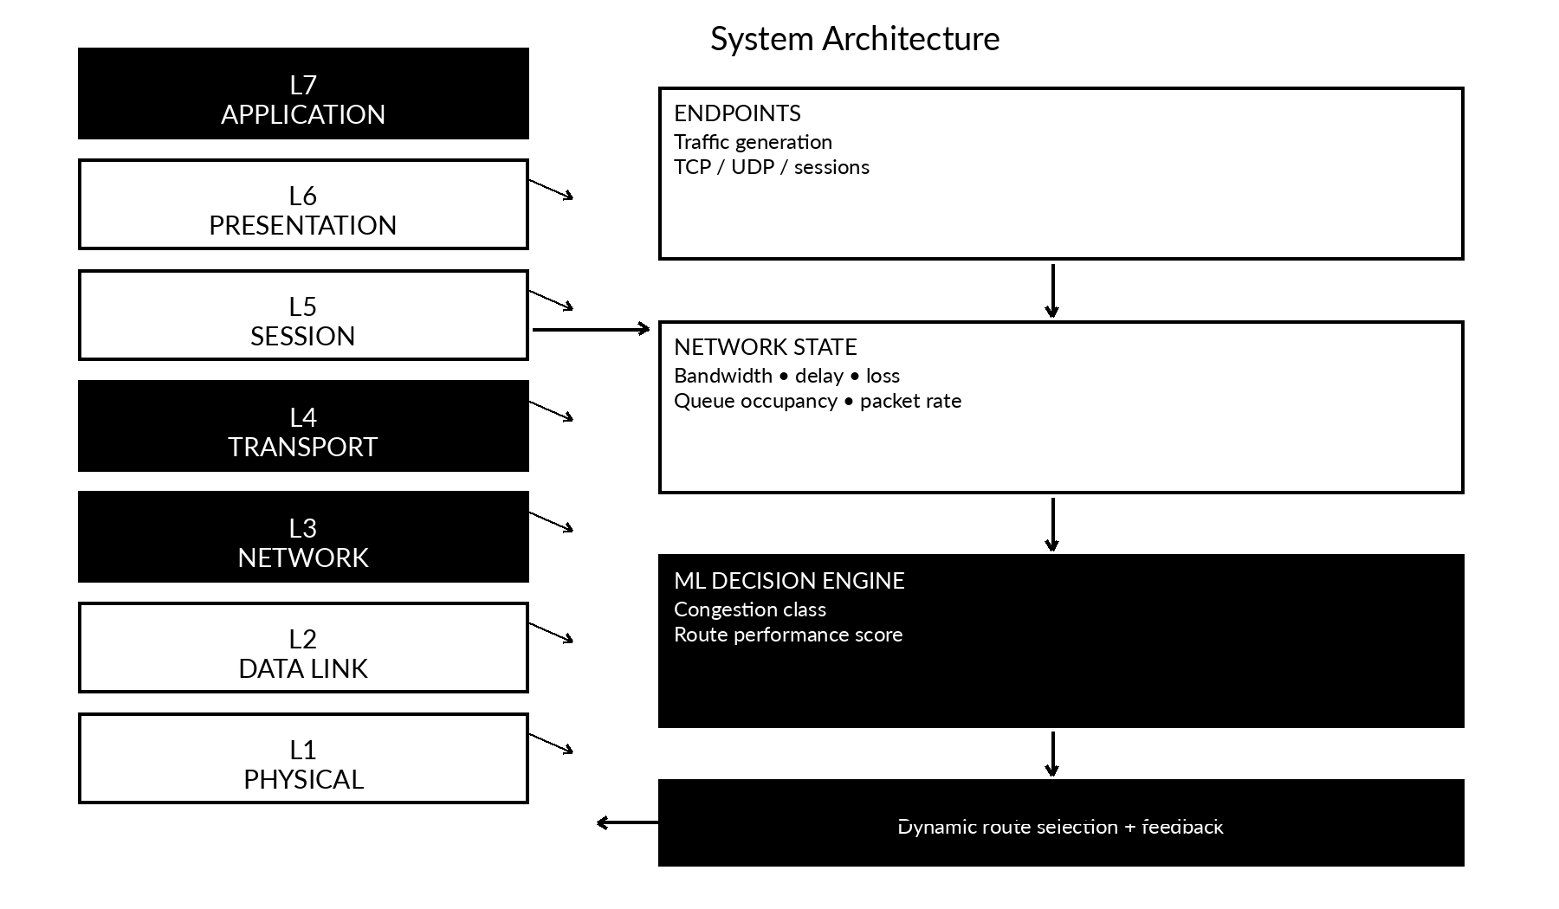
Figure 1. End-to-end architecture and ML feedback path.
Core modules
Module | Purpose
Endpoints | Generate messages/files and use TCP or UDP.
OSI packet engine | Encapsulate, decapsulate and expose headers / control fields.
Router simulator | Forward packets, maintain routes and model links / queues.
Performance monitor | Collect throughput, delay, loss, RTT and queue metrics.
ML engine | Predict congestion / route quality and influence route selection.

3. Seven-Layer OSI Demonstration
Every layer performs a concrete operation in the same communication flow. The project is therefore OSI-complete without becoming a collection of unrelated demonstrations.
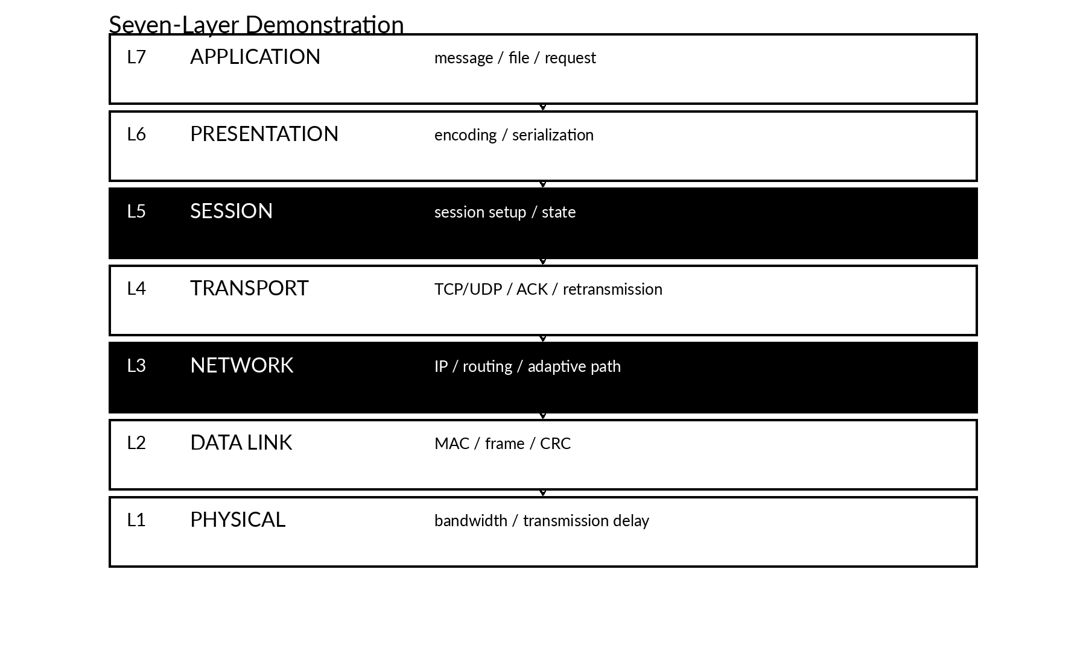
Figure 2. Seven OSI layers mapped to project operations.
Layer | Implementation
L7 Application | Message / file / request creation
L6 Presentation | UTF-8 / JSON encoding; optional compression
L5 Session | Session setup, state and termination
L4 Transport | TCP/UDP, sequence, ACK, timeout, retransmission
L3 Network | IP addressing and adaptive routing
L2 Data Link | MAC frames and CRC / checksum
L1 Physical | Bandwidth, transmission time and propagation delay

4. Adaptive Routing + Machine Learning
ML is used as a decision component, not as a replacement for networking. The simulator generates its own training data from controlled network conditions.
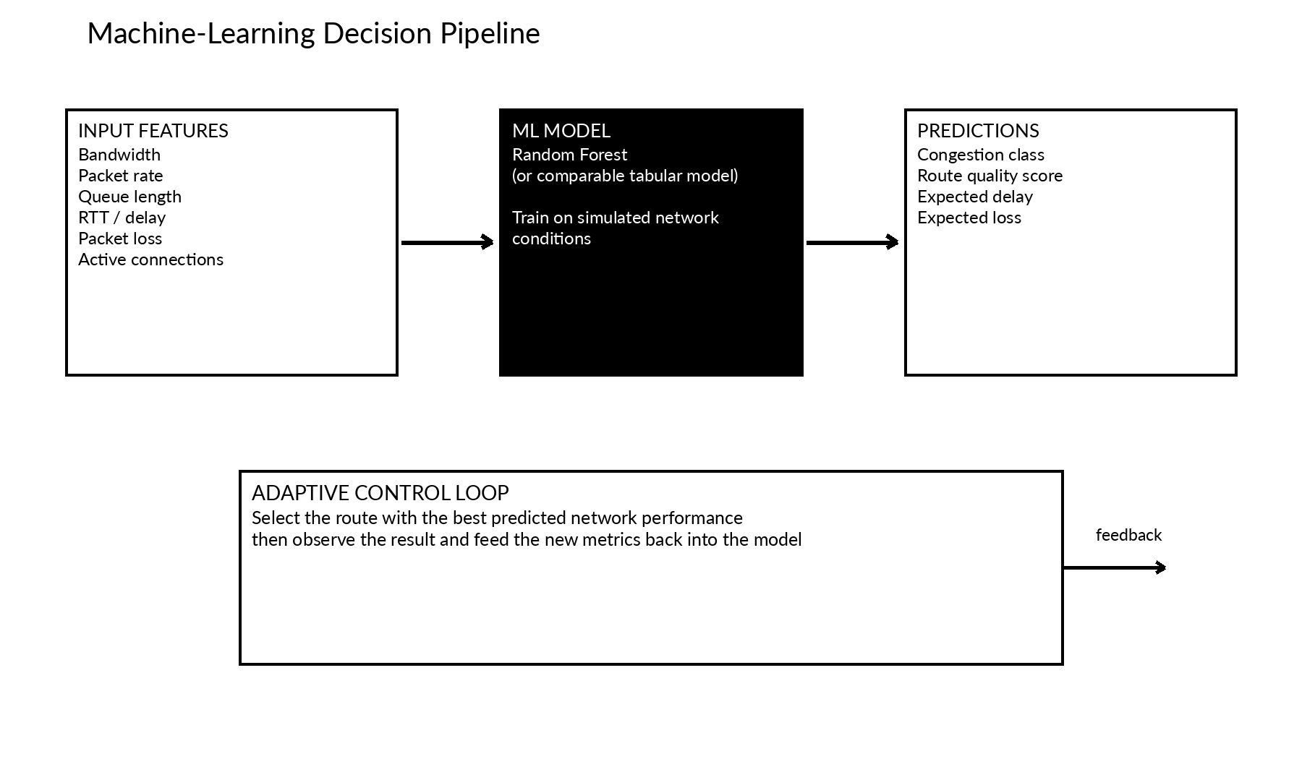
Figure 3. Network-state features flow into an ML model and back into routing.
ML setup
- Random Forest classifier: LOW / MEDIUM / HIGH congestion.
- Optional regression model: predicted route delay or packet loss.
- Training data: simulator-generated combinations of bandwidth, packet rate, queue length, RTT, loss and active connections.
Example decision
Route | Predicted delay | Decision
S → R1 → R2 → D | 76 ms | Avoid if congestion is high
S → R1 → R3 → D | 28 ms | Preferred
S → R1 → R4 → D | 43 ms | Backup

5. Routing, Congestion and Error Recovery
Stress one part of the network, observe the metrics, let the ML layer identify the problem, and adapt the route. The same run can include a deliberate frame error.
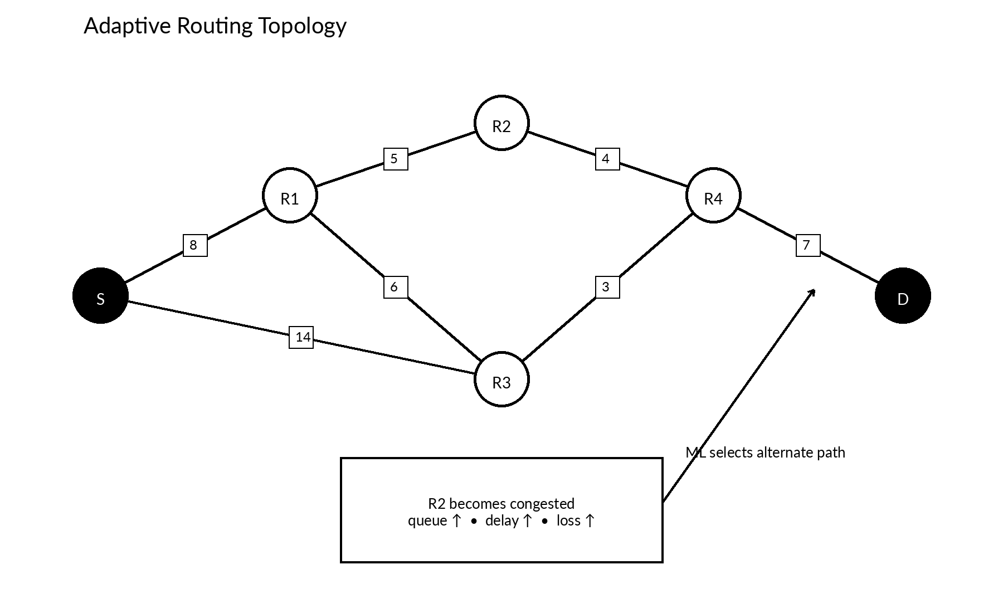
Figure 4. Example multi-route topology.
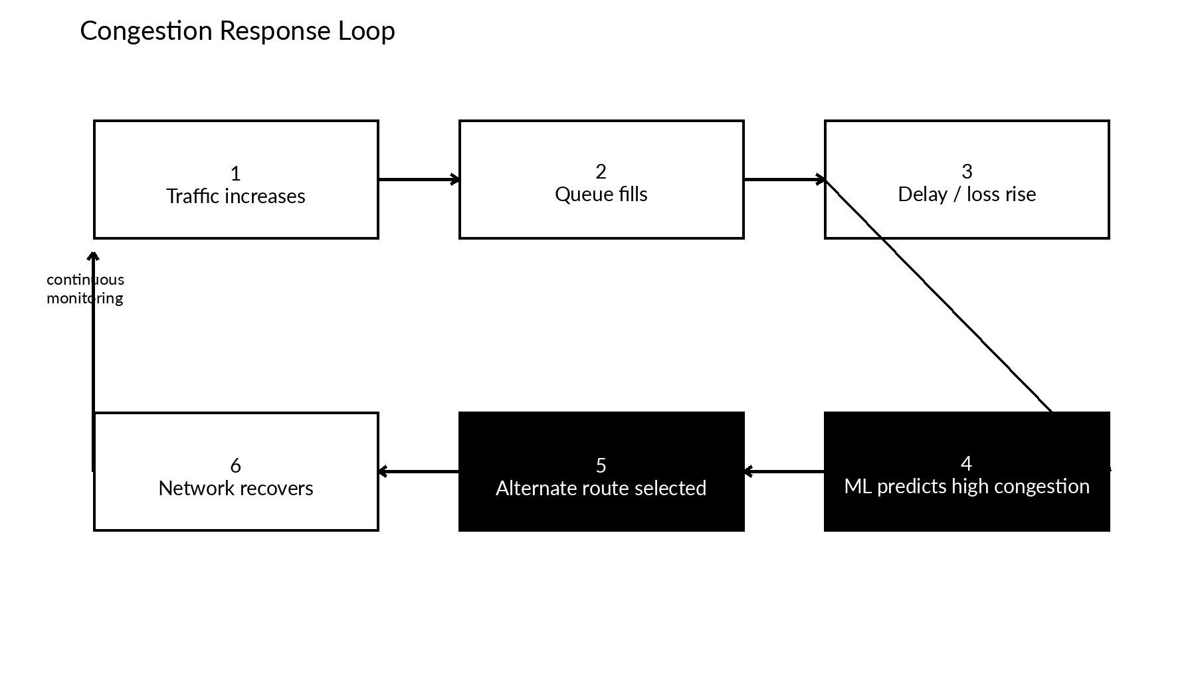
Figure 5. Traffic increase → queue growth → ML prediction → rerouting.
6. Lab Alignment and Review Flow
The project is broader than a single lab experiment, but each major laboratory topic has a direct place inside the same end-to-end system.
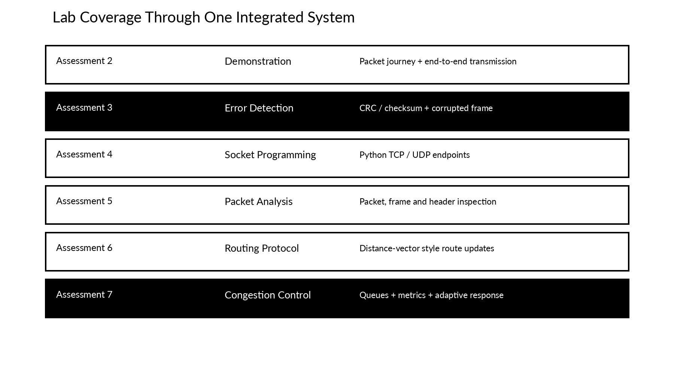
Figure 6. Assessment coverage through one integrated project.
7. Technology Stack and Expected Output
The implementation stays Python-first. External tools are optional and used only when they strengthen validation or presentation.
Tool | Role
Python + socket | Core simulator and TCP/UDP endpoints
NumPy / Pandas | Metrics and ML dataset preparation
scikit-learn | Random Forest / regression models
Matplotlib / Streamlit | Graphs and optional live dashboard
Scapy (optional) | Packet construction / inspection
Wireshark (optional) | Independent packet verification
Packet Tracer (optional) | Topology / routing comparison
One-line project description
A Python-based network simulator that demonstrates all seven OSI layers and uses machine learning to predict congestion and make adaptive routing decisions under changing network conditions.

