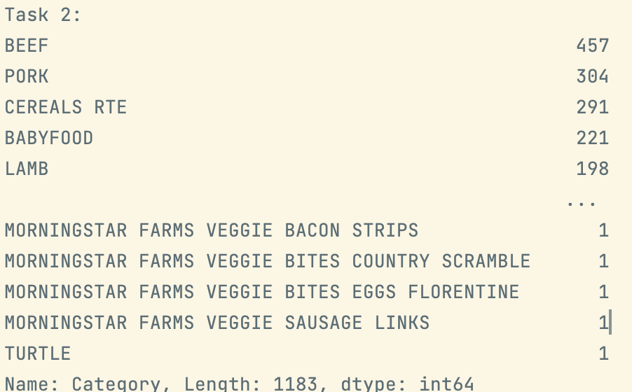

Top 20:

Task 4:

Examine the two plots. Any interesting observations?

The green dots, which represents cheese, contain varies calcium and vitamin E; while the red dots, represents potatoes, have very little calcium, yet have varies vitamin E.

Lowest value:

Data.Vitamins.Vitamin E Data.Vitamins.Vitamin B6 -0.391225

Highest value:

Data.Major Minerals.Calcium Data.Major Minerals.Calcium 1.000000

Task 14:

What would you change about your diet after completing this assignment?

I will probably eat more vegetables.