Luaran Kegiatan

Link Manual Book Sistem Informasi Edukasi Edbusui Pada Ibu Menyusui
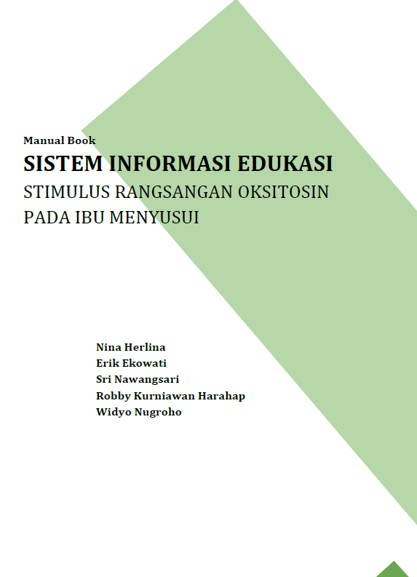
https://drive.google.com/drive/folders/1s5Q-HhR2KGv1Xkf5ZQxaCNImvLhjW2h7?usp=shari

Publikasi Jurnal Nasional Terakreditasi

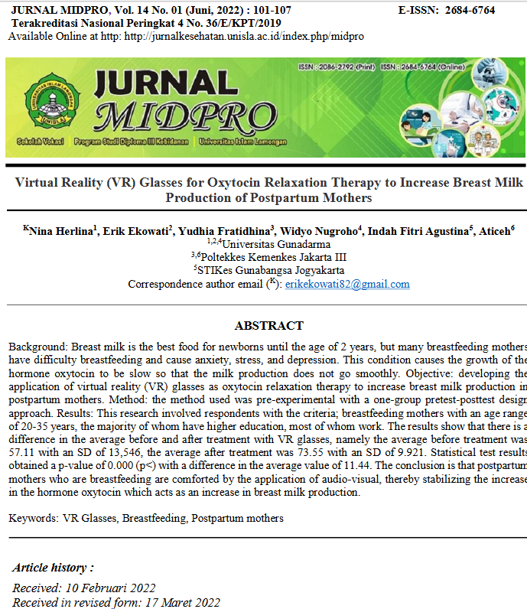
https://www.researchgate.net/publication/376662431_Virtual_Reality_VR_Glasses_for_Oxytocin_Relaxation_Therapy_to_Increase_Breast_Milk_Production_of_Postpartum_Mothers

Publikasi Jurnal Nasional Pengabdian Masyarakat

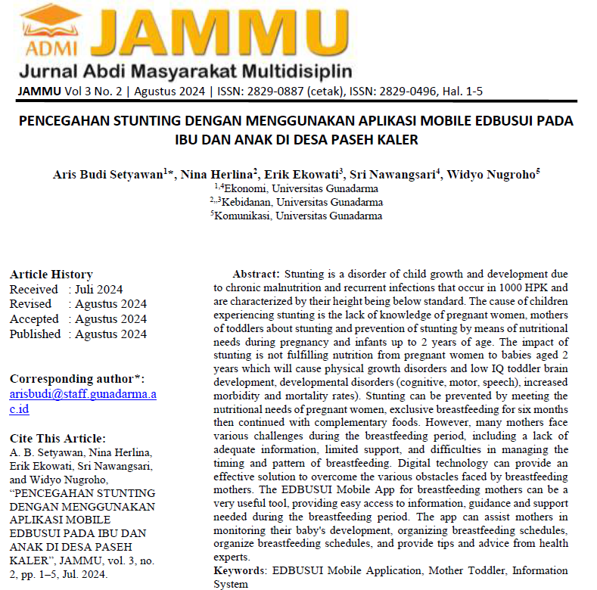
https://journal.admi.or.id/index.php/JAMMU/article/view/1527/version/1538

Publikasi Media Masa Youtube

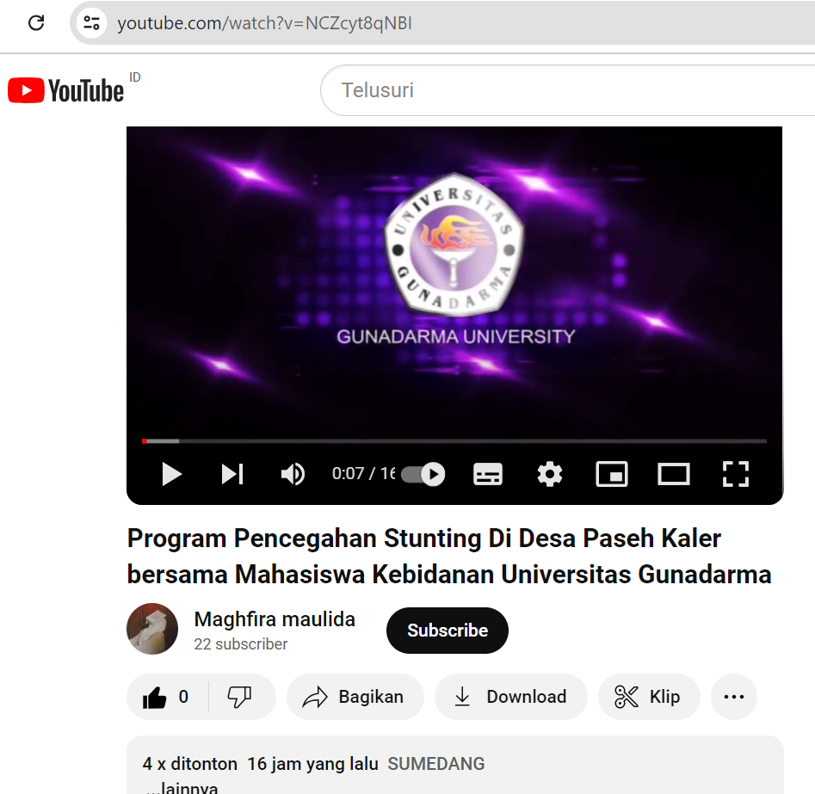
https://youtu.be/NCZcyt8qNBI?si=TF-o8_zocxV9RR9Z

Publikasi Media Masa Online Depok News

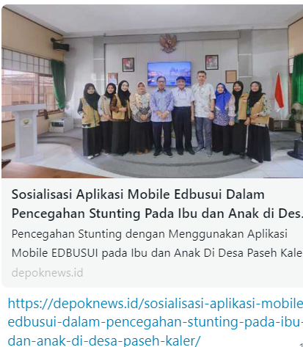 | 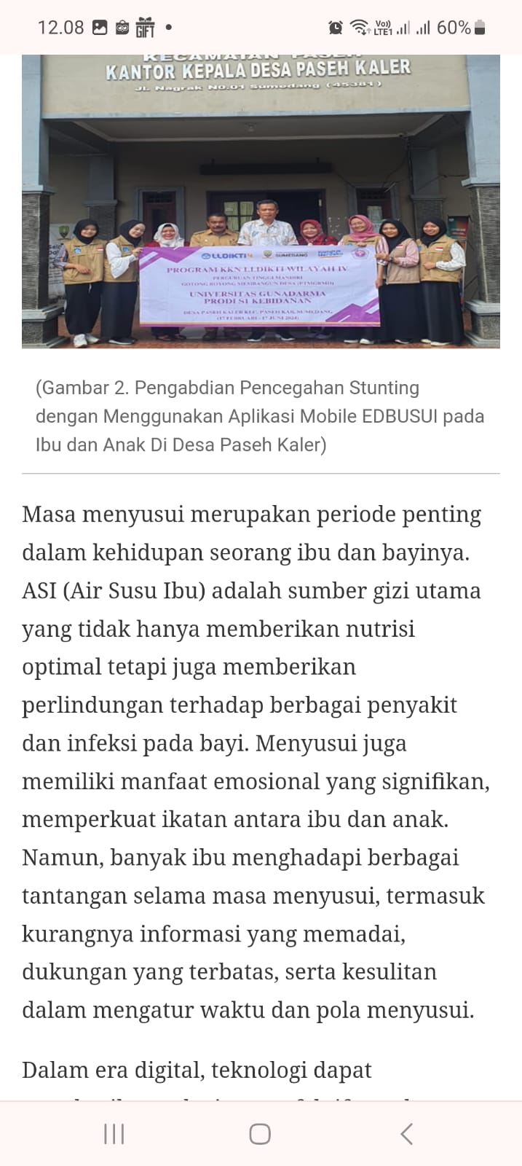
https://depoknews.id/sosialisasi-aplikasi-mobile-edbusui-dalam-pencegahan-stunting-pada-ibu-dan-anak-di-desa-paseh-kaler/

