**Graph**

A **graph** (sometimes called an *undirected graph* to distinguish it from a [directed graph](https://en.wikipedia.org/wiki/Graph_(discrete_mathematics)#Directed_graph), or a *simple graph* to distinguish it from a [multigraph](https://en.wikipedia.org/wiki/Multigraph))[[4]](https://en.wikipedia.org/wiki/Graph_(discrete_mathematics)#cite_note-FOOTNOTEBenderWilliamson2010148-4)[[5]](https://en.wikipedia.org/wiki/Graph_(discrete_mathematics)#cite_note-5) is a [pair](https://en.wikipedia.org/wiki/Ordered_pair) *G* = (*V*, *E*), where *V* is a set whose elements are called *vertices* (singular: vertex), and *E* is a set of paired vertices, whose elements are called *edges* (sometimes *links* or *lines*).

The vertices *x* and *y* of an edge {*x*, *y*} are called the *endpoints* of the edge. The edge is said to *join* *x* and *y* and to be *incident* on *x* and *y*. A vertex may belong to no edge, in which case it is not joined to any other vertex.

**Graph theory**

**Graph theory** is the study of [*graphs*](https://en.wikipedia.org/wiki/Graph_(discrete_mathematics)), which are mathematical structures used to model pairwise relations between objects.

**Independent set**

An **independent set**, **stable set**, **coclique** or **anticlique** is a set of [vertices](https://en.wikipedia.org/wiki/Vertex_(graph_theory)) in a [graph](https://en.wikipedia.org/wiki/Graph_(discrete_mathematics)), no two of which are adjacent.

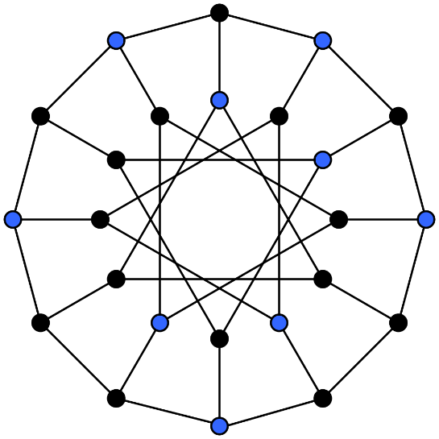

A **maximal independent set** (**MIS**) or **maximal stable set** is an [independent set](https://en.wikipedia.org/wiki/Independent_set_(graph_theory)) that is not a [subset](https://en.wikipedia.org/wiki/Subset) of any other independent set. In other words, there is no [vertex](https://en.wikipedia.org/wiki/Vertex_(graph_theory)) outside the independent set that may join it because it is maximal with respect to the independent set property.

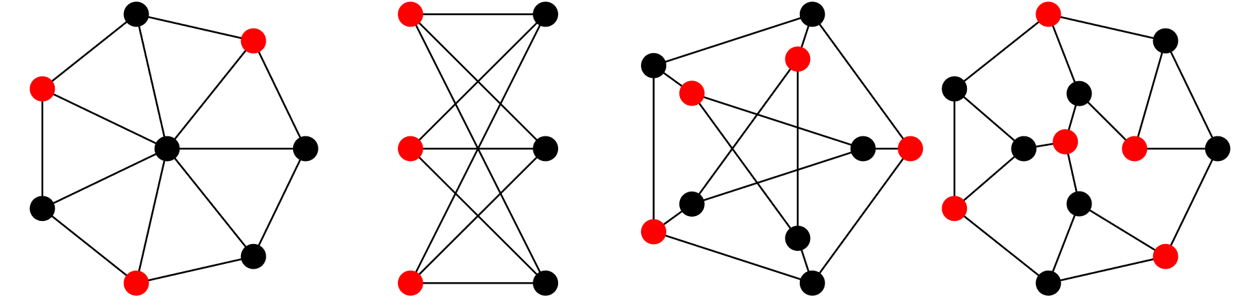

**Matching**

A **matching** (or **independent edge set)** in an undirected [graph](https://en.wikipedia.org/wiki/Graph_(discrete_mathematics)) is a set of [edges](https://en.wikipedia.org/wiki/Edge_(graph_theory)) without common [vertices](https://en.wikipedia.org/wiki/Vertex_(graph_theory)).[[1]](https://en.wikipedia.org/wiki/Matching_(graph_theory)#cite_note-NetworkX_2.8.2_documentation-1) In other words, a subset of the edges is a matching if each vertex appears in at most one edge of that matching.

A **maximum matching** (also known as maximum-cardinality matching[[2]](https://en.wikipedia.org/wiki/Matching_(graph_theory)#cite_note-2)) is a matching that contains the largest possible number of edges. There may be many maximum matchings.

**Vertex cover**

A **vertex cover** (sometimes **node cover**) of a [graph](https://en.wikipedia.org/wiki/Graph_(discrete_mathematics)) is a set of [vertices](https://en.wikipedia.org/wiki/Vertex_(graph_theory)) that includes at least one endpoint of every [edge](https://en.wikipedia.org/wiki/Edge_(graph_theory)) of the graph.

The **minimum vertex cover problem** is the [optimization problem](https://en.wikipedia.org/wiki/Optimization_problem) of finding a smallest vertex cover in a given graph.

