Sculpt

1 What is Sculpt?

1.1 Literally
Sculpt is a game of creativity and combat for 3-5 players. The objective is to create a Sculpted being and succeed in a combative trial to emerge into the world, the first of your kind to do so. The game consists of two phases; Emergence, where you create your character by choosing cards that grant you abilities and personality, then Combat, where you use your sculpted being to fight in one of many combative and collaborative modes.

1.2 Vibes
Sculpt is a game where power comes from unlikely synergy, and too much power will get you killed. It’s a game where you are constantly balancing the need to cooperate with the other players to defeat the boss and escape, against your desire to have more resources left when the dust settles.
Sculpt has as few rules as we could manage, for a game ultimately about tactical character creation and combat. This means there are situations that can unfold which are not explicitly explained here. When these situations arise, we recommend going with the table’s consensus on what should happen. After the game you can look up the details of the rules in the Appendix of the rulebook or head to the discord server for full rules discussions for each card.

1.3 Vision
Sculpt is a game made by people who like messing with the games they play. You will find blank cards of every type in this box, to use as you wish. Additionally, if you scan the QR code on the back of this rulebook, you will be invited to the Sculpt discord server. Here you can share photos of your own created cards, and monthly favourites of ours will be collated. We hope that the game can continue to evolve with feedback and contributions from players. If you think the game would be more fun if you tried a different ruling, please try it and let us know how it went.

2 Sculpted
Your character is a Sculpted being, earthly material that has attained sentience through prolonged exposure to wild magic deep within the Earth. You can take on many forms, and have developed unique quirks and capabilities during your long awakening. You seek to emerge onto the surface, however great perils await on the border.

2.1 Core Statistics
There are three core stats that define your character in Sculpt: Jazz, Heft, and Weird. They are essential for your existence, and if any become entirely wounded, you die. Each stat can be a number between 1 and 6. You will choose your stats during Emergence.
Jazz: represents your manoeuvrability and coordination. It affects how likely you are to hit and critically hit with attacks. Jazz Tokens may be spent to climb obstacles and perform feats of acrobatics.
Heft: represents your bulk and raw strength. It affects how much composure you have, which enables you to take a hit without being seriously injured. Heft Tokens may be spent to break things and overpower your foes.
Weird: encompasses many things, including your creativity, passion, and magical prowess. While it does not affect any core characteristic of your being, Weird will allow you to maximise the potential of the cards you acquire. Spending Weird Tokens may cause abilities on cards to trigger whenever you do so, and Weird allows you to interact with many terrain features during Combat.

2.2 Secondary Statistics
Secondary statistics are determined by your base stats. See the combat section for a more detailed description of the mechanics that these statistics relate to.
Hit Value: Your hit value is determined by your Jazz. When you attack, this is the number you need on a d12 roll to hit. Set your Jazz spinner to the right number to see your Hit value and Crit Thresholds. Critical Thresholds : Jazz also determines your critical thresholds. When you attack, if you roll as high as one of your critical thresholds, you get to pick that many critical effects in addition to dealing damage.
Composure: Taking damage depletes your composure, and when it runs out you will suffer a wound. Your composure is equal to your Heft.
Movement Speed: This is how many hexes you move when you take a move action. The default is 4 but equipped cards may modify this. You can adjust the dial on your spinner to track this.

2.3 Cards
There are three card types you can equip in Sculpt.
Forms: Describe the shape and size of your body. Your form gives you a significant amount of capability and opportunity for synergy. Many change your movement speed or give defensive abilities. You may only have one form equipped, but extra forms gained during emergence may be held and traded.
Limbs: Things attached to your form that you can use. The majority of limbs have activated abilities, and many have attacks. You may have any number of limbs equipped.
Impressions: The influence of wild magic, embossed on your form are imprints that grant you personality and power. You may have any number of impressions equipped.
A completed sculpt character will have 6 cards, which will consist of one form and a mix of limbs and impressions. There is no limit to the total amount of cards you may have equipped if you gain additional cards during combat.
[ANATOMY OF A CARD DIAGRAM]

3 Emergence
There are a total of 6 rounds in emergence, some give players a choice of card to take from a visible set, some allow you to draw from a deck or trade, and some offer a choice of good, mixed, and bad outcomes. The emergence board describes what to do in each round. By the end of emergence you will have a character ready to play in battle.

3.1 Boss Selection
Before creating characters, select which boss you will face. Put their map and summary card on the table so that you can make more informed decisions during character creation.
Take note of the win condition for the fight and the information on the boss summary card. Each boss comes with unique strengths and weaknesses, and different objectives for winning. The collaborative - competitive slider indicates how much the boss encourages you to work together to defeat it, and some cards are more collaboratively or competitively themed.

3.2 Round 1: Primordial Pools
Your sculpted being begins deep within the Earth, where slumbering magics infuse rock and clay. Deal each player 2 forms, 2 limbs, and 2 impressions. Then everyone chooses one card of each type to keep. This forms the basis of your character.
Give the player with the first form alphabetically the first player token. From this point on, players take turns in clockwise order moving up through the ground, developing their sculpted being with more cards. After each section of emergence, move the first player token around clockwise, which changes the starting player for next round.

3.3 Round 2: Crystal Depths
Flip one of each card type face up on the table. Starting with the player with the fist player token, each player chooses between one of the face up cards, or may take two cards from any face down pile and select one to keep. Replace any face up cards taken before the next player picks.

3.4 Round 3: Crystal Caves
Discard any face up cards and replace with fresh cards. Repeat the process of stage 2 starting with the new first player.

3.5 Round 4: Maze of Roots
Each player selects a card type and takes 4 cards of that type from the draw. Each player keeps of the 4.

3.6 Round 5: Midden Market
Display two of each card type from the draw face up. Starting with the first player, each may trade one of their cards for a face up card. The card type does not need to match. You can decide to keep your setup and not trade if you wish. Players trading later in the round can take cards that have been traded in by other players.

3.7 Round 6: The Antechamber
Each player chooses one positive status effect to gain. The options are Well Rested, Imbued, and Monstrous.
You should now assign your stats. You have a total of 10 points to spread between the three. You may not have a score higher than 6 in a stat. If you are a new player, we recommend starting with a balanced character that has 4 points in their favoured stat, and 3 points in the others. Because a character is killed if they are completely wounded in any of their stats, a balanced distribution is recommended for durability. Unbalanced stats allow for massive strengths, that must be

3.8 Sculpting
While progressing through emergence, you should begin to craft a miniature for your character. Materials are provided, although you can use many small household objects to adorn your sculpted being. Be creative in designing your character. They do not need to match your cards, although using them as a guide can help. You must be able to fit your miniature on a one hex base (or 3 hex base for a large form) and it should not have far reaching limbs as the sculpting material self adheres. Sculpted beings are sometimes humanoid but often not, and you may use a previously made miniature if you are in a rush. +

3.9 Summary
Upon creation your character should have:
- 10 points assigned between Jazz, Heft, Weird .
- Jazz, Heft, Weird , and composure tokens. - One equipped form
- A total of 6 equipped cards
- A status effect
- A miniature.
- A character sheet, with details filled in.
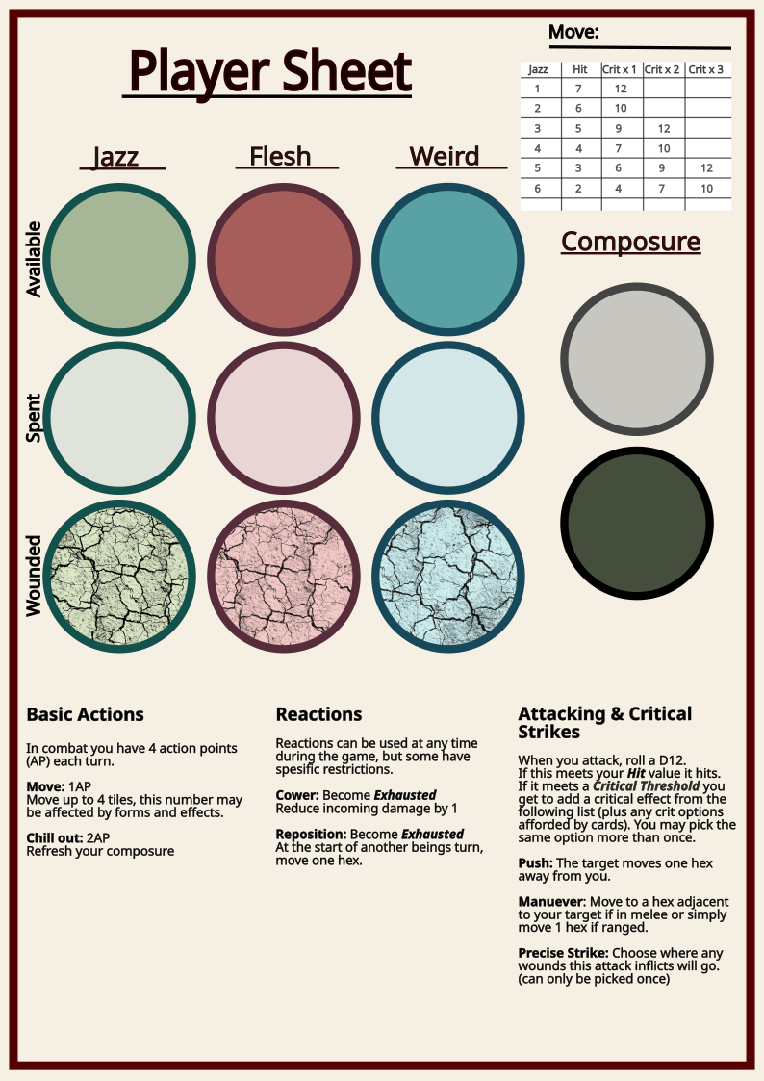

4 Core Combat Rules

4.1 The Map
Give the starting player token to the player with the first impression alphabetically, they will take the first turn in terrain placement and combat.

4.2 Terrain
Deal 2 pieces of terrain to each player. Each player picks one terrain card to place and discards the other, starting with the starting player. To place terrain, draw a representation of the card on the map on any hex that is not in a starting zone. The size and shape of the terrain piece is usually specified, and may have some choice involved. Leave terrain cards that are used on the table to reference during combat. When all terrain has been placed, combat will commence starting with the player with the starting player token.

4.3 Start position
The starting player rolls a d6 to determine their start position. Going clockwise each player takes the next start position in sequence, 1 comes after 6. Place the boss after all players.

4.4 The Round
A round consists of a turn for each player, then an additional turn for the starting player. At the end of each players turn they draw a boss action card from the deck and place it in the next slot in the boss action tracker. After all player turns are complete the boss will take its turn, executing each action in the tracker in order. For example, in a 3 player game, a round would consist of turns from players A,B,C,A then the boss would take a 4 action turn. At the end of the round, move the starting player token clockwise, so that the turn order continues next round with turns from players B,C,A,B.

4.5 Taking a Turn
On your turn you may spend Action points (AP) to have your character take basic actions, use the abilities of equipped cards, or interact with terrain features. At the start of your turn you refresh all of your AP. Some abilities are classified as reactions, which you may use outside of your turn if a condition is met. Reactions often have Exhaust as a cost, which removes one AP at the start of your turn and prevents taking further reactions.
The basic actions are:
Move : 1AP - Move your character up to your move speed in hexes. The default move speed is 4.
Chill Out: 1AP - Restore 2 composure.
Flail: 2AP - Attack: 3 damage, close.
Cower: Exhaust - Reaction - When you take damage from an attack, you may reduce the damage by 1. Exhaust is a status effect that reduces your AP for the next turn by 1. You may only be Exhausted once.
Reposition: Exhaust - Reaction - At the start of another beings turn, move 1 hex.
Once you cannot take any more actions, or don’t want to, your turn ends. Then draw a boss action card and place it in an open slot on the boss action board. Once the round is over, the boss will take its turn.

4.6 Targetting and line of sight
In order to use most abilities and all attacks against a being, you must be able to target them. If a card specifies a target you must be able to draw a clear line between you and them; a line of sight. This line must connect any part of the hex you are standing on to the centre of their hex.
[TARGETTING DIAGRAM HERE!!!!]

4.7 Attacking
If you have are within range of a being you can target, you may attack them. Different attacks have different range: Melee, Reach, and Ranged. Melee attacks can hit only adjacent hexes, Reach attacks gain one hex past that. Ranged attacks have no maximum range.
[RANGE DIAGRAM]
To attack, roll a 12 sided die: this is your to roll to hit. If this number meets your Hit threshhold, then the attack hits, inflicting damage and potentially wounding. If your attack roll meets one of your critical thresholds, then you may choose a number of bonus critical effects equal to the highest threshold your roll reached.
Your Hit Threshold and Crit Thresholds can be found by setting your Jazz spinner to your Jazz value.
Jazz | Hit Threshold | Crit Threshhold 1 | Crit Threshold 2 | Crit Threshold 3
1 | 7 | 12 | - | -
2 | 6 | 10 | - | -
3 | 5 | 9 | 12 | -
4 | 4 | 7 | 10 | -
5 | 3 | 6 | 9 | 12
6 | 2 | 4 | 7 | 10

4.8 Critical Hits
All players and bosses in sculpt have access to the following base critical options, you may choose the same effect multiple times and stack them and order them as you choose. For example, if you score a triple critical hit you can choose to Push, then Manoeuvre to the targets new location, and Push them again.
Push: Move the target 1 tile away from you, if they would be pushed into a wall, instead add 1 damage to the attack as they slam into it.
Manoeuvre: Move to any tile adjacent to your target (if in melee) or move 1 tile (if in ranged)
Precise Strike: Any wounds dealt by this attack are dealt to the stat of your choice.
Advanced critical effects:
These are found only on cards, and allow for some seriously nasty hits when combined. The below list does not include every effect but outlines some examples
Strike: Add 1 damage to this attack.
Brutal Strike: Add 2 damage to this attack.
Exult: Restore 2 composure, or gain 2 temporary composure.
Rally: Restore 2 composure to an ally you can see.
Entangle: Inflict the Entangled status effect, the target cannot move until they spend AP or Jazz to clear it.
Armour Piercing: The attack deals True Damage (Ignore the effect of damage reduction of any kind for this attack.)
Intimidate: The target may not approach you until the end of its next turn.
Dash: You may make a move action for free.

4.9 Damage and Wounds
When a being takes damage, it must lose that many composure tokens. When composure runs out, the entity suffers a wound then refreshes their composure and remaining damage carries over. This can cause a single attack to inflict multiple wounds. Wounds are inflicted to a random stat by rolling the wound die. If a hit inflicts multiple wounds, roll only once and assign all wounds to the rolled stat. When taking wounds, you may remove a token from either the available or spent section on your character sheet and place it in the wounded. Becoming wounded does not affect your stat values, your composure and Hit Thresholds remain unchanged.
For example, a being with 4 Heft (and therefore 4 max composure) suffers a massive hit for 9 damage. They remove 4 composure tokens, then reset their composure, remove another 4, reset, and remove a final token. This leaves them with 3 remaining composure and they suffer two wounds. They roll to determine the wound location and roll Weird, so they take two Weird Tokens, one from spent and one from available (as they had only 1 in spent) and place them in wounded. They have only 1 unwounded token remaining in Weird, so they must be wary because any critical strike that wounds would be able to precise strike and kill them.
[DAMAGE DIAGRAMS HERE]

4.10 Death
If any of your stats become entirely wounded, you die. You need a little of everything to exist in this reality. There are other rare ways to die, such as being pushed into a void or swallowed whole.
If you die, your miniature is removed from play and your cards are discarded.

4.11 The Boss
At the end of each players turn, they draw a card from the boss action deck and place it in the next slot on the boss action board. At the end of the round, when the starting player has taken a turn again, the boss will perform all the actions on the boss action board in order.
The boss has Jazz, Heft, and Weird the same as you do, and takes damage in the same way. When choosing how to perform a boss action, try to make the boss act intelligently. The boss actions will explain how to prioritise attacks and movement, but if there are ever situations where the rules are not clear, favour the action that allows the boss to effectively use its abilities on targets, or at least gets them in a better position to do so in the future.
Some bosses have a unique mechanic that changes their core functionality in some way, check the full rules for each boss in the boss book for information on how to enact the bosses turn.

5 Further Combat Rules

5.1 Movement
When you move in Sculpt, you may break the movement up between other abilities. Each time you take a move action it gives you that many hexes to use as you wish during your turn. For example, a being with a move of 4 (the default) may take two move actions for 2 AP, use 3 hexes to close a gap to a foe. Then make an attack for 2 AP, and then use the remaining 5 hexes of movement to move away after the attack.
Some terrain impedes movement, such as cliffs and vines. If a hex would take 2 movement hexes to move into, you must have 2 available (no rounding). If you climb up or jump across a terrain feature, any hexes moved must still be paid for in your movement. This is in addition to any tokens or AP spent to interact with the terrain piece.
Some forms make your model larger. When moving a large character, designate one hex on your model at the start of movement to count hexes for, move that hex as far as you wish, then freely rotate the model on the spot in your final position. If you are moving a large model into a narrow space where it does not fit, each hex of movement costs double.

5.2 Pushing
You have the ability to push others using critical hits and card effects. When you push a being, they must be pushed into a hex that is further away from you than their starting hex. If a being would be pushed into a solid object like a wall or another being, they instead they take damage equal to the number of hexes they would have moved. This damage is added onto the attack that caused the push and dealt simultaneously. If the pushed being is pushed into another being then the receiver also takes this additional damage.
[PUSHING DIAGRAM with collisions and damage]

5.3 Status effects
Status effects are cards that you receive from attacks, abilities, and terrain. They are temporary effects that can be positive or negative. You may not have the same status effect equipped multiple times, and status effects can have different effects on bosses. There is no limit to the number of status effects you can have equipped.

5.4 Losing Composure
Some abilities cause beings to lose composure. [IMAGE] This effect will reduce a beings current composure down to a minimum of 1, but it cannot inflict a wound, and does not count as damage.

5.5 Temporary Composure
Many abilities grant temporary composure. These are black temporary composure tokens [IMAGE] that you can place on top of your unspent composure tokens. Temporary composure is always removed first, and is not replenished when you refresh your composure. Temporary composure does not stack though; if an effect would grant you more temporary composure than you currently have, then you only then gain up to a total of that amount.

5.6 Flammable and Destructible
Some terrain pieces, and all sculpted beings, are Flammable. This keyword means that the object can be set on fire and suffer the Burning status effect. Things that are on fire have the following properties:
Any being that enters a Flaming hex, suffers the Burning status effect.
If the being is already Burning then they instead take 2 damage.

6 FAQ

6.1 Symbols
[SYMBOL KEY]

