Notes to self, remove these later!

I have copied Kage’s rulebook as a starting point to keep rulings and phrasing consistent. There’s plenty of unedited content at this point as I’m working on pictures too, so it’s slow going,

Research

This rule set should focus on core rules and give players direction to keep the game moving.
I’m looking at Root’s Appendix (The Law of Root) and Guidebook (Leaning to Play)
First observations about those books
The appendix has no pictures

Guidebook
- constant pictures, for both flavour and clarity
- examples after complicated rules
- Exceptions or niche rules are included, but they are set to the side to indicate that they are uncommon

Front Page

Introduction
Sculpt is a game of creativity and combat.

Players create and play as Sculpted beings, earthly material that has attained sentience through prolonged exposure to wild magic deep within the Earth. These creatures take many forms, and have developed unique quirks and capabilities during your long time in the deep.

The objective is succeed in a combative trial where clay creatures battle with and against each other in a struggle for life, to emerge into the world, the first of your kind to do so.

Flow of Play
The game consists of two main phases:
Emergence where players create their characters by choosing and trading cards
Combat where players use their characters in one of a variety of combative and collaborative formats.

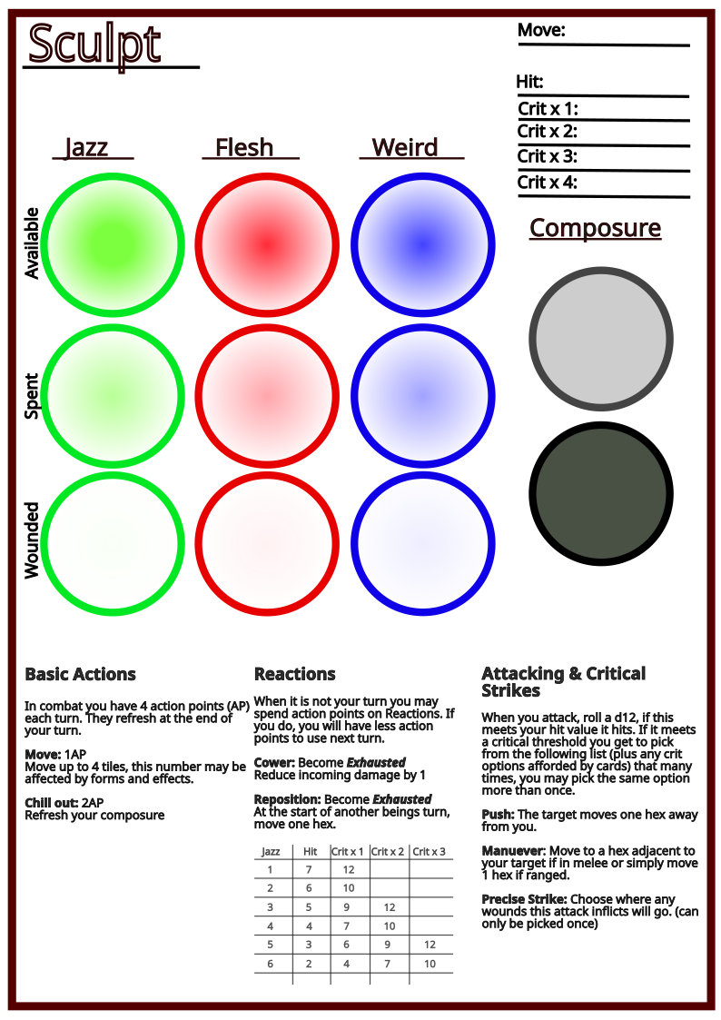
Player Sheet

Setup

The Guardian at the Gate
High above, the door to the world sits closed and sealed. Nearby, a figure holds the key.
Choose a boss challenge level, shuffle the boss summary cards of that level, and select what boss you will face. Place the appropriate map into play

Emergence
The emergence board describes what to do in each round. From this point on, players take turns in clockwise order moving up through the ground, developing their sculpted being with more cards. After each section of emergence, move the first player token around clockwise and thus the starting player changes. By the end of emergence you will have a character ready to play in battle.

Primordial Pools
Your sculpted being begins deep within the Earth, where slumbering magics infuse rock and clay.
Deal each player 2 forms, 2 limbs, and 2 impressions.
Then everyone chooses one card of each type to keep. This forms the basis of your character.
Give the player with the first form alphabetically the first player token.

Crystal Depths, and Fungal Caverns
Place

Clay Mire

Midden Market

Sewer Maze

Core Statistics
There are three core stats that make your character in Sculpt. They are essential for your existence, and if any become entirely wounded, you die. Each stat can be a number between 1 and 6. You choose your stats during Emergence.
Jazz: represents your manoeuvrability and coordination. It affects how likely you are to hit and critically hit with attacks. Jazz Tokens may be spent to climb obstacles and perform feats of acrobatics.
Flesh: represents your bulk and raw strength. It affects how much composure you have, which enables you to take a hit without being seriously injured. Flesh Tokens may be spent to break things and overpower your foes.
Weird: encompasses many things, including your creativity, emotion, and magical prowess. While it does not affect any core characteristic of your being, Weird will allow you to maximise the potential of the cards you acquire. Spending Weird Tokens allows you to interact with many terrain features and may cause abilities on cards to trigger.

Hit Value: Your hit value is determined by your Jazz. When you attack, this is the number you need on a d12 roll to hit.
Critical Thresholds: Jazz also determines your critical thresholds. When you attack, if you roll as high as one of your critical thresholds, you get to pick that many critical effects in addition to dealing damage.
Composure: Your composure is your current resolve, when it runs out by taking damage you will suffer a wound. Your composure is equal to your Flesh.
Movement Speed: This is how many hexes you move when you take a move action. The default is 4 but equipped cards may modify this.

Secondary Statistics
Secondary statistics are written on your character sheet and determined by your core stats. See the combat section for more detailed description of the mechanics that these statistics relate to.

Cards
There are three card types you can equip in Sculpt.
Forms: Describe the shape and size of your body. Your form gives you a significant amount of capability and opportunity for synergy. Many change your movement speed or give defensive abilities. You may only have one form equipped, but extra forms gained during emergence may be held and traded.
Limbs: Things attached to your form that you can use. The majority of limbs have activated abilities, 2 and many have attacks. You may have any number of limbs equipped.
Impressions: The influence of wild magic, embossed on your form are imprints that grant you personality and power. You may have any number of impressions equipped. A completed sculpt character will typically have 5-6 cards, which will consist of one form and a mix of limbs and impressions. There is no limit to the total amount of cards you may have equipped.

Sculpting
While progressing through emergence, you should begin to craft a miniature for your character. Materials are provided, you can take creative liberty in the design of your character, they do not need to match your cards, although using them as a guide can help. You must be able to fit the miniature on a one hex base (or 3 hex base for a large form) and it should not have far reaching pieces as the sculpting material will cause miniatures to adhere to each other. Sculpted beings are sometimes humanoid but often not, and you may use a previously made miniature if you are in a rush.

Summary (essential post emergence section)
Upon creation your character should have:
- 10 points assigned between Jazz, Flesh, Weird.
- Jazz, Flesh, Weird , and composure tokens.
- One equipped form
- A total of 5-6 equipped cards (typically)
- A miniature.
- A character sheet, with details filled in.

Here is an example of a completed character
-[INCLUDE ANNOTATED CHARACTER SHEET]

Combat

Setting up
Give the starting player token to the player with the first impression alphabetically, they will take the first turn in terrain placement and combat. Deal terrain cards to each player as specified by the map. Starting with the player with the starting player token, draw a piece of terrain onto the map. You may place terrain features anywhere outside the starting zones. You may decide the size and shape of the feature when it is not specified. When all terrain has been placed, combat will commence starting with the player with the starting player token.

The Round
A round consists of a turn from each player, then an additional turn from the starting player. At the end of each players turn, they draw a boss action card from the deck and place it in the next slot in the boss action tracker. After all player turns are complete the boss will take its turn, executing each action in the tracker in order. For example, in a 3 player game, a round would consist of turns from players 1,2,3,1 then the boss would take a 4 action turn. At the end of the round, move the starting player token clockwise, such that the turn order continues next round with turns from players 2,3,1,2

Taking a Turn
On your turn you may spend Action points (AP) to make your character take basic actions, use the abilities of equipped cards, or interact with terrain features. At the end of your turn you refresh all of your AP. Some abilities are classified as reactions, which happen outside of your turn when a condition is met and consume your AP before the turn starts. Keep track of your AP by using the provided tokens to ensure you don’t forget about reactions from previous players turns. The basic actions are: Move: 1AP - Move your character up to your move speed in hexes. The default move speed is 4.
Chill Out: 2AP - Restore all of your composure.
Cower: 1AP - Reaction - When you take damage from an attack, you may reduce the damage by 1 for each action point you spend.
Reposition: 1AP - Reaction - At the start of another beings
turn, move 1 hex.
Once you have spent all of your AP, end your turn and refresh your AP. Then draw a boss action card and place it in an open slot on the boss action board. Once the round is over, the boss will take its turn.

Attacking and Critical Hits
You may attack any target that you can see within range. Only large terrain features(Indicated by eye cross symbol on card) such as pillars and trees and beings block line of sight. Melee attacks target only adjacent hexes, some melee attacks have reach which allows for attacks 1 hex further away. Ranged attacks have infinite range. To attack, roll a 12 sided die, this is your to roll to hit. If this number meets your Hit threshold, then the attack hits, inflicting damage and potentially wounding. If your attack roll meets one of your critical thresholds, then you may choose a number of bonus critical effects equal to the highest threshold reached. Your Hit Threshold and Crit Thresholds are determined by your Jazz score, as indicated in the table below.

Critical Hits:
All players and bosses in sculpt have access to the following base critical options, you may choose the same effect multiple times and stack them and order them as you choose. For example, if you score a triple critical hit you can choose to Push, then Manoeuvre to the targets new location, and Push them again.
Push: Move the target 1 tile away from you, if they would be pushed into a wall, instead add 1 damage.
Manoeuvre: Move to any tile adjacent to your target (if in melee) or move 1 tile (if in ranged)
Precise Strike: Any wounds dealt by this attack are dealt to the stat of your choice.

Advanced critical effects:
These are found only on cards, and allow for some seriously nasty hits when combined. The below list does not include every effect but outlines some examples
Strike: Add 1 damage to this attack.
Brutal Strike: Add 2 damage to this attack.
Exult: Restore 2 composure, or gain 2 temporary composure.
Rally: Restore 2 composure to an ally you can see.
Entangle: Inflict the Entangled status effect, the target cannot move until they spend AP or Jazz to clear it.
Armour Piercing: Ignore the effect of damage reduction of any kind for this attack.
Intimidate: The target may not approach you until the end of its next turn.
Dash: You may make a move action for free.

Damage and Wounds
When a being takes damage, it must lose that many composure tokens. When composure runs out, the entity suffers a wound, refreshes their composure, and any remaining damage carries over. This can cause a single attack to inflict multiple wounds. Wounds are inflicted to a random stat by rolling the wound die. If a hit inflicts multiple wounds, roll only once and assign all wounds to the rolled stat. When taking wounds, you may remove a token from either the available or spent section on your character sheet and place it in the wounded. Becoming wounded does not affect your stat values, your composure and Hit Threshold remains unchanged. For example, a being with 4 Flesh (and therefore 4 max composure) suffers a massive hit for 9 damage. They remove 4 composure tokens, then reset their composure, remove another 4, reset, and remove a final token. This leaves them with 3 remaining composure and they suffer two wounds. They roll 5 to determine the wound location and roll Weird, so they take two Weird Tokens, one from spent and one from available (as they had only 1 in spent) and place them in wounded. They have only 1 un- wounded token remaining in Weird so must be very wary, any critical strike that wounds would be able to precise strike

Death
If any of your stats become entirely wounded, you die. You need a little of everything to exist in this reality. There are other rare ways to die, such as being pushed into a void or swallowed whole. If you die, your miniature is removed from play and your cards are discarded.

The Boss
At the end of each players turn, they draw a card from the boss action deck and place it in the next slot on the boss action board. At the end of the round, when the starting player has taken a turn again, the boss will perform all the actions on the boss action board in order.
The boss has Jazz, Flesh, and Weird the same as you do, and takes damage in the same way. When choosing how to perform a boss action, try to make the boss act intelligently. The boss actions will explain how to prioritise attacks and movement, but if there are ever situations where the rules are not clear, favour the action that allows the boss to effectively use its abilities on targets, or at least gets them in a better position to do so in the future.

