**Wildcat Guide Documentation**

**API**

1. POST - Create User

**Purpose:**  
Create a new user with their email when they log in.

**Endpoint:**  
POST /api/users

Sample Request Body:

{

"email": "student@northwestern.edu"

}

Sample Response:

{

"message": "User created"

}

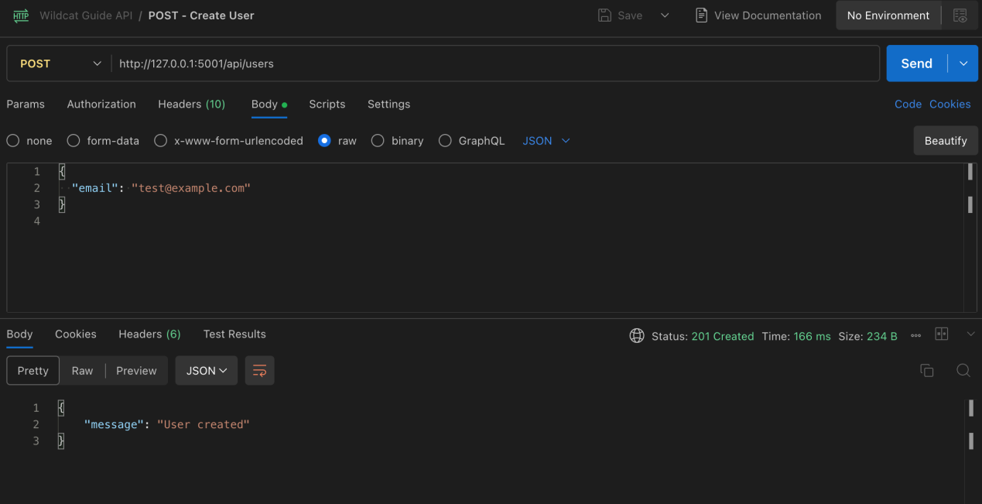

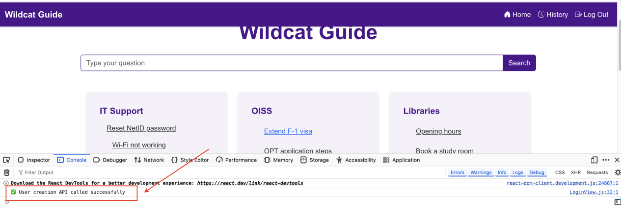

1. GET - Get All Categories

**Purpose:**  
Retrieve all available question categories.

**Endpoint:**  
GET /api/categories

**Sample Request:**  
No body required.

**Sample Response:**

[

{

"id": 1,

"name": "IT Support"

},

{

"id": 2,

"name": "OISS"

},

{

"id": 3,

"name": "Libraries"

}

]

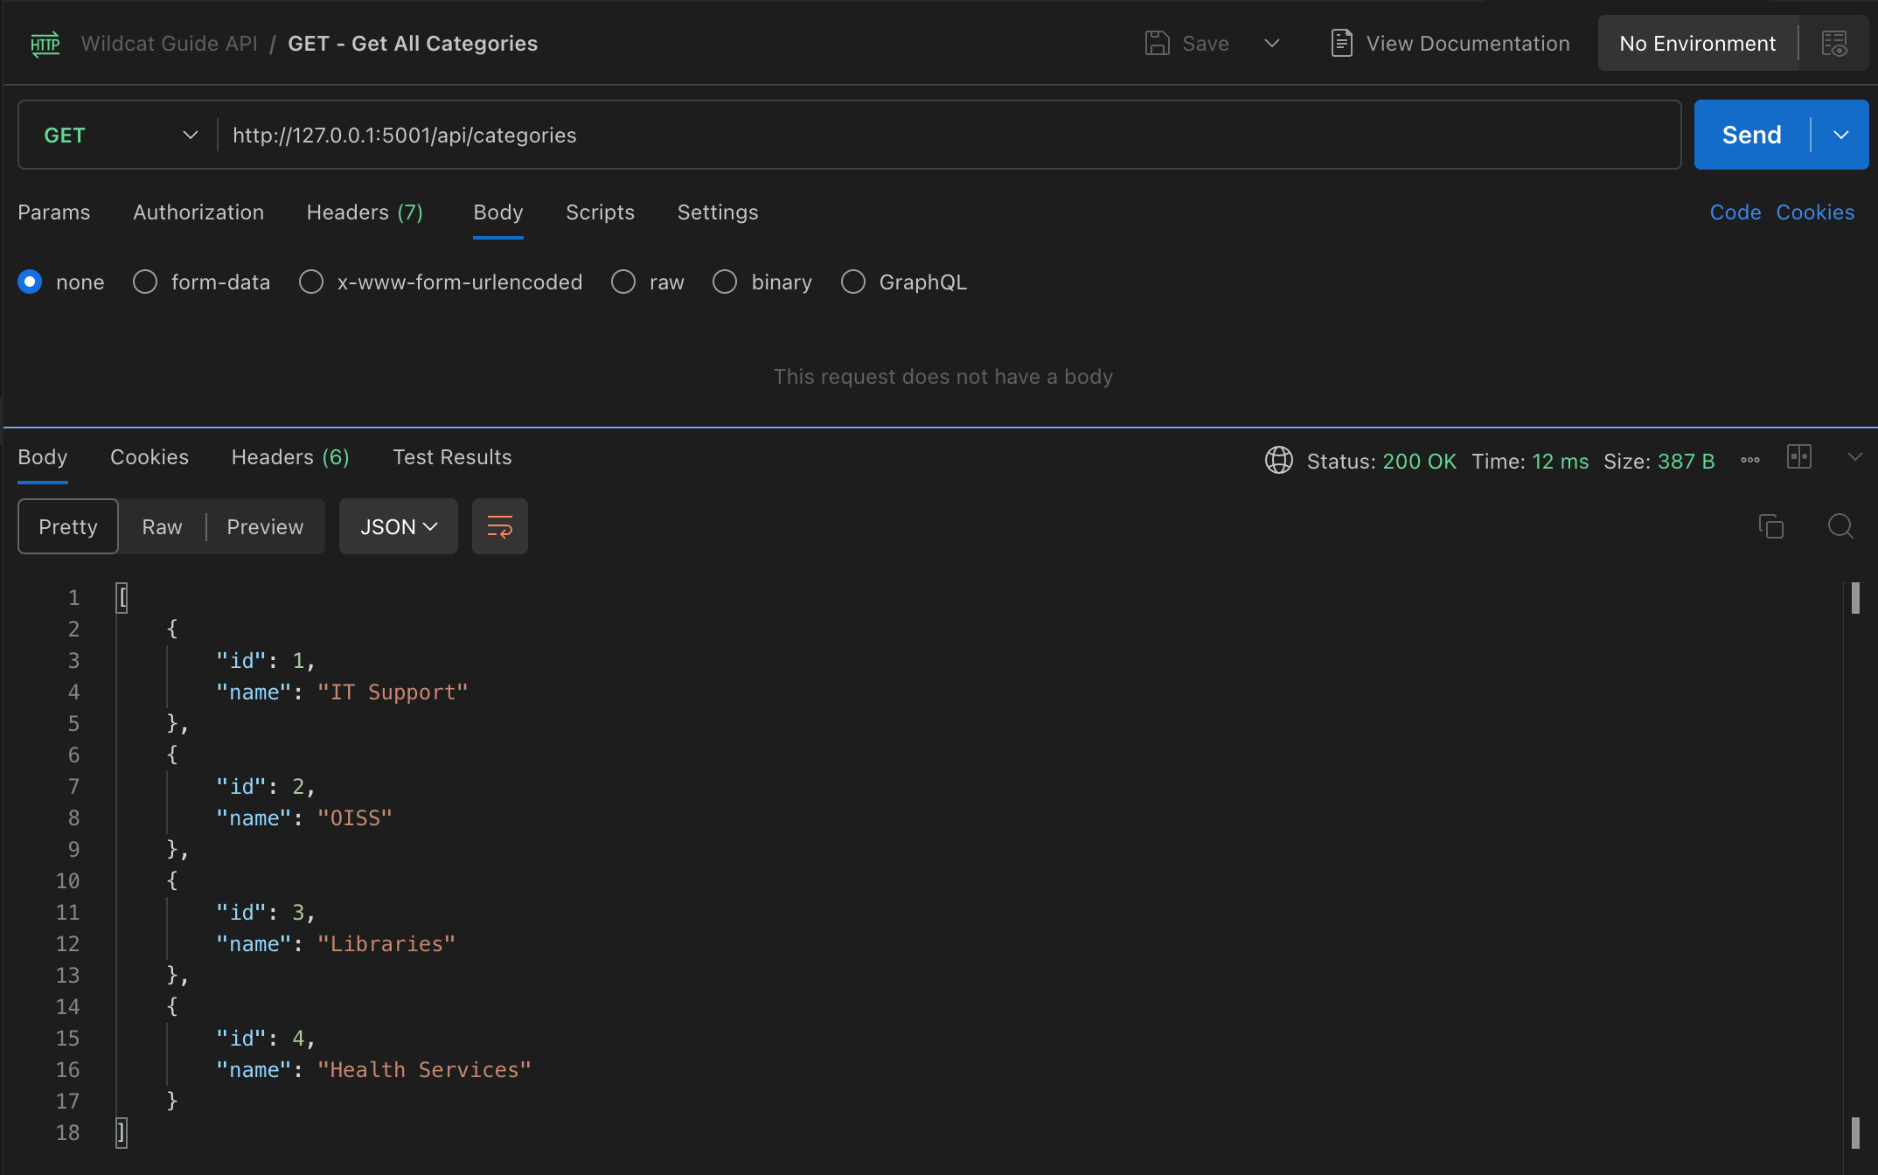

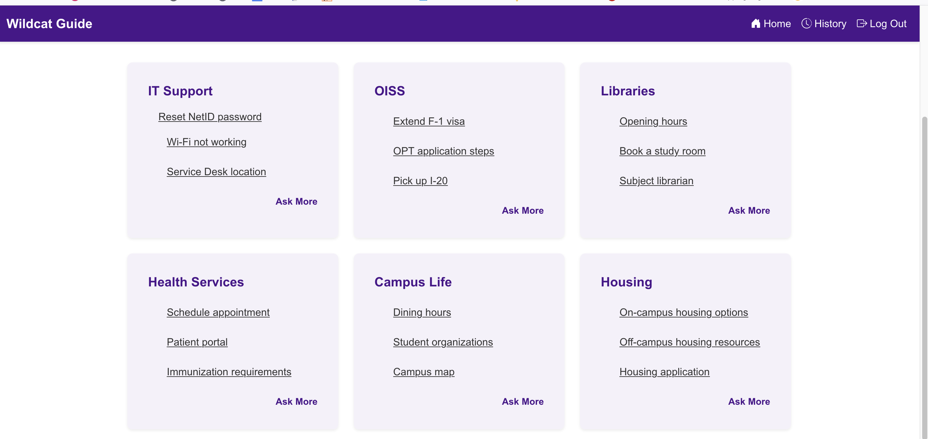

1. POST - Add Search History

**Purpose:**  
Save a search action to the user’s history.

**Endpoint:**  
POST /api/history

**Sample Request Body:**

{

"email": "student@northwestern.edu",

"search_query": "Where can I find the dining hall?"

}

Sample Response:

{

"message": "Search history recorded"

}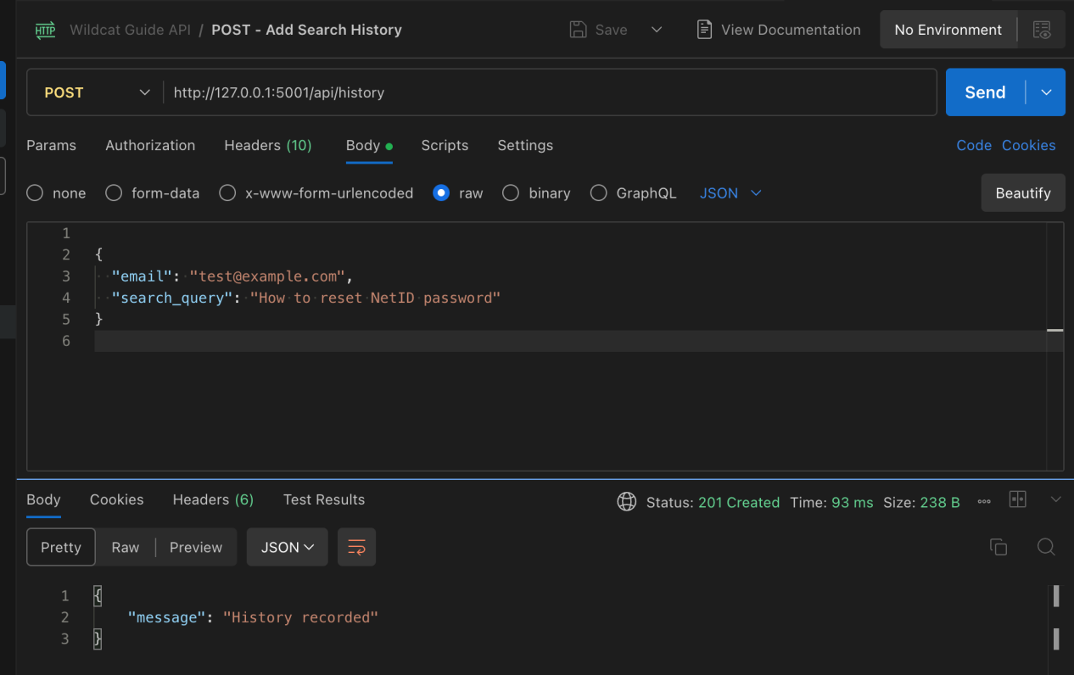

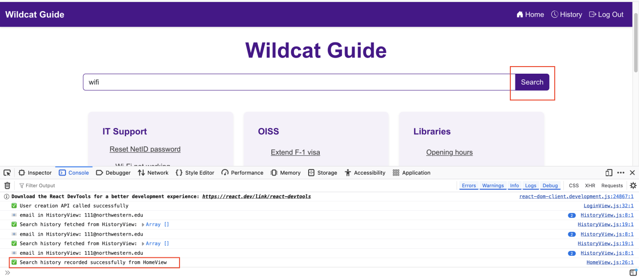

1. GET - Get Search History for User

**Purpose:**  
Retrieve all search history associated with a user's email.

**Endpoint:**  
GET /api/history/student@northwestern.edu

**Sample Request:**  
No body required.

**Sample Response:**

[

{

"search_query": "Where can I find the dining hall?",

"timestamp": "2025-07-30T20:00:00.000Z"

},

{

"search_query": "How to contact IT support?",

"timestamp": "2025-07-30T20:01:00.000Z"

}

]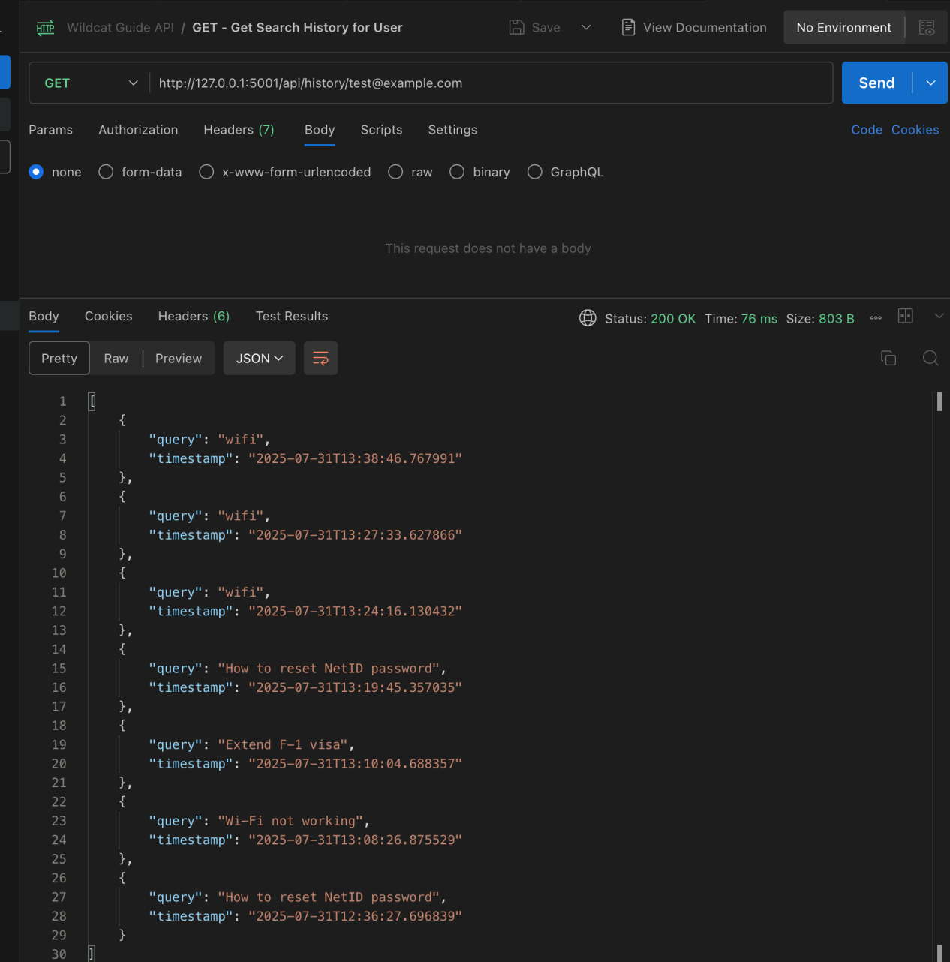

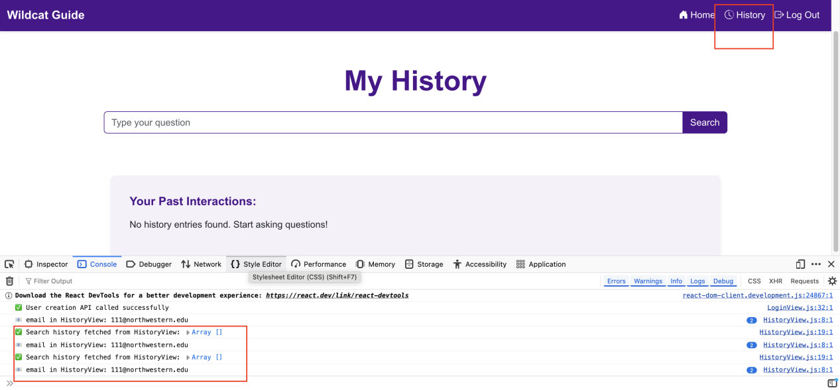

1. GET - Search Questions by Keyword

**Purpose:**  
Search questions from the database using a keyword.

**Endpoint:**  
GET /api/questions/search?keyword=dining

**Sample Request:**  
No body required.

**Sample Response:**

[

{

"question": "Where is the main dining hall?",

"answer": "The main dining hall is located in Norris Center.",

"category": "Dining"

}

]

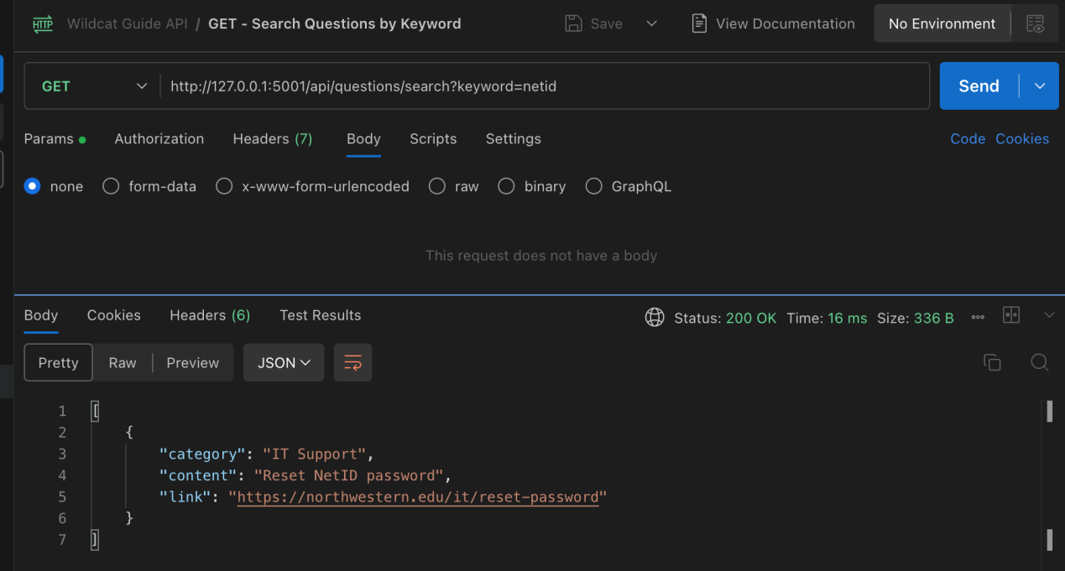

**DATABASE**

Table structure：

|  |  |  |
| --- | --- | --- |
| Table | Field | Data Type |
| categories | id | integer (PK) |
| categories | name | character varying(120) |
| questions | id | integer (PK) |
| questions | content | character varying(500) |
| questions | link | character varying(500) |
| questions | category_id | integer (FK to categories.id) |
| users | id | integer (PK) |
| users | email | character varying(120) |
| histories | id | integer (PK) |
| histories | user_email | character varying(120) |
| histories | search_query | character varying(255) |
| histories | timestamp | timestamp without time zone |

1. categories

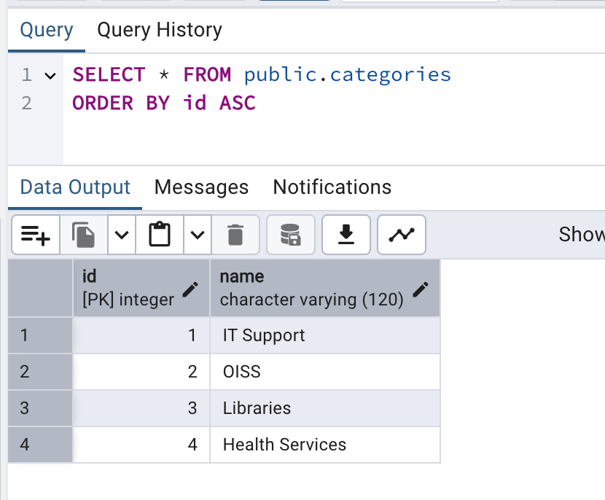

1. histories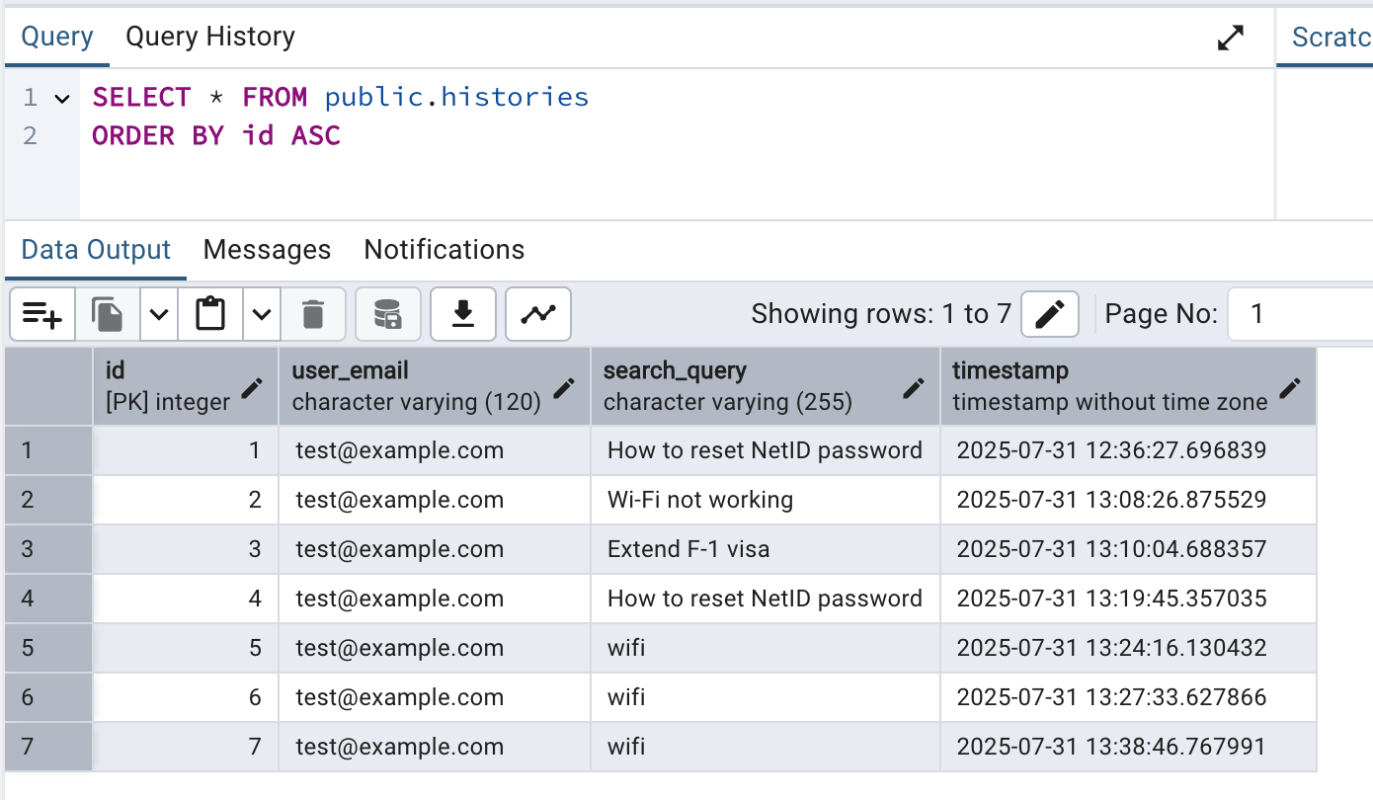
2. questions

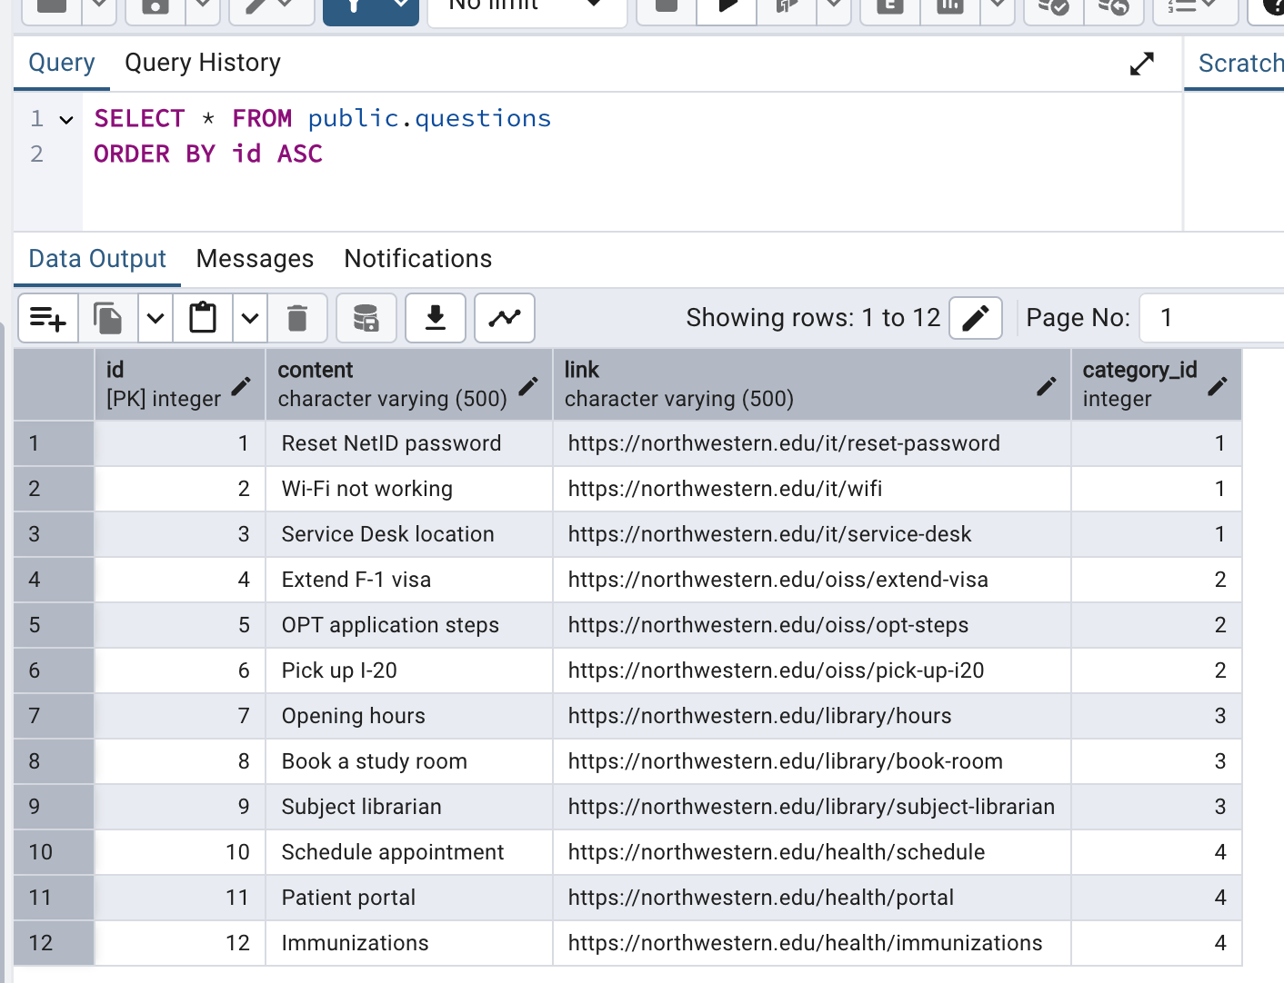

1. users

