Árbol:

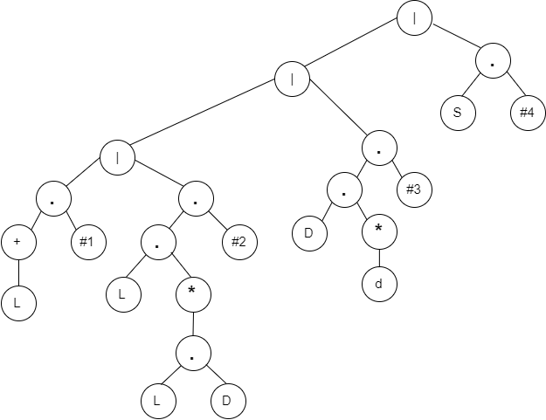

DFA:

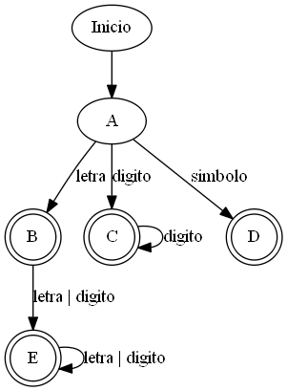

FOLLO TRANSICIONES

|  |  |
| --- | --- |
| 1-L | 2 |
| 2-#1 |  |
| 3-L | 4,5,6 |
| 4-L | 4,5,6 |
| 5-d | 4,5,6 |
| 6-#2 |  |
| 7-D | 8,9 |
| 8-d | 8,9 |
| 9-#3 |  |
| 10-S | 11 |
| 11-#4 |  |

|  |  |  |  |  |  |
| --- | --- | --- | --- | --- | --- |
|  | L | d | D | S | FDC |
| A = 1,3,7,10 | B = 2,4,5,6 | - | C = 8,9 | D = 11 | - |
| B = 2,4,5,6 | E = 4,5,6 | E = 4,5,6 | - | - | ACEPTADO |
| C = 8,9 | - | C = 8,9 | - | - | ACEPTADO |
| D = 11 | - | - | - | - | ACEPTADO |
| E = 4,5,6 | E = 4,5,6 | E = 4,5,6 | - | - | ACEPTADO |

Gramática

S → [principal] : { CUERPO }

CUERPO → [P CUERPO

| ε

P → intervalo]: (num);

| nivel]: {[P_N}

| enemigo]: {[P_E}

| personaje]: {P_PE}

P_N → dimensiones]: (num,num);

| inicio_personaje]: (num,num);

| ubicación_salida]: (num,num);

| pared]: {P_PA}

P_PA → [ P_PA_1 P_PA

| id := OPER; P_PA

| ε

P_PA_1 → casilla]: (num,num);

| varias_casillas]: (num VARIACION);

| variable]: id VARIACION_2);

VARIACION → ..num,num

| ,num VARIACION_1

VARIACION_1 → ..num

| ε

VARIACION_2 → ,id VARIACION_2

| ε

P_E → caminata]: (num, VARIACION); P_E

| ε

P_PE → [P_PE_1

| id := OPER; P_P

| ε

P_PE_1 → paso]: (num,num); P_PE

| caminata]: (num VARIACION); P_PE

| variable]: id VARIACION_2

OPER → K OPER_2

OPER_2 → K

K → id

|numa