Tutorial: Setting Up Raspberry Pi with polliguide_flower.img and Running YOLOv5

Download the Image File
- Open the link to the file: polliguide_flower.img.zip.
https://mega.nz/file/yc1VnApT#NZ2mby4EJUvyzZ2mLhtx8Qg6cBOHz3PhE7sqGfRMVow
- Download the ZIP file to your computer.
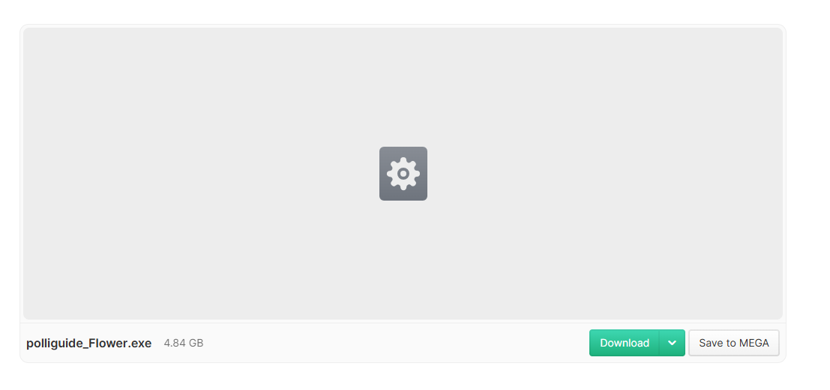
- Unzip the file to get polliguide_flower.img.
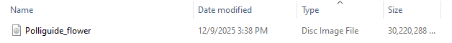

Flash the SD Card
- Download and install Raspberry Pi Imager:
https://www.raspberrypi.com/software/
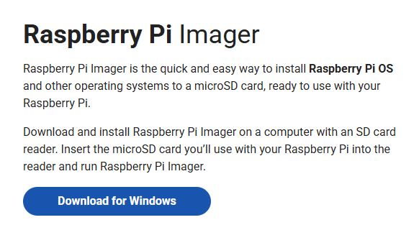
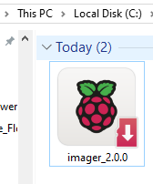
- Double-click the downloaded .exe file.
- Click Yes if Windows asks for permission.
- Follow the installation wizard → Click Next → Install.
- After installation, click Finish.
- Raspberry Pi Imager will now be available in your Start Menu.
- Insert your SD card into your laptop.
- Open Raspberry Pi Imager → Click CHOOSE OS → Select Use custom → Select polliguide_flower.img.
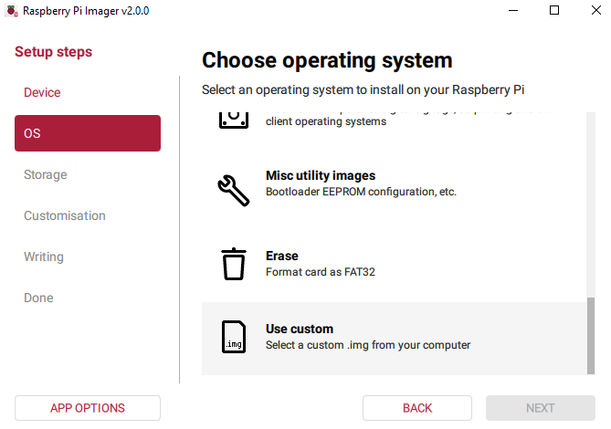
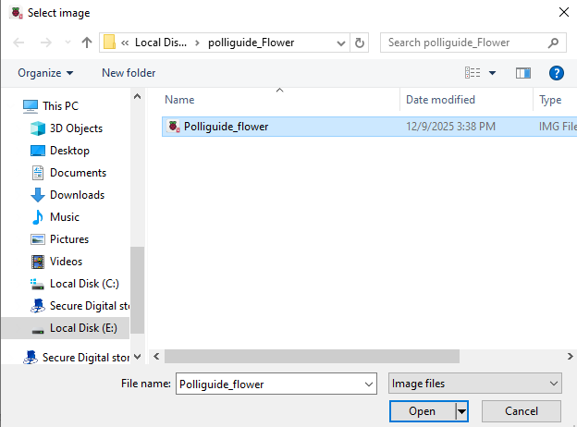
- Click CHOOSE SD CARD → Select your SD card make sure you have 32GB card
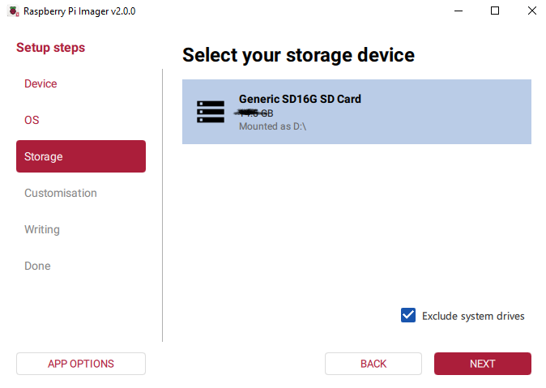
- Click WRITE → Wait until the writing process is complete.
- Safely eject the SD card from your laptop.

Boot the Raspberry Pi
- Insert the flashed SD card into your Raspberry Pi 4.
- Connect monitor, keyboard, mouse, and power supply.
- Power on the Raspberry Pi.
- Raspberry Pi OS will boot automatically.
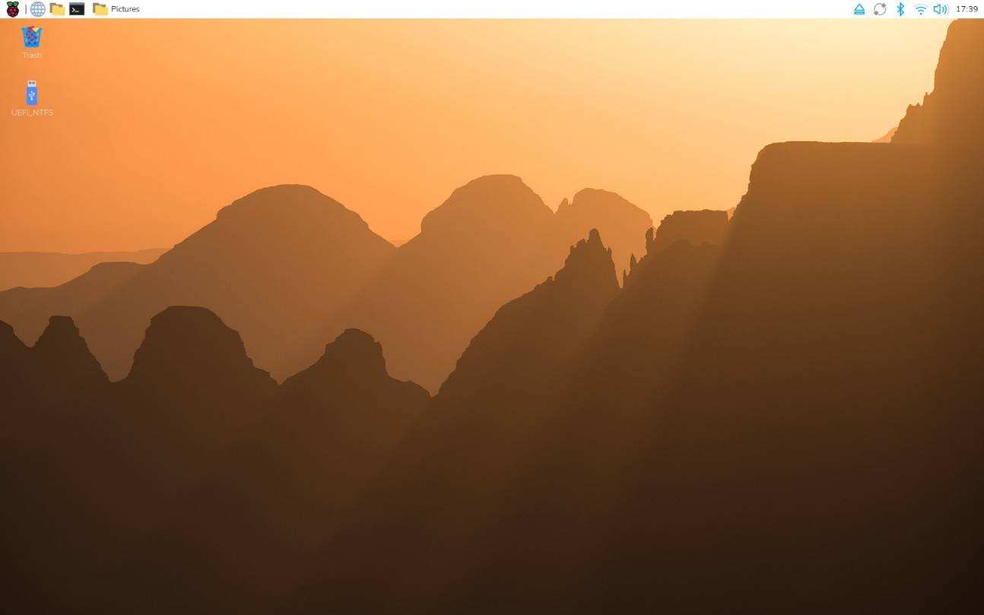
- Make sure the camera is connected and recognized by the Pi.
rpicam-still -o test.jpg
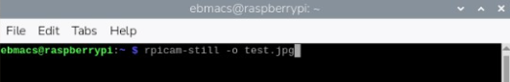
you will get test.jpg in home/ebmacs
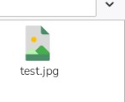
4. Run YOLOv5 Detection
- Open Terminal on the Raspberry Pi.
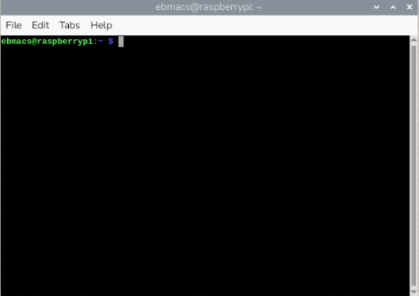
- Activate your YOLO environment:
source ~/yolo_env/bin/activate
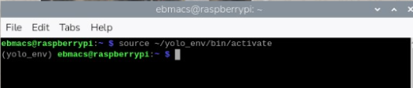
- Navigate to the YOLOv5 project folder:
cd ~/yolov5
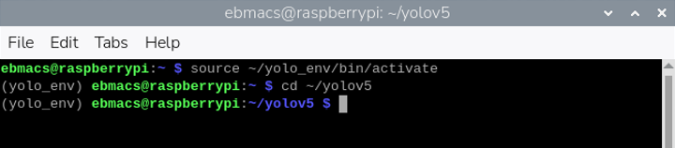
- Run the detection script:
python detect7.py --weights /home/ebmacs/model/best.pt --source 0
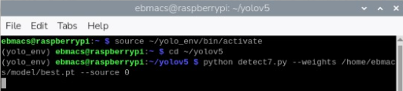
Your camera stream should start, and YOLOv5 will detect pollen bees as per your trained model.
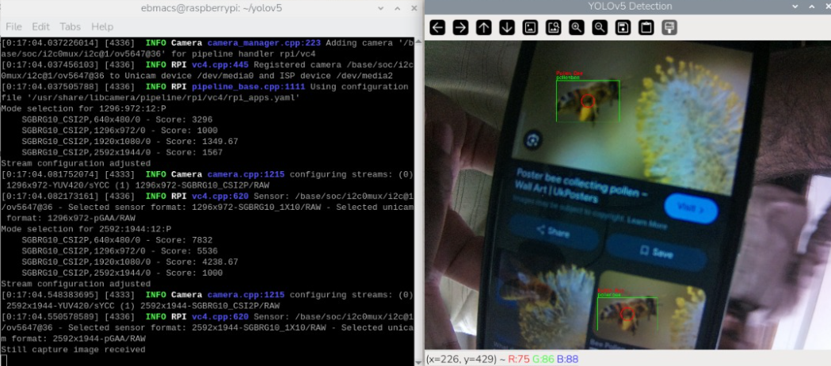
Make sure these two file are available
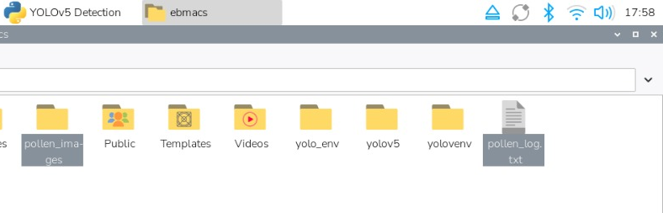
By opening pollen_log.txt you see:
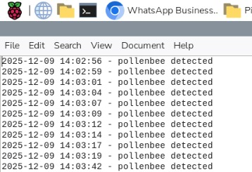
By opening pollen_images you see the images of detected pollen_bees
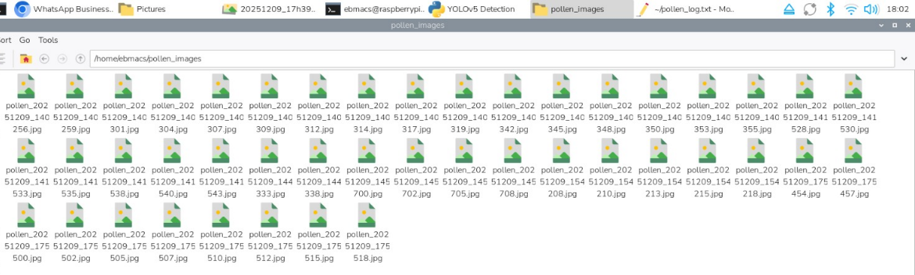
One of the image:
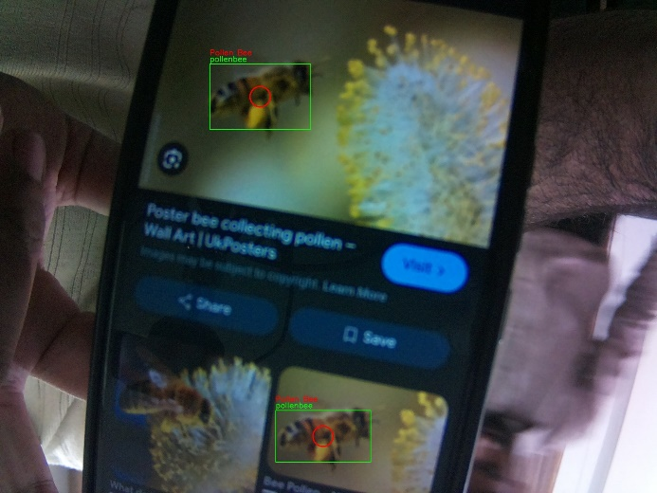
Press CTRL+C to stop detection

