1) Component List
Mandatory Components
- ESP32 Dev Board
- Ultrasonic Sensor (HC-SR04)
- Humidifier / Mist Module (with digital control pin)
- 5V power for ESP32
- Voltage Divider for ECHO pin
- 1 kΩ resistor
- 2 kΩ resistor
- Jumper wires

2) Connections

Ultrasonic Sensor HC-SR04
HC-SR04 Pin | ESP32 Pin
VCC | 5V
GND | GND
TRIG | GPIO 27
ECHO | GPIO 26

Humidifier Module
Humidifier Pin | ESP32 Pin
SIGNAL | GPIO 25
GND | GND
VCC | 5v
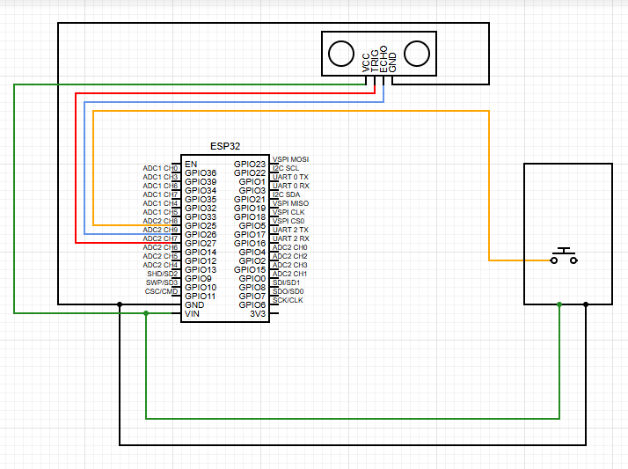

3) Code
#define TRIG 27
#define ECHO 26
#define HUMIDIFIER 25

unsigned long lastPing = 0;

// states for humidifier sequence
bool sequenceRunning = false;
unsigned long seqTimer = 0;
int seqStep = 0;

void setup() {
Serial.begin(115200);

pinMode(TRIG, OUTPUT);
pinMode(ECHO, INPUT);
pinMode(HUMIDIFIER, OUTPUT);

digitalWrite(HUMIDIFIER, HIGH); // idle = HIGH
}

// FAST ultrasonic
int getDistanceFast() {
long duration;

digitalWrite(TRIG, LOW);
delayMicroseconds(2);
digitalWrite(TRIG, HIGH);
delayMicroseconds(8);
digitalWrite(TRIG, LOW);

duration = pulseIn(ECHO, HIGH, 20000);

if (duration == 0) return -1;
return duration * 0.034 / 2;
}

// -------------------------
// HUMIDIFIER SEQUENCE
// -------------------------
void triggerHumidifierSequence() {
if (sequenceRunning) return;

sequenceRunning = true;
seqStep = 1;
seqTimer = millis();
}

// non-blocking sequence handler
void updateHumidifierSequence() {
if (!sequenceRunning) return;

unsigned long now = millis();

switch (seqStep) {

case 1: // FIRST SIGNAL (ON)
digitalWrite(HUMIDIFIER, LOW);
if (now - seqTimer >= 100) { // 0.1 sec
digitalWrite(HUMIDIFIER, HIGH);
seqStep = 2;
seqTimer = now;
}
break;

case 2: // WAIT 0.9 sec before second signal
if (now - seqTimer >= 900) {
digitalWrite(HUMIDIFIER, LOW);
seqStep = 3;
seqTimer = now;
}
break;

case 3: // SECOND SIGNAL (closing soon)
if (now - seqTimer >= 100) {
digitalWrite(HUMIDIFIER, HIGH);
seqStep = 4;
seqTimer = now;
}
break;

case 4: // WAIT 0.1 sec before final close pulse
if (now - seqTimer >= 100) {
digitalWrite(HUMIDIFIER, LOW);
seqStep = 5;
seqTimer = now;
}
break;

case 5: // THIRD SIGNAL (closed)
if (now - seqTimer >= 100) {
digitalWrite(HUMIDIFIER, HIGH);
sequenceRunning = false; // done
}
break;
}
}

void loop() {

// ultrasonic ping every 15ms
if (millis() - lastPing >= 15) {
lastPing = millis();

int distance = getDistanceFast();

Serial.println(distance);

// Start sequence only if bee detected
if (distance > 0 && distance < 20 && !sequenceRunning) {
triggerHumidifierSequence();
}
}

// update humidifier state machine
updateHumidifierSequence();
}

Changes for Mist Timing.
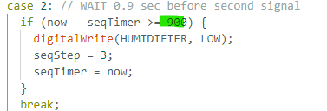
Now its set to 1 sec 900 mean 0.9 sec but 0.1 sec is closing time so if you want to increase then
1900 for 2 sec
2900 foe 3 sec
3900 for 4 sec ans soo on

