# Report

## Summary

The game is coded in python 3.8+. The main aim was to develop a console based game just like command and conquer but based on console operations. The very first operation of this game is showing the menu for interaction of user with the game. Menu contains options for navigation and actions separately. The player can interact with the game using this menu. In which player can check status at any time, buy some resources, attack to some enemy and save the game. The navigation menu contains navigation in 4 direction east, west, north and south. In these direction player can find loots and displayed immediately to the player. In the beginning if there is no save file present then the player is asked for the experience and name. If the player selects buy options then the buy function called which displays the player’s current balance and the list of available resources with their prices. Then players select the item to buy and if it is available the player is prompted to tell the number of items to buy then cost is calculated and check if it is less than equal to available money then player is displayed with the of buying the item and adding them to the player resources of if the costs goes above the balance then the player is displayed with the messages of not enough money. If the player selects status option then all the damages and available resources for the player is displayed in a proper format. If the player selects attack option then forces are traverse in any random direction and checks if the player versus enemy strength if the enemy has more strength then the chances of losing the attack is from 50% to 100 % and if the player has more strength then the wining chances are from 50% to 100%. If player selects the save and exit option then the game data currently in use is overwritten in JSON format in configuration file and on saving successfully the player is asked for exiting or not. In the navigation operations the user can select any direction and the chances of finding the loot are less the 20%.

## Development Problems

Problems faced during development are common block of any kind of development e.g. correct data structure to store data, correct steps to carry to make the program or script to run efficiently. Followings problems were faced during the development of this console based game:

### Data structure for saving the players data

If I stored the player’s data in array then it was difficulty to parse and save each time player runs the game or save it. So JSON was the good idea for this. I used JSON format data that is going to save in config.json file. This data structure uses keys and arrays mixture and can easily be parsed and saved.

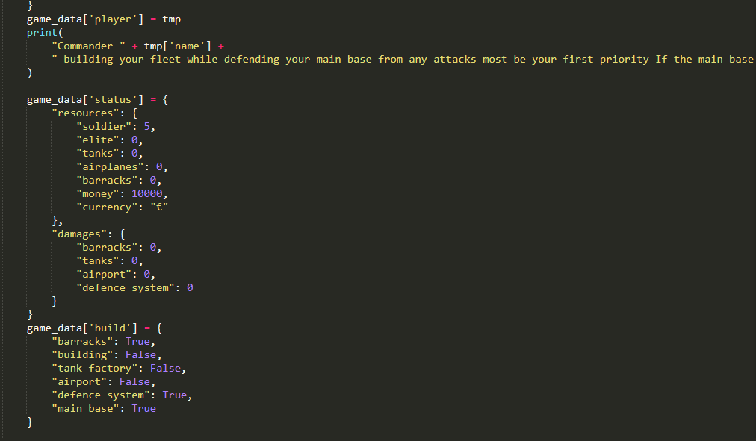

### Controlling the previous and new save data

This problem was faced when the previous data is already in file and player runs the game so I came up with a logic that check if the save file exists already the simply load all the JSON data to a variable. If the file not exists then the initialization function is called that asks the player for name and experience.

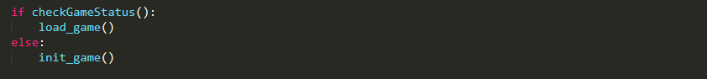

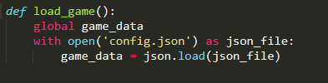

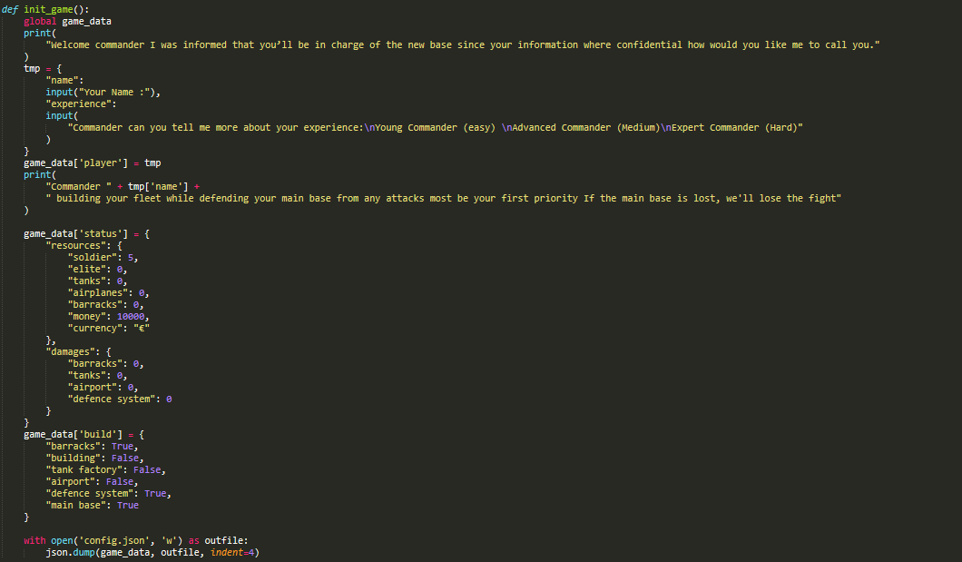

### Saving the Data that is currently in memory

The data is saved by overwriting the previous data of save file because the previous data as already loaded into the variable and used throughout the running of game.

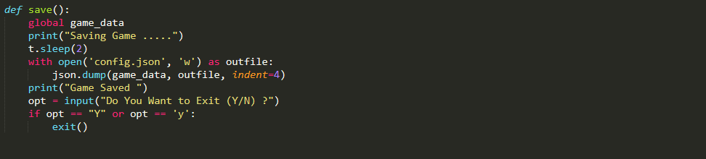

## How to run?

### Pre Requisites

Pre requisites are the software, modules or some libraries that required running some application. For example for running Chrome Browser we required internet connection.

For this program (game) only Python installed in the system and added to SYSTEM PATH. You can simply download and install it from the link (<https://www.python.org/>).

### Running

The following steps are used to run the code (make sure to install the pre requisites)

1. Navigate to the directory where you **main.py** file is located.

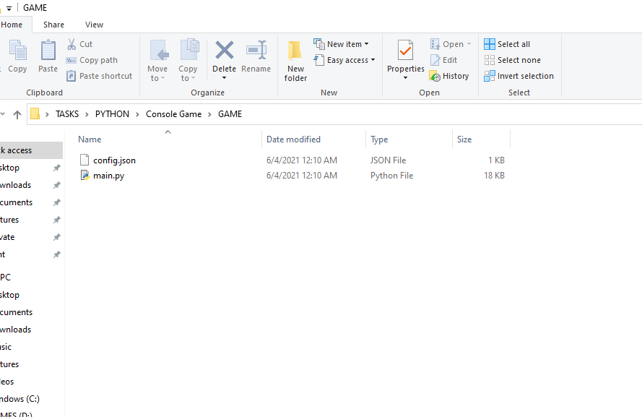

1. Then open the command prompt in that directory by simply writing **cmd** in top path bar.

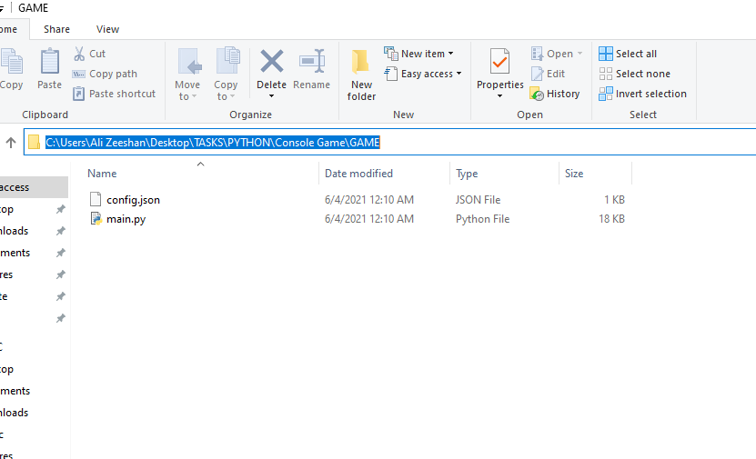

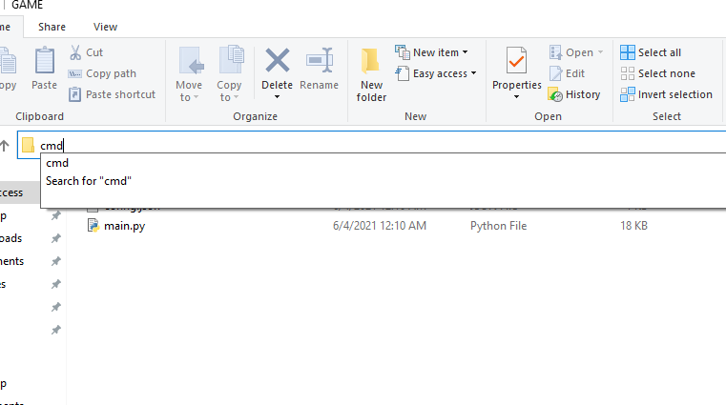

1. After opening the command prompt you, simply type the command **python main.py** to run the code.

