

CST3511 Internet Scale Applications and Development

BEng Computer Systems Engineering

Topic: Coursework 2 proposal

Student Names - MISIS:

Mohammad Sinan – M00696779

Divyangshu Patnaik – M00692938

Hassam Mahmood Khan – M00676112

Tutor : Jaspreet Singh

Date: 12th February 2021

Table of Contents

Introduction 3

Background 3

Network communication 4

Application approach 4

Design and Architecture 4

Game Architecture 4

UI/ Framework and features 4

API Gateway 7

Project methodology 7

Implementation 7

Tool and technique 7

Tools 7

Techniques 7

Gantt chart 8

Work breakdown structure 9

Four Field Map 9

Proposal statement 9

Resources 10

# Introduction

Quiz games have created a huge impact in the online world, considering the competitiveness between different individuals no matter what the age would imply. Conceptually trivia would deliver interest and additional curiosity from consumers in different sets of applicable media such as, television adverts and television shows regarding interactive questionnaires about common knowledge, however social trivia gaming improves an individual’s skill in cognitive learning. Hence retaining information with topics of interest which will improve mental capabilities, resulting towards greater interest to gaining more knowledge.

There will be a coverage on the description of the trivia gaming project, “Brain Mania,” the necessary framework towards network communication and application protocol will be illustrated to span out the proper visualization of the application, there will be a layout towards the management of the project through the display of a Gantt chart, a work breakdown structure and a four-field map.

# Background

The project entails a multiplayer feature throughout the network. Up to five people with the host inclusive is able to play the game by answering a random set of questions testing their knowledge within the selected topic of questions (i.e., animals, sports, books, and etc.). The game will consist of:

* A username creation page.
* A host/player role selection page.
* A host player page to set the rules (Selection of topics, time and amount).
* A private key login.
* Finally, the main trivia pages chosen at random.

A player that has earned the highest number of correct answers will be the winner. The main selection will feature a specific number of points stored within the randomly generated questions. Moreover, the project will feature a projection of the answers with the names of the participants. The host will also have the liberty to add more participants till the players maximum is reached which will be followed by an alert box notifying the Host, that they have reached the limit of players. The questions will hold a certain time limit for each question to test the participants of how quick they will be able to answer as well, failure to not answer will lead to no points added in the scoreboard. With the end of the game the scoreboard will appear allowing the participants to check their score.

The logic will include an API gateway which will be stored in the database in order to randomly project questions during the session, every correct answer will increment the score of the participant representing an algorithm to recognize the highest score a player has earned within every game. To improve on accuracy of the trivia a timer function and a scoreboard will be applied so that the players are notified with time is almost up or who has the highest score mid game.

# Network communication

## Application approach

To enable access to the game, a connection much be established from the game server to the host, hence generating a private key for 4 other players to join in the chosen domain. Five clients will have ceased modes of communication within the interface of the program, allowing data and messages to be transferred within the server. A collaboration between the constant functions of TCP (transmission control protocol) will be overseen along with the utilization of sockets to consolidate connection within the server and client. TCP, which is used in most applications has successfully transferred data reliably, as well as maintained in order. Since the protocol is heavily reliable and secure, such a connection is proven to gather less latency that a UDP connection or any other protocols. The fact that UDP is considered to be a “Light weight protocol,” the network will lack error control and flow control.

Sockets are one of the most suitable methods of connection due to the light weight messaging connectivity protocol which also utilizes TCP, which with pass data freely with minimal overhead once the connection is established, such a communication protocol has been utilized in scribble, kahoot and quizup for quicker and a rather quirkier environment to keep the user’s attention. The connection should also be used within a peer-to-peer communication.

# Design and Architecture

## Game Architecture

The opponents will be connected through internet using a security that will be generated by the host which will be shared amongst the players to play inside one game.

These users will be connected one sever and also to the database server which will generate real time questions from the API services.

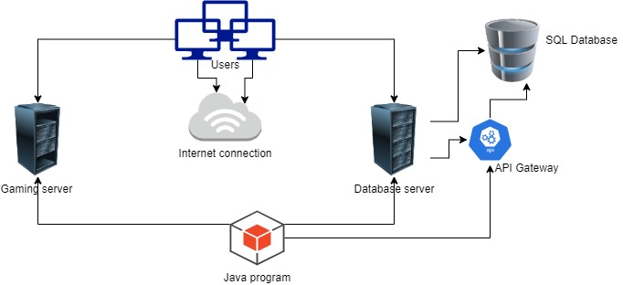

## UI/ Framework and features

Here is preview of the game on how it will be looking and will be also discussing the features of the game. The report will discuss the features of each screen of the game and its functionalities.

1. **Screen 1:** On this screen the player will be asked to enter his/her preferred name which will be shown on the opponent’s screen.

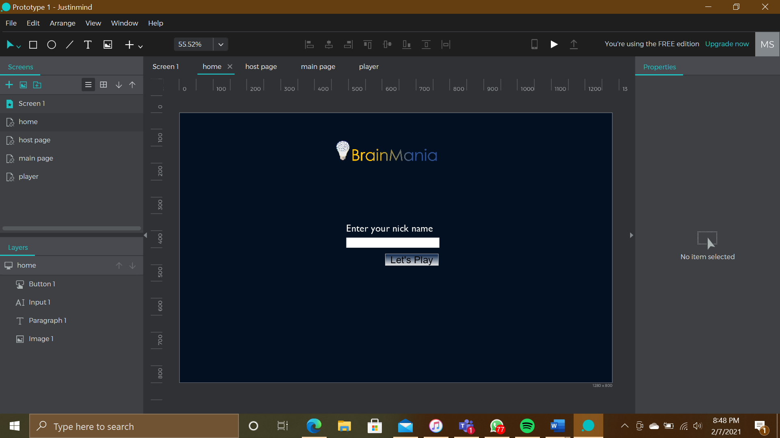

Screen 1

1. **Screen 2**: On this screen the player will be asked if he wants to host or enter the match directly.

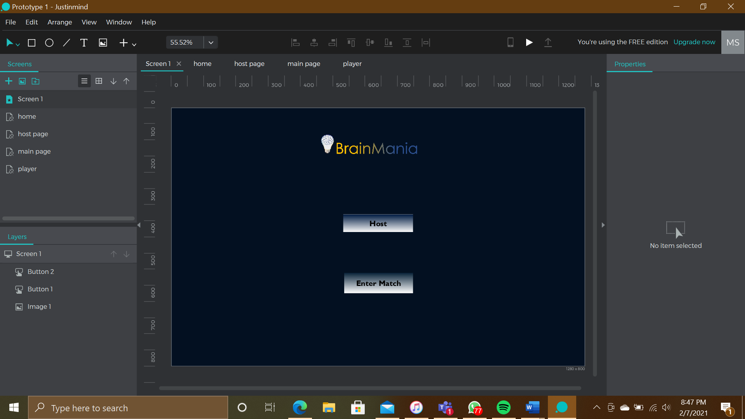

Screen 2

1. **Screen 3:** This screen is for hosting the match. The host will be asked to select the number of questions and the type of questions they want to play against the opponents. After clicking submit the application will generate a private key which should be shared to the opponents to play against each other.

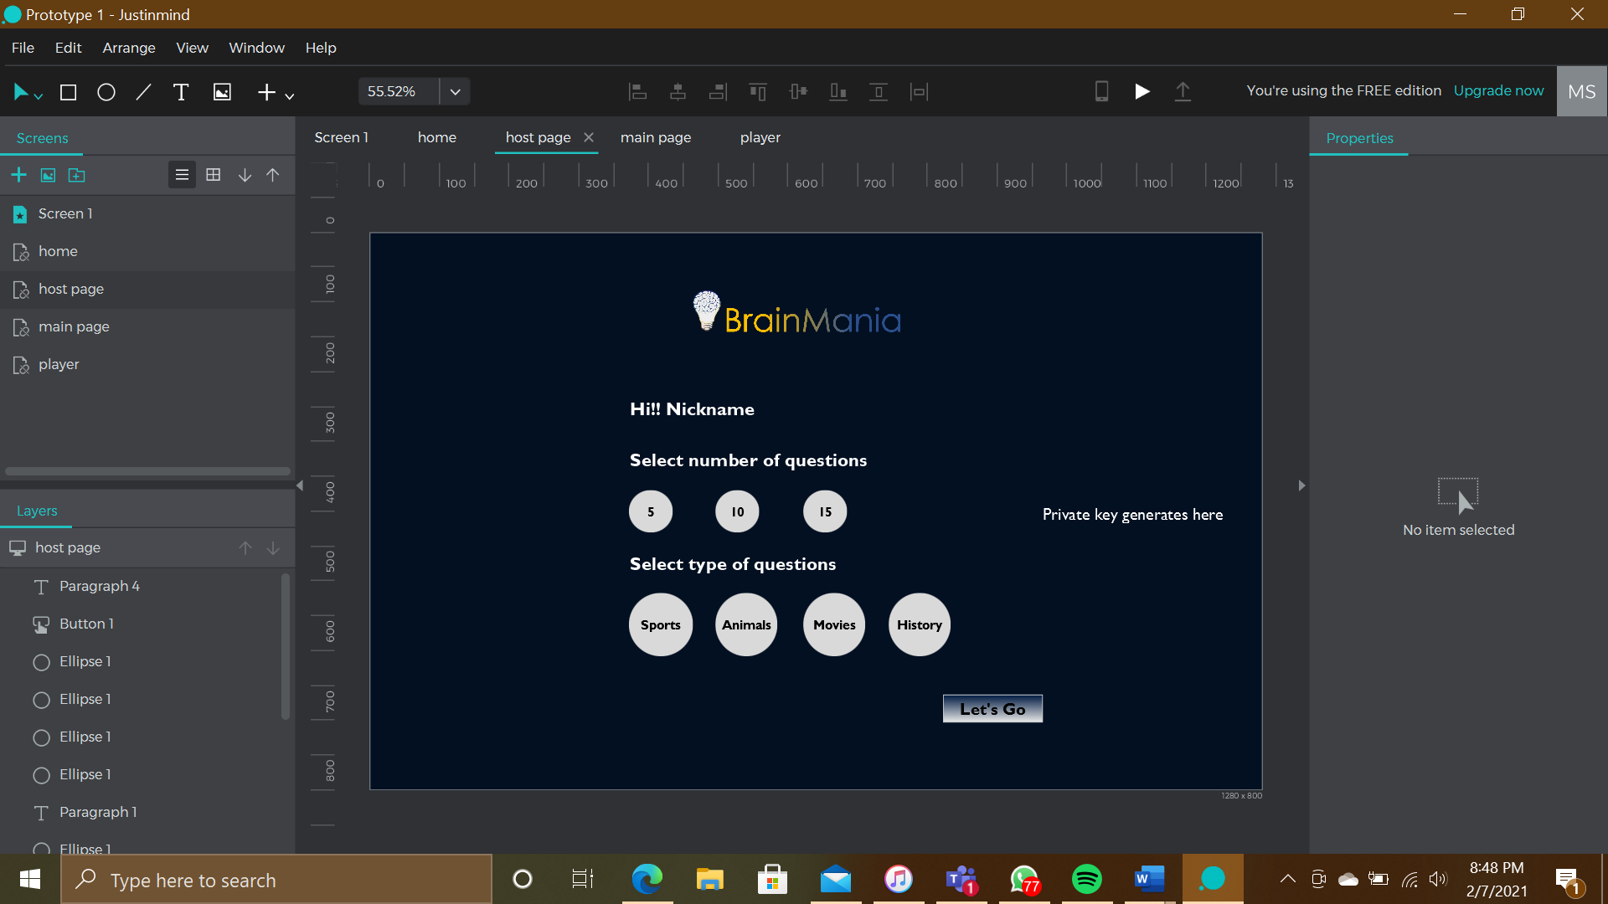

Screen 3

1. **Screen 4**: The opponent will the enter the private key generated by the host to enter the private match. There can be more than two players and a maximum of 5 players for a game.

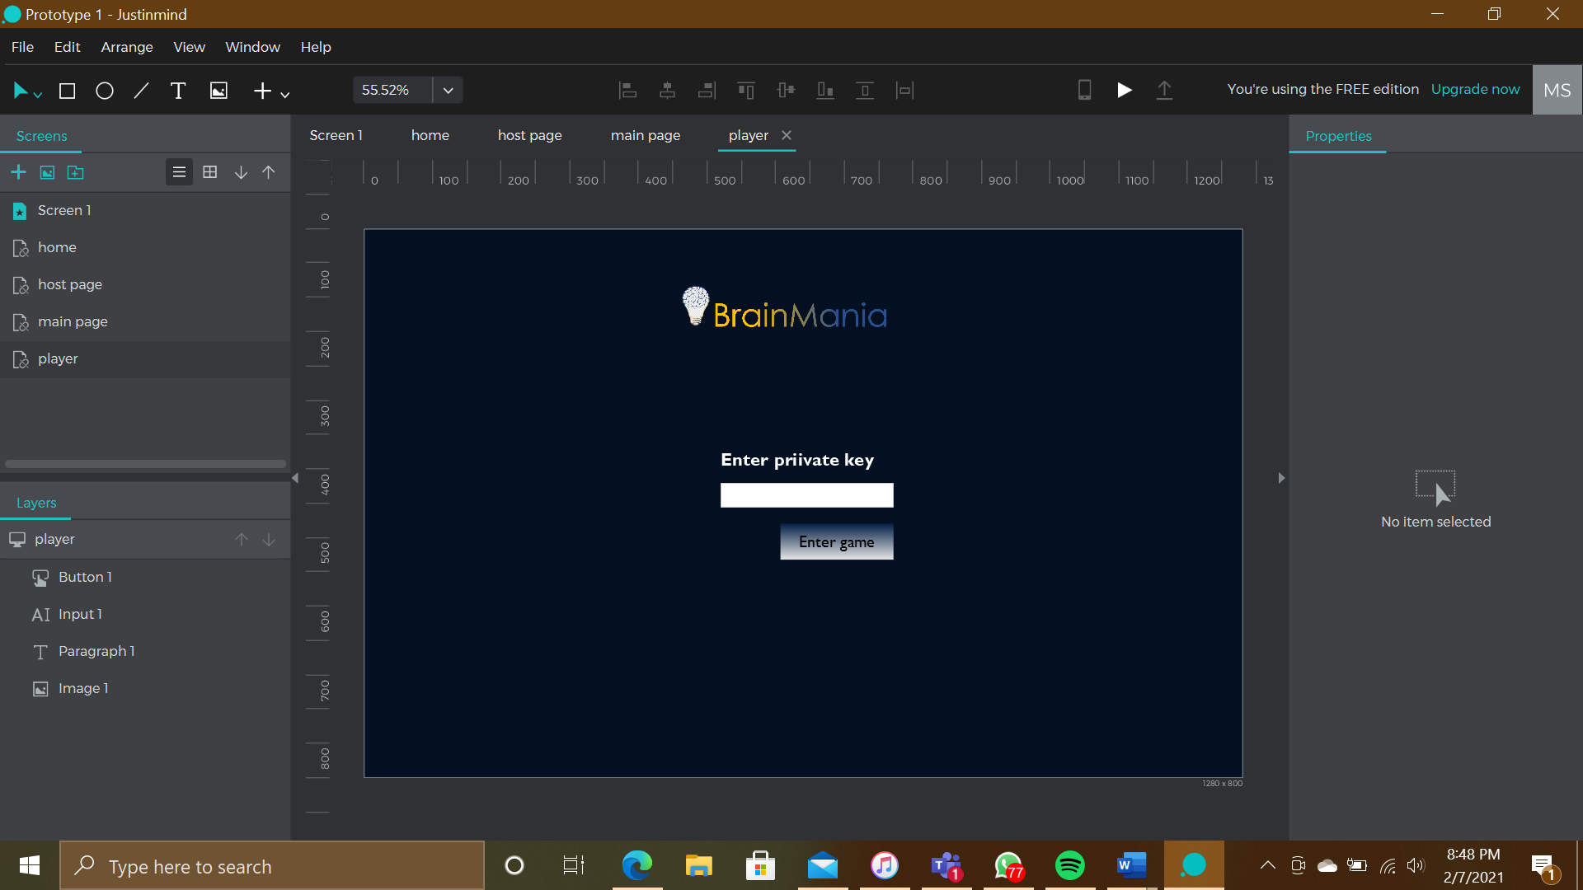

Screen 4

1. **Screen 5**: This questionnaire layout for the questions and four options to answer and a clock that triggers the players to answer fast.

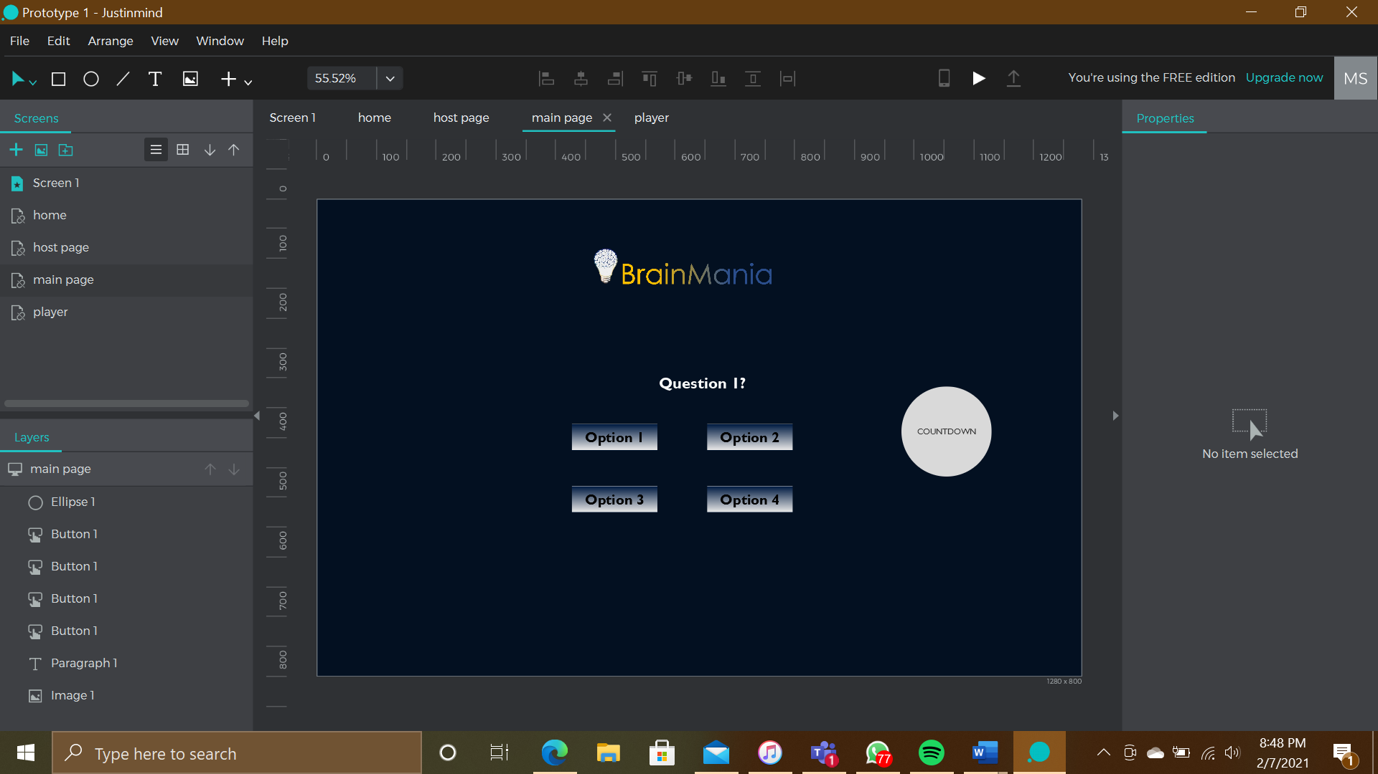

Screen 5

## API Gateway

The API will generate real time questions for the game depending on the topic and number of questions per game the questions generated will change. The questions will have four options to select from where one will be correct.

The API gateway will allow us to jumble questions and will generate questions on random making it less predictable for players.

We will be using the free API provided by open trivia database which consists of many topics and hundreds of questions that we need for the game.

# Project methodology

# Implementation

## Tool and technique

The following tools and techniques will be implemented:

## Tools

* NetBeans
* Draw.io
* MySQL/Derby database
* An API Gateway (Random generated series of questions of the game)
* Work Breakdown Structure
* Gantt Chart
* Four-field Map

## Techniques

* Multithreading
* Sockets/TCP IP connections
* JavaFX GUI programming
* API calling

Such tools and techniques will aid the project to fruition, completing the interface and functionalities.

## Gantt chart

The following scheduled project is shown in order to recognize production lines better. The project concerns:

* Research and Initialization
* Analysis and design
* Implementation
* Testing
* Finally, Maintenance

The visual display allows us to foresee the remaining tasks during the given time, so that we deliver the proper results accurately. The project phases have been determined through the start date and end date, which will be completed accordingly. The tool also shows the relationship and dependencies between each task. This will also give us visibility for accurate scheduling to finish the social trivia game “Brain Mania” prior the needed deadlines.

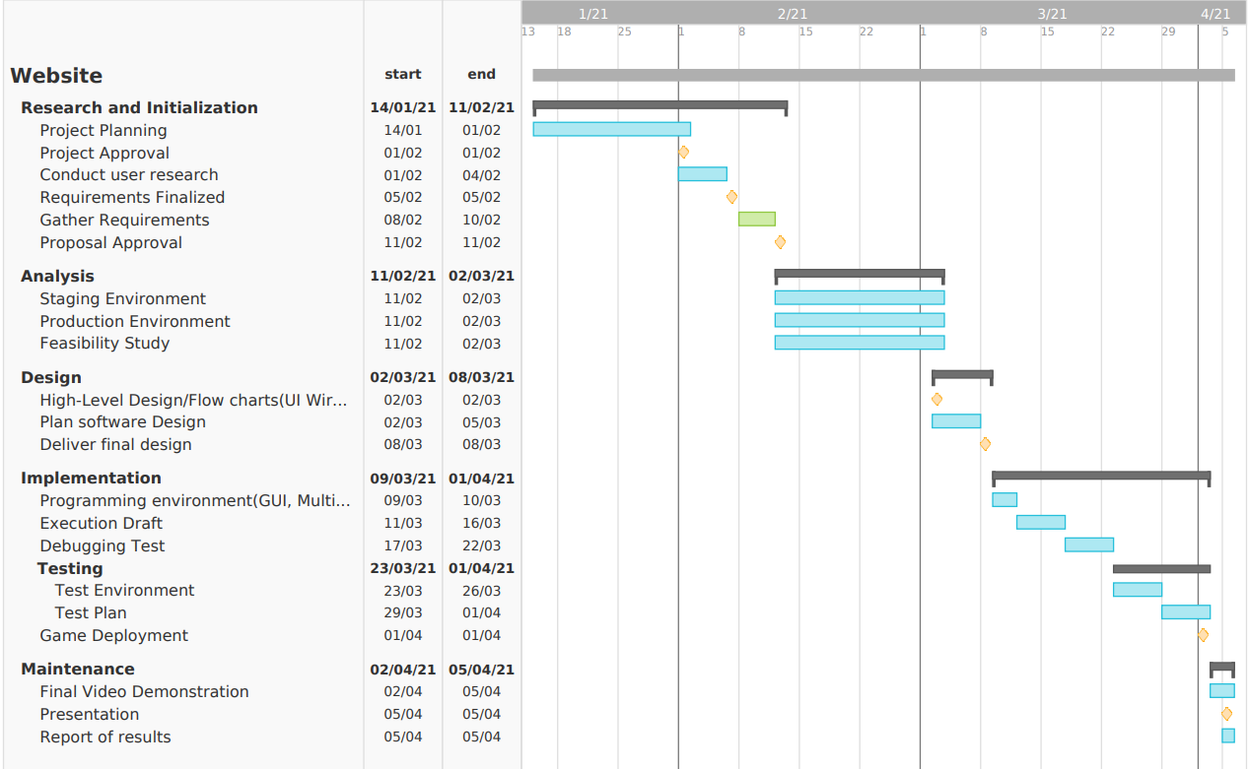

## Work breakdown structure

The work breakdown structure will explain briefly what all will be done to complete the project successfully.

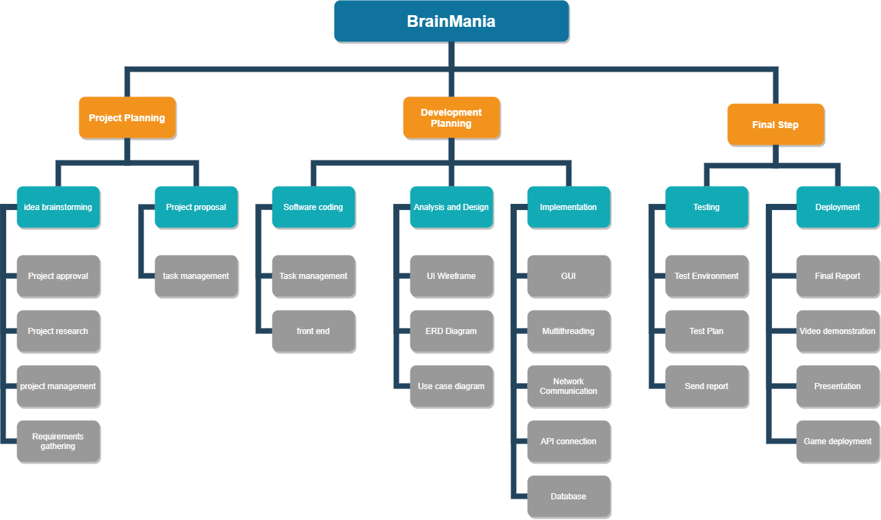

## Four Field Map

The four-field map will acknowledge how we will be working as a team.

|  |  |  |  |  |  |  |  |  |
| --- | --- | --- | --- | --- | --- | --- | --- | --- |
| **Team Member** | **Project planning** | | **Implementation** | | | | **Report** | |
| **Mohammed Sinan** | Idea brainstorming | Design and architecture | GUI | API Connection | Game Logic | Test plan | Final report | Video demo |
| **Divyangshu** **Patnaik** | Introduction and network communication | Multithreading | Test environment |
| **Hassam Khan** | Project methodology and management | Network communication |

# Proposal statement

For the project proposal all three members have contributed equally to complete the proposal before the submission date and has helped each other to tackle all kinds of hurdles. Now we all will be working as a team to complete and build a working game to submit by the end of the academic year.

Here is the list of members and percentage of contribution.

|  |  |  |
| --- | --- | --- |
| **Name of member** | **Percentage of contribution** | **Signature** |
| Mohammed Sinan | 33.33% |  |
| Divyangshu Patnaik | 33.33% |  |
| Hassam Mahmood Khan | 33.33% |  |

# Resources

Apm.org.uk. 2021. What Is A Gantt Chart? | Definition & Examples | APM. [online] Available at: <https://www.apm.org.uk/resources/find-a-resource/gantt-chart/> [Accessed 11 February 2021].

App.diagrams.net. 2021. *Flowchart Maker & Online Diagram Software*. [online] Available at: <https://app.diagrams.net/> [Accessed 11 February 2021].

Chang, M., Popescu, E., Kinshuk., Chen, N., Jemni, M., Huang, R., Spector, J. and Sampson, D., 2019. *Foundations and Trends in Smart Learning*. Singapore: Springer Singapore.

Corey Clark, P., 2021. Introduction to Game Network Programming. [online] Slideshare.net. Available at: <https://www.slideshare.net/CoreyClark/introduction-to-game-network-programming> [Accessed 11 February 2021].

DEV Community. 2021. Building a multiplayer game using WebSockets - Part 1. [online] Available at: <https://dev.to/sauravmh/building-a-multiplayer-game-using-websockets-1n63> [Accessed 11 February 2021].

Netbeans.org. 2021. *Creating a Web Connected, Multi-Player Mobile Game Using NetBeans - NetBeans IDE Tutorial*. [online] Available at: <https://netbeans.org/kb/71/javame/mobilegame.html> [Accessed 11 February 2021].

Opentdb.com. 2021. *Open Trivia DB*. [online] Available at: <https://opentdb.com/api_config.php> [Accessed 11 February 2021].

WhatIs.com. 2021. What is WebSocket? - Definition from WhatIs.com. [online] Available at: <https://whatis.techtarget.com/definition/WebSocket> [Accessed 11 February 2021].