**Type Shirt options**

1. Unisex 2.Female 3.Youth  
  
if “youth” is selected then these options will show for the type of garment would be

Short Sleeve Cotton T-shirt

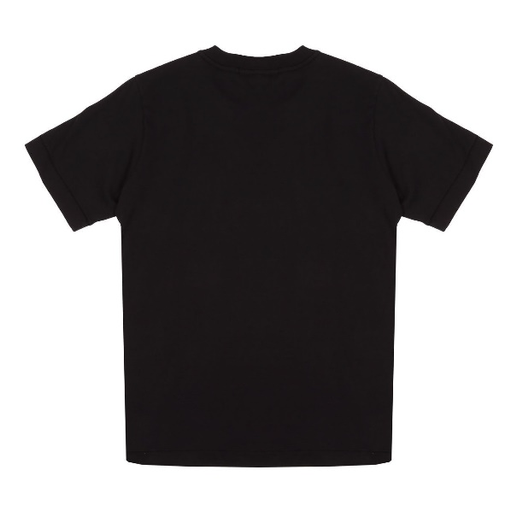

Long Sleeve Dry Fit

Short Sleeve Polo Dry Fit

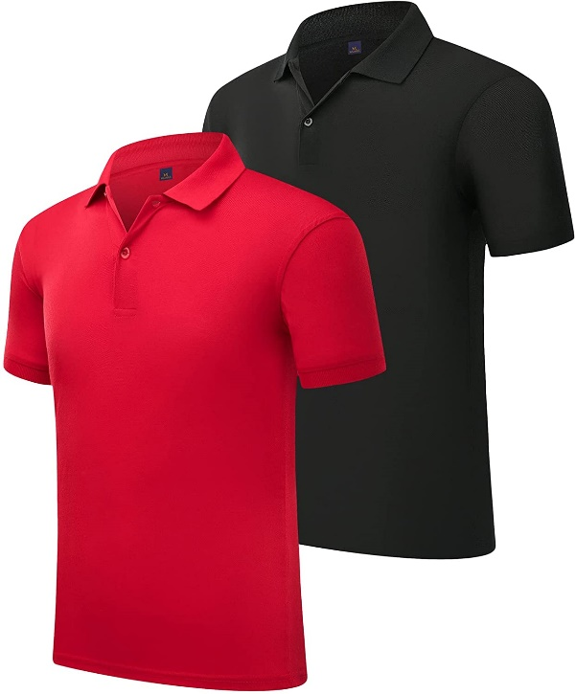

If “Short Sleeve Cotton T-shirt” is selected for youth then these will be the colors

Black White Red Royal

Pink Purple Kelly Green

If “Long Sleeve Dry Fit” is selected for youth then these will be the colors

Black White Red Royal

Pink Purple Kelly Green Neon yellow

Neon pink

If “Short Sleeve Polo Dry Fit” is selected for youth then these will be the colors

Black White Red Royal

Pink Purple Kelly Green Neon yellow

Neon pink

**Sizes for “Youth” are  
2t 3t 4t xs**

**Small medium large**

If “Unisex” is selected then these options will show for the type of garment would be

Short Sleeve Cotton T-shirt

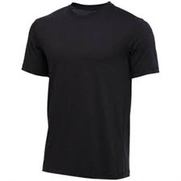

Long Sleeve Dry Fit (same as above) Short Sleeve Polo Dry Fit(same as above)

**Size if “Unisex” is selected**

**Small medium large xl**

**Xxl xxxl**

If “Female” is selected then these options will show for the type of garment would be

Baby Rib T-Shirt

Shot Sleeve Poly Dry Fit  
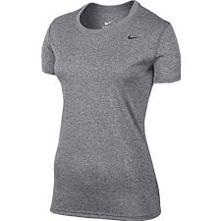  
**Sizes if “Female” is selected  
small medium large xl**

**xxl**

**If silhouette option is selected for any of the shirts then a color chart will pop up where they get to the amount of colors they want, if 1 color then they will be able to select 1 color, if 2 they will be able to select two colors.**

1 color

2 color

3 color

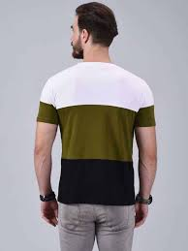

4 color

