Person of Interest
Campaign Name: 5.10.1 Exposed | Level Name: Exposed

Current Version: Ver.1.01.0000-2026.10.31.0000,0003 | Owned by Sherlock

Contact: sherlock@example.com | Escalate to: lead.designer@example.com



Contents | Overview  Finch (Who), exposed by Samaritan for one day (When), must escape across New York (Where) by stealth and his team's firefights (How), ending captured and resolved to destroy Samaritan (What).  Finch is killed or taken before the scripted capture; Reese or Shaw is downed in a firefight.  After Sotto Voce (5.09): Shaw's return exposes Finch; Elias is an ally.  Payphone call needs the Machine voice test from Subway Station.
  1 Overview 1  2 Context 2  2.1 Themes and Background 2  2.2 Characters 4  3 Mission Walkthrough 7  3.01 Last Coffee 7  3.02 Teaching a Voice 7  3.03 Number Up 8  3.04 Safe House Council 8  3.05 Elias's Tower 9  3.06 Temporary Resolutions 9  3.07 The Fall of Elias 10  3.08 Greer's Offer 10  3.09 Run the Gauntlet 11  3.10 Roadblock 11  3.11 Interrogation 12  3.12 The Machine Calls 12  4 Layout Plan Legends 13 | 4.1 Master 13  4.2 Surveillance & Cameras 14  5 2D Layout Plan 15  5.1 Overview 15  5.2 Café & Street 16  5.3 Subway Station 17  5.4 College Office 18  5.5 Safe House 19  5.6 Elias's Tower 20  5.7 Greer's Base 21  6 Flow 22  6.1 Main Flow 22  6.2 Temporary Resolutions (Reese & Fusco) 23  6.3 Breadcrumbs & Exploration Guidance 24  7 Beats 25  8 Battle Intensity 28  A Minor Modify List 31  B PO List 32

Context

Themes and Background

Themes
Exposure and loss: privacy, the cost of being seen, and losing the people you protect.  Principles under pressure: Finch abandons his rules and decides Samaritan must be destroyed.  Tone: quiet dread rising to frantic escape, then grief.
  

World Setting
Present-day New York watched by two rival artificial super-intelligences.
Samaritan sees almost everything; the Machine runs on limited, hidden hardware.
Hired killers from "Temporary Resolutions" and Greer's operatives hunt the team; police can be steered by Samaritan.

Background
Campaign  Finch built the Machine to predict violent crimes. Its rival Samaritan, run by John Greer, now controls the city's surveillance.  Previous level (Sotto Voce): the team hunts a negotiator; Shaw's return leaves a trail Samaritan can follow. | This Level  Samaritan identifies Finch. Elias is killed protecting him, Finch is captured, Root takes a sniper bullet meant for him and dies.  In custody Finch drops his principles and vows to kill Samaritan; the Machine calls him in Root's voice. | Following Levels  Next level (Synecdoche): the team, now without Root, starts its counter-attack on Samaritan.  The Machine keeps Root's voice for the rest of the campaign.

Characters
Harold Finch  Role: Playable lead / escort target  Creator of the Machine. Recognised at a café; spends the level evading, then captured. Delivers the interrogation soliloquy. | John Reese  Role: Playable gunfighter  Field operative. Protects Finch at the college office and safe house, then investigates Temporary Resolutions with Fusco. | Root  Role: Playable hacker / escort  The Machine's analog interface. Escapes with Finch from Greer's base and takes Blackwell's bullet.

Sameen Shaw  Role: Playable rear-guard  Deduces her return exposed Finch. Holds off Greer's men so Root and Finch can escape. | Lionel Fusco  Role: Support NPC / playable  Detective. Ambushed with Reese at Temporary Resolutions; brings the news of Root's death. | Carl Elias  Role: Ally NPC  Crime boss. Hides Finch in his tower; killed by a headshot while covering the escape.

John Greer  Role: Antagonist  Samaritan's operator. Wants Finch to work on Samaritan, by force if needed. | Jeff Blackwell  Role: Antagonist / sniper  Hitman who fires on the car from a rooftop, aiming for Finch.

Mission Walkthrough | Total Duration: 570-980s · 12 subsections

01 - Last Coffee (Cinematic)
Finch sits in a quiet café and talks to the Machine through a camera. He asks whether his friends will die too; the Machine does not answer.
A waitress greets him as a regular. Finch realises he has been identified and leaves.
Intensity: +1 | Duration: 35-60s

Sit at the window table (look at the camera to talk) [Rest: 20s]
Order a coffee, waitress greets Finch [Event: Recognised (20s)]
Leave through the back door before the street cameras sweep

02 - Teaching a Voice (Puzzle)
At the subway station Finch and Root discuss shutting the Machine down. Finch tests whether the Machine can choose its own voice and name.
Intensity: -1 | Duration: 50-90s

Talk to Root on the platform (optional: inspect the server racks) [Rest: 30s]
Voice puzzle: combine audio clips into a sentence the Machine can speak
Machine answers in a borrowed voice

03 - Number Up (Chase)
Reese and Root reach Finch's college office: his own number has come up. They leave seconds before the hitmen arrive.
Intensity: +3 | Duration: 40-70s

Reese and Root arrive, Finch's number is revealed [Event: Number comes up (85s)]
Grab the hard drive (optional: the photo of Grace)
Escape down the stairwell or the service lift [Battle: Campus Hit Squad (20s)]

04 - Safe House Council (Battle)
The team regroups. Shaw works out her return exposed Finch; Root reveals the self-defence program only Finch can trigger.
Hitmen breach the house; Elias leaves with Finch while the rest fight.
Intensity: +2 | Duration: 55-95s

Team conversation (chitchat with Shaw, Fusco and Elias) [Rest: 25s]
Root explains the self-defence program
Defend the safe house as Reese and Shaw [Battle: Safe House Breach (35s)]
Elias drives Finch away

05 - Elias's Tower (Puzzle)
Elias hides Finch in a high-rise. Finch realises the café was where he had his first date with Grace: Samaritan is tracking his past.
Intensity: -1 | Duration: 45-80s

Talk with Elias about old enemies [Rest: 30s]
Memory puzzle: match the café to Finch's past with Grace
Finch understands how Samaritan found him

06 - Temporary Resolutions (Battle)
Reese and Fusco follow the hitmen's employer, the company "Temporary Resolutions", and walk into an ambush.
Intensity: +3 | Duration: 60-100s

Search the office lobby and the client files (optional: CCTV room)
Ambush in the open-plan office [Event: Ambush sprung (230s)] [Battle: TR Office Ambush (45s)]
Escape through the archive

07 - The Fall of Elias (Battle)
Hitmen find the tower. Elias's men cover the escape, but Elias is shot in the head and Finch is captured.
Intensity: +3 | Duration: 50-90s

Elias's men hold the corridor [Battle: Tower Assault (35s)]
Elias is shot during the escape [Event: Elias killed (325s)]
Finch is captured (scripted)

08 - Greer's Offer (Battle)
Greer orders Finch to work on Samaritan. Root and Shaw storm the base; Shaw stays behind so Root and Finch can run.
Intensity: +2 | Duration: 70-120s

Greer's offer (dialogue) [Rest: 30s]
Root and Shaw assault the compound [Battle: Greer's Compound (60s)]
Shaw holds the line, Root takes Finch to the car

09 - Run the Gauntlet (Chase)
A long car chase through the city. Blackwell fires from a rooftop at Finch; Root blocks the shot and is wounded.
Playtest note: the chase now has a 10 s calm stretch before the sniper fires.
Intensity: +2 | Duration: 55-95s

Drive through Samaritan's camera net (optional: alternative alleys)
Rooftop sniper fire [Battle: Blackwell Overwatch (25s)]
Root is hit protecting Finch [Event: Root is hit (455s)]

10 - Roadblock (Cinematic)
A police roadblock ends the chase. Finch is arrested and Root is rushed to hospital.
Intensity: -2 | Duration: 25-40s

Car is boxed in at the roadblock [Rest: 25s]
Finch arrested, Root taken away

11 - Interrogation (Cinematic)
Finch is held for a treason charge from 1974. In the interrogation room he drops his principles and vows to kill Samaritan.
Intensity: -1 | Duration: 50-80s

Interrogation (branching dialogue) [Rest: 50s]
Finch's soliloquy

12 - The Machine Calls (Puzzle)
On the way to his cell Finch takes a call at a payphone. It is the Machine, speaking in Root's voice: Root has died. Finch asks for help; the power fails and the inmates escape.
Elsewhere Fusco tells Reese and Shaw that Root is dead.
Intensity: +2 | Duration: 35-60s

Answer the payphone [Event: Machine speaks as Root (560s)]
Ask the Machine for help
Power fails, cell doors open [Event: Prison blackout (560s)]
Cliffhanger: Reese and Shaw learn of Root's death

Layout Plan Legends | Last Update: 2026.10.26

Master

Surveillance & Cameras

2D Layout Plan
Overview | Last Update: 2026.10.26

Café & Street | Last Update: 2026.10.26

Subway Station | Last Update: 2026.10.26

College Office | Last Update: 2026.10.26

Safe House | Last Update: 2026.10.26

Elias's Tower | Last Update: 2026.10.26

Greer's Base | Last Update: 2026.10.26

Flow

Main Flow
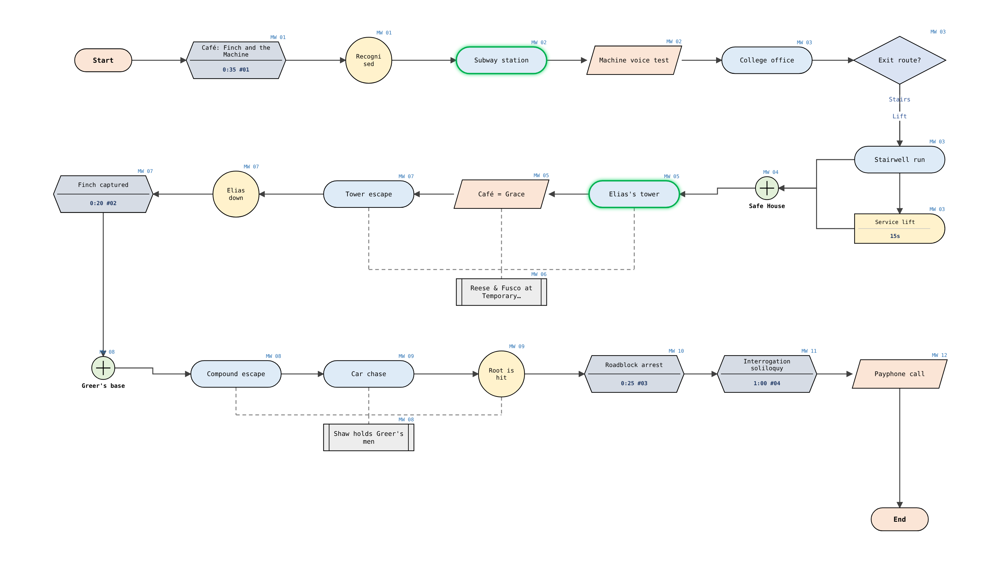

Temporary Resolutions (Reese & Fusco)
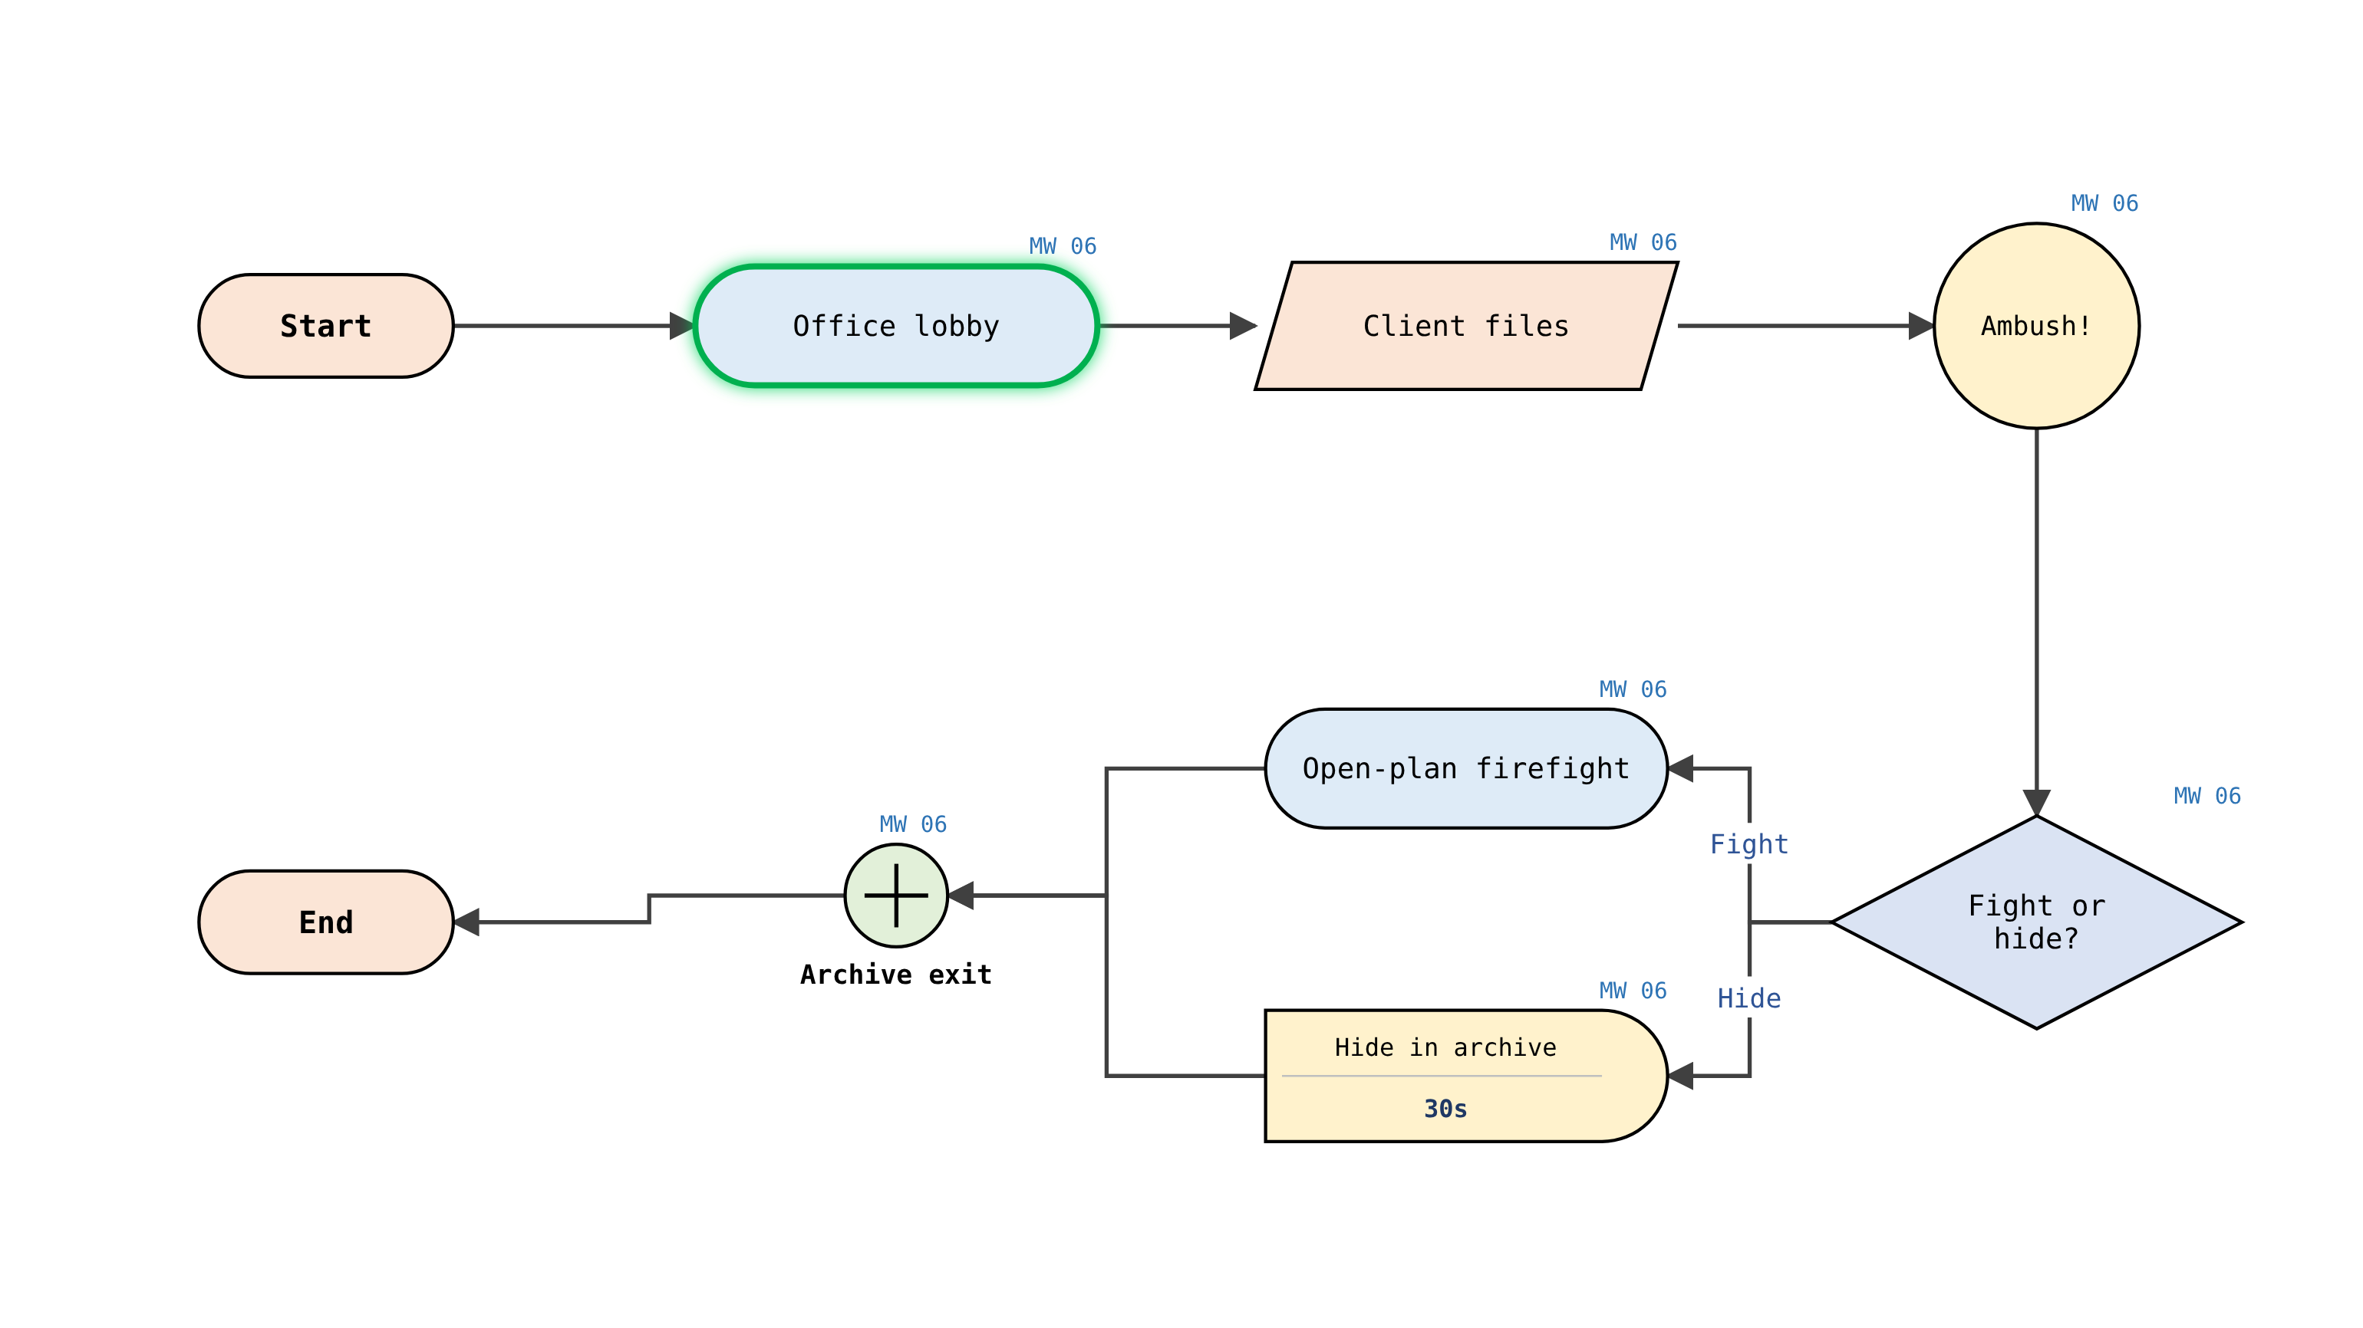

Breadcrumbs & Exploration Guidance
Café: the camera above the counter is the brightest object in the room, pulling the eye to where Finch must look to talk to the Machine. | Safe house: lamps are switched on room by room as the team moves Finch to the garage. | Elias's tower: emergency exit signs and Elias's men at each landing mark the escape route.

Greer's base: the open loading door and daylight lead Root to the car. | Chase: police lights and closed streets narrow the route towards the roadblock. | Prison: the ringing payphone is the only sound in the corridor and draws Finch to it.

Beats

Beats Chart (Time Based)
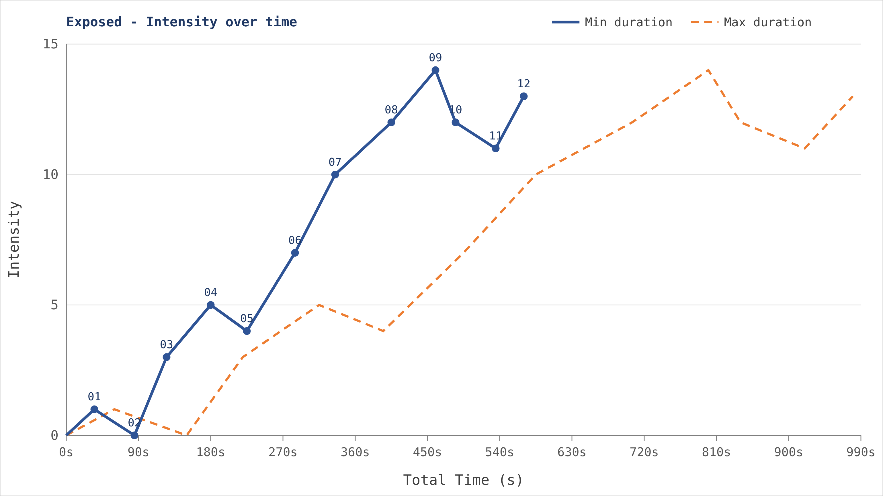

Beats Chart (Battle Based)
Shortest durations. A battle sets intensity to its combat unit estimate, events add their change, and time outside combat drops 2 every 30s.
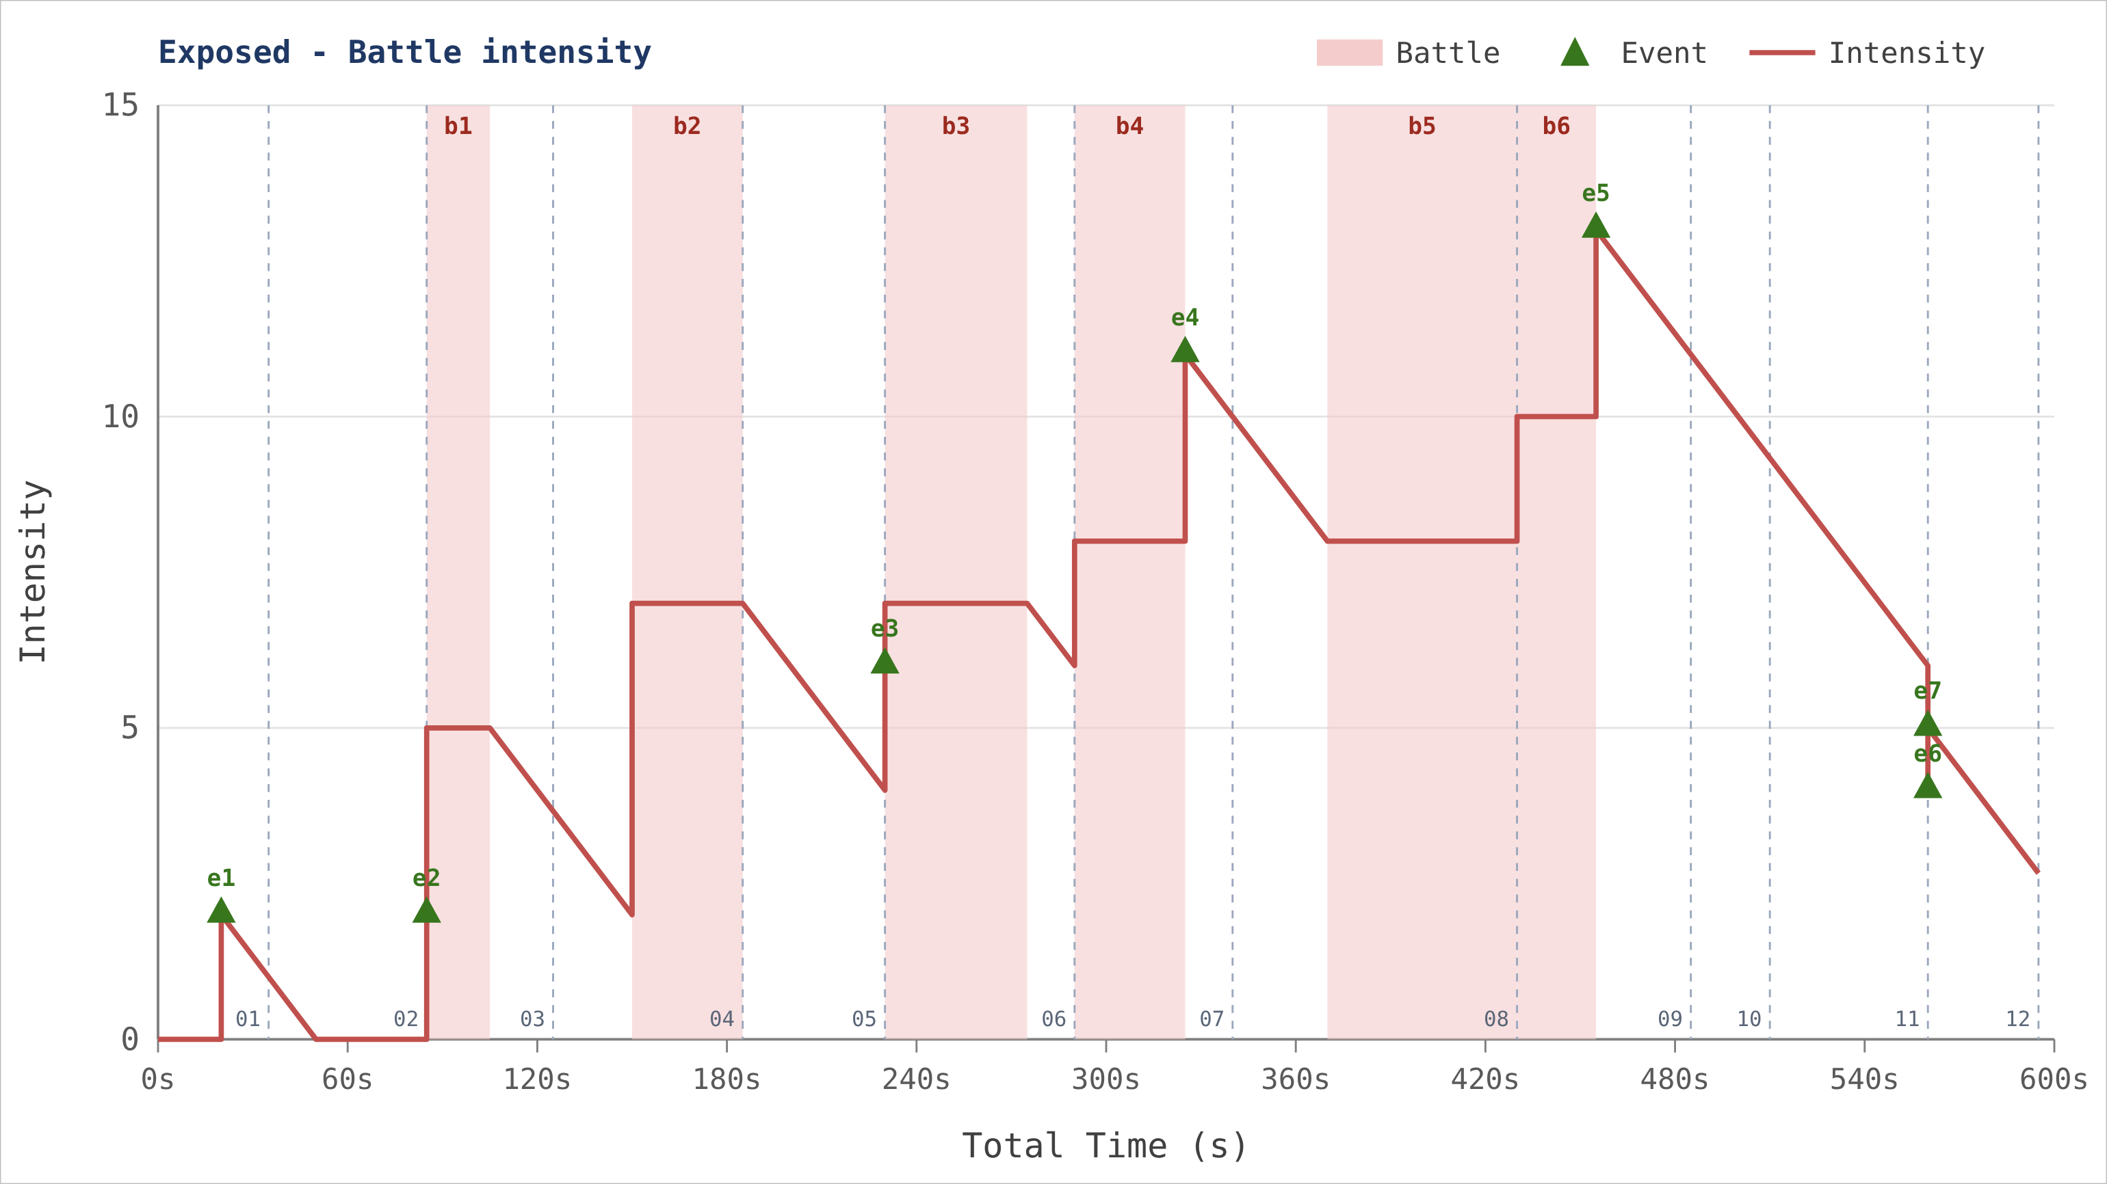

Beats Timeline
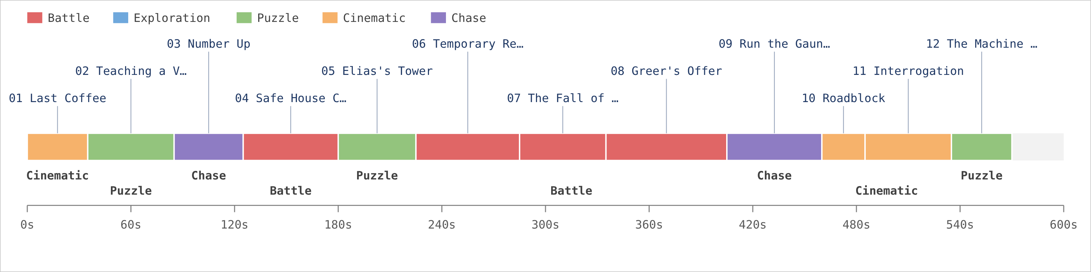

Battle Intensity

Enemy Types & Combat Units
Enemy types: Samaritan Operative · Temporary Resolutions Hitman · Greer Henchman · Sniper
No | Combat Unit | Enemies | Est. Intensity
b1 | Campus Hit Squad | Temporary Resolutions Hitman ×3 | 5
b2 | Safe House Breach | Temporary Resolutions Hitman ×3, Samaritan Operative ×1 | 7
b3 | TR Office Ambush | Temporary Resolutions Hitman ×5 | 7
b4 | Tower Assault | Samaritan Operative ×4, Temporary Resolutions Hitman ×2 | 8
b5 | Greer's Compound | Samaritan Operative ×6, Greer Henchman ×3 | 8
b6 | Blackwell Overwatch | Sniper ×1, Samaritan Operative ×2 | 10

Events & Defaults
No | Event | Intensity Change
e1 | Recognised | +2
e2 | Number comes up | +2
e3 | Ambush sprung | +2
e4 | Elias killed | +3
e5 | Root is hit | +3
e6 | Machine speaks as Root | -2
e7 | Prison blackout | +1

Natural decay: -2 every 30s outside combat

Battle & Event Frequency by Brief
Count of each combat unit (red) and event (green) per Mission Walkthrough subsection.
Type | 01 | 02 | 03 | 04 | 05 | 06 | 07 | 08 | 09 | 10 | 11 | 12
b1 Campus Hit Squad |  |  | 1
b2 Safe House Breach |  |  |  | 1
b3 TR Office Ambush |  |  |  |  |  | 1
b4 Tower Assault |  |  |  |  |  |  | 1
b5 Greer's Compound |  |  |  |  |  |  |  | 1
b6 Blackwell Overwatch |  |  |  |  |  |  |  |  | 1
e1 Recognised | 1
e2 Number comes up |  |  | 1
e3 Ambush sprung |  |  |  |  |  | 1
e4 Elias killed |  |  |  |  |  |  | 1
e5 Root is hit |  |  |  |  |  |  |  |  | 1
e6 Machine speaks as Root |  |  |  |  |  |  |  |  |  |  |  | 1
e7 Prison blackout |  |  |  |  |  |  |  |  |  |  |  | 1

Appendix A - Minor Modify List
Version | Section | Reason (Issue / Feedback) | Before | After | Change Notes
Ver.1.01.0000-2026.10.31.0000,0003 | 3.04 | Issue #48 | 04 Safe House Council › Player actions  Team conversation (chitchat with Shaw, Fusco and Elias) !(25) Root explains the self-defence program Defend the safe house as Reese and Shaw !(b2,40) Elias drives Finch away | Team conversation (chitchat with Shaw, Fusco and Elias) !(25) Root explains the self-defence program Defend the safe house as Reese and Shaw !(b2,35) Elias drives Finch away | Combat pacing pass after lead review
Ver.1.01.0000-2026.10.31.0000,0003 | 8.1 | Issue #48 | Combat unit b2  Safe House Breach · Temporary Resolutions Hitman ×4, Samaritan Operative ×1 · intensity 7 | Safe House Breach · Temporary Resolutions Hitman ×3, Samaritan Operative ×1 · intensity 7 | Combat pacing pass after lead review
Ver.1.01.0000-2026.10.31.0000,0003 | 8.1 | Issue #48 | Combat unit b6  Blackwell Overwatch · Sniper ×1, Samaritan Operative ×2 · intensity 9 | Blackwell Overwatch · Sniper ×1, Samaritan Operative ×2 · intensity 10 | Combat pacing pass after lead review
Ver.1.00.0001-2026.10.31.0000,0002 | 3.09 | Feedback PT-12 playtest | 09 Run the Gauntlet › Description  A long car chase through the city. Blackwell fires from a rooftop at Finch; Root blocks the shot and is wounded. | A long car chase through the city. Blackwell fires from a rooftop at Finch; Root blocks the shot and is wounded. Playtest note: the chase now has a 10 s calm stretch before the sniper fires. | Chase felt too short before the sniper beat
Ver.1.00.0001-2026.10.31.0000,0002 | 3.09 | Feedback PT-12 playtest | 09 Run the Gauntlet › Duration min  50 | 55 | Chase felt too short before the sniper beat
Ver.1.00.0001-2026.10.31.0000,0002 | 3.09 | Feedback PT-12 playtest | 09 Run the Gauntlet › Duration max  90 | 95 | Chase felt too short before the sniper beat

Appendix B - PO List

Paint-over review entries. Newest first.
Version | PO Image | Before | After | Reason | Location
Ver.1.00.0001-2026.10.31.0000,0002 |  |  |  | Sniper rooftop not readable from the car; add a glint and a crane silhouette. | Chase route, Lexington Ave rooftop (grid F7)
Ver.1.00.0001-2026.10.31.0000,0002 |  |  |  | Stairwell too dark; players missed the exit sign. | College Office, stairwell B (grid C4)

