Joel Youngberg

CIS 17C Project

BOGGLE Game

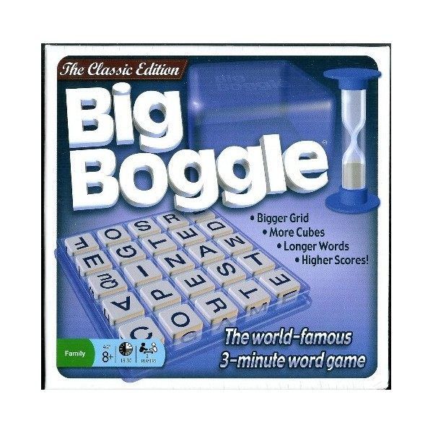

**Boggle Rules: How to Play**

**The Boggle Round**

All Boggle players should start the game with a pen or pencil and some paper. The Boggle cube, filled with the Boggle dice and closed with the cover, is shaken to redistribute the letters. The Boggle dice are then settled so that they lie flat. Once the Boggle timer is turned over and all players can see the Boggle board, the round begins.

During the Boggle round, players try to find as many words as possible of three or more letters each and write them on their piece of paper (hiding them from other Boggle players). The words must only use a single letter on the Boggle board once (unless it appears twice- having more than one die with an "s" on it, for example), and all letters in the word must be connected on the Boggle board horizontally, vertically, or diagonally. Once the Boggle timer runs out, all players must put their pens/pencils down after finishing the one word they were writing.

**Boggle Scoring**

After time is called, Boggle players take turns (in a clockwise circle) reading the words they wrote down. If another player or players have the same Boggle word, all players with that word must cross it out (ie. no points are to be gained). Only unique words receive points in Boggle.

If a player reads off a word which another player thinks may not be a valid Boggle word (because it isn't a real word, or is slang, etc.), you can either use a dictionary as the deciding factor or all players can vote on it. If it is decided that the word is not a valid Boggle word, the player who read the word must subtract points equal to what they would have gained from the word. There is NO penalty in Boggle for writing down an invalid Boggle word. It's only a problem if the Boggle player decides to read the word during the scoring period.

Each Boggle round a different player should be the first one to read his/her Boggle words. The reason is that it is an advantage to be the last one to read your Boggle list. If you wrote down an invalid Boggle word that someone else already lost points for, for instance, then you will know not to read that word!

Boggle players receive one point for each unique three or four letter word (that no other player wrote down). For words over four letters long, players receive one point plus one additional point for each letter over four. So, for example, a six letter word in Boggle would be worth three points. One point for the first four letters and then two points for the fifth and sixth letters. Words less then three letters receive no points in Boggle.

Plural words ("game" versus "games") and words of different tenses ("play" versus "played") are all valid Boggle words individually.

Once all Boggle players read their words, they announce their scores to the group. Boggle can either be played round by round (ie. there's an individual winner for each Boggle round separate from other rounds), or a cumulative score can be kept to have one overall Boggle winner at the end of the game.

My Implementation boggle utilizes a two dimensional vector and a list. The two dimensional vector of chars represents the playing board, and is generated from random integers between 60-90 being casted into the uppercase letters that the ASCII values between 60-90 represent. After making the list of words that a player finds within the game, the program then takes the list and validates the words against a dictionary list of over 100,000 English language words. During that validation, a point is added to the player’s score for each word that is matched in the dictionary. The tolower function is utilized to make sure that the words entered are not case sensitive during the dictionary match.

I am currently working on a validation algorithm that checks to make sure the words entered by the user are actually valid found words. This algorithm could also be used to create an AI for the game for players to play against. Both of these are my ideas for expansion of this project further.

I still have a lot to do on this project, but I feel I have made a good start on it.