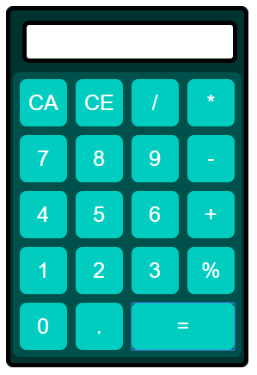James Fearnleys Calculator

Brief Description of The App:

This app implements a simple calculator using javascript to run the input of numbers and operators, determing sums, and to be able to clear some or all of the input. There is a screen for output and big buttons for input.

Description of the 5 implemented event handeling features:

1. Onclick number: clicking this button element triggers information to the javascript function ‘insert’ which places the number into the display (which is a form). This also places the number into the variable ‘sum’ .

2. Onclick operator: clicking this button element triggers information to the javascript function ‘insert’ which places the operator into the display (which is a form). This also places the operator into the variable ‘sum’ .

3. Onclick clear entry: clicking this button element triggers information to the javascript function ‘clear entry’ function which subtracts -1 the length of the var sum displayed in the ‘displaybox.

4. Onclick clear all: clicking this button element triggers information to the javascript function ‘clear all’ funciton which replaces the ‘document.form.displaybox.value;’ with an empty “”.

5. Onclick equals: clicking this button element triggers information to the javascript function ‘equal’ which uses the javascript built in function ‘eval’, once the sum is ‘eval’ it is displayed in the ‘displaybox.

Test Cases:

Issues found:

1. Being able to close the app using a function.
2. Decimal rounding
3. JS code not working

Issues Resolved:

1. Issue one was not resolved because JavaScript does not allow this action since 2016.
2. Unable to fix. I found out that the eval() creates a string output, I managed to parse this string output to a float but then could not figure out how to then include Math.round() into the function.
3. Fixed by moving ‘ to the correct place.