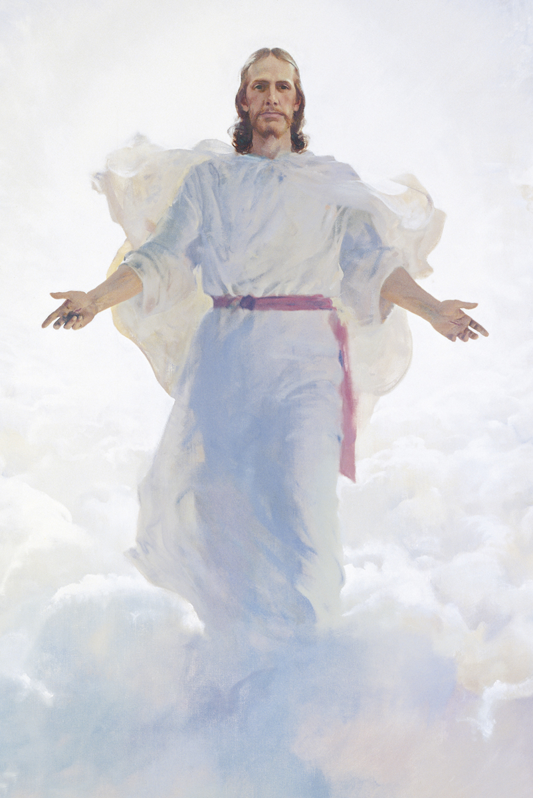
Ward Leadership Directory
Front cover image: "The Resurrected Jesus Christ," by Harry Anderson:
https://www.lds.org/media-library/images/the-second-coming-39621?lang=eng.
Bulletin created with LibreBulletin: https://github.com/ElectricRCAircraftGuy/LibreBulletin.
Welcome to
The Church of Jesus Christ
of Latter-day Saints
Name of Ward

Sacrament Meeting Bulletin
October 14, 2018

9999 Chapel Blvd.,
City, TX 99999

Bishop | John Doe | 111-111-1111
1st Counselor | Alex Albert | 222-222-2222
2nd Counselor | Billy Bob | 333-333-3333
Ward Clerk | Camden Cookie | 444-444-4444
Executive Secretary | Dilbert Dalton | 555-555-5555
Relief Society President | Edwina Enigma | 666-666-6666
Elders Quorum President | Edward Eldon | 777-777-7777
Young Men President | Frank Franklin | 888-888-8888
Young Women President | Fannie Flowers | 999-999-9999
Primary President | Aunt Jemima | aaa-aaa-aaaa
Sunday School President | Goldilocks Goodwin | bbb-bbb-bbbb
Ward Mission Leader | Henry Hopper | ccc-ccc-cccc
Full-Time Missionaries | Sisters Hylda & Hedwig  Elders Illinois & Iliad | ddd-ddd-dddd  eee-eee-eeee
Ward Bulletin Coordinator | See bottom of Announcements pg.
For the complete ward directory please log in to your LDS account at www.lds.org, or use the LDS Tools App on your phone. If you don’t have an LDS account, ask the Ward Clerk for your membership number so you can create one.

Missionaries from our Ward
Elder First Last  9999 Street Name St.  City, TX 99999  email@myldsmail.net  Sister Soandso Soandso  1947 Far Away Place  Distant City, Strange Land  Unpronounceable Country  soandso.soandso@myldsmail.net | Elder First Last  9999 Street Name St.  City, TX 99999  email@myldsmail.net  Sister Soandso Soandso  1947 Far Away Place  Distant City, Strange Land  Unpronounceable Country  soandso.soandso@myldsmail.net

Announcements (Cont.)

Announcement Name – 4pm – 9:30pm 1 Oct.
These are the announcement details. Please sign up.

Announcement Name – 4pm – 9:30pm 2 Oct.
These are the announcement details. Please sign up.

Announcement Name – 4pm – 9:30pm 10 Oct.
These are the announcement details. Please sign up.

Name of Ward
Please send bulletin announcements to Bro. Gabriel Staples at myemail@gmail.com by 6:18pm every Thurs. evening. If you'd like to pick the front cover image, please email one to me and tell me in one sentence (to possibly be printed on the bulletin) why you like this image.
Sacrament Meeting

Presiding Bishop Bobby Blake
Conducting Carl Caddy, 2nd Counselor
Organist Daisy Daffodil
Chorister Emma Emmerson

Opening Hymn 131
“More Holiness Give Me”

Invocation Frank Flanders

Ward and Stake Business

Sacrament Hymn 196
“Jesus, Once of Humble Birth”

Administration and Passing of the Sacrament

Youth Speaker Gina Good

Speaker Zara Zarahemla

Intermediate Hymn 129
“Where Can I Turn for Peace?”

Speaker Nephi Sonofalma

Closing Hymn 304
“Teach Me to Walk in the Light”

Benediction Alma Theyounger

Announcements

Be sure to join our ward Facebook page! https://www.facebook.com/groups/999999.
Ward bulletins now available online! https://tinyurl.com/999999.

How can I find volunteer opportunities in my community?
Go to the church-sponsored website, www.JustServe.org, and get familiar with what opportunities exist in your city or neighborhood! JustServe.org is provided as a service by The Church of Jesus Christ of Latter-day Saints.

Announcement Name – 4pm – 9:30pm 18 Sept.
These are the announcement details. Please sign up. This section should contain the location, and may contain extra details, contacts, information, emails, tinyurls, etc etc. This section should contain the location, and may contain extra details, contacts, information, emails, tinyurls, etc etc. This section should contain the location, and may contain extra details, contacts, information, emails, tinyurls, etc etc.

Announcement Name – 4pm – 9:30pm 19 Sept.
These are the announcement details. Please sign up. This section should contain the location, and may contain extra details, contacts, information, emails, tinyurls, etc etc. This section should contain the location, and may contain extra details, contacts, information, emails, tinyurls, etc etc.

Announcement Name – 4pm – 9:30pm 21 Sept.
These are the announcement details. Please sign up. This section should contain the location, and may contain extra details, contacts, information, emails, tinyurls, etc etc.

Announcement Name – 4pm – 9:30pm 22 Sept.
These are the announcement details. Please sign up. This section should contain the location, and may contain extra details, contacts, information, emails, tinyurls, etc etc.

Announcement Name – 4pm – 9:30pm 23 Sept.
These are the announcement details. Please sign up. This section should contain the location, and may contain extra details, contacts, information, emails, tinyurls, etc etc.

Announcement Name – 4pm – 9:30pm 24 Sept.
These are the announcement details. Please sign up.

(Announcements Continued on Back Pg.)

Upcoming Church Cleaning Assignments
Coordinator: Mosiah King, 123-456-7890
- To enter the church building to clean, either coordinate with Mosiah King before-hand to have him let you into the building and open the two custodian closets, or coordinate to borrow keys from a member of the bishopric. The full schedule of cleaning assignments is here: https://tinyurl.com/9999.

Month | Day | Family | Family | Family
OCTOBER | 20 | X-ray | Yankee | Zulu
 | 27 | Yagi | Antennas | Aredirectional
NOVEMBER | 3 | Relief Society/SS/Ward Mission
 | 10 | Zener | Diodes | Avalanche
 | 17 | Raspberry | Banana | Pi
 | 24 | Arduino | Makeslearning | Fun
DECEMBER | 1 | Bishopric
 | 8 | Potentiometer | Rheostat | Variableresistor
 | 15 | Electric | Skateboards | Zoom
 | 22 | Don’t | Overcharge | LiPos
 | 29 | Flying | RC | Planes
JANUARY | 5 | Bishopric

