# Overview of formulation changes for Commissioning Risk

|  |  |  |  |
| --- | --- | --- | --- |
| Version | Date | Who | Description |
| 1.0 | 30-JAN-2025 | David Bullen | Initial |

## Versioning

Version: 15

Change: Add Link Risk and account for AC Secondary Risk

## Link Risk Sets

In: Fundamental Sets

Move RiskGroup to the end of the declaration and add LinkRisk:

## Link Risk Derived Sets

The existing risk calculation for Risk Groups is as follows. This will be used as a starting point for creating the risk calculation for Link Risk.

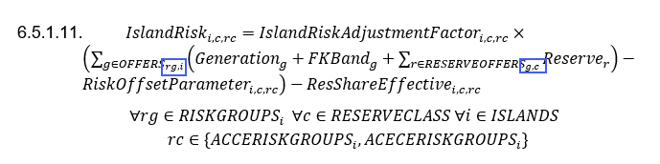

In Derived Sets the associated declarations are currently as follows:

Updates to existing declarations:

1. Risk Groups are indexed by island, so the offers associated with the risk group do not need to be indexed by island.
2. In the risk calculation the reserve offers are associated with the risk group via the generation offer but it would be clearer if the reserve offers had their own risk group index, and this will also allow the link risk calculation to use the same pattern.

In: Derived Sets

Apply these updates and add link risk:

## Link Risk Flow

The risk represented by the link risk is based on the sum of branch flows, accounting for the direction of flow.

In: Fundamental Sets

The existing definition of AC Line is as follows:

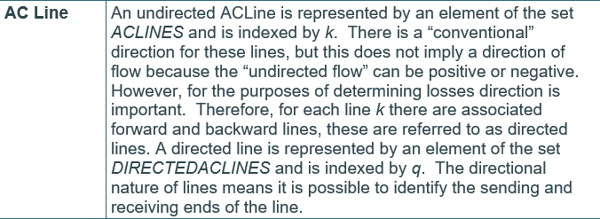

Update the definition of AC Line to explicitly identify the direction of flow:

In: Risk and Reserve – Parameters

Define the Link Risk parameter TowardsNode, which is the input parameter defining the direction of the link risk for that branch.

Define the Link Risk parameter DirectionalRiskFactor which is derived from TowardsNode for use in the risk calculation.

Note that the definition of DirectionalRiskFactor includes a description of the pre-processing that calculates the value, having this description avoids the need for a separate pre-processing subsection:

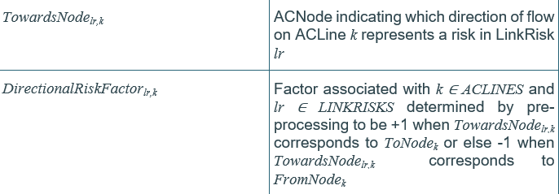

## Link Risk Calculation of Risk

In: Fundamental Sets

Add a risk class definition for link risk.

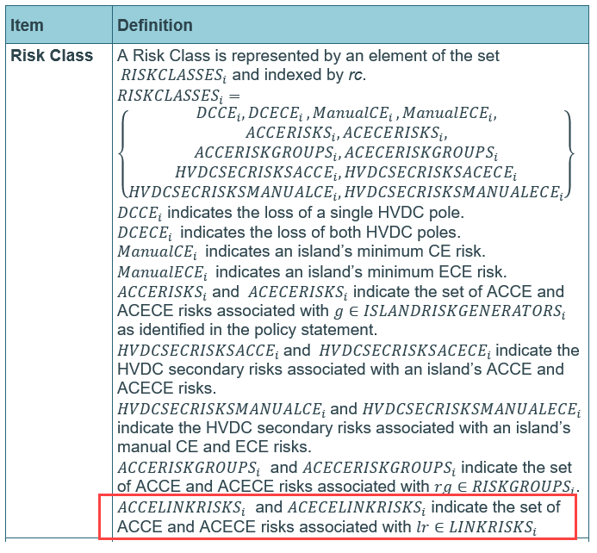

In: Constraints - Risk and Reserve - Risk

Update the Island Risk calculation for Risk Group to incorporate the indexing changes described in the Derived Sets section above, i.e., drop the island index from offers because the associated risk group is already island indexed, and give reserve offers their own risk group index.

Add an IslandRisk calculation for LinkRisk (the secondary risk component is covered by the Risk Adjustment for Secondary Risk section below).

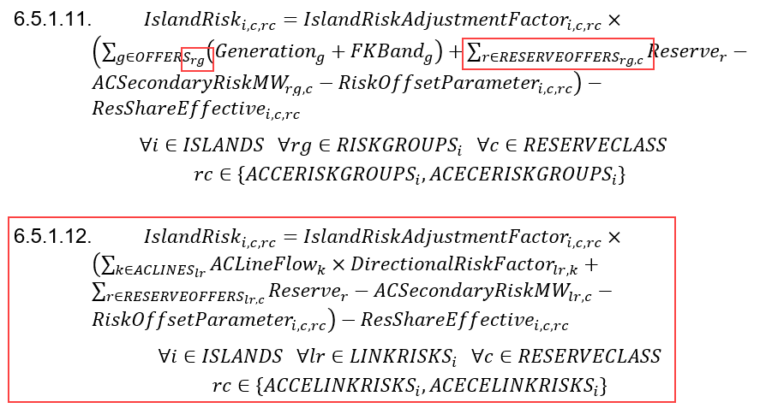

## Zeroing Reserve Offers on Commissioning Risk

In: Pre-Processing

Add a section:

Not directly related but noticed...

In: Fundamental Sets

Remove the mention of virtual reserve:





## Risk Adjustment for Secondary Risk

In: Risk and Reserve – Parameters

The existing risk calculations include the RiskOffsetParameter (NFR):

The definition helpfully mentions that the RiskOffsetParameter accounts for secondary generators risk:

Because RiskOffsetParameter includes the secondary risk it effectively adds the secondary risk to the calculated risk of every primary risk. If a primary risk (unit or risk group or link risk) has some secondary risk then this needs to be subtracted from its risk calculation so that the secondary risk is not double counted.

Note that there is already a secondary risk associated with the HVDC...

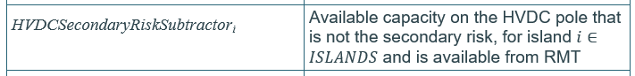

... so the new one will have an AC prefix.

In: Risk and Reserve – Parameters

Declare the secondary risk associated with a generator. The secondary risk will also be assigned to any risk group or link risk that includes the generator because these are also a primary risk which is directly dependent on the generators output:

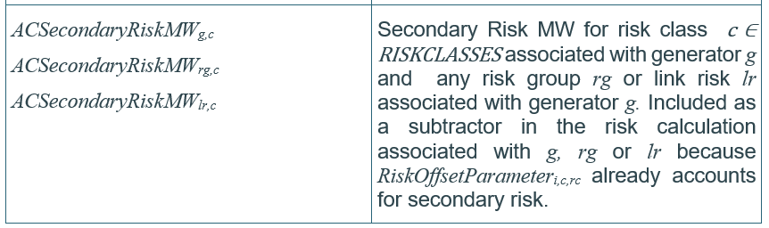

In: Constraints – Risk and Reserve – Risk

Update the unit risk, risk group and link risk calculations to subtract the secondary risk (the link risk was already done above):



