You must install Net Framework 4.
If you use Win8.1 and higher make sure that :
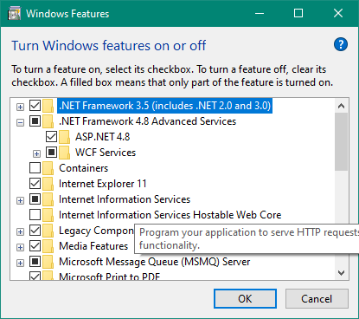
These net framework buttons are turned on.
If you are using Win7 and lower download last net framework for your pc .

