1. Add a new row in the ORDERS table with the following data: Order# = 1021, Customer# = 1009, and Order date = July 20, 2009.
   1. INSERT INTO ORDERS(ORDER#, CUSTOMER#, ORDERDATE)

VALUES (1021, 1009, DATE'2009-07-20');

* 1. A picture containing food

     Description automatically generated

1. Modify the zip code on order 1017 to 33222.
   1. UPDATE ORDERS

SET SHIPZIP = '33222'

WHERE ORDER# = 1017;

* 1. A picture containing food

     Description automatically generated

1. Save the changes permanently to the database.
   1. COMMIT;
   2. 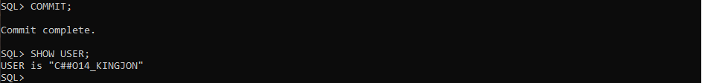
2. Add a new row in the ORDERS table with the following data: Order# = 1022, Customer# = 2000, and Order date = August 6, 2009. Describe the error raised and what caused the error.
   1. INSERT INTO ORDERS(ORDER#, CUSTOMER#, ORDERDATE)

VALUES (1022, 2000, DATE'2009-09-06');

* 1. Foreign key not available for CUSTOMER#2000 because it doesn’t exist in the CUSTOMER Table
  2. Text

     Description automatically generated

1. Add a new row in the ORDERS table with the following data: Order# = 1023 and Customer# = 1009. Describe the error raised and what caused the error.
   1. INSERT INTO ORDERS(ORDER#, CUSTOMER#)

VALUES (1023, 1009);

* 1. Since there is not a date object inserted into the statements above, date object can not be nothing.
  2. Text

     Description automatically generated

1. Create a script using substitution variables that allows a user to set a new cost amount for a book based on the ISBN.
   1. UPDATE BOOKS

SET ISBN = '&ISBN'

WHERE COST = '&COST';

* 1. 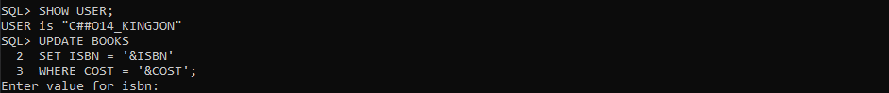

1. Execute the script and set the following values: isbn = 1059831198 and cost = $20.00.
   1. A picture containing rectangle

      Description automatically generated
2. Execute a command that undoes the change in Step 7.
   1. ROLLBACK;
   2. 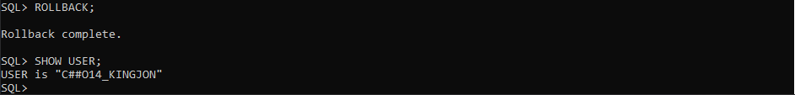
3. Delete Order# 1005. You need to address both the master order record and the related detail records.
   1. DELETE FROM ORDERITEMS

WHERE ORDER#=’1005’;

DELETE FROM ORDERS

WHERE ORDER#=’1005’;

* 1. A picture containing rectangle

     Description automatically generated

1. Execute a command that undoes the previous deletion.
   1. ROLLBACK;
   2. A picture containing text

      Description automatically generated