Microcontroller:STM32F401RE

Peripheral port: Port A and Port C

Peripheral Pin: A5//User Led

C0//Input pin

Peripheral MODE: A5 output mode

C0 Input Mode

Memory addresses of registers used.

0x4002 3800 + 0x30=> 0x40023830 --RCC_AHB1ENR //Set bit 0 for enabling port A peripheral clock and bit 2 for port C

0x4002 0000=>0x40020000 --GPIOA_MODER //Reset bit 11 and set bit 10 fOR Output mode

0x4002 0800=>0x40020800 --GPIOC_MODER // Reset bit 0 and 1 for input mode

0x4002 0800 + 0x10=>0x40020810 --GPIOC_IDR // Set bit 0 for read high and vice versa

0x4002 0000 + 0x14=> 0x40020014 --GPIOA_ODR // Set high for write high and vice versa

Simulation results:

Software: Proteus 8 Professional

1: Schematic Capture

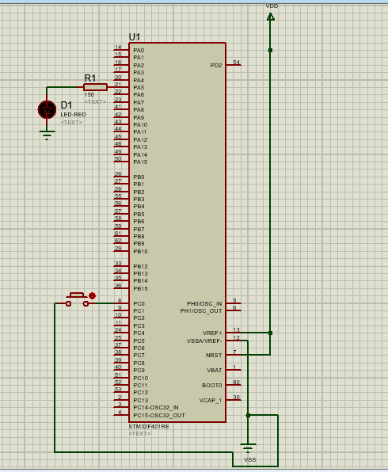

2:PinC0 reading high

Led turned ON

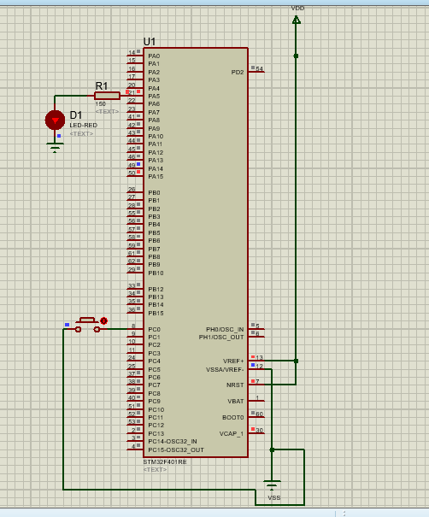

3.PinC0 reads Low

Led turned OFF

