RANKZY AI — QA FAILED TEST CASES REPORT
Field | Details
Document Title | QA Failed Test Cases Report
Project Name | Rankzy AI
Application URL | https://rankzyai.com
Version | 1.0

Overview
This document contains all the failed test cases identified during the testing of the Rankzy AI application. Each failed test case includes the expected result, actual result, issue description, reproduction steps, supporting evidence, and recommendations for resolution.

1. DEPLOYMENT & ENVIRONMENT VERIFICATION

TC-DEP-F01: Custom 404 Page Not Displayed
- TC ID: TC-DEP-F01
- Section: Deployment & Environment Verification
- Priority: Medium | Severity: Medium
- Automation Tool: Google Chrome / DevTools
- Automation Framework: N/A
- Test Scenario: Verify that navigating to an invalid URL displays a custom 404 page.
- Expected Result: A branded custom 404 page with an appropriate error message and navigation options should be displayed.
- Actual Result: A blank page was displayed instead of a custom 404 page.
- Execution Status: FAILED
- Issue Description: The application does not provide a user-friendly response for invalid URLs, resulting in a poor user experience.
- Steps to Reproduce:
  - Open https://rankzyai.com.
  - Enter an invalid URL (for example: https://rankzyai.com/abcd1234).
  - Observe the displayed page.
- Environment: Production
- Browser: Google Chrome
- Operating System: Windows 11
- Bug ID: BUG-DEP-01

Evidence
Screenshot:
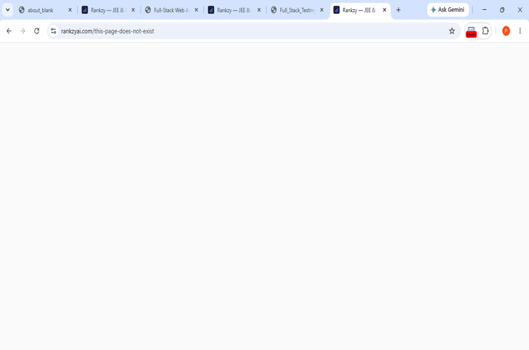
alt text
Figure DEP-01: Blank page displayed instead of a custom 404 page. - Developer Recommendation: Implement a branded custom 404 page with a meaningful error message and navigation back to the homepage.

TC-DEP-F02: robots.txt Not Configured Correctly
- TC ID: TC-DEP-F02
- Section: Deployment & Environment Verification
- Priority: Medium | Severity: Medium
- Automation Tool: Google Chrome / DevTools
- Automation Framework: N/A
- Test Scenario: Verify that /robots.txt returns a valid robots file.
- Expected Result: https://rankzyai.com/robots.txt should return a plain text robots file.
- Actual Result: The application returned the website’s index.html instead of a valid robots.txt file.
- Execution Status: FAILED
- Issue Description: The robots.txt file is not configured correctly, which may affect search engine crawling.
- Steps to Reproduce:
  - Open https://rankzyai.com/robots.txt.
  - Observe the returned content.
- Environment: Production
- Browser: Google Chrome
- Operating System: Windows 11
- Bug ID: BUG-DEP-02 #### Evidence Screenshot:
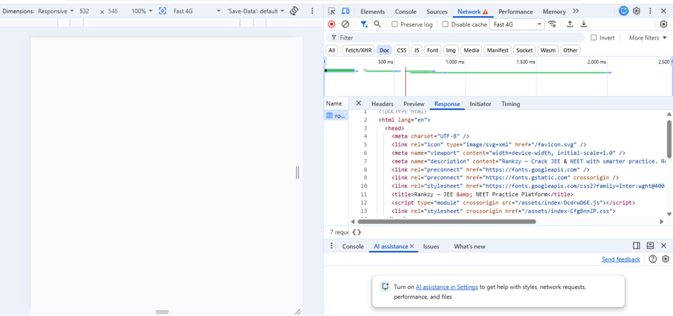
Figure DEP-02: robots.txt returned the application’s HTML page instead of plain text. - Developer Recommendation: Place a valid robots.txt file in the application’s public/static directory and configure the server to return it as plain text.

TC-DEP-F03: sitemap.xml Not Configured Correctly
- TC ID: TC-DEP-F03
- Section: Deployment & Environment Verification
- Priority: Medium | Severity: Medium
- Automation Tool: Google Chrome / DevTools
- Automation Framework: N/A
- Test Scenario: Verify that /sitemap.xml returns a valid XML sitemap.
- Expected Result: https://rankzyai.com/sitemap.xml should return a valid XML sitemap.
- Actual Result: The application returned the website’s index.html instead of a valid XML sitemap.
- Execution Status: FAILED
- Issue Description: The sitemap is missing or incorrectly configured, which may affect search engine indexing.
- Steps to Reproduce:
  - Open https://rankzyai.com/sitemap.xml.
  - Observe the returned content.
- Environment: Production
- Browser: Google Chrome
- Operating System: Windows 11
- Bug ID: BUG-DEP-03

Evidence
Screenshot:
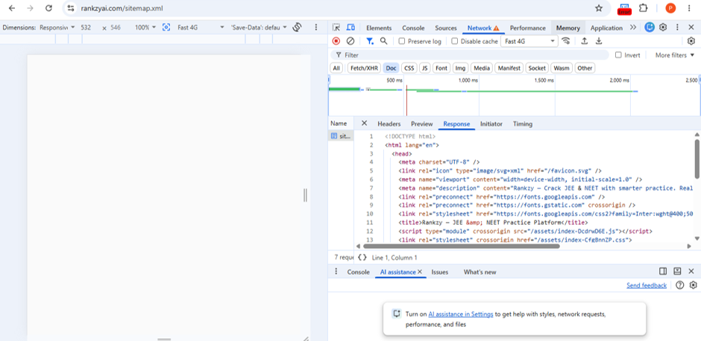
alt text
Figure DEP-03: sitemap.xml returned the application’s HTML page instead of XML.
- Developer Recommendation: Generate a valid sitemap.xml, place it in the application’s public/static directory, and configure the server to serve the XML file correctly.
- Failed Count: 3
- Critical: 0 | High: 0 | Medium: 3 | Low: 0

2. FUNCTIONAL TESTING

TC-FUN-F01: Review Button Redirects to Dashboard Instead of Results Page
- TC ID: TC-FUN-F01
- Section: Functional Testing
- Priority: High | Severity: High
- Automation Tool: Google Chrome
- Automation Framework: N/A
- Test Scenario: Verify that clicking the Review button from My Tests opens the corresponding test review/results page.
- Expected Result: Clicking Review should navigate to the selected test’s review/result page.
- Actual Result: Clicking Review redirects the user to the Dashboard instead of the review/results page.
- Execution Status: FAILED
- Issue Description: The Review button does not navigate to the intended page, preventing users from reviewing completed tests.
- Steps to Reproduce:
  - Log in to Rankzy AI.
  - Open My Tests.
  - Select a completed test.
  - Click Review.
- Environment: Production
- Browser: Google Chrome
- Operating System: Windows 11
- Bug ID: BUG-FUN-01

Evidence
Screenshot:
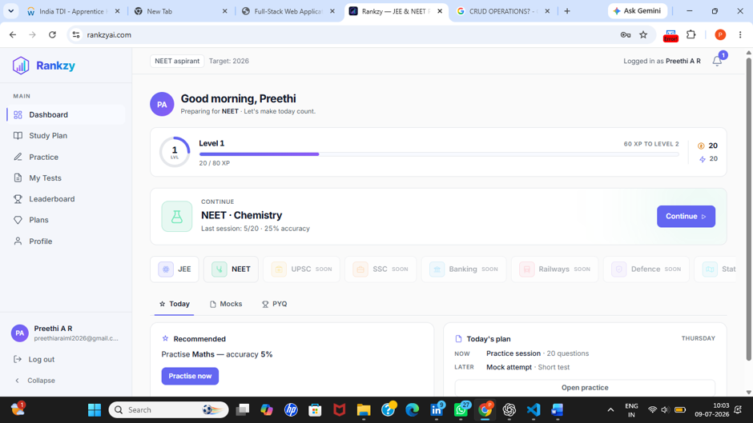 Figure FUN-01: Review button redirects to the Dashboard instead of the test review page. - Recommendation: Update the Review button navigation to open the correct test review/results page.

TC-FUN-F02: Weak Areas Report Displays Subject Name Instead of Topic Details
- TC ID: TC-FUN-F02
- Section: Functional Testing
- Priority: Medium | Severity: Medium
- Automation Tool: Google Chrome
- Automation Framework: N/A
- Test Scenario: Verify that the performance report displays detailed weak areas within each subject.
- Expected Result: The report should display topic/chapter-level weak areas (for example, Biology → Plant Physiology, Botany, Genetics).
- Actual Result: The Weak Areas section displays only the subject name, which is the same as the Strong Areas section.
- Execution Status: FAILED
- Issue Description: The report does not provide meaningful topic-level analysis, making it difficult for users to identify improvement areas.
- Steps to Reproduce:
  - Complete a practice test.
  - Open the performance report.
  - Compare the Strong Areas and Weak Areas sections.
- Environment: Production
- Browser: Google Chrome
- Operating System: Windows 11
- Bug ID: BUG-FUN-02

Evidence
Screenshot:
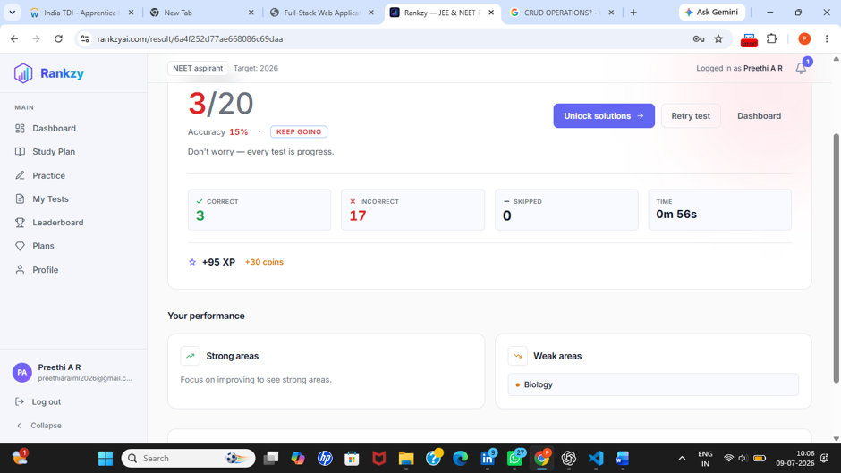 Figure FUN-02: Weak Areas section displays only the subject name instead of detailed topics. - Recommendation: Display chapter/topic-level weak areas instead of repeating the subject name.

TC-FUN-F03: Notification Preferences Cannot Be Customized
- TC ID: TC-FUN-F03
- Section: Functional Testing
- Priority: Medium | Severity: Medium
- Automation Tool: Google Chrome
- Automation Framework: N/A
- Test Scenario: Verify that users can manage notification history and configure notification timings.
- Expected Result:
  - Previous notifications should remain available in the notification panel.
  - Users should be able to configure notification timings according to their preference.
- Actual Result:
  - Previous notifications are not retained in the notification panel.
  - Notification timings are fixed (for example, 7:00 AM) and cannot be customized by the user.
- Execution Status: FAILED
- Issue Description: The notification feature lacks notification history and user-configurable scheduling.
- Steps to Reproduce:
  - Log in to the application.
  - Open the Notifications panel.
  - Observe previously received notifications.
  - Check whether notification timing can be modified.
- Environment: Production
- Browser: Google Chrome
- Operating System: Windows 11
- Bug ID: BUG-FUN-03

Evidence
Screenshot:
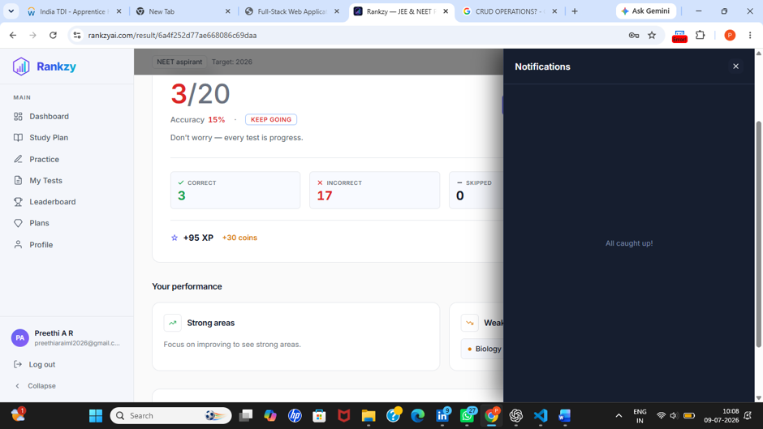 Figure FUN-03: Notification history is unavailable and notification timing cannot be customized.
- Developer Recommendation: Store notification history and provide users with an option to configure notification schedules.
- Failed Count: 3
- Critical: 0 | High: 1 | Medium: 2 | Low: 0 _ _ _ ## 3. UI TESTING

TC-UI-F01: Loading Indicator Not Displayed During Processing
- TC ID: TC-UI-F01
- Section: UI Testing
- Priority: Medium | Severity: Medium
- Automation Tool: Google Chrome
- Automation Framework: N/A
- Test Scenario: Verify that a loading indicator or spinner is displayed while requests are being processed.
- Expected Result: A loading indicator or spinner should be displayed until the requested operation is completed.
- Actual Result: No loading indicator or spinner was displayed during processing.
- Execution Status: FAILED
- Issue Description: Users do not receive visual feedback while the application processes requests, making it difficult to determine whether the operation is still in progress.
- Steps to Reproduce:
  - Log in to the application.
  - Perform an operation that requires processing.
  - Observe the UI while waiting for the response.
- Environment: Production
- Browser: Google Chrome
- Operating System: Windows 11
- Bug ID: BUG-UI-01

Evidence
Screenshot:
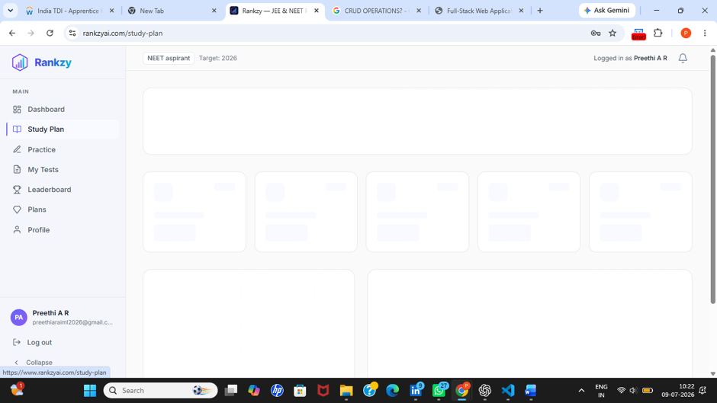 Figure UI-01: No loading indicator displayed while processing the request.
- Recommendation: Display a loading spinner or progress indicator until the operation completes.

TC-UI-F02: Navigation Underline Indicator Misaligned
- TC ID: TC-UI-F02
- Section: UI Testing
- Priority: Low | Severity: Low
- Automation Tool: Google Chrome
- Automation Framework: N/A
- Test Scenario: Verify that the navigation underline aligns correctly with the selected tab.
- Expected Result: The underline indicator should align properly beneath the selected tab (Today, Mocks, PYQ).
- Actual Result: The underline indicator is misaligned beneath the navigation tabs.
- Execution Status: FAILED
- Issue Description: Incorrect alignment affects the visual consistency of the navigation menu.
- Steps to Reproduce:
  - Open the Practice Tests page.
  - Switch between Today, Mocks, and PYQ tabs.
  - Observe the underline indicator.
- Environment: Production
- Browser: Google Chrome
- Operating System: Windows 11
- Bug ID: BUG-UI-02

Evidence
Screenshot:
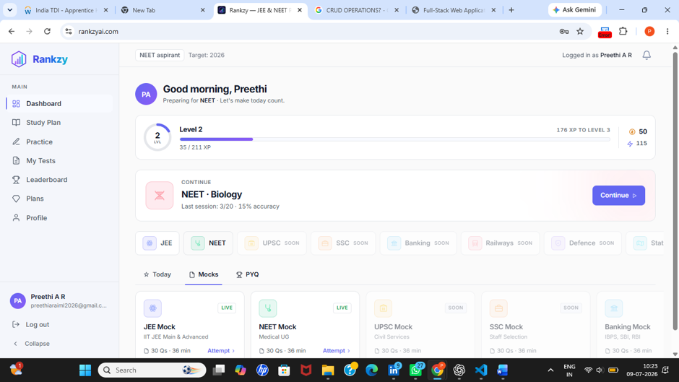 Figure UI-02: Underline indicator is not aligned with the selected navigation tab. - Developer Recommendation: Adjust the CSS styling to align the underline indicator correctly.

TC-UI-F03: Test Legend Colours Are Not Clearly Visible
- TC ID: TC-UI-F03
- Section: UI Testing
- Priority: Medium | Severity: Medium
- Automation Tool: Google Chrome
- Automation Framework: N/A
- Test Scenario: Verify that the legend colours for Answered, Marked, and Unanswered questions are clearly distinguishable.
- Expected Result: Each legend item should have a clear and distinguishable colour with sufficient contrast.
- Actual Result: The legend colours are difficult to distinguish and the colour indicators are not displayed clearly.
- Execution Status: FAILED
- Issue Description: Poor visibility of the legend makes it difficult for users to identify question statuses during a test.
- Steps to Reproduce:
  - Start a practice test.
  - Observe the legend displaying Answered, Marked, and Unanswered.
- Environment: Production
- Browser: Google Chrome
- Operating System: Windows 11
- Bug ID: BUG-UI-03 #### Evidence Screenshot:
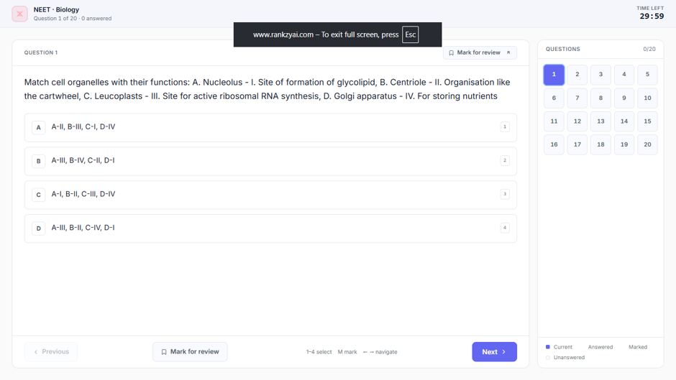 Figure UI-03: Question status legend lacks clear colour visibility. - Developer Recommendation: Improve colour contrast and ensure each legend item displays its corresponding colour indicator.

TC-UI-F04: Dashboard Button Unnecessarily Displayed on Result Page
- TC ID: TC-UI-F04
- Section: UI Testing
- Priority: Low
- Severity: Low
- Automation Tool: Google Chrome
- Automation Framework: N/A
- Test Scenario: Verify that only relevant navigation controls are displayed on the Result page.
- Expected Result: The Result page should display only relevant actions for users.
- Actual Result: An unnecessary Dashboard button is displayed on the Result page.
- Execution Status: FAILED
- Issue Description: The additional Dashboard button creates unnecessary visual clutter on the Result page.
- Steps to Reproduce:
  - Complete a test.
  - Open the Result page.
  - Observe the available action buttons.
- Environment: Production
- Browser: Google Chrome
- Operating System: Windows 11
- Bug ID: BUG-UI-04 #### Evidence Screenshot:
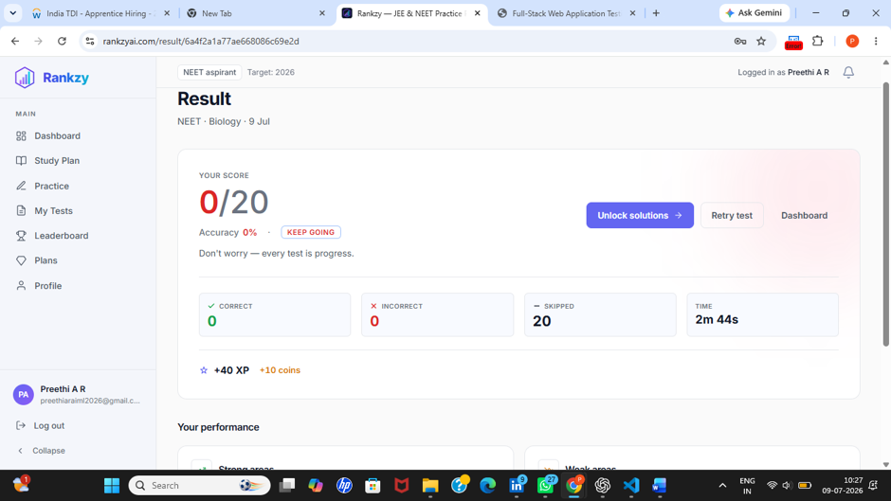 Figure UI-04: Dashboard button displayed unnecessarily on the Result page. - Recommendation: Remove the unnecessary Dashboard button or relocate it appropriately.

TC-UI-F05: Notification Theme Is Inconsistent with Application Theme
- TC ID: TC-UI-F05
- Section: UI Testing
- Priority: Low
- Severity: Low
- Automation Tool: Google Chrome
- Automation Framework: N/A
- Test Scenario: Verify that notification colours follow the application’s design theme.
- Expected Result: Notification colours should match the overall application theme.
- Actual Result: Notification colours are inconsistent with the application’s colour scheme.
- Execution Status: FAILED
- Issue Description: Inconsistent colours reduce the visual consistency of the user interface.
- Steps to Reproduce:
  - Trigger a notification.
  - Compare the notification colours with the application’s theme.
- Environment: Production
- Browser: Google Chrome
- Operating System: Windows 11
- Bug ID: BUG-UI-05

Evidence
Screenshot:
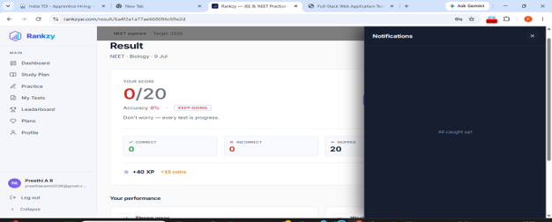 Figure UI-05: Notification colour scheme differs from the application theme. - Developer Recommendation: Update the notification styling to match the application’s design system.
- Failed Count: 5
- Critical: 0 | High: 0 | Medium: 2 | Low: 3

4. UX TESTING

TC-UX-F01: No User-Friendly Error Message Displayed During Network Failure
- TC ID: TC-UX-F01
- Section: UX Testing
- Priority: Medium |
- Severity: Medium
- Automation Tool: Google Chrome
- Automation Framework: N/A
- Test Scenario: Verify that the application displays a meaningful error message when a network failure occurs.
- Expected Result: A clear and user-friendly message should be displayed when the application is unable to connect to the server (e.g., “Network connection lost. Please check your internet connection and try again.”).
- Actual Result: No error message was displayed during the network interruption, leaving the user without feedback.
- Execution Status: FAILED
- Issue Description: The application does not provide appropriate feedback during network failures, which may confuse users and make it difficult to determine whether the issue is with the application or the network.
- Steps to Reproduce:
  - Open the application.
  - Disconnect the internet connection or simulate a network failure.
  - Perform an operation that requires server communication.
  - Observe the application’s response.
- Environment: Production
- Browser: Google Chrome
- Operating System: Windows 11
- Bug ID: BUG-UX-01

Evidence
Screenshot:
 Figure UX-01: No user-friendly error message displayed during network failure. - Recommendation: Display a clear and informative error message whenever a network connection failure occurs and provide users with an option to retry the operation.
- Failed Count: 1
- Critical: 0 | High: 0 | Medium: 1 | Low: 0

5. RESPONSIVE TESTING

TC-RES-F01: Navigation Underline Misaligned on Smaller Screens
- TC ID: TC-RES-F01
- Section: Responsive Testing
- Priority: Low | Severity: Low
- Automation Tool: Google Chrome Responsive Mode
- Automation Framework: N/A
- Test Scenario: Verify that the navigation underline aligns correctly with the selected tab on different screen sizes.
- Expected Result: The underline indicator should remain properly aligned below the selected tab (Today, Mocks, PYQ) on all supported screen sizes.
- Actual Result: The underline indicator becomes misaligned on smaller screen sizes.
- Execution Status: FAILED
- Issue Description: The responsive layout does not maintain proper alignment of the navigation indicator on smaller devices.
- Steps to Reproduce:
  - Open the Practice Tests page.
  - Enable mobile responsive view.
  - Switch between Today, Mocks and PYQ.
  - Observe the underline alignment.
- Environment: Production
- Browser: Google Chrome
- Operating System: Windows 11
- Bug ID: BUG-RES-01 #### Evidence Screenshot:
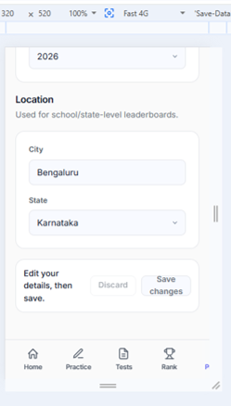
alt text
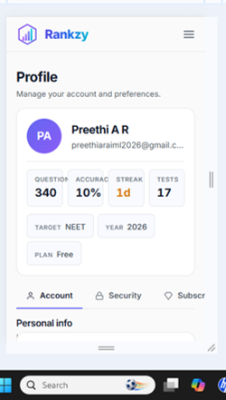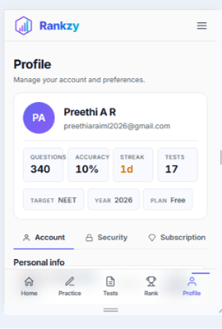
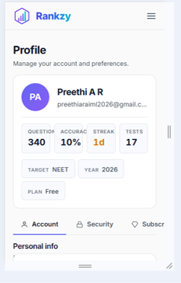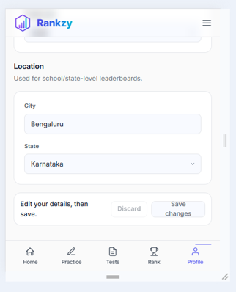
Figure RES-01: Underline indicator and other cards is not aligned correctly on smaller screen sizes. - Recommendation: Adjust the responsive CSS so that the UI remains properly aligned across all supported screen sizes.

TC-RES-F02: Question Status Legend Not Clearly Visible on Mobile Devices
- TC ID: TC-RES-F02
- Section: Responsive Testing
- Priority: Medium | Severity: Medium
- Automation Tool: Google Chrome Responsive Mode
- Automation Framework: N/A
- Test Scenario: Verify that the question status legend is clearly visible on smaller devices.
- Expected Result: Answered, Marked and Unanswered indicators should remain clearly visible with sufficient colour contrast.
- Actual Result: The legend colours are difficult to distinguish on smaller screens.
- Execution Status: FAILED
- Issue Description: Poor colour visibility reduces the usability of the question status legend during tests.
- Steps to Reproduce:
  - Open a practice test.
  - Enable mobile responsive mode.
  - Observe the legend.
- Environment: Production
- Browser: Google Chrome
- Operating System: Windows 11
- Bug ID: BUG-RES-02

Evidence
Screenshot:

Figure RES-02: Question status legend is difficult to distinguish on screens. - Recommendation: Improve the responsive styling and increase the colour contrast of the legend.

TC-RES-F03: Dashboard Cards Do Not Resize Properly on Small Viewports
- TC ID: TC-RES-F03
- Section: Responsive Testing
- Priority: Medium | Severity: Medium
- Automation Tool: Google Chrome Responsive Mode
- Automation Framework: N/A
- Test Scenario: Verify that dashboard cards resize correctly on different mobile screen sizes.
- Expected Result: Dashboard cards should resize proportionally and remain properly aligned on all supported viewports.
- Actual Result: Dashboard cards do not resize correctly on smaller viewports such as 320px, 375px and 420px, causing inconsistent spacing and layout.
- Execution Status: FAILED
- Issue Description: The responsive layout does not adapt correctly for smaller mobile screen sizes.
- Steps to Reproduce:
  - Open the Dashboard.
  - Enable responsive mode.
  - Test at 320px, 375px and 420px widths.
  - Observe the card layout.
- Environment: Production
- Browser: Google Chrome
- Operating System: Windows 11
- Bug ID: BUG-RES-03
- Recommendation: Update the responsive layout so cards resize consistently across all supported mobile screen sizes.
- Failed Count: 3
- Critical: 0 | High: 0 | Medium: 2 | Low: 1

6. ACCESSIBILITY TESTING

TC-ACC-F01: Insufficient Colour Contrast
- TC ID: TC-ACC-F01
- Section: Accessibility Testing
- Priority: Medium | Severity: Medium
- Automation Tool: Google Lighthouse / Google Chrome
- Automation Framework: N/A
- Test Scenario: Verify that the application maintains sufficient colour contrast between text and background elements.
- Expected Result: All text and interactive UI elements should meet the recommended WCAG colour contrast guidelines to ensure readability.
- Actual Result: Certain text and UI elements have insufficient colour contrast, making them difficult to read.
- Execution Status: FAILED
- Issue Description: Low colour contrast reduces readability and may impact users with visual impairments.
- Steps to Reproduce:
  - Open the application.
  - Navigate to pages containing the affected UI elements.
  - Run a Lighthouse Accessibility audit or visually inspect the interface.
  - Observe the colour contrast of the affected elements.
- Environment: Production
- Browser: Google Chrome
- Operating System: Windows 11
- Bug ID: BUG-ACC-01 #### Evidence Screenshot:

Figure ACC-01: UI elements with insufficient colour contrast. - Recommendation: Increase the colour contrast of the affected text and UI elements to comply with WCAG accessibility guidelines.
- Failed Count: 1
- Critical: 0 | High: 0 | Medium: 1 | Low: 0

7. API TESTING

TC-API-F01: Invalid Password Error Message Not Returned in API Response
- TC ID: TC-API-F01
- Section: API Testing
- Priority: Medium | Severity: Medium
- Automation Tool: Postman
- Automation Framework: N/A
- Test Scenario: Verify that the API returns an appropriate error message when an incorrect password is submitted.
- Expected Result: The API should return a clear error message such as “Invalid Password” along with the appropriate HTTP status code.
- Actual Result: The API returned the status code, but the expected invalid password error message was not included in the response body. The message was displayed correctly only through the application’s user interface.
- Execution Status: FAILED
- Issue Description: The API response does not provide a meaningful error message for invalid password attempts, making debugging and API integration more difficult.
- Steps to Reproduce:
  - Open Postman.
  - Send a login request using a valid email address and an incorrect password.
  - Observe the response body.
- Environment: Production
- Tool: Postman
- Operating System: Windows 11
- Bug ID: BUG-API-01

Evidence
Screenshot:
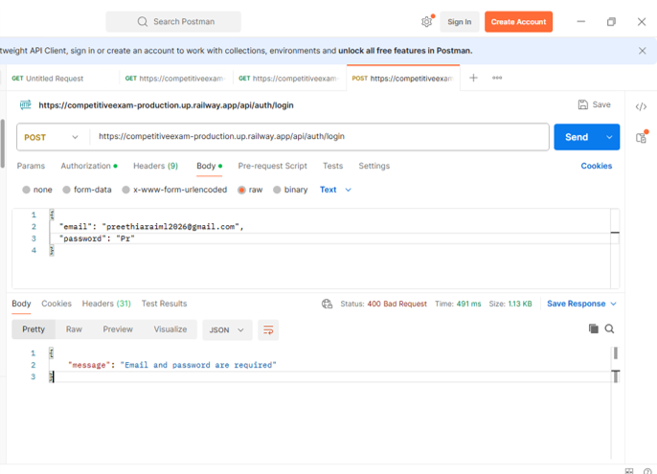
Figure API-01: API response does not include the expected invalid password error message. - Recommendation: Return a consistent and descriptive error message in the API response body while maintaining appropriate HTTP status codes.
- Failed Count: 1
- Critical: 0 | High: 0 | Medium: 1 | Low: 0

8. VALIDATION & NEGATIVE TESTING

TC-VAL-F01: Mobile Number Validation Not Enforced
- TC ID: TC-VAL-F01
- Section: Validation & Negative Testing
- Priority: High | Severity: High
- Automation Tool: Google Chrome
- Automation Framework: N/A
- Test Scenario: Verify that the mobile number field accepts only valid mobile numbers of the required length.
- Expected Result: The application should reject mobile numbers with fewer or more digits than the allowed length.
- Actual Result: The application accepts mobile numbers with invalid lengths.
- Execution Status: FAILED
- Issue Description: Mobile number length validation is not enforced, allowing invalid contact information to be saved.
- Steps to Reproduce:
  - Open the Profile page.
  - Edit the mobile number.
  - Enter fewer or more digits than the required length.
  - Save the changes.
- Environment: Production
- Browser: Google Chrome
- Operating System: Windows 11
- Bug ID: BUG-VAL-01

Evidence
Screenshot: 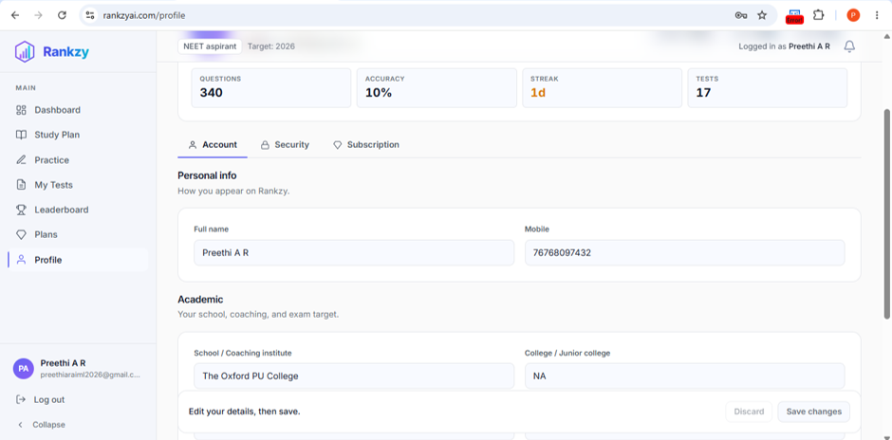
Figure VAL-01: Mobile number field accepts invalid lengths.
- Recommendation: Enforce minimum and maximum length validation for the mobile number field.

TC-VAL-F02: OTP Verification Proceeds Without Mandatory Profile Details
- TC ID: TC-VAL-F02
- Section: Validation & Negative Testing
- Priority: High | Severity: High
- Automation Tool: Google Chrome
- Automation Framework: N/A
- Test Scenario: Verify that mandatory profile fields are validated before OTP verification.
- Expected Result: OTP verification should not proceed until all mandatory profile fields are completed.
- Actual Result: OTP verification proceeds even when mandatory profile fields are left empty.
- Execution Status: FAILED
- Issue Description: Required field validation is missing before OTP verification.
- Steps to Reproduce:
  - Open the Profile section.
  - Leave the mandatory fields empty.
  - Proceed with OTP verification.
- Environment: Production
- Browser: Google Chrome
- Operating System: Windows 11
- Bug ID: BUG-VAL-02
- Recommendation: Validate all required profile fields before allowing OTP verification.

TC-VAL-F03: Profile Fields Accept Special Characters
- TC ID: TC-VAL-F03
- Section: Validation & Negative Testing
- Priority: Medium | Severity: Medium
- Automation Tool: Google Chrome
- Automation Framework: N/A
- Test Scenario: Verify that profile fields reject invalid special characters where they are not allowed.
- Expected Result: Fields such as Name and Mobile Number should reject invalid special characters.
- Actual Result: Profile fields accept special characters without validation.
- Execution Status: FAILED
- Issue Description: Input validation does not restrict unsupported special characters.
- Steps to Reproduce:
  - Open the Profile page.
  - Enter special characters into applicable fields.
  - Save the profile.
- Environment: Production
- Browser: Google Chrome
- Operating System: Windows 11
- Bug ID: BUG-VAL-03

Evidence
Screenshot:
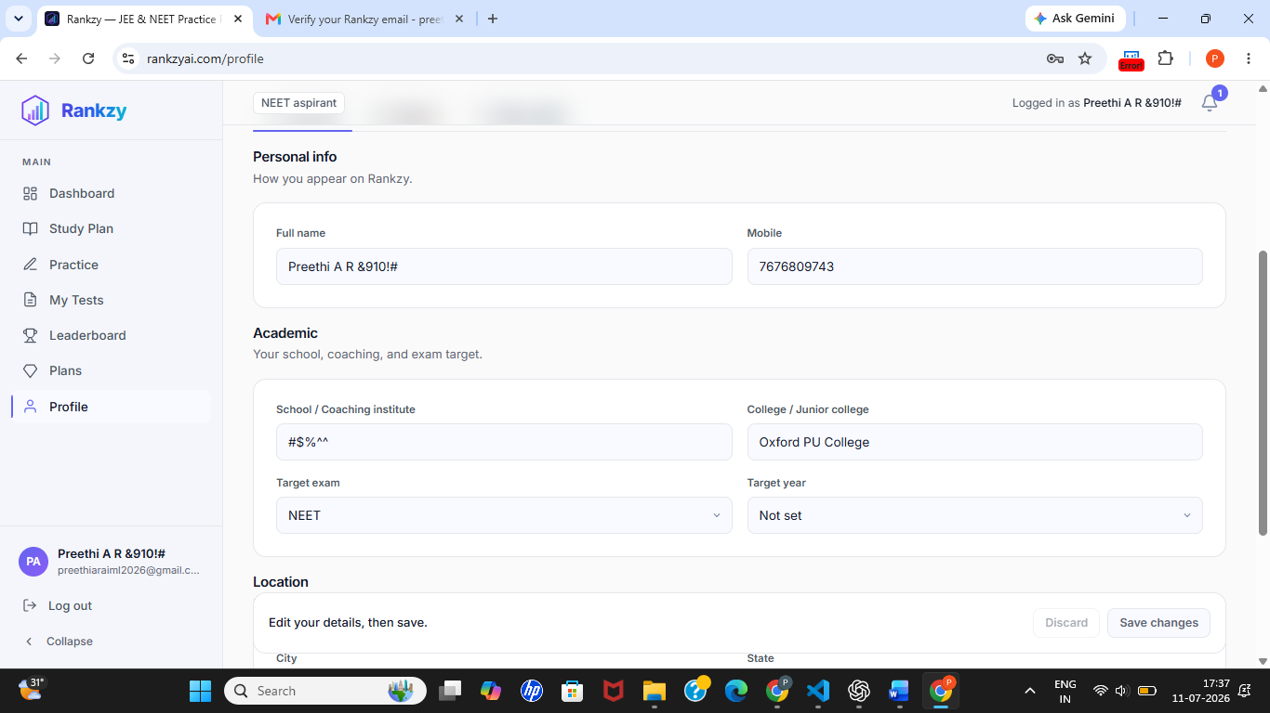
Figure VAL-03: Profile fields accept unsupported special characters. - Recommendation: Validate input fields and restrict unsupported special characters where appropriate.

TC-VAL-F04: Invalid Input Accepted in Profile Fields
- TC ID: TC-VAL-F04
- Section: Validation & Negative Testing
- Priority: Medium | Severity: Medium
- Automation Tool: Google Chrome
- Automation Framework: N/A
- Test Scenario: Verify that invalid input values are rejected.
- Expected Result: Invalid input should be rejected with an appropriate validation message.
- Actual Result: Invalid input values are accepted.
- Execution Status: FAILED
- Issue Description: Input validation is insufficient for profile fields.
- Steps to Reproduce:
  - Open the Profile page.
  - Enter invalid values into editable fields.
  - Save the changes.
- Environment: Production
- Browser: Google Chrome
- Operating System: Windows 11
- Bug ID: BUG-VAL-04 #### Evidence Screenshot:

Figure VAL-04: Invalid profile input accepted without validation. - Recommendation: Apply appropriate validation rules before accepting user input.

TC-VAL-F05: Maximum Character Length Validation Missing
- TC ID: TC-VAL-F05
- Section: Validation & Negative Testing
- Priority: Medium | Severity: Medium
- Automation Tool: Google Chrome
- Automation Framework: N/A
- Test Scenario: Verify that profile fields enforce maximum character limits.
- Expected Result: Profile fields should reject input exceeding the defined maximum length.
- Actual Result: No maximum character limit is enforced for fields such as Name and Mobile Number.
- Execution Status: FAILED
- Issue Description: Missing character limits allow excessively long input values.
- Steps to Reproduce:
  - Open the Profile page.
  - Enter values exceeding a reasonable character limit.
  - Save the profile.
- Environment: Production
- Browser: Google Chrome
- Operating System: Windows 11
- Bug ID: BUG-VAL-05

Evidence
Screenshot:

Figure VAL-05: No maximum character limit enforced. - Recommendation: Define and enforce appropriate maximum character limits for all profile fields.
- Failed Count: 5
- Critical: 0 | High: 2 | Medium: 3 | Low: 0

9. BOUNDARY VALUE TESTING

TC-BVA-F01: Password Maximum Length Validation Not Enforced
- TC ID: TC-BVA-F01
- Section: Boundary Value Testing
- Priority: Medium | Severity: Medium
- Automation Tool: Google Chrome
- Automation Framework: N/A
- Test Scenario: Verify that the password field enforces a maximum character limit.
- Expected Result: Passwords exceeding the maximum allowed length should be rejected with an appropriate validation message.
- Actual Result: Passwords exceeding the expected maximum length were accepted without validation.
- Execution Status: FAILED
- Issue Description: The application does not enforce a maximum password length, allowing excessively long passwords to be entered.
- Steps to Reproduce:
  - Open the Sign Up or Profile page.
  - Enter a password longer than the expected maximum length.
  - Submit the form.
- Environment: Production
- Browser: Google Chrome
- Operating System: Windows 11
- Bug ID: BUG-BVA-01

Evidence
Screenshot:
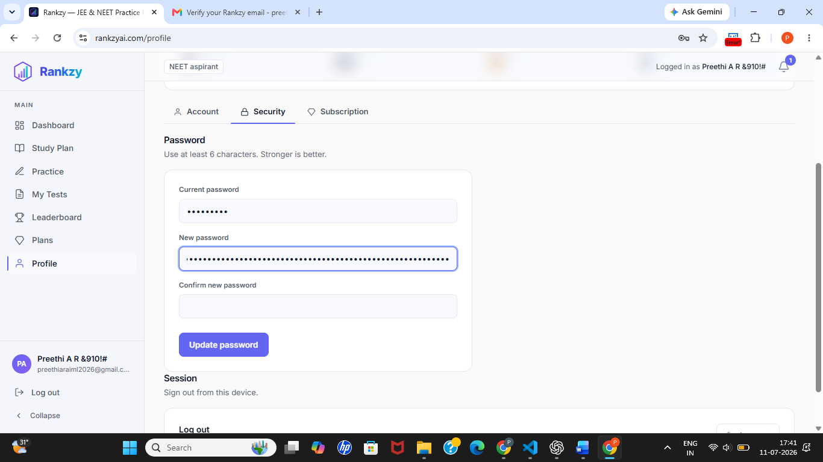
Figure BVA-01: Password field accepts input beyond the expected maximum length. - Recommendation: Define and enforce a maximum password length with appropriate validation.

TC-BVA-F02: Maximum Character Limits Not Defined for Profile Fields
- TC ID: TC-BVA-F02
- Section: Boundary Value Testing
- Priority: Medium | Severity: Medium
- Automation Tool: Google Chrome
- Automation Framework: N/A
- Test Scenario: Verify that profile fields enforce maximum character limits.
- Expected Result: Fields such as Name and Mobile Number should reject input exceeding the defined maximum length.
- Actual Result: No maximum character limit is enforced for profile fields, allowing excessively long input values.
- Execution Status: FAILED
- Issue Description: Missing boundary validation allows users to enter values beyond reasonable limits.
- Steps to Reproduce:
  - Open the Profile page.
  - Enter a very long value into editable fields.
  - Save the profile.
- Environment: Production
- Browser: Google Chrome
- Operating System: Windows 11
- Bug ID: BUG-BVA-02

Evidence
Screenshot:
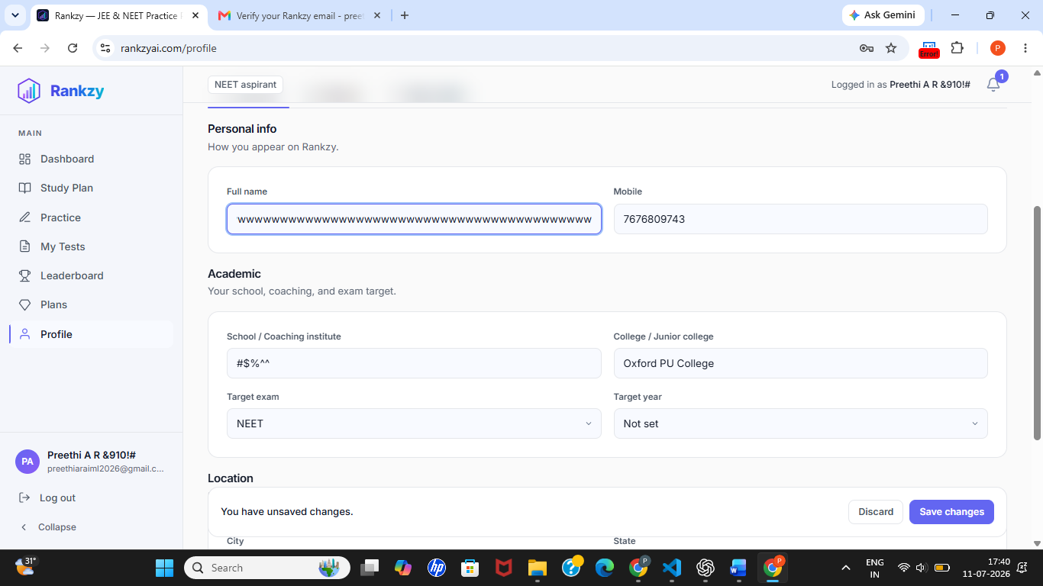
Figure BVA-02: Profile fields accept excessively long input values. - Recommendation: Define and enforce maximum character limits for all applicable profile fields.
- Failed Count: 2
- Critical: 0 | High: 0 | Medium: 2 | Low: 0

10. ERROR HANDLING TESTING

TC-ERR-F01: Session Expiration Handling Not Implemented
- TC ID: TC-ERR-F01
- Section: Error Handling Testing
- Priority: Medium | Severity: Medium
- Automation Tool: Google Chrome
- Automation Framework: N/A
- Test Scenario: Verify that the application automatically expires inactive user sessions and prompts the user to log in again.
- Expected Result: After a period of inactivity, the session should expire automatically and redirect the user to the login page or display a session expiration message.
- Actual Result: The application did not automatically expire the session during the observed testing period.
- Execution Status: FAILED
- Issue Description: Automatic session expiration is not enforced, allowing inactive sessions to remain active.
- Steps to Reproduce:
  - Log in to the application.
  - Leave the application idle for an extended period.
  - Return to the application and observe the session status.
- Environment: Production
- Browser: Google Chrome
- Operating System: Windows 11
- Bug ID: BUG-ERR-01

Evidence
Session remained active after prolonged inactivity. - Recommendation: Implement automatic session expiration after a configurable period of inactivity and notify users before redirecting them to the login page.
- Failed Count: 1
- Critical: 0 | High: 0 | Medium: 1 | Low: 0

11. Security Testing

TC-SEC-F02: Brute-Force Protection Not Implemented
- TC ID: TC-SEC-F02
- Section: Security Testing
- Priority: High | Severity: High
- Automation Tool: Playwright / Google Chrome
- Automation Framework: Playwright
- Test Scenario: Verify that repeated failed login attempts trigger brute-force protection such as account lockout, CAPTCHA, or rate limiting.
- Expected Result: After multiple failed login attempts, the application should trigger a security mechanism such as temporary account lockout, CAPTCHA, or request throttling.
- Actual Result: Five consecutive invalid login attempts returned authentication errors, but no lockout, CAPTCHA, or rate limiting was triggered.
- Execution Status: FAILED
- Issue Description: The login endpoint does not implement brute-force protection, allowing unlimited repeated authentication attempts.
- Steps to Reproduce:
  - Open the Login page.
  - Enter a valid email address and an incorrect password.
  - Repeat the login attempt five times.
  - Observe the application’s response.
- Environment: Production
- Browser: Google Chrome
- Operating System: Windows 11
- Bug ID: BUG-SEC-02

Evidence
Screenshot: 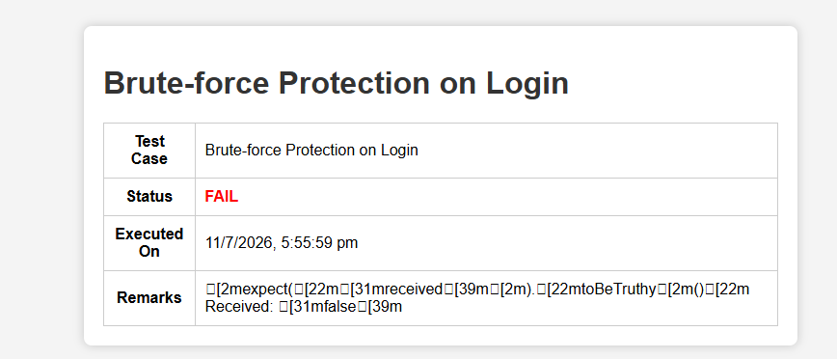
Figure SEC-02: Multiple failed login attempts did not trigger account lockout, CAPTCHA, or rate limiting.
#### Automation Snippet
for (let i = 1; i <= 5; i++) {
await page.goto('https://www.rankzyai.com/login');
await page.locator('input[type="email"]')
.fill('preethiaraiml2026@gmail.com');
await page.locator('input[type="password"]')
.fill('WrongPassword123');
await page.locator('button[type="submit"]').click();
await page.waitForTimeout(1000);
}
Observed Result: The application returned authentication errors for each attempt but did not trigger account lockout, CAPTCHA, or request rate limiting. - Recommendation: Implement brute-force protection using account lockout, CAPTCHA, request rate limiting, or a combination of these mechanisms after repeated failed authentication attempts.
- Failed Count: 2
- Critical: 0 | High: 2 | Medium: 0 | Low: 0

12. PERFORMANCE TESTING

TC-PER-F01: GTmetrix Audit Could Not Be Completed Due to Lighthouse Error
- TC ID: TC-PER-F01
- Section: Performance Testing
- Priority: Low | Severity: Low
- Automation Tool: GTmetrix
- Automation Framework: N/A
- Test Scenario: Verify that the application can be successfully analyzed using GTmetrix.
- Expected Result: GTmetrix should complete the performance analysis and generate a performance report with Lighthouse metrics.
- Actual Result: GTmetrix failed to complete the analysis because Lighthouse encountered an internal error during report generation.
- Execution Status: FAILED
- Issue Description: Performance metrics could not be generated through GTmetrix due to a Lighthouse execution error.
- Steps to Reproduce:
  - Open GTmetrix.
  - Enter https://www.rankzyai.com.
  - Start the performance analysis.
  - Observe the generated result.
- Environment: GTmetrix (Web)
- Browser: Google Chrome
- Operating System: Windows 11
- Bug ID: BUG-PER-01

Evidence
Screenshot:
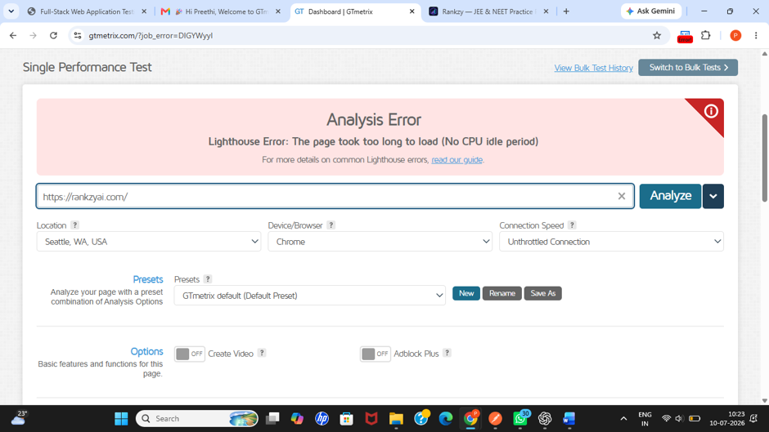
Figure PER-01: GTmetrix failed to generate the performance report because Lighthouse encountered an error. - Recommendation: Review the GTmetrix/Lighthouse error details, verify the application’s accessibility during testing, and rerun the audit after resolving any configuration or connectivity issues.
- Failed Count: 1
- Critical: 0 | High: 0 | Medium: 0 | Low: 1

13. SESSION TESTING

TC-SES-F01: Auto Logout After Inactivity Not Implemented
- TC ID: TC-SES-F01
- Section: Session Testing
- Priority: High | Severity: High
- Automation Tool: Google Chrome
- Automation Framework: N/A
- Test Scenario: Verify that the application automatically logs out inactive users after the configured inactivity timeout.
- Expected Result: The application should automatically terminate the user session after a period of inactivity and redirect the user to the login page.
- Actual Result: The user session remained active even after prolonged inactivity and no automatic logout occurred.
- Execution Status: FAILED
- Issue Description: The application does not automatically terminate inactive sessions, which may expose authenticated accounts if devices are left unattended.
- Steps to Reproduce:
  - Log in to the application.
  - Leave the application inactive for an extended period.
  - Return to the application.
  - Observe the session status.
- Environment: Production
- Browser: Google Chrome
- Operating System: Windows 11
- Bug ID: BUG-SES-01
- Recommendation: Implement automatic session timeout after a configurable inactivity period and redirect users to the login page when the session expires.
- Failed Count: 1
- Critical: 0 | High: 1 | Medium: 0 | Low: 0

