SUNBEAM BOT

**V.V.P. Engineering College**



**Prepared by-**

Heet Zalavadiya

Vaikunth Patel

Dhaval Joshi

Manish Nebhani

**Description-**

The project we’ve made is basically a programmed robot which sanitizes the whole room by illuminating it with highly intense infrared light by using an IR lamp and as the virus cannot survive in such high temperatures it dies in presence of such intense heat.

The illumination can be constant or in form of pulses according the way it is programmed. The robot scans the room and is programmed to avoid the obstacles.

For detection purpose, there are proximity (IR) sensor used which would signal the microcontroller in presence of any obstacles, the controller would then provide signals to motors to change their rotation cycles in order for robot to avoid those obstacles.

In our project, we have used array of SMD led instead of IR lamp as it was not available to us but the schematic of proposed driver is given with the documentation.

**Hardware & Software requirements-**

* Hardware- The hardware used includes the use of a

Arduino (microcontroller) for programming the robot, robot chassis, motor driver , proximity (IR) sensors to detect obstacles, battery pack, switch, led array, driver transistor, few resistors, motors and wheels.

* Software- Arduino IDE is the software that is used to program the robot.

**Process Flow**

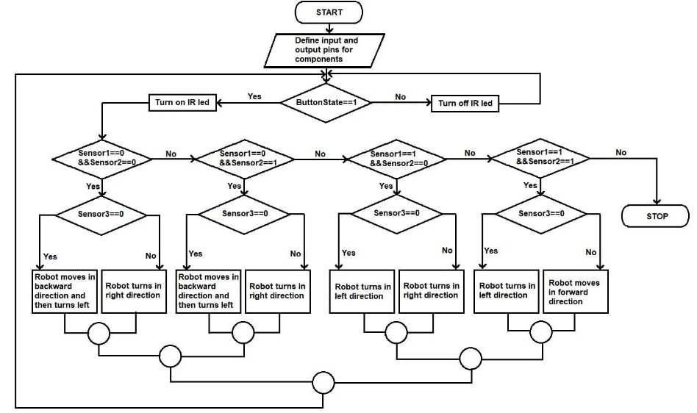

**Data Flow Diagram**

