**CSC 375/475: Introduction to Robotics - Spring 2019/20**

Due 4/15/20 at 5 PM.

This is a GLE Group Assignment. All questions carry equal marks. Please upload your solution as a single PDF file on D2L.

Robot Floor Cleaner

(Proposed by A. Davison)

In this activity, we will consider and discuss the design of a low-cost robot cleaner able to clean the floorspace of typical homes with a vacuum or other cleaning mechanism. The design of such a robot should balance the performance desired of it by users with the technical challenges and cost of equipping it with various capabilities. For now, we will assume that this is a small robot with wheels and no ability to manipulate objects or climb stairs! The robot is round, with a diameter of 30cm, and has a maximum speed of 30cm/s and a maximum turn rate of 40◦/s.

The following table has unordered lists of some aspects to consider in a robot of this type: 1) requirements that users might have, which we might consider selling points which would differentiate it from other robots on the market; 2) algorithmic/software capabilities we could try to implement on the robot; and 3) pieces of hardware, such as sensors, with which the robot could be equipped.

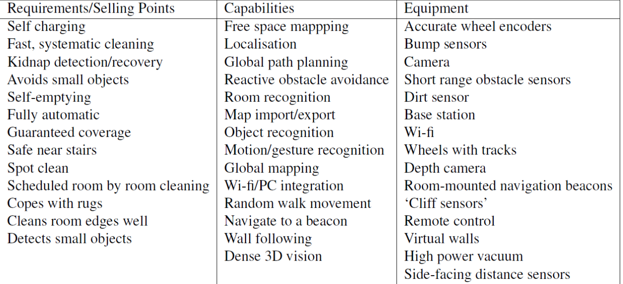

Consider the following questions:

1. Which elements of the lists above would provide the minimum requirements for a reasonable robot floor cleaner, similar to the first-generation Roomba released in 2002?  
Read the Operation section in <https://robotsupremacy.fandom.com/wiki/Roomba> to know about the basic operation of the initial Roomba robot models.

[Answer] :

2. On the following pages are copies of the floor plan of the ground floor of a typical family home (scale in meters). If the robot is turned on in the kitchen, which is temporarily closed off from the rest of the house by a closed door, and navigates in a ‘random bounce’ style,

* + a sketch on the diagram what the trajectory of the robot might look like over its first three minutes.

[Answer] :

* + b Estimate the fraction of the floor surface of the kitchen it would have cleaned.

[Answer] :

* + c What will probably happen if the robot is left to run for an extended period?

[Answer] :

3. Supposenowthatamuchmoreadvancedrobothadperfectlocalizationandcameequippedwith a complete map of all the walls and furniture in the house. Estimate the minimum amount of time for the robot to clean the whole ground floor, executing the best possible navigation strategy.

[Answer] :

