Software Architecture and Design Specification
Project: Electronics Store Inventory Management System
Version: 1.0
Authors: Ruchitha Y, Pranjal, Sudhe, Shanthinath
Date: 28-09-2026
Status: Draft

Revision History
Version | Date | Author | Change Summary
1.0 | 28-09-2026 | Team 26 | Initial draft of architecture and design

Approvals
Role | Name | Signature/Date
Project Guide | Vadiraj Acharya
Team Lead
Reviewer

1. Introduction
1.1 Purpose
This document specifies the architecture and design of the Electronics Store Inventory Management System. It describes how the system is structured, how its parts interact, and the design decisions taken to meet the project requirements.
1.2 Scope
Covers the inventory services of an electronics store: maintaining the component inventory, adding new items, deleting items, generating an availability report, and viewing a dashboard with stock summary and low-stock alerts. Billing, online sales and supplier payments are outside the scope of this version.
1.3 Audience
Developers, QA engineers, instructors and evaluators, and the store staff who will maintain the system.
1.4 Definitions
SKU (Stock Keeping Unit), CRUD, RBAC (Role-Based Access Control), ORM (Object Relational Mapper), MVT (Model-View-Template), ADR (Architecture Decision Record), UML, CSRF, TLS.

2. Document Overview
2.1 How to use this document
Provides the architectural deliverables of the project, including the UML component diagram, sequence diagrams, architecture decisions, threat model and API design. Section 3 covers the architecture and Section 4 covers the detailed design.
2.2 Related Documents
SRS (Software Requirements Specification), STP (Software Test Plan), RTM (Requirements Traceability Matrix).

3. Architecture
3.1 Goals & Constraints
Goals: keep an accurate, up-to-date record of all electronic components in the store; make stock availability visible quickly; be simple to use for non-technical staff; and be easy to maintain and extend.
Constraints: the system is built as a web application using Python (Django); it runs on a single store server or a standard PC; data must be stored in a relational database; only authorised users may change inventory data; and the project must be completed within the mini-project timeline.
3.2 Stakeholders & Concerns
Store Owner / Manager: accurate stock counts, reports, low-stock alerts
Store Staff: fast and simple item entry and lookup
Administrator: user management, data integrity, backups
Developers: modularity, readable code, ease of testing
Instructors / Evaluators: clear documentation and working features.

3.3 Component (UML) Diagram
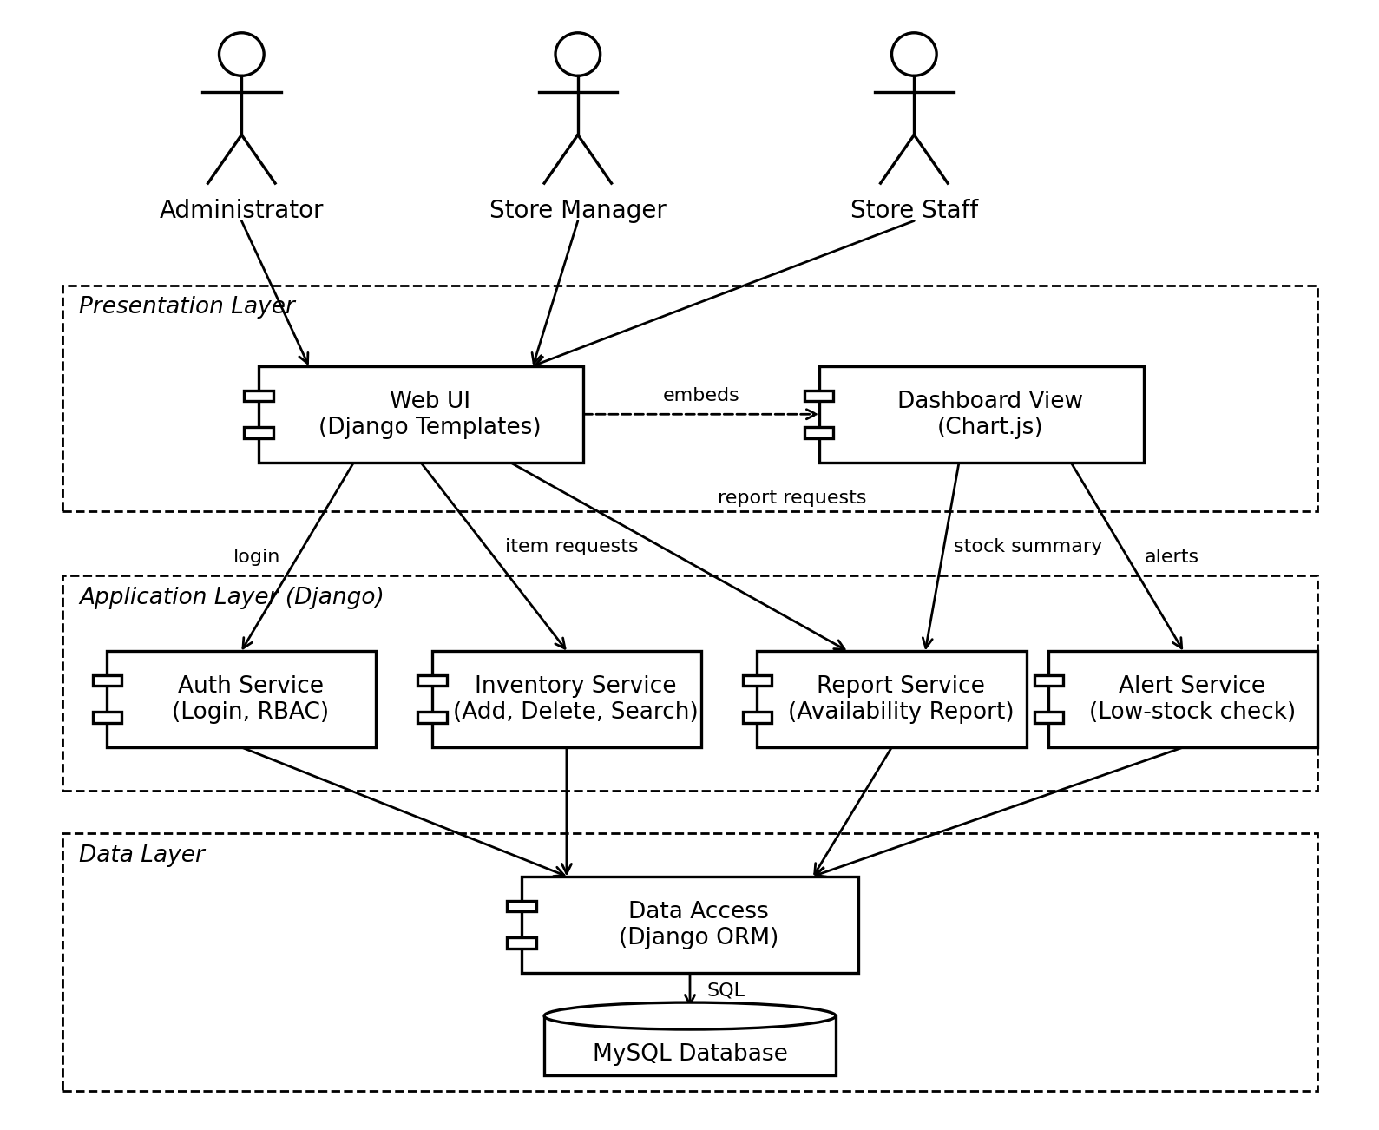
Figure 1: Component diagram of the Electronics Store Inventory Management System

3.4 Component Descriptions
- Web UI: Django templates with HTML, CSS and JavaScript. Handles user input and displays inventory lists, forms and reports.
- Dashboard View: shows total items, total stock quantity, category-wise stock and low-stock alerts using simple charts.
- Auth Service: handles login and logout and checks the user role (Admin, Manager, Staff) before an action is allowed.
- Inventory Service: implements adding items, deleting items, and searching or listing the inventory. Validates data such as unique SKU and non-negative quantity.
- Report Service: produces the availability report and classifies each item as In Stock, Low Stock or Out of Stock. Supports filtering and CSV export.
- Alert Service: compares each item's quantity with its reorder level and supplies the list of low-stock items to the dashboard.
- Data Access (Django ORM): the only layer that talks to the database, so business logic does not contain raw SQL.
- Database: MySQL database storing items, categories, users and audit log entries.

3.5 Chosen Architecture Pattern and Rationale
A layered architecture (presentation, application, data) is used, implemented with Django's Model-View-Template structure. This gives a clear separation of concerns, lets each layer be tested separately, and matches the size of the project. Microservices were rejected because they add deployment and communication overhead that is not justified for a single-store inventory application. A MERN stack was also considered, but Django was chosen because it provides authentication, an ORM, form validation and an admin interface out of the box, which reduces development effort.

3.6 Technology Stack & Data Stores
Backend: Python 3 with Django and Django REST Framework. Frontend: Django templates, HTML, CSS, JavaScript and Chart.js for the dashboard. Database: MySQL, accessed through the Django ORM. Version control: Git and GitHub.
Main data stores (tables):
- Item: id, sku (unique), name, category, quantity, unit_price, reorder_level, is_deleted, created_at, updated_at
- Category: id, name
- User: id, username, password hash, role
- AuditLog: id, user, action, item, timestamp

3.7 Risks & Mitigations
Risk: wrong or duplicate item entries → Mitigation: unique SKU constraint and form validation.
Risk: an item is deleted by mistake → Mitigation: soft delete (the item is marked deleted rather than removed) and a confirmation prompt.
Risk: data loss due to system failure → Mitigation: regular database backups.
Risk: unauthorised changes to stock → Mitigation: login required and role-based permissions, with every change written to the audit log.

3.8 Traceability to Requirements
R1 (User login and role check) → Auth Service
R2 (View and search inventory) → Inventory Service
R3 (Add item) → Inventory Service
R4 (Delete item) → Inventory Service
R5 (Availability report) → Report Service
R6 (Dashboard and low-stock alerts) → Dashboard View, Alert Service

3.9 Security Architecture
Threat Modeling (STRIDE): Spoofing → login with hashed passwords and session management; Tampering → CSRF protection and server-side validation of all inputs; Repudiation → audit log of add and delete actions; Information disclosure → HTTPS/TLS and no sensitive data in error messages; Denial of Service → request rate limiting on the login page; Elevation of Privilege → RBAC checks on every view.

4. Design

4.1 Design Overview
The system is designed as a set of Django modules (apps) for accounts, inventory, reports and dashboard. Views receive requests from the browser, call service functions that hold the business rules, and use models to read and write the database. Templates render the results. This keeps each module small and easy to maintain.

4.2 UML Sequence Diagrams
Flow 1: Add a new item
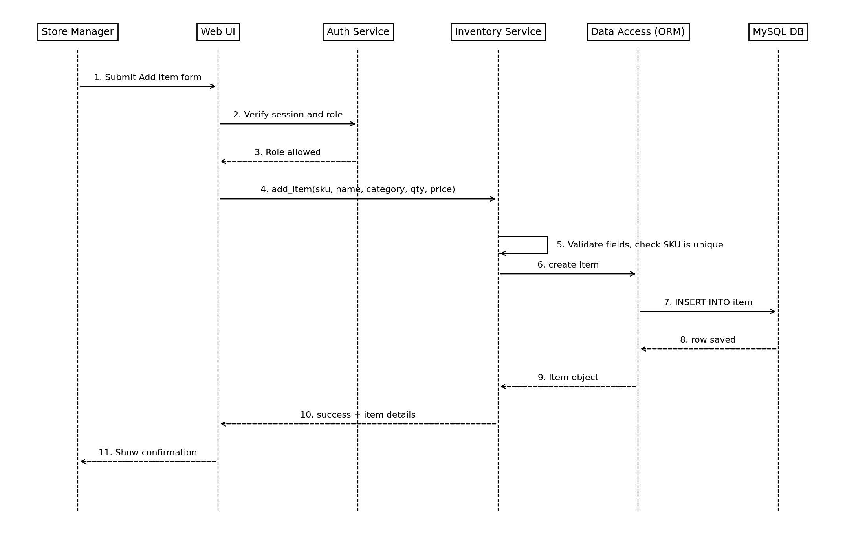
Figure 2: Sequence diagram for adding an item
Flow 2: Generate availability report
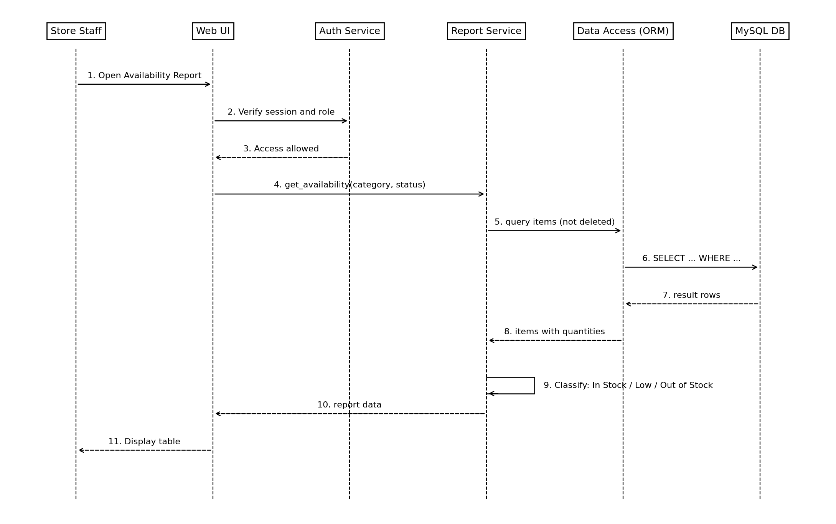
Figure 3: Sequence diagram for the availability report

4.3 API Design
Inventory Service
Endpoint: /api/items/
Method: POST
Request: {sku, name, category, quantity, unit_price, reorder_level}
Response: {id, sku, name, quantity, status}
Errors: 400 Invalid data, 401 Not logged in, 403 Not permitted, 409 SKU already exists.

Endpoint: /api/items/{id}/
Method: DELETE
Request: none (item id in the URL)
Response: {status: "deleted"}
Errors: 401 Not logged in, 403 Not permitted, 404 Item not found.
Report Service
Endpoint: /api/reports/availability/
Method: GET
Request: optional query parameters category and status (in_stock, low, out)
Response: {generated_at, items: [{sku, name, category, quantity, status}]}
Errors: 401 Not logged in, 400 Invalid filter.

4.4 Error Handling, Logging & Monitoring
Standardised error messages are shown for validation errors, permission errors and missing records. Passwords and other sensitive data are never written to logs. Add and delete actions are recorded in the audit log with user and time. Django logging is used to record application errors, and the number of failed requests and low-stock items is monitored from the dashboard.

4.5 UX Design
Simple, clean pages with a navigation menu (Dashboard, Inventory, Add Item, Reports). Tables support search and filtering. Forms show clear validation messages, delete asks for confirmation, and stock status is shown as text labels (In Stock, Low Stock, Out of Stock) so it is readable without depending on colour. Layout works on desktop and tablet screens.

4.6 Open Issues & Next Steps
Future enhancements: barcode scanning for items, supplier and purchase order management, automatic email alerts for low stock, and a mobile-friendly interface.

5. Appendices
5.1 Glossary: SKU, CRUD, RBAC, ORM, MVT, ADR, STRIDE, CSRF, TLS.
5.2 References: IEEE 42010, OWASP, NIST SP 800-160, Django documentation.
5.3 Tools: PlantUML, draw.io, Graphviz, Django, MySQL, Git.

