Software Requirements Specification (SRS)
Project: Electronics Store Inventory Management System
Version: 1.0
Authors: Ruchitha Y, Pranjal, Sudhe, Shanthinath
Date: 28-09-2026
Status: Draft

Revision history
Version | Date | Author | Change summary | Approval
1.0 | 28-09-2026 | Team 26 | SRS aligned to the course template; use-case diagrams, security and RTM added

Approvals
Role | Name | Signature / Email | Date
Course Coordinator

Table of Contents
1. Introduction
2. Overall description
3. External interface requirements
4. System features (detailed)
5. Non-functional requirements (detailed)
6. Quality attributes & Acceptance tests
7. System models and diagrams
8. Requirements Traceability Matrix (RTM)
Appendix A. Data requirements
Appendix B. Future enhancements

1. Introduction

1.1 Purpose
This document is the Software Requirements Specification (SRS) for the Electronics Store Inventory Management System, a web-based application that helps an electronics store manage its inventory of electronic components efficiently. It defines the functional and non-functional requirements, security requirements, interfaces and verification criteria of the system.
The system will allow authorized users to add and delete component records, view available inventory, generate availability reports, and monitor inventory information through a dashboard.

1.2 Scope
The system will provide the following major functionalities:
- Maintain electronic component inventory
- Add new components
- Delete existing components
- View component availability
- Generate inventory availability reports
- Display inventory information through a dashboard
The system is intended to replace or reduce manual inventory management and provide quick access to the current stock status. It does not include sales or billing functionality (see 2.5 and Appendix B).

1.3 Audience
Developers, QA engineers, project guides and evaluators, and the store staff who will use and maintain the system.

1.4 Definitions
SRS (Software Requirements Specification), UI (User Interface), FR (Functional Requirement), NFR (Non-Functional Requirement), SR (Security Requirement), AC (Acceptance Criteria), TC (Test Case), RBAC (Role-Based Access Control), TLS (Transport Layer Security), HTTPS (HTTP over TLS), RTM (Requirements Traceability Matrix).

2. Overall description

2.1 Product perspective
The system is a web-based inventory management application consisting of the user, a web interface, a backend application and a database. The web interface allows users to interact with inventory records, while the backend processes requests and maintains the database. The backend is organised into the following modules:
- Authentication Module: user login, user authentication and access control.
- Inventory Management Module: viewing, adding and deleting components and maintaining component information.
- Availability Management Module: determining component availability and identifying low-stock and out-of-stock components.
- Reporting Module: generating availability reports and presenting current inventory information.
- Dashboard Module: displaying inventory statistics and an overview of the current inventory status.

2.2 Major product functions
- Authenticate users and control access to inventory functions
- Component inventory: maintain and view component records (component ID, name, category, manufacturer, quantity, unit price, supplier, minimum stock level and availability status) and search them
- Add component
- Delete component
- Availability report: show available, out-of-stock and low-stock components with their current quantities
- Dashboard: show total number of components, total items in stock, and the number of available, low-stock and out-of-stock components

2.3 User roles and characteristics
- Store Administrator: manages inventory and monitors the system; needs an overview of stock status and reports.
- Inventory Staff: adds, deletes and checks component inventory; has basic computer and web application knowledge and expects quick, clear operations.

2.4 Operating environment
The system runs on a local or web server and is used through a standard web browser on a computer inside the store. The proposed technology stack is:
Layer | Technology
Frontend | HTML, CSS, JavaScript
Backend | Python Django
Database | SQLite
Development Environment | VS Code
Deployment | Local/Web Server

2.5 Constraints

Constraints
- The system requires a database for storing inventory records.
- Only authorized users can modify inventory.
- The initial system focuses on inventory management and does not include complete sales or billing functionality.
- The system depends on the availability of the server and database.

Assumptions
- Users who manage inventory will have valid login credentials.
- Each component will have a unique Component ID.
- Inventory staff will have basic computer and web application knowledge.
- The system will initially be designed for a single electronics store.

3. External interface requirements

3.1 User interfaces
The system shall provide a web-based interface containing the following major screens:
1. Login Page
2. Dashboard
3. Inventory Page
4. Add Component Page/Form
5. Availability Report Page
The inventory page shall allow authorized users to view and search existing components and perform permitted inventory operations such as deleting a component. Messages for success, validation errors and failures shall be shown on the same screen.

3.2 Hardware interfaces
The system does not interface with any special hardware in this version. It runs on a standard computer or server and is used from a computer with a keyboard, mouse or touch input. Barcode or QR-code scanners are listed as a future enhancement.

3.3 Software interfaces
- Database interface: the system shall use a database to store and retrieve component inventory information, including component details, quantities, stock levels and availability status.
- Web browser: the user interface shall work in current versions of common web browsers.
- No external third-party services or APIs are used in this version.

3.4 Communications
The browser communicates with the server over HTTP. When deployed on a network, HTTPS with TLS 1.2 or higher shall be used (see SR-007). The system does not require communication with any other system.

4. System features (detailed)
Each requirement below includes acceptance criteria and a reference test case. IDs follow FR-###.

4.1 Authentication and access control
Description: Authenticate users with a username and password and allow inventory operations only to authorized users.
Req ID | Requirement | Type | Priority | Source / Stakeholder | Acceptance criteria / Test case ref | Comments / Dependencies
FR-014 | The system shall restrict inventory management operations to authorized users. | Functional | High | Store Administrator | AC-FR-014: An unauthorized user attempting to add or delete inventory records is denied access to the operation. Test: TC-AUTH-02 | Depends on FR-015
FR-015 | The system shall allow a registered user to log in with valid credentials and to log out, and shall reject invalid credentials. | Functional | High | Store Administrator | AC-FR-015: Valid credentials start a session and open the dashboard; invalid credentials show an error and no session is created; logout ends the session. Test: TC-AUTH-01 | Needed before any other feature; see SR-001, SR-002

4.2 Inventory viewing and search
Description: Display the stored component records with their quantities and allow users to search them.
Req ID | Requirement | Type | Priority | Source / Stakeholder | Acceptance criteria / Test case ref | Comments / Dependencies
FR-001 | The system shall allow authorized users to view the list of electronic components in the inventory. | Functional | High | Inventory Staff | AC-FR-001: When an authorized user opens the inventory page, the system displays the stored component records with their relevant details. Test: TC-INV-01 | Depends on FR-015
FR-006 | The system shall display the current quantity of each component. | Functional | High | Inventory Staff | AC-FR-006: The inventory page displays the current quantity associated with every component record. Test: TC-INV-02 | Shown on the inventory page (FR-001)
FR-016 | The system shall allow authorized users to search the inventory by component ID, name or category. | Functional | Medium | Inventory Staff | AC-FR-016: Searching with a valid ID, name or category returns only the matching component records; if nothing matches, a 'no records found' message is shown. Test: TC-INV-03 | Depends on FR-001

4.3 Add component
Description: Add a new component after validating the details and checking that the Component ID is unique.
Req ID | Requirement | Type | Priority | Source / Stakeholder | Acceptance criteria / Test case ref | Comments / Dependencies
FR-002 | The system shall allow authorized users to add a new component to the inventory. | Functional | High | Inventory Staff | AC-FR-002: When valid component details are submitted, the system creates the component record and displays it in the inventory. Test: TC-ADD-01 | Fields listed in Appendix A
FR-003 | The system shall validate the required details before adding a new component. | Functional | High | Inventory Staff | AC-FR-003: The system shall reject an incomplete or invalid component form and display an appropriate validation message. Test: TC-ADD-02 | Applies to FR-002
FR-004 | The system shall prevent duplicate component IDs from being stored in the inventory. | Functional | High | Store Administrator | AC-FR-004: When a user attempts to add a component with an existing Component ID, the system rejects the entry and displays an error message. Test: TC-ADD-03 | Component ID is the unique key

4.4 Delete component
Description: Remove an existing component from the inventory after the user confirms.
Req ID | Requirement | Type | Priority | Source / Stakeholder | Acceptance criteria / Test case ref | Comments / Dependencies
FR-005 | The system shall allow authorized users to delete an existing component from the inventory. | Functional | High | Inventory Staff | AC-FR-005: When an authorized user selects a component and confirms deletion, the component is removed from the inventory. Test: TC-DEL-01 | Confirmation step required (see 7.2)

4.5 Availability status and report
Description: Determine the availability of each component and present it in an availability report.
Req ID | Requirement | Type | Priority | Source / Stakeholder | Acceptance criteria / Test case ref | Comments / Dependencies
FR-007 | The system shall determine the availability status of a component based on its current quantity and defined stock level. | Functional | High | Store Administrator | AC-FR-007: The system displays an appropriate availability status based on the component's quantity and minimum stock level. Test: TC-AVL-01 | Statuses: Available (above minimum), Low Stock (above zero, at or below minimum), Out of Stock (zero)
FR-008 | The system shall identify components that have reached or fallen below their minimum stock level. | Functional | Medium | Store Administrator | AC-FR-008: Components at or below the defined minimum stock level are identified as low-stock components. Test: TC-AVL-02 | Uses FR-007
FR-009 | The system shall identify components that are out of stock. | Functional | High | Store Administrator | AC-FR-009: Components with a quantity of zero are identified as out of stock. Test: TC-AVL-03 | Uses FR-007
FR-010 | The system shall generate an availability report containing current inventory information. | Functional | High | Store Administrator | AC-FR-010: When the user requests the report, the system generates and displays a report containing current component availability information. Test: TC-AVL-04 | Uses FR-007 to FR-009

4.6 Dashboard
Description: Give a summary of inventory information on one screen.
Req ID | Requirement | Type | Priority | Source / Stakeholder | Acceptance criteria / Test case ref | Comments / Dependencies
FR-011 | The system shall display inventory statistics on the dashboard. | Functional | Medium | Store Administrator | AC-FR-011: The dashboard displays summary information such as total components, available components, low-stock components, and out-of-stock components. Test: TC-DSH-01 | Uses FR-007 to FR-009

4.7 User messages
Description: Inform the user about the result of every inventory operation.
Req ID | Requirement | Type | Priority | Source / Stakeholder | Acceptance criteria / Test case ref | Comments / Dependencies
FR-012 | The system shall display a confirmation message after a successful inventory operation. | Functional | Medium | Inventory Staff | AC-FR-012: After a successful add or delete operation, the system displays a confirmation message to the user. Test: TC-MSG-01 | Applies to FR-002, FR-005
FR-013 | The system shall display an appropriate error message when an inventory operation cannot be completed. | Functional | Medium | Inventory Staff | AC-FR-013: When an operation fails due to invalid input or another error, the system displays an understandable error message. Test: TC-MSG-02 | Applies to all inventory operations

5. Non-functional requirements (detailed)
NFRs below are measurable and tied to test plans. IDs follow NFR-###.
Req ID | Requirement | Category | Priority | Acceptance criteria / Measurement
NFR-001 | The system shall respond to normal user operations within 3 seconds for at least 90% of requests under normal operating conditions (up to 10 concurrent users and up to 10,000 component records). | Performance | High | 90th percentile response time is 3 seconds or less in a test with the stated load. Test: TC-PERF-01
NFR-002 | The system shall require user authentication before allowing access to inventory management functions. | Security | High | An unauthenticated user attempting to access inventory management functions is redirected to or shown the login page. Test: TC-AUTH-03
NFR-003 | The system shall restrict component addition and deletion operations to authorized users. | Security | High | A user without the required permissions cannot add or delete component records. Test: TC-AUTH-02
NFR-004 | The system shall be available during the store's operating hours, except during scheduled maintenance. | Availability | Medium | Users can access the system for at least 99% of the store's operating hours in a month, excluding planned maintenance. Test: uptime review (TC-OPS-01)
NFR-005 | The system shall provide a simple and intuitive user interface that allows inventory staff to perform common inventory operations with minimal training. | Usability | Medium | A user can navigate to the inventory, add/delete component, and view availability/report functions without requiring extensive instructions. Test: TC-UX-01
NFR-006 | The system shall maintain consistent inventory records and prevent invalid inventory data from being stored. | Reliability | High | After an inventory operation, the stored component information remains valid and consistent with the operation performed. Test: TC-REL-01
NFR-007 | The system shall be capable of handling an increasing number of component records without requiring major changes to the system architecture. | Scalability | Medium | The system continues to provide its core inventory functions as the number of stored component records increases up to the intended capacity of 10,000 records. Test: TC-PERF-02
NFR-008 | The system shall use a modular structure so that future inventory-related functionality can be added with minimal modification to existing modules. | Maintainability | Low | Individual modules can be modified or extended without requiring major changes to unrelated system functionality. Test: design review (TC-MNT-01)

5.1 Security

5.1.1 Security objectives
1. Confidentiality and access control: only authenticated and authorized users can view or change inventory data.
2. Integrity: inventory records are changed only through validated operations, so the stored data stays correct and consistent.
3. Accountability: every change to the inventory can be traced to a user and a time.

5.1.2 Security requirements
Req ID | Requirement (shall...) | Type | Priority | Acceptance criteria / Test case ref
SR-001 | User passwords shall be stored only as salted hashes and never in plain text. | Security | High | AC-SR-001: The database contains no readable passwords. Test: TC-SEC-01
SR-002 | A user session shall expire automatically after 30 minutes of inactivity. | Security | Medium | AC-SR-002: After 30 minutes without activity the next request redirects to the login page. Test: TC-SEC-02
SR-003 | The system shall check the user's authentication and role on the server for every request to an inventory function, not only in the user interface. | Security | High | AC-SR-003: Opening an add or delete address directly without permission is denied. Test: TC-SEC-03
SR-004 | The system shall validate all user input on the server and protect forms against SQL injection, cross-site scripting and cross-site request forgery. | Security | High | AC-SR-004: Malicious input and forms without a valid request token are rejected and nothing is stored. Test: TC-SEC-04
SR-005 | The system shall record every add and delete operation in an audit log with the user, component ID and date/time, and shall not write passwords to any log. | Security | Medium | AC-SR-005: Each add/delete appears in the log with the required details; logs contain no passwords. Test: TC-SEC-05
SR-006 | The system shall temporarily block login for a user after 5 consecutive failed attempts. | Security | Medium | AC-SR-006: After 5 failed attempts further login attempts are refused for 15 minutes and a message is displayed. Test: TC-SEC-06
SR-007 | When deployed on a network, all communication between the browser and the server shall use HTTPS (TLS 1.2 or higher). | Security | High | AC-SR-007: Requests over plain HTTP are refused or redirected to HTTPS. Test: TC-SEC-07

6. Quality attributes & Acceptance tests
Quality attributes addressed by this SRS: performance (NFR-001), security (NFR-002, NFR-003, SR-001 to SR-007), availability (NFR-004), usability (NFR-005), reliability (NFR-006), scalability (NFR-007) and maintainability (NFR-008).
- Exit criteria for acceptance: all high-priority functional requirements are implemented and verified, no critical NFR or security requirement fails, and the RTM shows all test cases passed.
- Acceptance test suites: Authentication, Inventory (view and search), Add Component, Delete Component, Availability and Report, Dashboard, Messages, Performance, Reliability, Security and Usability tests.

7. System models and diagrams

7.1 UML Use-Case diagrams
Use-case diagram 1 shows inventory management.
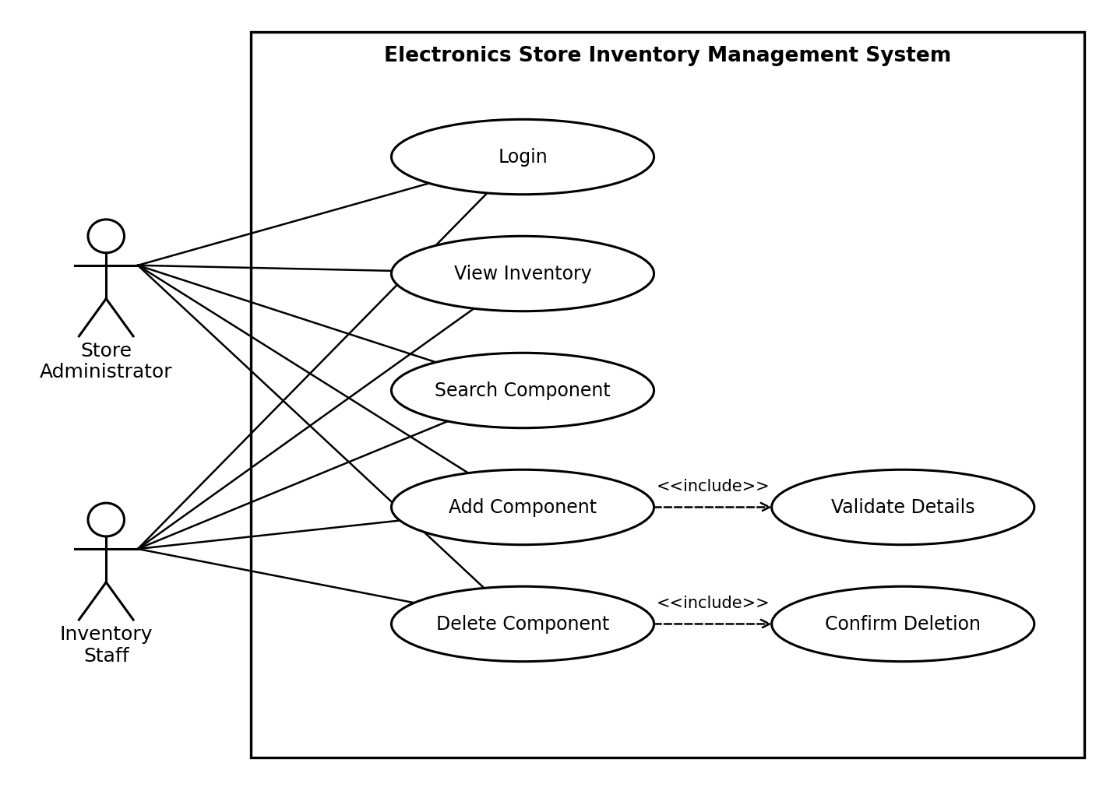
Figure 1: Use-case diagram for inventory management (all use cases other than Login require a logged-in user)
Use-case diagram 2 shows availability monitoring and reporting.
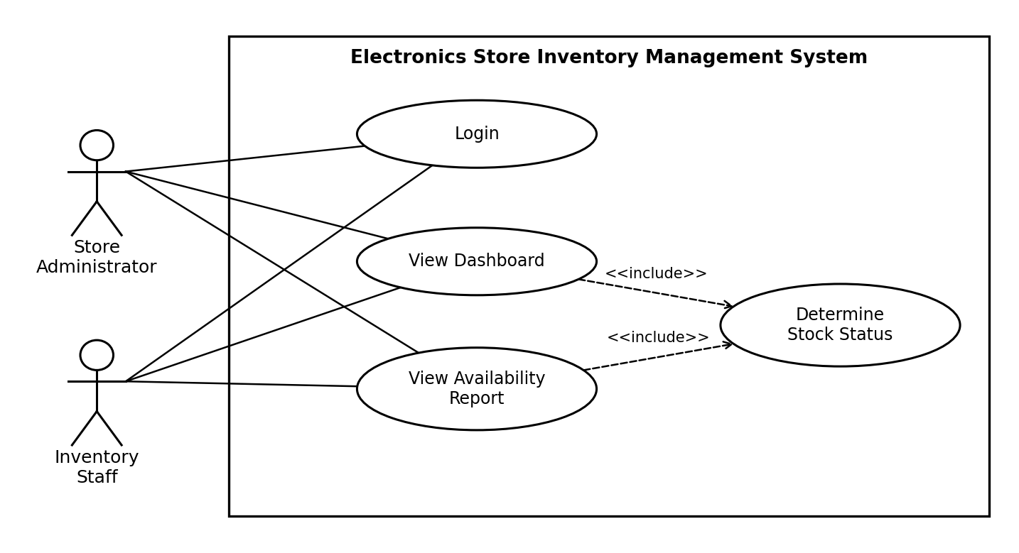
Figure 2: Use-case diagram for availability monitoring and reporting

7.2 Basic system workflow
Adding a Component
User Login → Dashboard → Add Component → Enter Component Details → Validate Details → Save Component → Display Confirmation
Checking Availability
User Login → Dashboard → Availability Report → Retrieve Inventory Data → Determine Stock Status → Display Availability Report
Deleting a Component
User Login → Inventory → Select Component → Delete Component → Confirm Deletion → Remove Record → Display Confirmation

8. Requirements Traceability Matrix (RTM)
SAD refers to the Software Architecture and Design Specification of this project.
Req ID | Requirement short | Section ref / Design Spec | Module | Test case(s) | Status (N/P/A) | Comments
FR-001 | View component list | 4.2 / SAD 3.4 | Inventory Management Module | TC-INV-01 | N
FR-002 | Add component | 4.3 / SAD 3.4, 4.3 | Inventory Management Module | TC-ADD-01 | N
FR-003 | Validate component details | 4.3 / SAD 3.4 | Inventory Management Module | TC-ADD-02 | N
FR-004 | Prevent duplicate ID | 4.3 / SAD 3.6 | Inventory Management Module | TC-ADD-03 | N
FR-005 | Delete component | 4.4 / SAD 3.4, 4.3 | Inventory Management Module | TC-DEL-01 | N
FR-006 | Show current quantity | 4.2 / SAD 3.4 | Inventory Management Module | TC-INV-02 | N
FR-007 | Determine availability status | 4.5 / SAD 3.4 | Availability Management Module | TC-AVL-01 | N
FR-008 | Identify low stock | 4.5 / SAD 3.4 | Availability Management Module | TC-AVL-02 | N
FR-009 | Identify out of stock | 4.5 / SAD 3.4 | Availability Management Module | TC-AVL-03 | N
FR-010 | Availability report | 4.5 / SAD 3.4, 4.3 | Reporting Module | TC-AVL-04 | N
FR-011 | Dashboard statistics | 4.6 / SAD 3.4 | Dashboard Module | TC-DSH-01 | N
FR-012 | Confirmation message | 4.7 / SAD 4.4 | Inventory Management Module | TC-MSG-01 | N
FR-013 | Error message | 4.7 / SAD 4.4 | All modules | TC-MSG-02 | N
FR-014 | Restrict to authorized users | 4.1 / SAD 3.9 | Authentication Module | TC-AUTH-02 | N
FR-015 | Login and logout | 4.1 / SAD 3.4 | Authentication Module | TC-AUTH-01 | N
FR-016 | Search inventory | 4.2 / SAD 3.4 | Inventory Management Module | TC-INV-03 | N
NFR-001 | Response time target | 5 / SAD 3.5 | All modules | TC-PERF-01 | N
NFR-002 | Authentication required | 5 / SAD 3.9 | Authentication Module | TC-AUTH-03 | N
NFR-003 | Add/delete restricted | 5 / SAD 3.9 | Authentication Module | TC-AUTH-02 | N
NFR-004 | Availability in store hours | 5 / SAD 3.1 | All modules | TC-OPS-01 | N
NFR-005 | Simple user interface | 5 / SAD 4.5 | All modules | TC-UX-01 | N
NFR-006 | Consistent inventory data | 5 / SAD 3.6 | Inventory Management Module | TC-REL-01 | N
NFR-007 | Handles growing records | 5 / SAD 3.5 | All modules | TC-PERF-02 | N
NFR-008 | Modular structure | 5 / SAD 3.5 | All modules | TC-MNT-01 | N
SR-001 | Hashed passwords | 5.1.2 / SAD 3.9 | Authentication Module | TC-SEC-01 | N
SR-002 | Session timeout | 5.1.2 / SAD 3.9 | Authentication Module | TC-SEC-02 | N
SR-003 | Server-side role check | 5.1.2 / SAD 3.9 | Authentication Module | TC-SEC-03 | N
SR-004 | Input validation, CSRF/XSS/SQLi | 5.1.2 / SAD 3.9 | All modules | TC-SEC-04 | N
SR-005 | Audit log | 5.1.2 / SAD 3.9, 4.4 | Inventory Management Module | TC-SEC-05 | N
SR-006 | Login lockout | 5.1.2 / SAD 3.9 | Authentication Module | TC-SEC-06 | N
SR-007 | HTTPS/TLS | 5.1.2 / SAD 3.9 | All modules | TC-SEC-07 | N

Appendix A. Data requirements
The primary entity maintained by the system is Component. A component record shall contain the following information:
Attribute | Description
Component ID | Unique identifier for the component
Component Name | Name of the electronic component
Category | Category to which the component belongs
Manufacturer | Manufacturer of the component
Quantity | Current quantity available
Unit Price | Price per unit
Supplier | Supplier of the component
Minimum Stock Level | Minimum quantity that should be maintained
Availability Status | Current availability of the component

The Component ID shall uniquely identify each component.

Appendix B. Future enhancements
The following features may be considered for future versions. They are not part of the initial system scope.
- Editing/updating component information
- Supplier management
- Purchase and sales tracking
- Automatic low-stock notifications
- Barcode or QR-code scanning
- Inventory history
- Exporting reports to PDF or Excel
- Multiple-store inventory management

