## FEATURES

* **Wind speed sensor**
* **Total error within 10% of full-scale**
* **Temperature sensor**
* **Low consumption**
* **No moving parts**
* **Real time transmission capabilities**
* **No-maintenance**

## 

## GENERAL DESCRIPTION

The WIND2301 is a hot wire thermal anemometer based on solid-state components. It operates without moving parts, making it a sensor with low maintenance and cost. Capable of recording wind data accurately on any plane and in real time.

To provide win speed measurements, the device reads a NTC sensor type. An internal algorithm computes all measurements, establishing the wind speed every second. Additionally, it captures temperature information which, combined with speed data, is useful for predicting thermal turbulence.

The simplicity of the WIND2301 does not compromise its versatility.

## MEASUREMENT CAPABILITY

|  |  |
| --- | --- |
| Wind speed resolution | 0,01 m/s |
| Wind speed accuracy * | 10 % |
| Wind direction | omnidirectional |
| Wind speed range | 0 – 120 km/h |

* Approximate values. They depend on the use and conditions of the environment.

## ENVIROTMENT & POWER SUPPLY

|  |  |
| --- | --- |
| Working temperature range | -20 ºC +50 ºC |
| Temperature accuracy | ±0.2 ºC |
| Power DC input Supply | 3.3 V |
| Consumption | <1 mA |

## FUNCTIONALBLOCKDIAGRAM

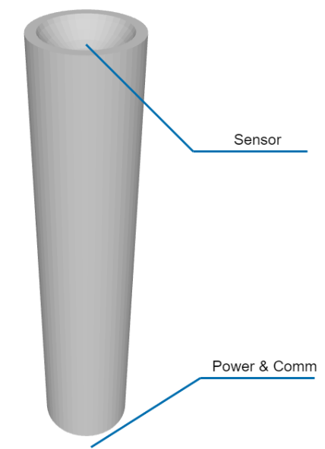

## COMPLIANCE AND CERTIFICATIONs

IP68 full waterproof protection

## COMMUNICATIONS

|  |  |
| --- | --- |
| Serial connectivity | 115,200 baud |
| Max. reading frequency | 1 per second |

## APPLICATIONS

* **Wind measures in remote locations**
* **Prediction of thermal turbulence**