# **Integration Testing**

# For Use-Case: Check In

1. Brief Description

When a customer

Wants to stay at the hotel they check in

So that they can gain access to their room

Hotel use case for check in is all about A Customer(guest)’s need to stay in a hotel. And to do that he needs to check in to the hotel so they can get access to particular room.

1. Actors

Customer (Guest)

1. Pre-Conditions
   1. The main menu is displayed
2. Normal Flow

The use case begins when customer selects check in option on the main menu.

|  |  |
| --- | --- |
| **Actor** | **System** |
|  | 1. Prompt to enter confirmation number |
| 1. Enter confirmation number | 1. Find booking by confirmation number |
|  | 1. Display booking information |
|  | 1. Prompt to confirm check in |
| 1. Confirm Check in | 1. Display check in confirmed message |
| 1. Continue |  |

The use case ends.

Here are the sample code screenshots for above flow:

1. Prompt to enter confirmation number
2. Enter confirmation number

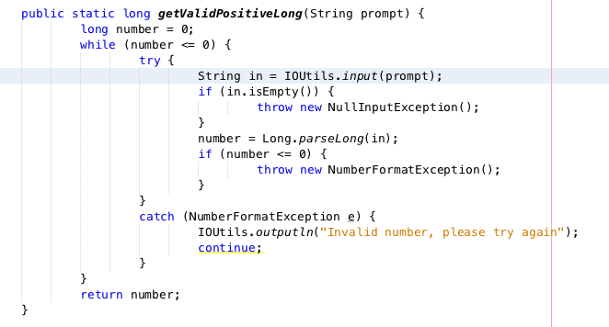

Figure : Prompt to enter confirmation number

1. Find booking by confirmation number

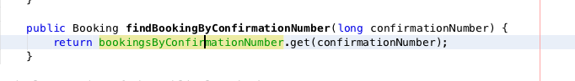

Figure 2: Find booking details by conformation number

1. Display booking information

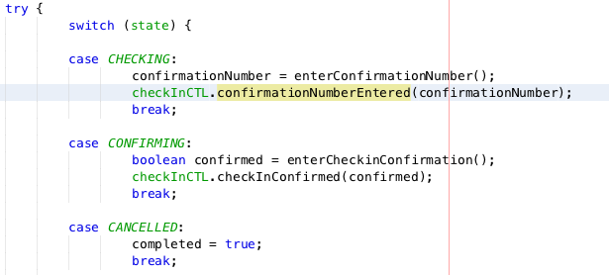

Figure 3: Display information

1. Prompt to confirm check in
2. 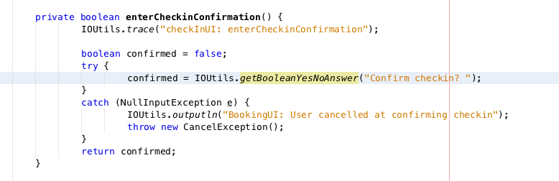Confirm check in

Figure : Prompt user to confirm & Response to prompt

1. Display checkin confirm message

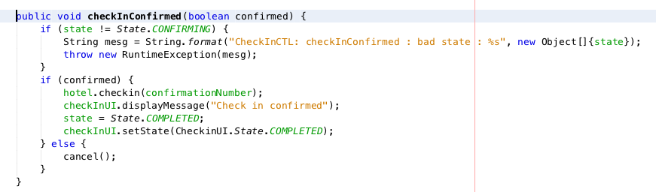

Figure 5: Display confirm message

1. Alternate Flow
   1. Confirmation Number Not Found

If at step 3, of the normal flow the booking is not found, then

|  |  |
| --- | --- |
| Actor | System |
|  | The system displays a confirmation number not found message |

The normal flow is resumed at step 1.

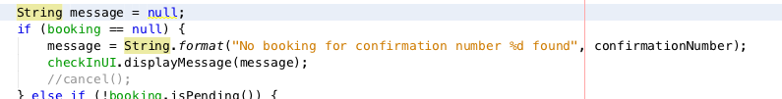

Figure 6: Error - Confirmation number not found

* 1. Already Checked In

If at step 3, of the normal flow the booking is found, but has already checked in, then

|  |  |
| --- | --- |
| Actor | System |
|  | The system displays an already checked in message |

The normal flow is resumed at step 1.

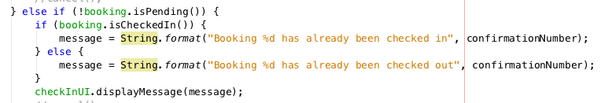

Figure 7: Error - Booking is pending

* 1. Already Checked Out

If at step 3, of the normal flow the booking is found, but has already checked out, then

|  |  |
| --- | --- |
| Actor | System |
|  | The system displays an already checked out message |

The normal flow is resumed at step 1.



Figure 8: Error - alrerady checked out

* 1. Room Not Ready

If at step 3, of the normal flow the booking is found, but the room is still occupied, then

|  |  |
| --- | --- |
| Actor | System |
|  | The system displays a room not ready message |

The normal flow is resumed at step 1.

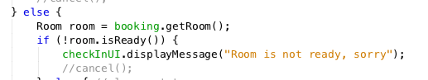

Figure 9: Error - Room is not ready

1. Key Scenarios
   1. Successful check in
   2. No booking found
   3. Already checked in
   4. Already checked out
   5. Room not ready
2. Post-conditions
   1. Normal flow and other flows where a check in is successful.

Booking state updates to CHECKED_IN

Room state updated to OCCUPIED

The active booking can be found by the hotel using the room number

* 1. All other unsuccessful scenarios

No change to anything