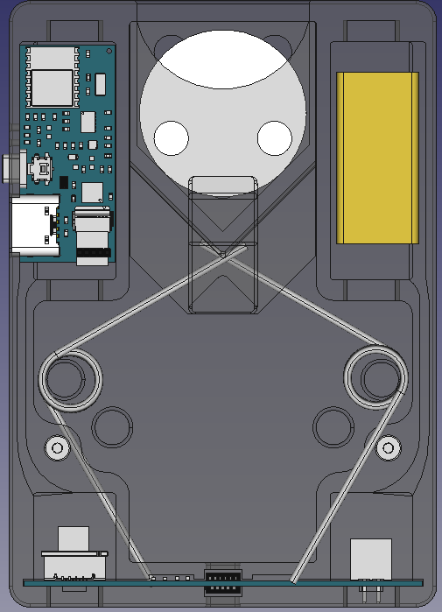
Method for Calculating Spring Angle Unloaded and Loaded
b₁
γ₁
a
b
c
β
α
γ
Find angle with 3 sides
α = arccos [(b² + c² - a²)/(2bc)]
β = arccos [(a² + c² - b²)/(2ac)]
γ = arccos [(a² + b² - c²)/(2ab)]

Find side with 2 sides and 1 angle
a = √[b² + c² - 2bc • cos(α)]
b = √[a² + c² - 2ac • cos(β)]
c = √[a² + b² - 2ab • cos(γ)]

Find 3rd angle with 2 angles
α + β + γ = 180°

Find side with 1 side and 2 angles
a / sin(α) = b / sin(β) = c / sin(γ)

α₁
a
β
c₁
The red Δ represents the spring unloaded in which:
‘α₁’ = 90°
‘b₁’ = case dimension
‘c₁’ or ‘γ₁’ is optional input
to determine ‘a’ and ‘β’

Once ‘a’ and ‘β’ are calculated from the red Δ, then they can be used as a reference to calculate ‘γ₂’ and ‘b₂’ for the orange Δ

Angle ‘γ₂’ is the spring’s deflection angle which is used to determine the force exerted on the carrier

Side ‘a’ is the lever arm length for the red Δ and side ‘b₂’ is the lever arm length for the orange Δ
c₂
γ₂
b₂
Method for Calculating Height Offset of Projectile In Carriage
(1)
(2)
(3)
(4)
(1) Carrier position is acquired from the inner range sensor

(2) Back of carrier to vertex of the carrier pocket is a known case dimension

(3) Projectile offset is calculated from above equations

(4) Height offset = (1) + (2) + (3)
Projectile
Vertex of carrier pocket
is physically designed at 45°
c
b
a
Know data:
α = 45°
β = 45°
γ = 90°
a = projectile radius

Therefor:
c = b*sin(γ)/sin(β)
or..
c = a*sin(γ)/sin(α)
β
α
γ
Method for Calculating Target Height Given Target Distance and Device Height
γ₂
γ₁
Phone
Procedure:

(1) Point phone camera at base of target to get target distance using the device height and pitch angle

(2) Lock in the calculated target distance

(3) With the phone at the same height, tilt the phone upwards to the top of the target

(4) The app will then use the new angle delta and the locked in target distance to determine the target height
α₁ = 180 - γ₁ - β₁
α₂
α₁
c
0°
90°
β₀
Pitch angle from phone’s gyro
β₃
β₂
Target height angle:
β₃ = 90° - β₀
Angle delta when β₃ > β₁:
β₂ = β₃ - β₁

c = √(a₁² + b₁²)
or..
c = (a₁ • sin(90°)) / sin(α₁)
or..
c = (b₁ • sin(90°)) / sin(β₁)

γ₂ = 180 - α₂ – β₂

α₂ = 90 - α₁
Target height = b₂ = (c • sin(β₂)) / sin(γ₂)
Target distance = b₁ = a₁ • tan(β₁)
a₁ is the lens height
Target distance angle:
β₁ = 90° - β₀
β₁
a₂
b₂
b₁
a₁
Method for Calculating Lens Height At Pitch Angle
α₂ = 90° – α₁
b = c • sin(α₂)
a = c • cos(α₂)

h_{t} = h_{d} + b
a
c
h_{t}
c
Ground
b
α₁ is the pitch angle in degrees acquired from the phone’s gyro

b is the adjusted lens height offset

h_{d} is the distance from the face of the bottom sensor to ground

h_{t} is the total lens height
Lens
c is the distance between the face of bottom sensor to center of phone’s rear camera lens
Device
Phone
α₂
α₁
h_{d}
Method for Calculating Spring Forces
γ
α₁
γ₁
α₂

In order to find the net forward force on the projectile we need to find Fy and then multiply by 2 since there are two springs with an assumed equal spring constant.
F
F_{y}
F_{x}
γ₁ = α₁
α₂ = 90 – γ₁

F_{x} = F • cos(α₂)
F_{y} = F • sin(α₂)

OR

F_{x} = F • sin(γ)
F_{y} = F • cos(γ)
a
b
c

Method for Calculating Hit Confidence (HC)

In the above example:
- Projectile (A) has 100% hit confidence.
- Projectile (B) has < 100% hit confidence.

If Target Height > 0

HC = ((Target Distance + Est Impact Height) / (Target Distance + Target Height)) • 100

Else..

HC = (Est Impact Distance / Target Distance) • 100
Target Height
Target Distance
Est Impact Height
Est Impact Distance
(A)
(B)
Target
Method for Calculating The Projectile Height and Distance Offsets
α₂ = 90° – α₁

a₁ = c₁ • sin(α₂)
b₁ = c₁ • sin(α₂)

b₂ = c₂ • sin(α₂)
a₂ = c₂ • cos(α₂)

h_{t1} = h_{d} + b₁
h_{t2} = h_{d} + b₂

a₃ = a_{1 –} a₂

d_{tt} = d_{t +} a₃
d_{tt}
d_{t}
a₃
h_{t2}
c₂
b₂
a₂
a₁
c₁
h_{t1}
b₁
α₂
α₁
h_{d}

How to find the equation of a line, tangent to a circle, that passes through a given external point
