COMP 340  
Control Flow  
Paul Kim

1. Control Flow
2. Control Flow Statement
3. Sequence
4. Loop
   1. Count-based loop statement
   2. Collection-based loop statement
   3. Condition-based loop statement
5. Count-based loop statement
   1. C, Java, C#  
        
      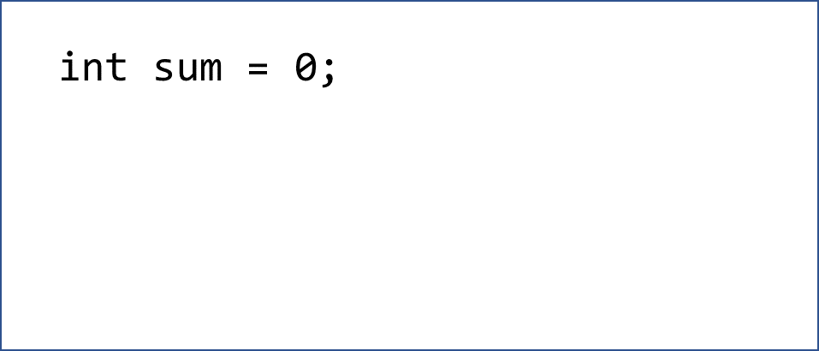
   2. Pascal  
        
      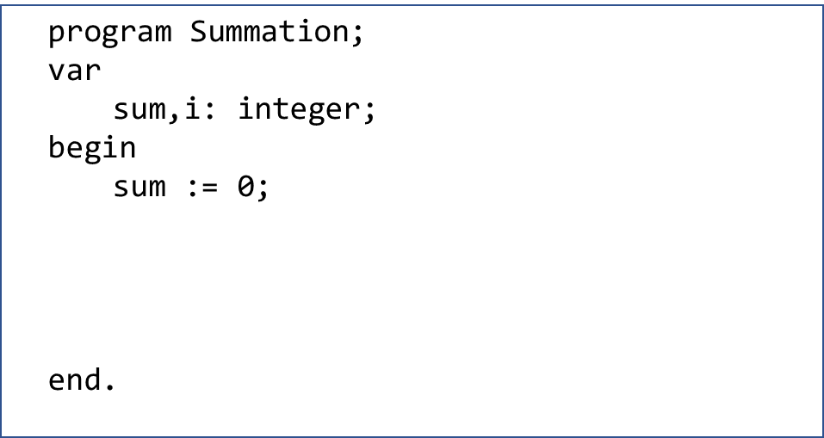
   3. Ruby  
        
      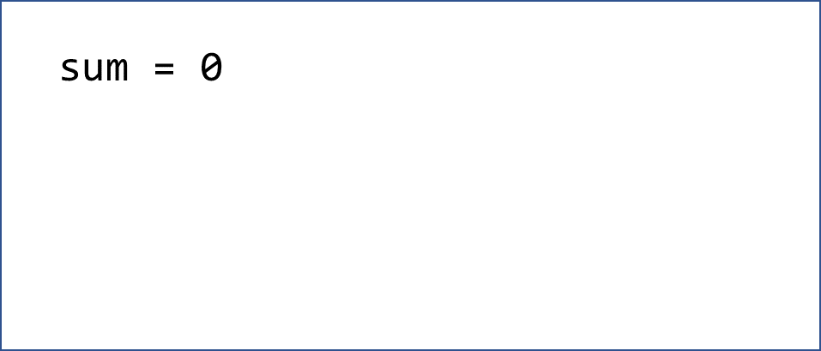
6. Collection-based loop statement
   1. Python  
        
      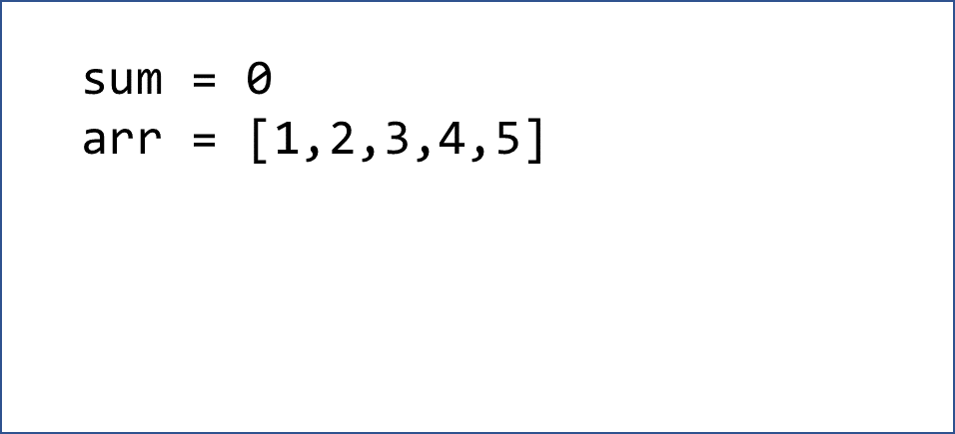
   2. Java, C#  
        
      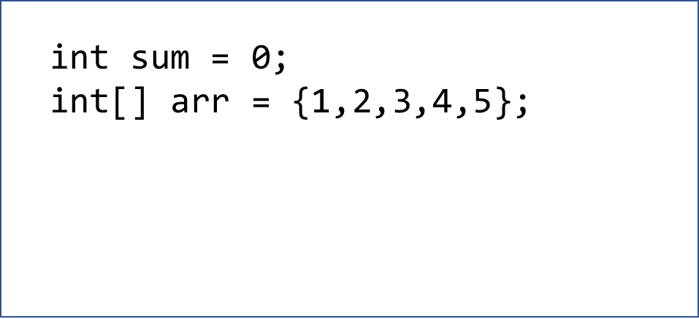
   3. Ruby  
        
      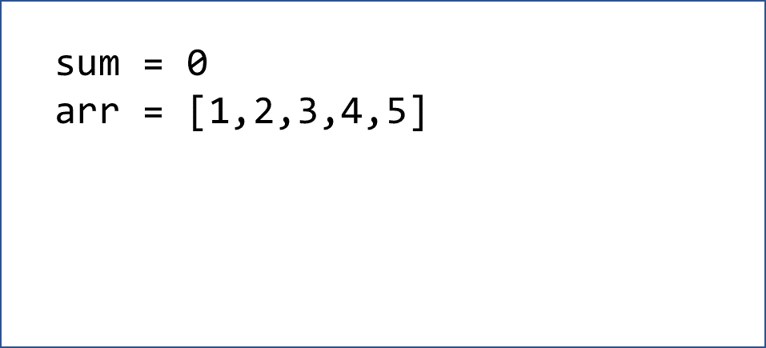
7. Condition-based loop statement
   1. Pre-test loop (while (condition)…)
      1. C, Java, C#  
           
         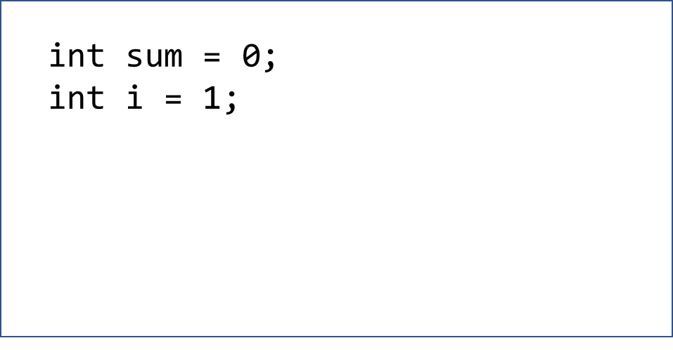
      2. Python  
         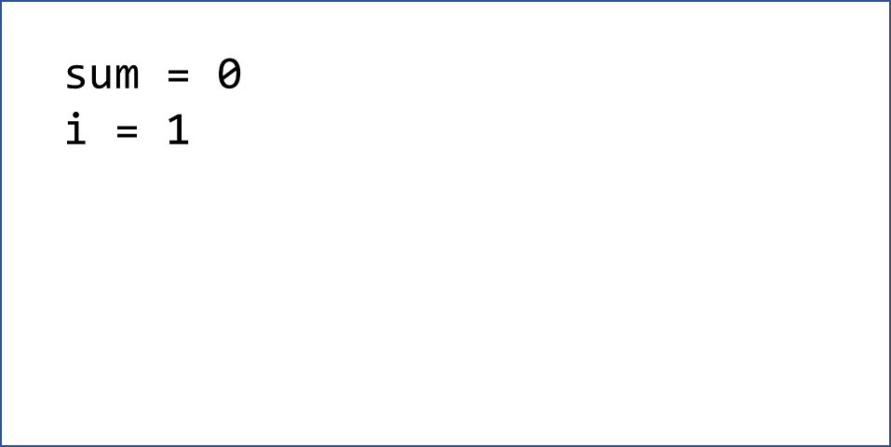
      3. Pascal  
           
         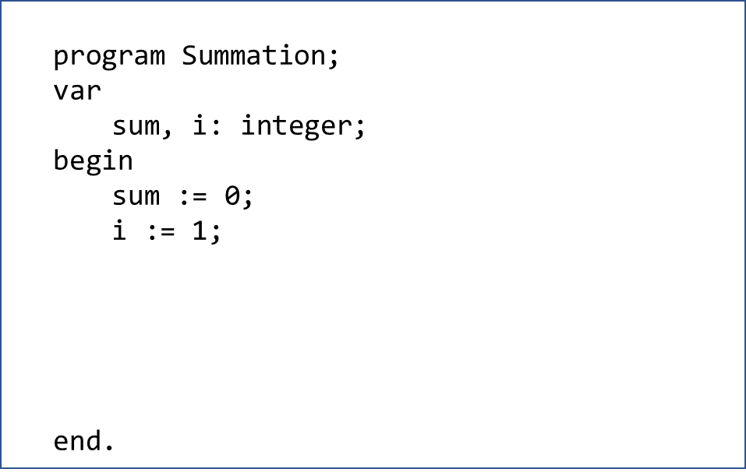
   2. Post-test loop (Do…while(condition))
      1. C, Java, C#  
           
         
      2. Swift  
           
         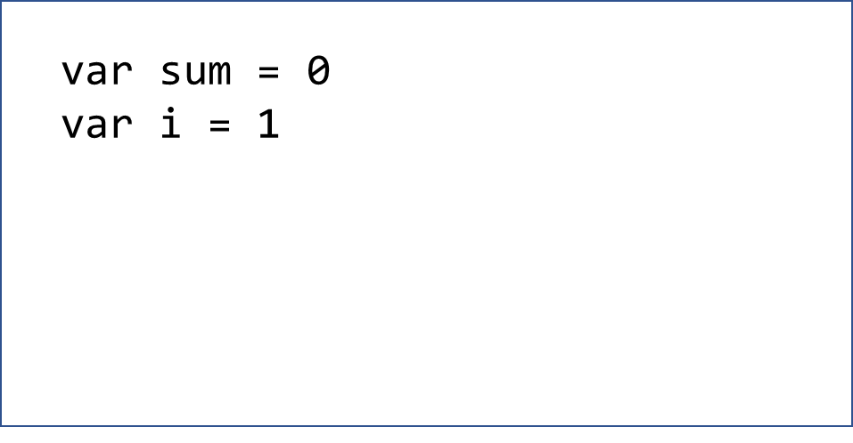
      3. Ruby  
           
         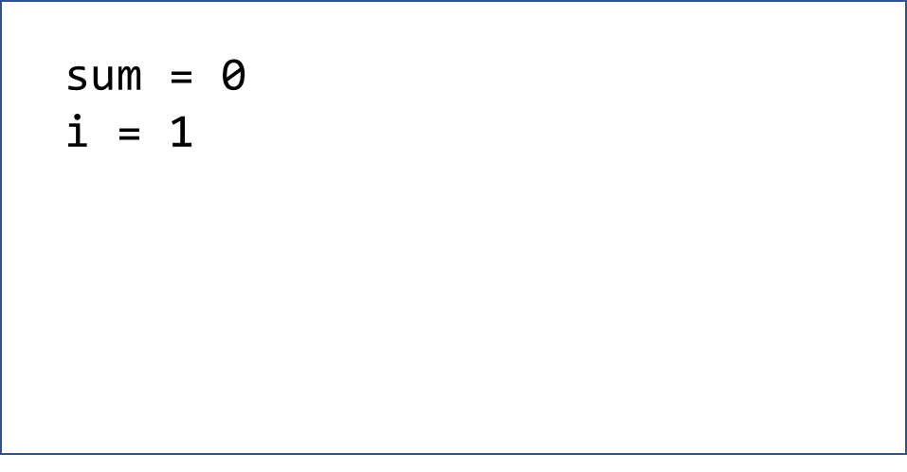
      4. Pascal  
           
         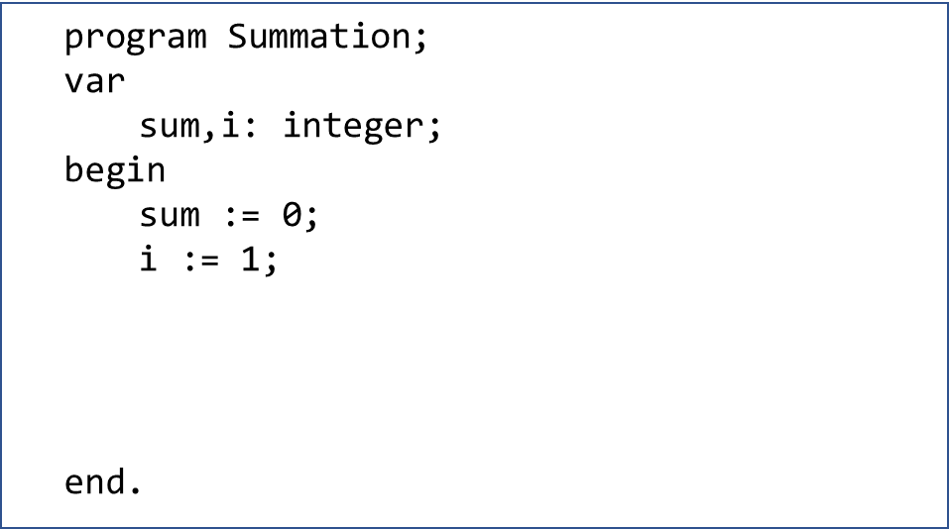
   3. Pre-test loop vs post-test loop  
        
        
      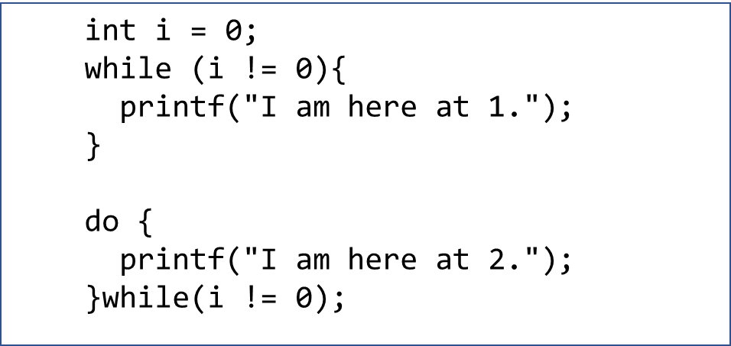
8. Choice

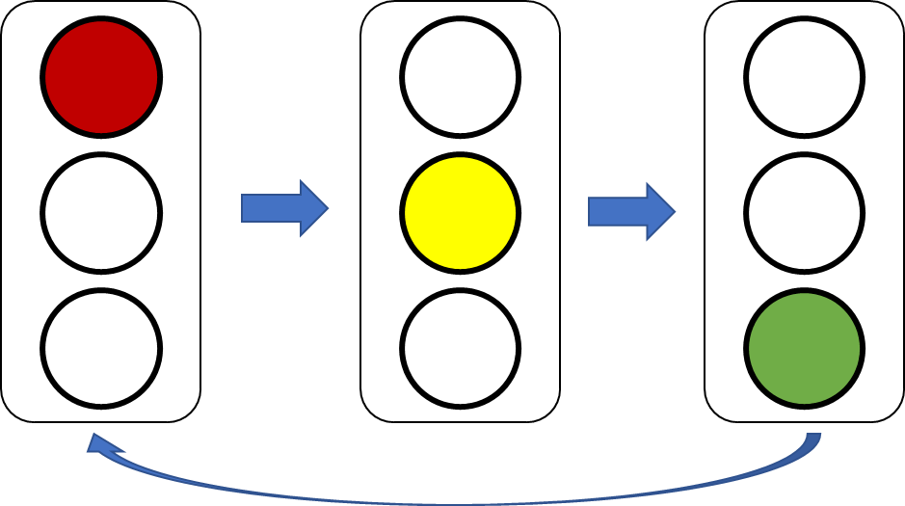

* 1. If statement
     1. Java, C#  
          
        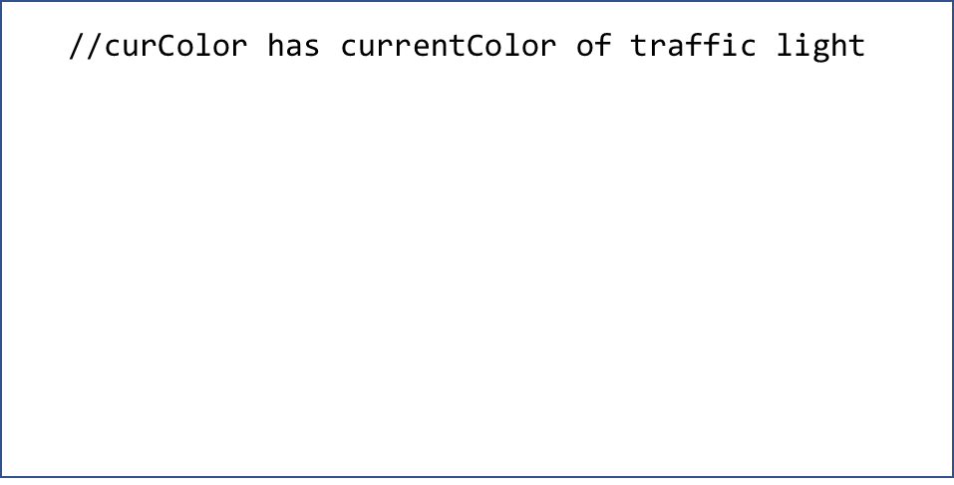
     2. Python  
          
        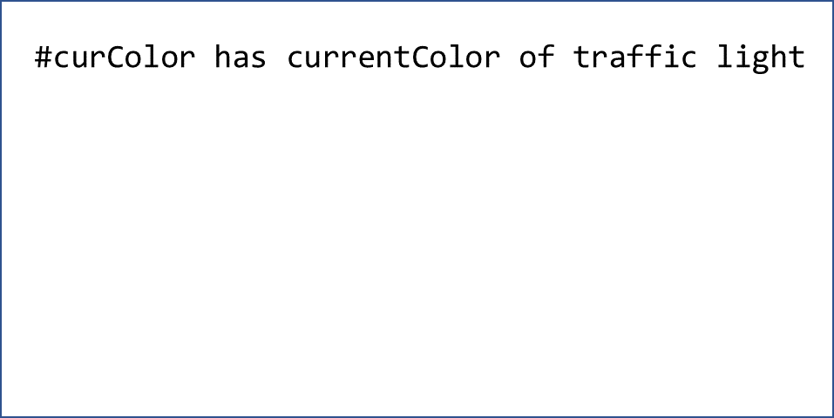
  2. If expression
     1. Rust  
          
        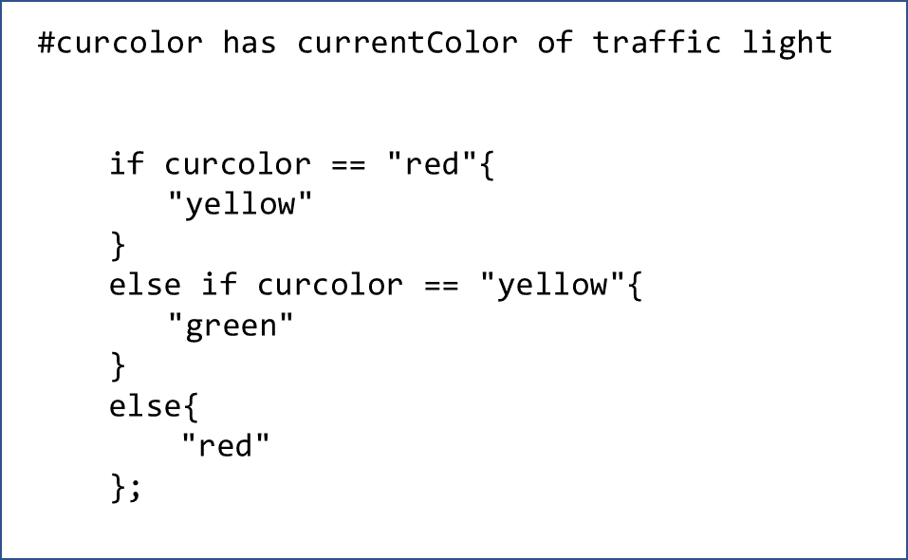
  3. If expression with ternary operator
     1. Python
        1. Single condition
        2. Multiple conditions

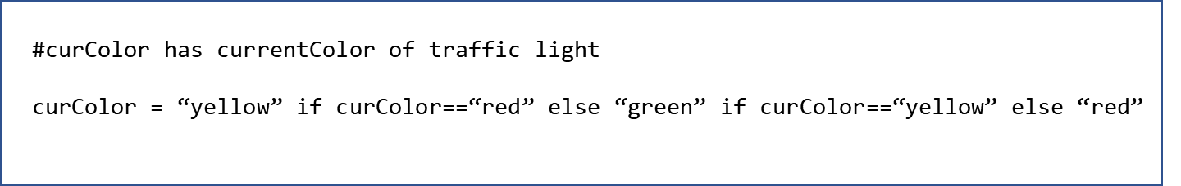

* + 1. Java, C#
       1. Single condition
       2. Multiple conditions

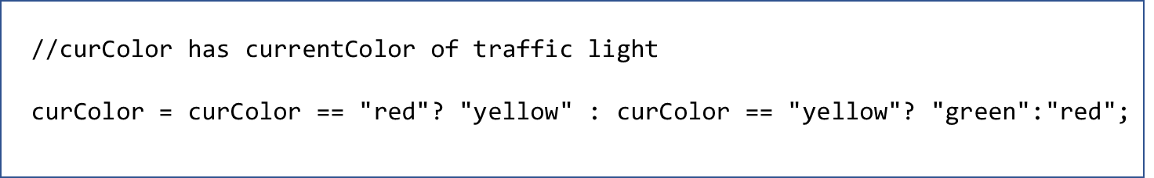

* 1. Switch (Case) Statement  
     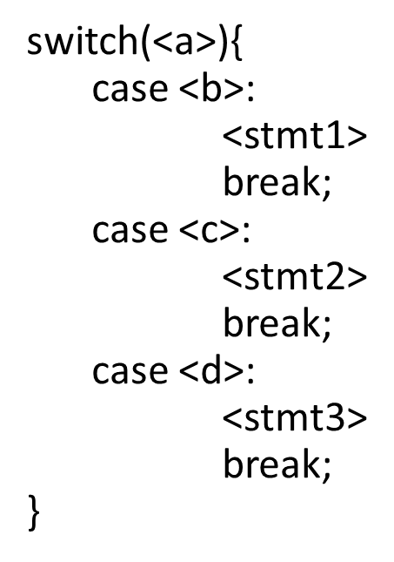
     1. Java, C#  
          
        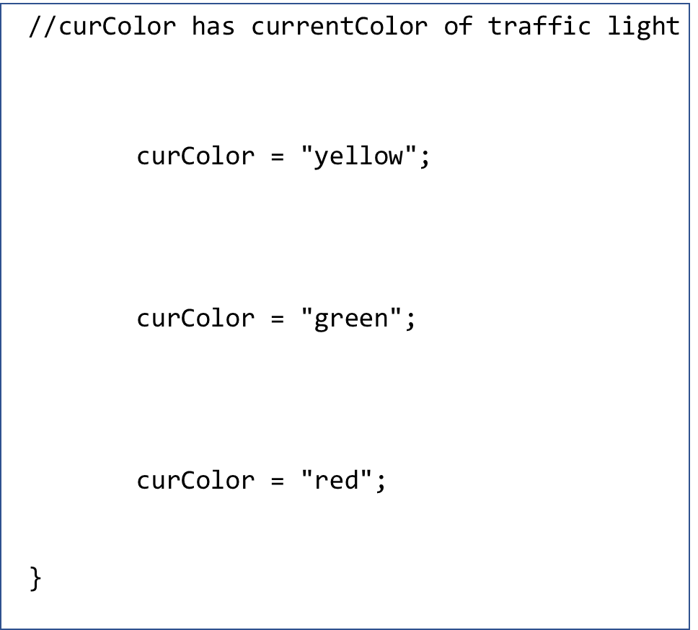
     2. Ruby  
          
        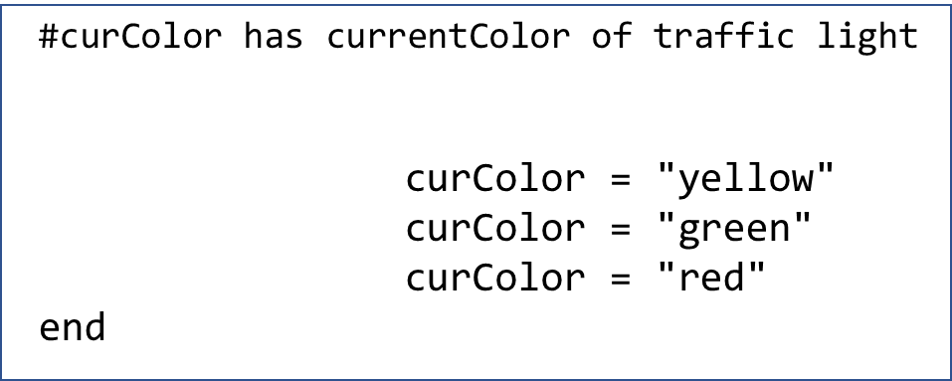
     3. Pascal  
          
        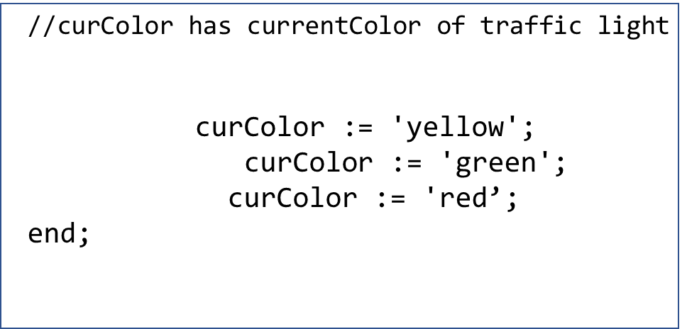
  2. Arithmetic if in Fortran (Bonus)
     1. if ( <exp> ) L1, L2, L3

