COMP 340  
Object-Oriented Programming  
Paul Kim

1. Object-Oriented Programming
   1. Class & Object
2. Goomba Walking Project

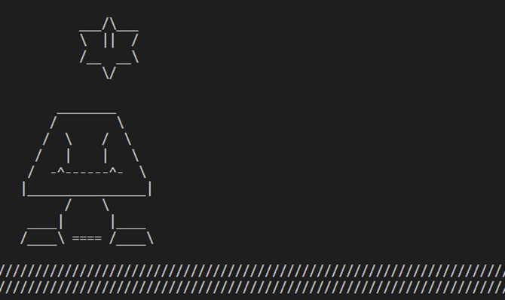

* 1. Programming Environment

1. Structure of Project
   1. Three Classes – Star, Goomba, Ground

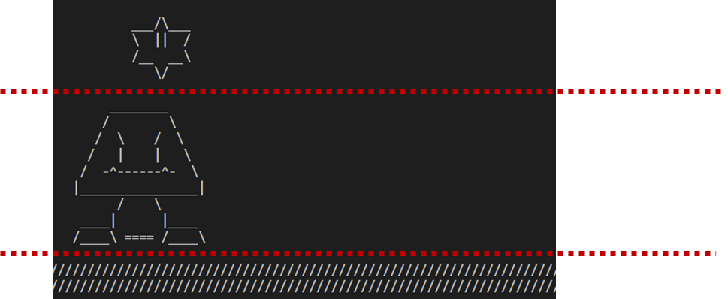

* 1. GoombaWalk Class

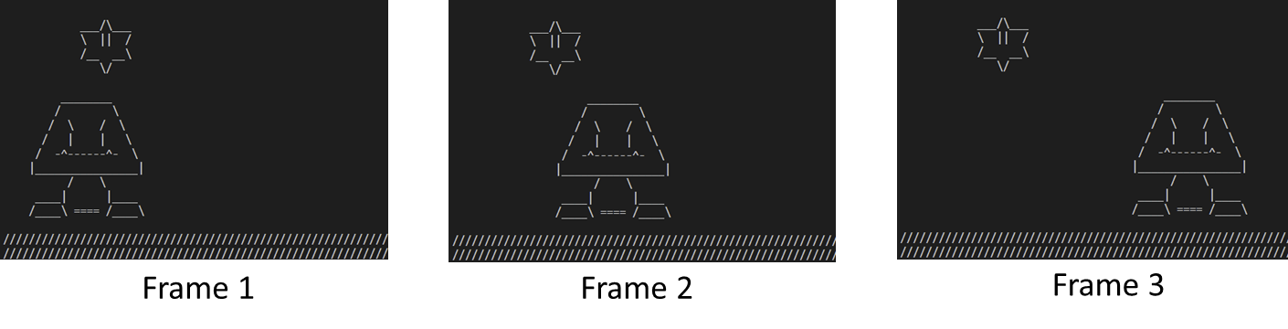

* 1. Whole Structure of Project

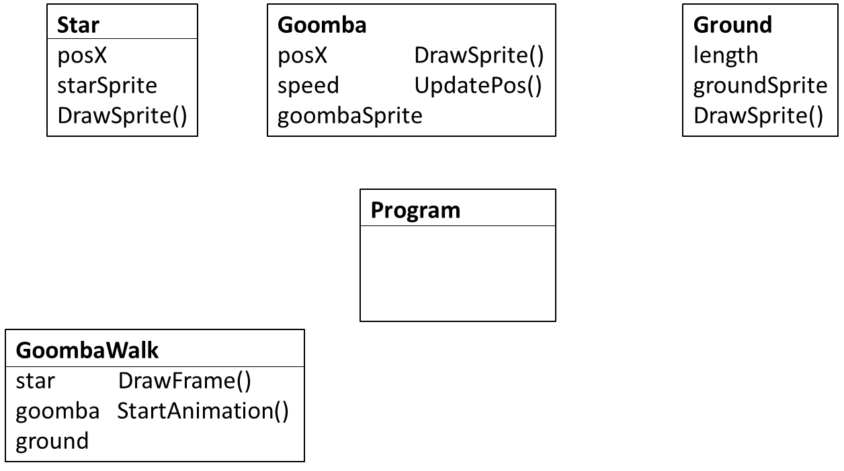

1. Main Class (Program.cs)

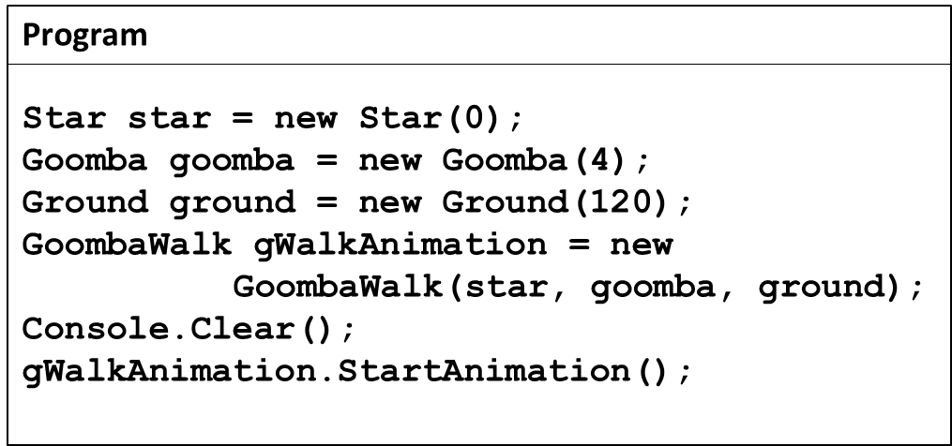

|  |
| --- |
|  |

Stage

1. Star Class (Star.cs)
   1. Class variables & constructor
   2. Access Modifiers
      1. private
      2. public
   3. Encapsulation
   4. Abstraction
   5. SetSprite()

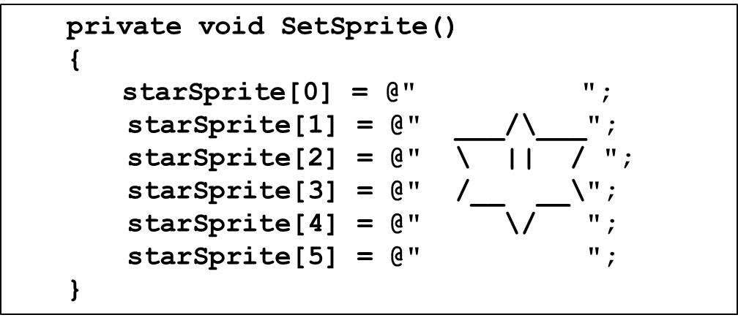

* 1. DrawSprite()
     1. How to place star based on posX?

|  |  |  |
| --- | --- | --- |
| posX = 0 | posX = 1 | posX = 3 |
|  |  |  |

* + 1. Code

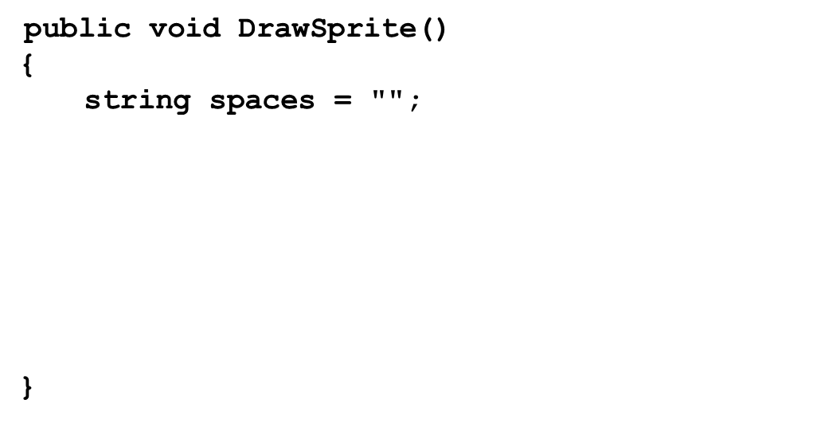

1. Ground Class (Ground.cs)
   1. Class variables & constructor
   2. SetSprite()
      1. How to change length of ground image?

|  |  |  |
| --- | --- | --- |
| length = 5 | length = 10 | length = 20 |
|  |  |  |

* + 1. Code

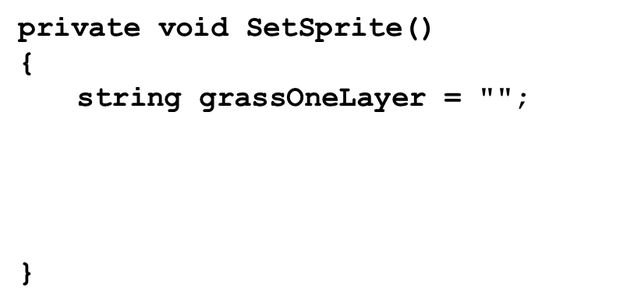

* 1. DrawSprite()

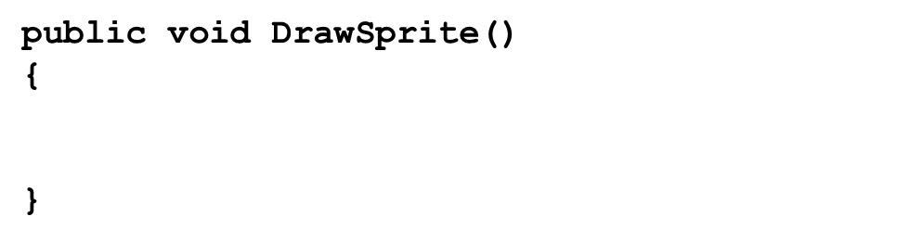

1. Goomba Class (Goomba.cs)
   1. Class variables & constructor
   2. SetSprite()

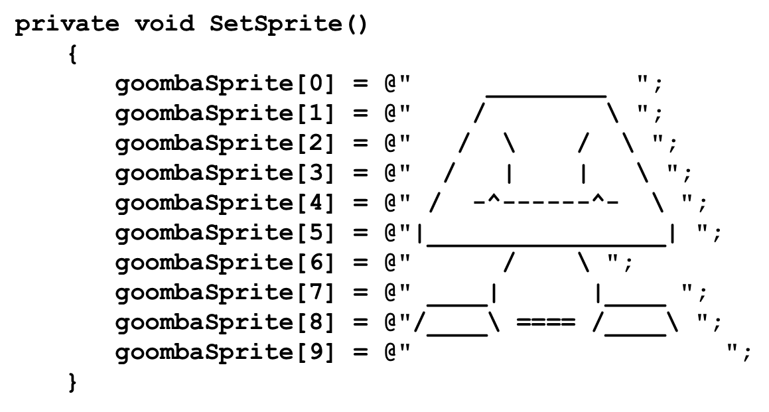

* 1. How to make goomba walk? (one-way animation)
     1. DrawSprite() & UpdatePos()

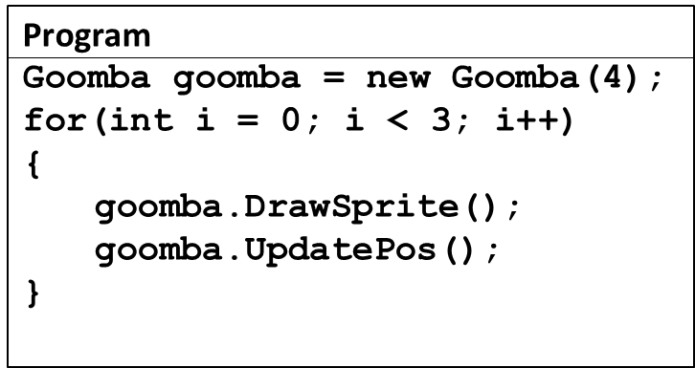

* + 1. Animation

|  |  |  |
| --- | --- | --- |
| posX = 0  speed = 4 | posX =  speed = 4 | posX =  speed = 4 |
|  |  |  |

* + 1. DrawSprite() (*modify Star’s DrawSprite())  
         
       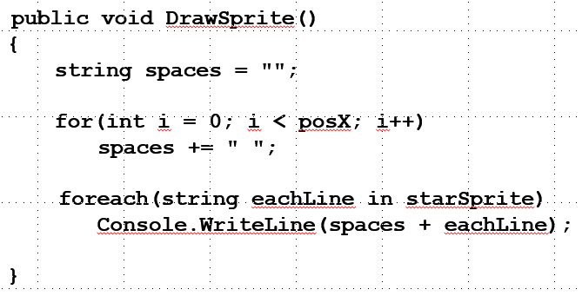
    2. UpdatePos()  
       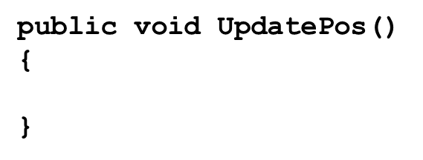
  1. How to make goomba walk? (Round-trip animation)
     1. ChangeDir() & new UpdatePos()

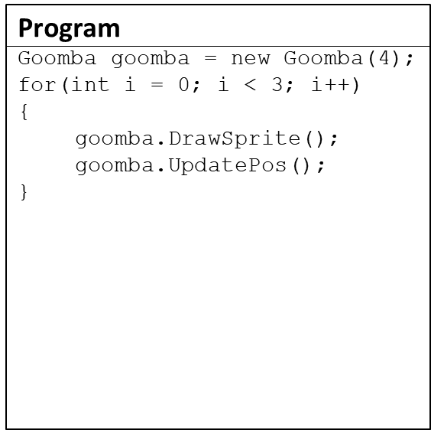 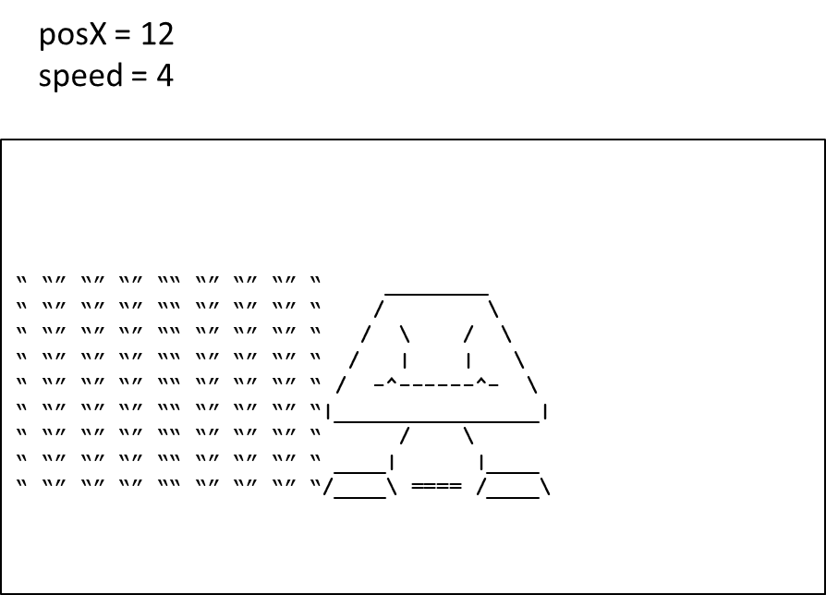

* + 1. Animation

|  |  |  |
| --- | --- | --- |
| posX =  speed = 4 | posX =  speed = 4 | posX =  speed = 4 |
|  |  |  |

* + 1. ChangeDir()  
       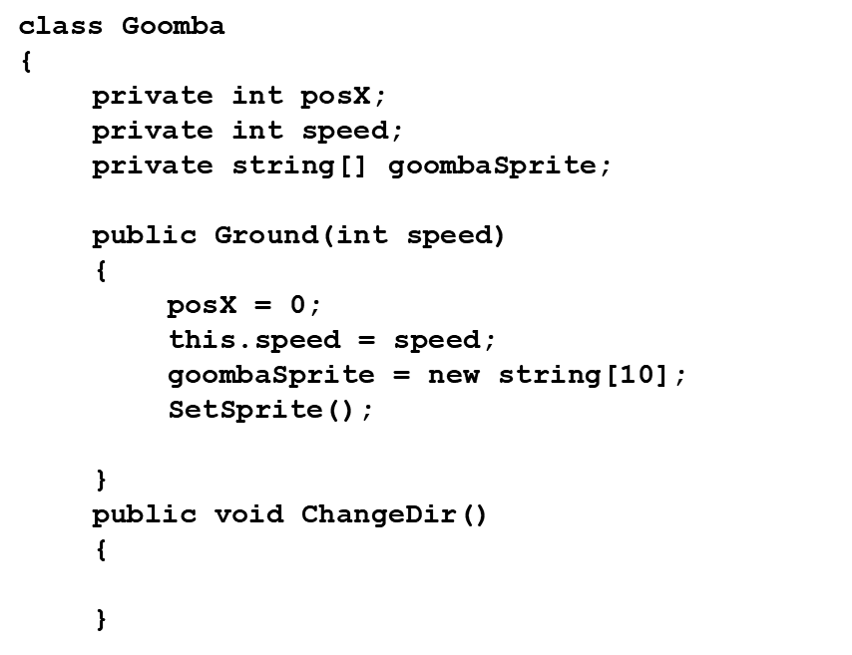
    2. New UpdatePos()  
       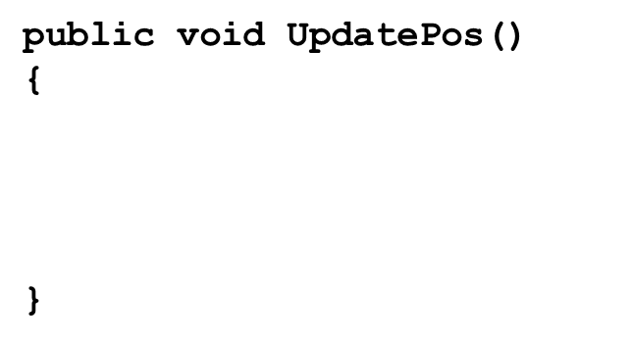

1. GoombaWalk Class (GoombaWalk.cs)
   1. Class variables & constructor
   2. StartAnimation()

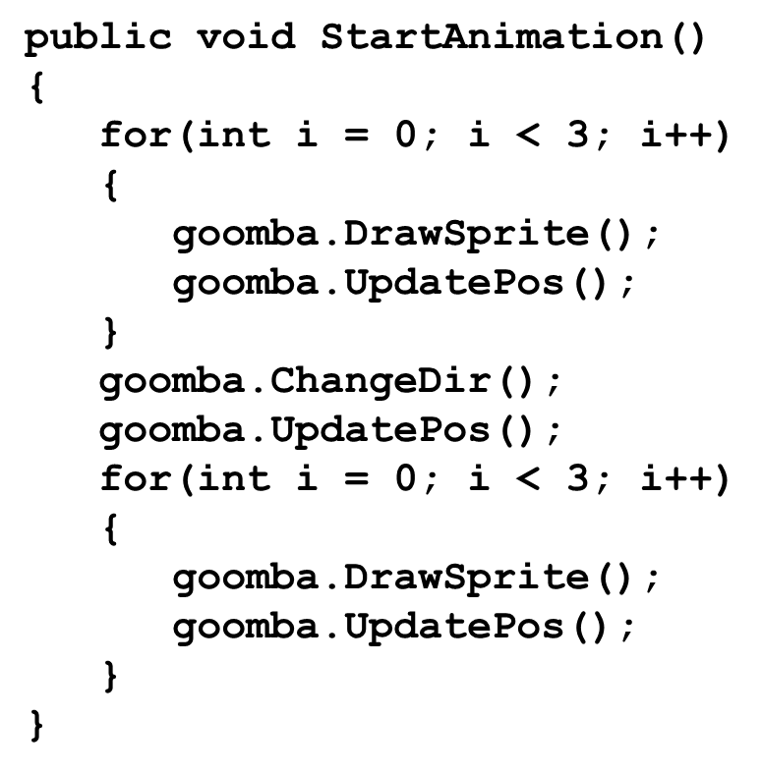

* 1. DrawFrame()  
     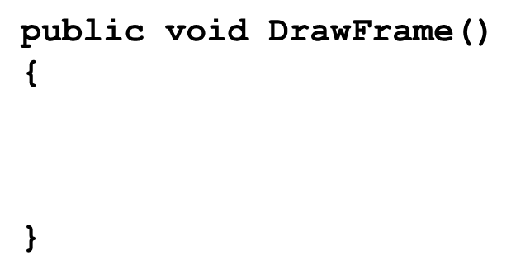
  2. Updated StartAnimation()  
     