LED Triangle Lamp
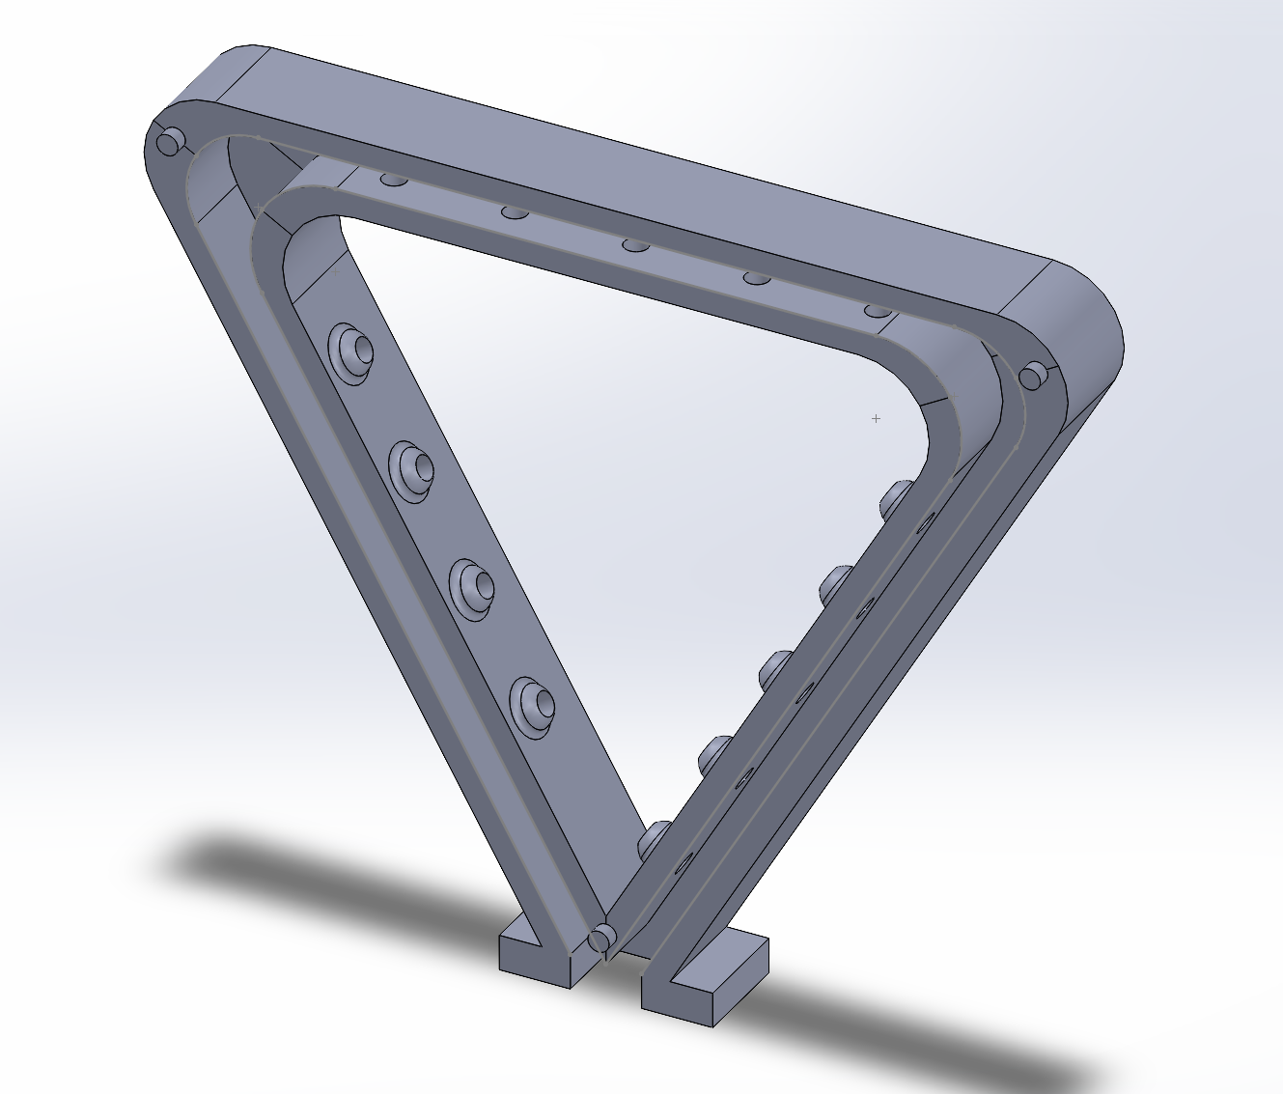

To start off we will look at what the finished model will look like.
When we are done you should have a model that looks like this.

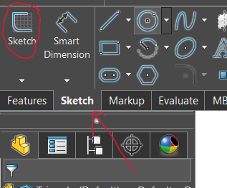
It may look complicated but let’s break it down to smaller parts and mold it into the shape we want.

1st step is to make a base that we will build more features on top of.
In the top left corner click on the sketch tab and then click on the sketch button.

Then select the front plane.

Next start to sketch a rough outline of the base then use “Constraints” to move the sketch into the place we want it.
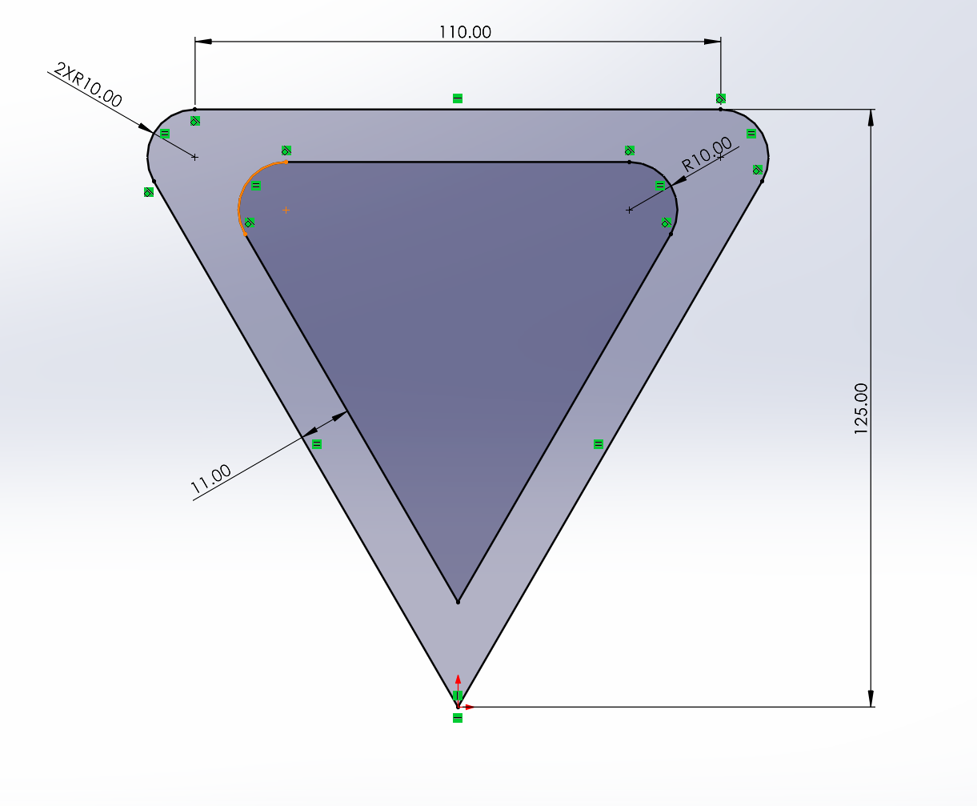

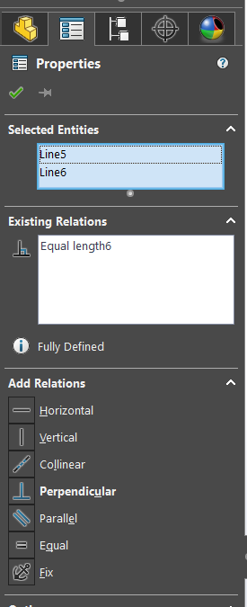
Start with the “Origin” and make a tingle. Hold Ctrl and click on the left and right outside line and select equal in the properties menu.

After constrain top line to be horizontal and with “smart dimension” tool set the top to be 125 from the origin.

Next use the “Sketch Fillet” tool to create the 10R fillets.

Lastly, select “Offset Entity’s” and make an offset that’s on the inside. You might need to delete the internal fillets and create them again.

Now select Features and Extrude Boss/base 15mm

Now that the base feature is extruded we can start cutting features out and adding features on.

Let’s start by selecting new sketch and click on the face that has just been extruded. Select offset entities and offset the inside and outside by 3.5mm

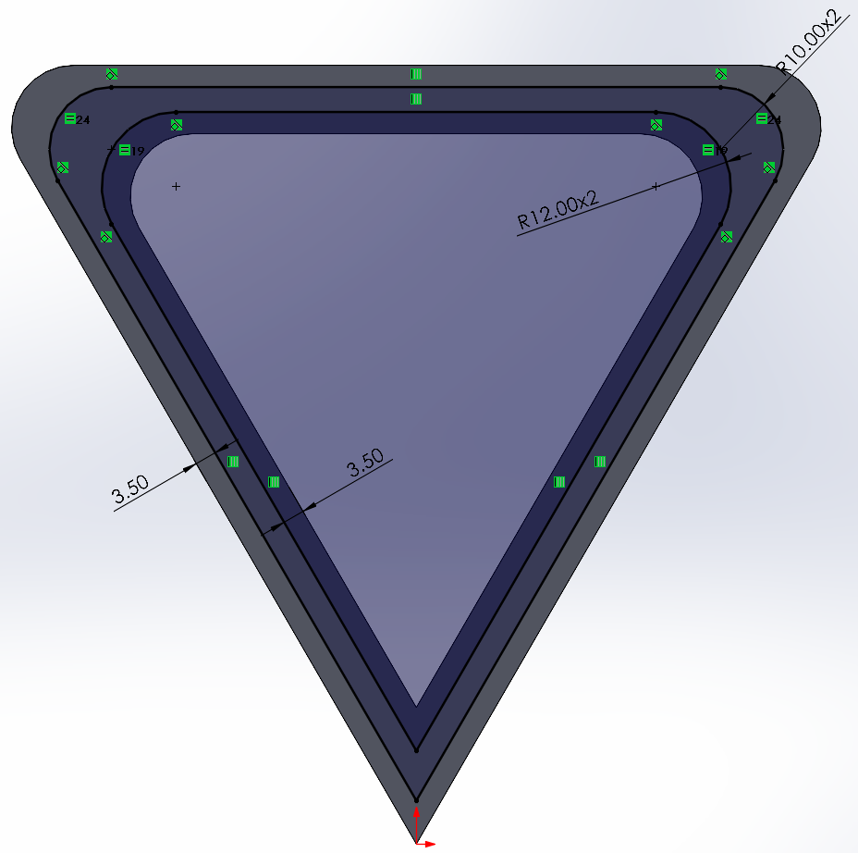
After adding the correct fillets go to features and extruded cut. The cut will be at a depth of 11mm.

Nice work, we are about 40% with this part.

For the next step let’s mold the bottom.

Simply make a box and constrain it to apex of the point. Make sure the box covers the rest of the part we are going to cut off.

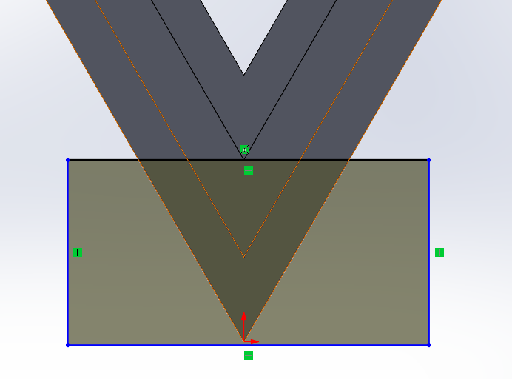
It will look something like this, then go to extruded cut.
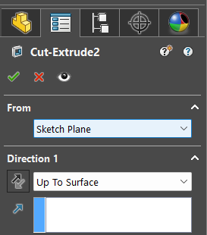

When making this cut you may want to select “Up To Surface” and select the opposite face.

Next new sketch and select the bottom surface we just made.

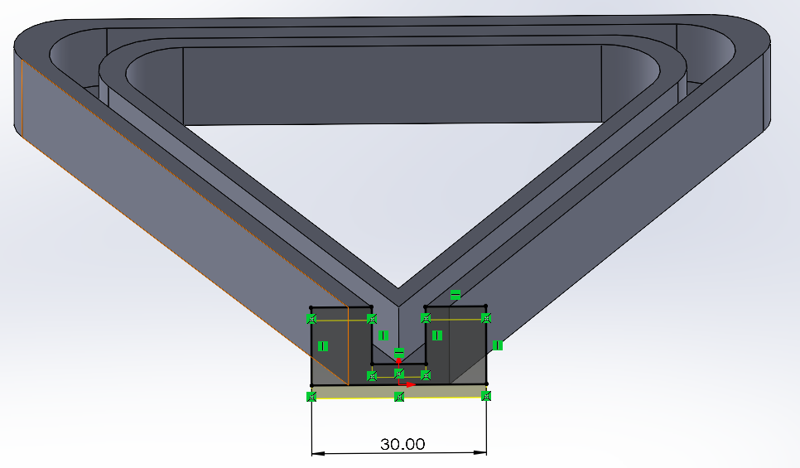
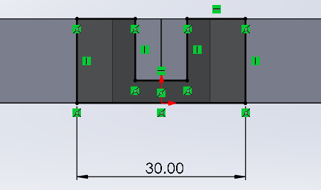
Trace the face or optionally use the “Convert Entities” to copy the face then adjust it as shown. Also constrain the sketch to the original depth of the whole part.

Once sketched extrude by 5mm.

The next step involves creating the same feature on the inside 3 faces.

Create a sketch on the first face and make a construction line from the top line all the way to the bottom line.

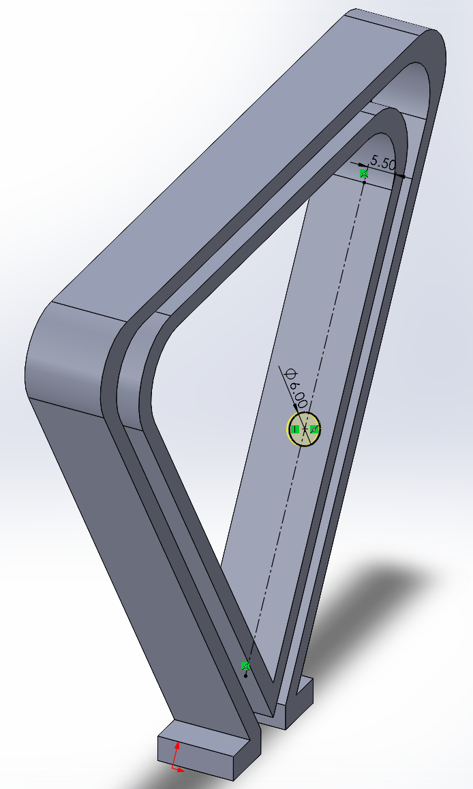
Use the dimensions as shown, then extrude by 1mm.

Next we need a tool that’s not on the toolbar so go to the top in the search bar and search “dome”

Go to the top face of the circle and in the properties make the dome 2mm.

Now in the timeline roll back the dome we just made. The line should be under the features we just made.

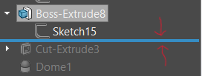

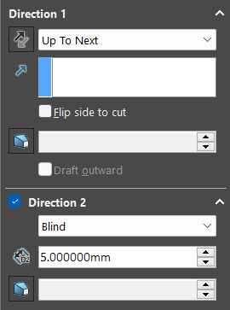
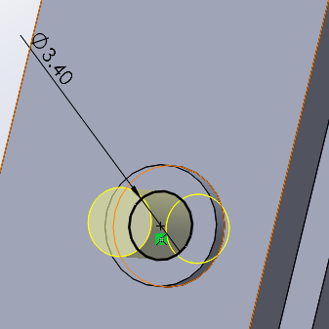
Make a sketch that is concentric with the face. With a cut in 2 directions.

Once the cut has been made remember to roll forward the timeline.

Now that the port is made the last step for this section is to make a pattern.
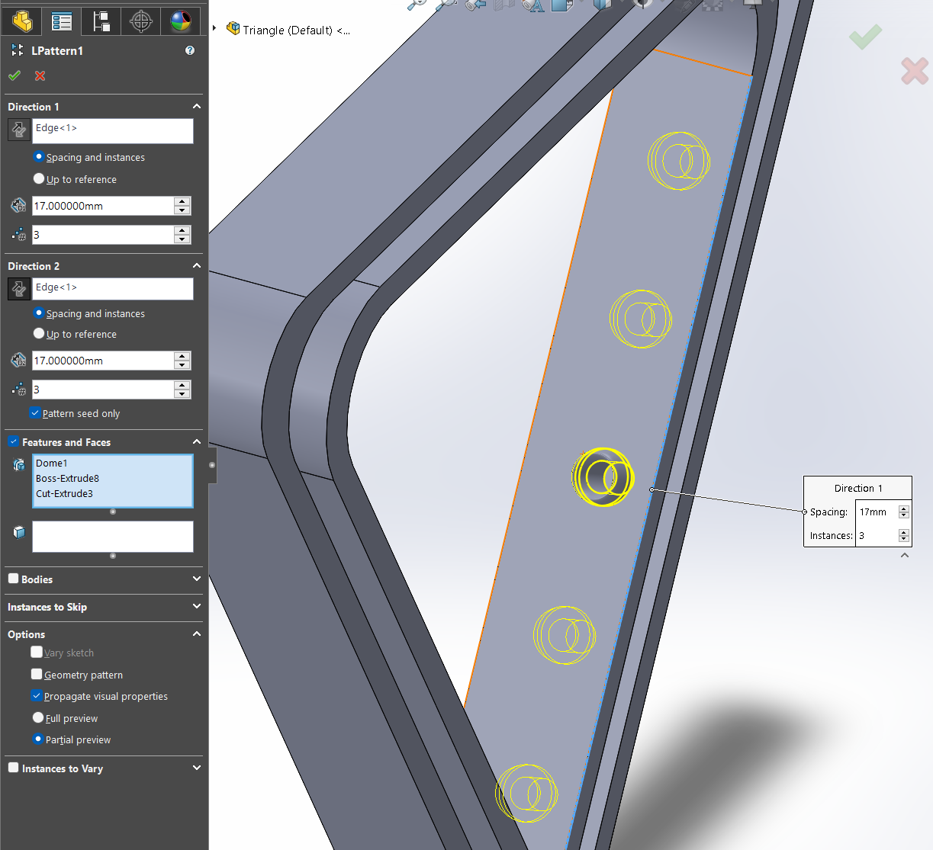
Go to features and select “Linear Pattern” select the right edge twice as shown.

Now click the check and repeat for the top and left sides.

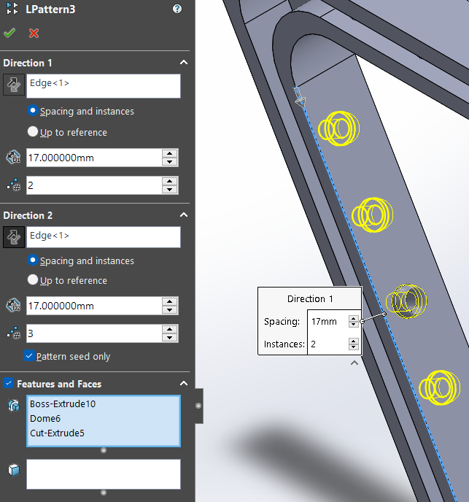
Keep in mind that the left will have only 4 ports so make sure to adjust the settings.

We are almost done!

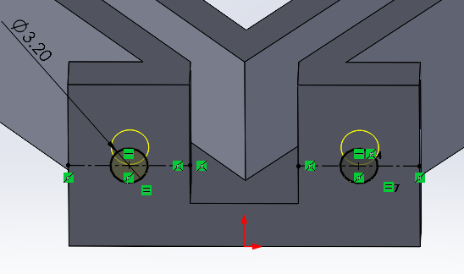
Select the bottom and make a new sketch. Make construction lines at the midpoints of the sides with the circles in the midpoints of the construction lines.

Make the cut depth 4mm.

Next, new sketch. Make construction lines connecting the midpoints and use the dimensions as shown then extrude out 2mm.
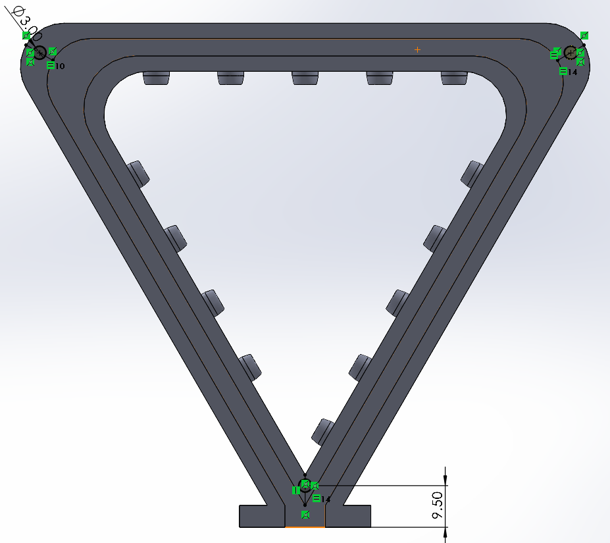
Congratulations you are done with the most complicated part in designing this lamp.

