Example 1: Calculating the Excess Chemical Potential using the Iterative Adaptive GCMC (A-GCMC) Algorithm

Contents

Example file folders 1

Example 1A: Excess chemical potential calculation for 100 mM NaCl, using the Unrestricted Primitive Model (UPM) 2

Setting parameters in the ./inputfiles/inputparameters.in file 2

Setting the hard sphere cut-off distances in ./inputfiles/hard_sphere_cutoffs.in file 4

Setting the types of interactions in the ./inputfiles/particle_pair_interactions.in file 4

Starting the simulation 4

Checking simulation outputs 4

Computing the Average Excess Chemical Potential and Number of each Ion 5

Computing ion pair radial distribution functions 5

Example 1B: Excess potential calculation for 100 mM NaCl, using the Solvent Primitive Model (SPM) 6

Setting the parameters in the ./inputfiles/inputparameters.in file 6

Setting the hard Sphere cut-off distances in ./inputfiles/hard_sphere_cutoffs.in file 7

Setting the types of Interactions in the ./inputfiles/particle_pair_interactions.in file 7

Starting the simulation 7

Checking convergence 7

Computing the average excess chemical potential and number of each Ion 8

Ion-Ion and Ion-Water Radial Distribution Functions 8

# Example file folders

Uncompress the files listed in the table below, using the command

$ tar –zxvf {filename}.tar.gz

|  |  |
| --- | --- |
| Simulation Examples | Compressed files |
| Example 1A: Excess chemical potential calculation for 100 mM NaCl, using the Unrestricted Primitive Model (UPM) | ./gibs/Simulation_Examples/excess_chempot_nacl_100mM_AGCMC_UPM.tar.gz |
| Example 1B: Excess potential calculation for 100 mM NaCl, using the Solvent Primitive Model (SPM) | ./gibs/Simulation_Examples/excess_chempot_nacl_100mM_AGCMC_SPM.tar.gz |

# Example 1A: Excess chemical potential calculation for 100 mM NaCl, using the Unrestricted Primitive Model (UPM)

In this example, we calculate the excess chemical potential of Na+ and Cl- in 100 mM NaCl, using the unrestricted primitive model (UPM) and the A-GCMC method.

**Simulation run directory**: ./gibs/Simulation_Examples/excess_chempot_nacl_100mM_AGCMC_UPM

## Setting parameters in the ./inputfiles/inputparameters.in file

**Step 1**: Specify the simulation type

SIMULATION_TYPE GCMC_FOR_CHEMICAL_POTENTIAL_CALCULATION

**Step 2**: Set cavity grid spacing and number of segments

CAVITY_GRID_SPACING 0.5

CAVITY_GRID_SEGMENTS 1000

**Step 3**: Set solute model type to none. Also set the solute all atom coordinate file name to some name, since it won’t be used. Let the solute coordinate file type be PQR.

SOLUTE_MODEL_TYPE none

SOLUTE_ALLATOM_COORDINATE_FILETYPE PQR

SOLUTE_ALLATOM_COORDINATE_FILENAME nofile.pqr

**Step 4**: Specify not to use SPM and monoatomic water models, since we are using the UPM model (no solvent hard spheres).

USE_SPM NO

USE_MWATER NO

**Step 5**: Specify not to use the PID method for computing the excess chemical potential (This setting will select the A-GCMC method)

USE_PID NO

**Step 6:** Set the maximum number of hard spheres (particles) in the simulation box

MAXIMUM_NUMBER_OF_PARTICLES 40000

**Step 7**: Set the number of A-GCMC iterations (e.g., to 20 as in this example)

NUM_ITER 20

**Step 8**: Set the number of GCMC steps, insertion/deletion cycles, and single-particle displacement cycles

NUM_STEPS 1000000

NUM_GCMCCYCL 3

NUM_MOVCYCL 7

NUM_EQSTEPS 300000

**Step 9:** Create a random initial state configuration instead of reading it from a file

START_STATE 0

**Step 10**: Set what results to record

RECORD_PARTICLETYPE_COUNT YES

RECORD_MOVE_ACCEPTANCE_RATE YES

RECORD_SYSTEM_ENERGY YES

RECORD_EVERY_N_STEPS 100

NUM_RECORD_STATES 20

**Step 11**: Set the Sloth Sorensen correction factor to 1 (used only in A-GCMC)

SLOTH_SORENSEN_CORRECTION 1

**Step 12**: Specify whether to calculate the RDF for each particle pair. In this example, we set them NO (as we are interested only in finding the excess chemical potential). Once we know the excess chemical potential for a given concentration, additional simulations should be run to compute the RDFs (discussed later).

CALCULATE_SOLUTE_PARTICLE_RDF NO

CALCULATE_PARTICLE_PAIR_RDF NO

**Step 13**: Specify the ion labels, radii (Angstrom), charge (e units), and initial guess for the excess chemical potential (kcal/mol)

Use the ION keyword : ION {ion label} {charge} {radius} {conc} {excess chemical potential}

ION Na 1.0 1.02 0.10 0.0

ION Cl -1.0 1.81 0.10 0.0

Note: The ion labels should match the labels used in other input files.

**Step 14:** Specify the box dimensions and grid spacings (all values are in Angstrom units)

X_LEN 100

Y_LEN 100

Z_LEN 100

HX 1.0

HY 1.0

HZ 1.0

X_MIN -50.0

Y_MIN -50.0

Z_MIN -50.0

**Step 15:** Set the temperature (Kelvin) and solvent dielectric constant values

TEMPERATURE 298.0

SOLVENT_DIELECTRIC 78.5

## Setting the hard sphere cut-off distances in ./inputfiles/hard_sphere_cutoffs.in file

The hard sphere cut-off distances are set equal to the sum of the hard sphere radii of the ions.

PARTICLE_TYPE PARTICLE_TYPE HARD_SPHERE_CUTOFF

Na Na 2.04

Cl Cl 3.62

Na Cl 2.83

## Setting the types of interactions in the ./inputfiles/particle_pair_interactions.in file

In this example, ions interact via hard sphere repulsions and Coulomb potentials.

ParticleType ParticleType HARD_SPHERE_REPULSION COULOMB_POTENTIAL LENNARD_JONES_POTENTIAL SQUARE_WELL_POTENTIAL LOOKUP_TABLE

Na Na 1 1 0 0 0

Cl Cl 1 1 0 0 0

Na Cl 1 1 0 0 0

## Starting the simulation

To start the simulation in the simulation run folder (if executable file is located in the same folder), do

$ ./gibs.exe > run_2_13_2017_r1.out

The screen output is written out to run_2_13_2017_r1.out file.

## Checking simulation outputs

Plots the counts, energies, and acceptance rates (e.g., using Gnuplot) in the outputfiles folder, from the last A-GCMC iteration.

$ plot 'particlecount_Na.out' u 1:2, 'particlecount_Cl.out' u 1:2

$ plot 'energy.out' u 1:2

$ plot 'insertion_acceptance_rate' u 1:4

$ plot 'deletion_acceptance_rate' u 1:4

$ plot 'displacement_acceptance_rate' u 1:4

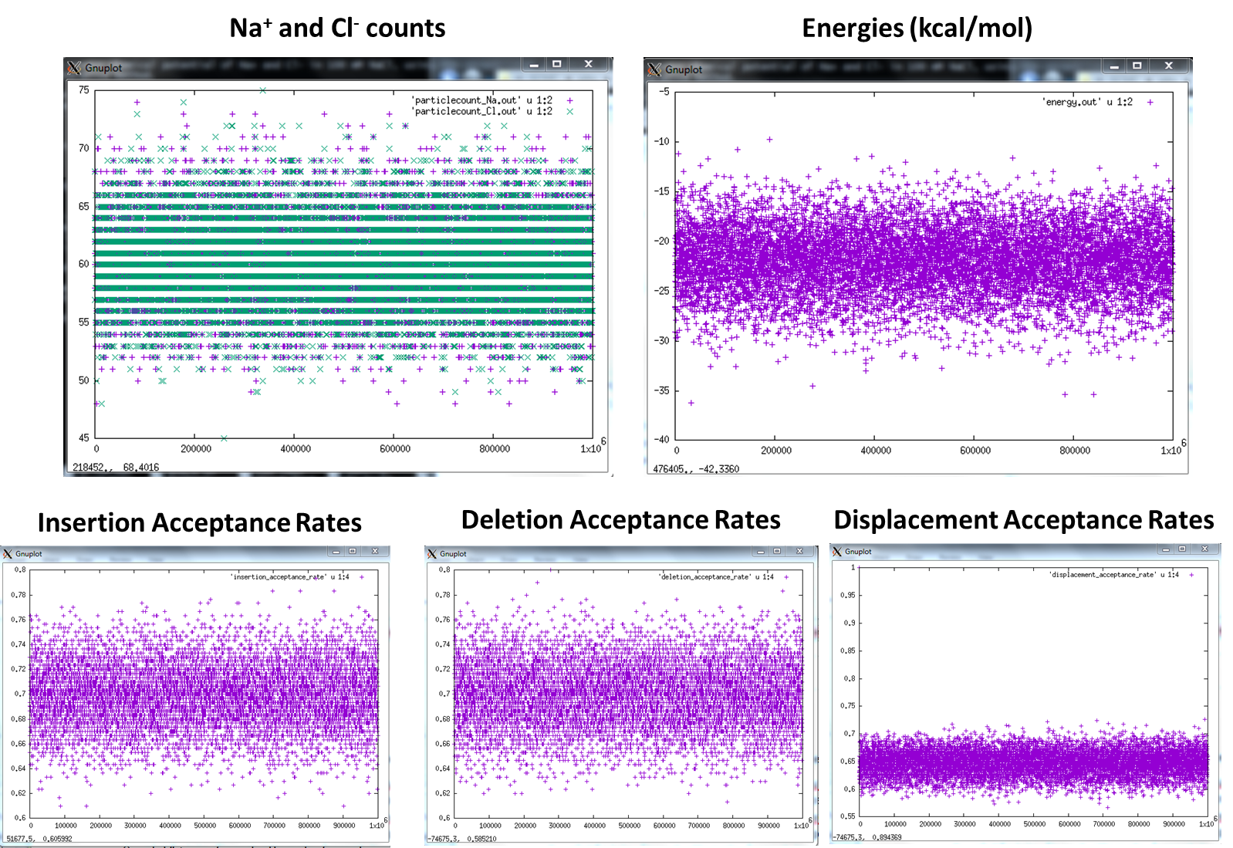

## Computing the Average Excess Chemical Potential and Number of each Ion

* Na+ chemical potential values are written out to chempot_particletype_Na.out
* Cl- chemical potential values are written out to chempot_particletype_Cl.out
* Average excess chemical potential based on the last 10 iterations = **-0.1669 kcal/mol (Na+)** and -**0.1651 kcal/mol (Cl-)**.
* Average number of Na+ ions = **60.227**
* Average number of Cl- ions = **60.229**

### Computing ion pair radial distribution functions

Run a GCMC simulation with the excess chemical potential fixed at the average value (computed from above) and record a desired number of equilibrated states. Select these states (e.g., 8) as initial state configurations to run independent simulations (production runs) to calculate the RDFs.

**Step 1:** Create the inputfiles and outputfiles directories in another simulation run directory. Copy all the input files to the inputfiles directory, and change the following parameters in the inputparameters.in file,

NUM_ITER 1

START_STATE 0

NUM_RECORD_STATES 20

ION Na 1.0 1.02 0.10 -0.1669

ION Cl -1.0 1.81 0.10 -0.1651

**Step 2:** Copy the final state file (finalstate_iter20) from the last iteration of our previous run to the current inputfiles folder, and name it as state_0.

**Step 3**: Run the simulation as the previous one. This will write out 20 states in files (state_1000000, state_965000, …)

**Step 4:** Create the directories for the independent simulations. If we want to run 8 independent simulations, then create 8 simulation run directories, and in each directory, create the inputfiles and outputfiles directories. Copy the input files (from Step 1) to the inputfiles directory of each simulation run directory, and change the option to calculate the RDFs to YES.

CALCULATE_PARTICLE_PAIR_RDF YES

Keep the parameter values from Step 1 as they are.

Select 8 of the 20 states from Step 3, and use them as initial states for the 8 independent simulations.

**Step 5:** Run the 8 simulations. Each simulation will compute and save the RDFs in the following files: rdfpair_Na_Na.out, rdfpair_Cl_Cl.out, rdfpair_Na_Cl.out

**Step 6:** Take the average of the 8 RDFs to get the RDF of each ion pair.

# Example 1B: Excess potential calculation for 100 mM NaCl, using the Solvent Primitive Model (SPM)

In this example, we calculate the excess chemical potential of Na+ and Cl- in 100 mM NaCl and water with solvent packing fraction of 0.3 in a 100 Angstrom cube box, using the solvent primitive model (SPM) and the A-GCMC method.

**Simulation run directory**: ./gibs/Simulation_Examples/excess_chempot_nacl_100mM_AGCMC_SPM

## Setting the parameters in the ./inputfiles/inputparameters.in file

Copy the input files from the first simulation of Example 1A to the inputfiles directory.

**Step 1**: Set the following parameters for the SPM calculations

USE_SPM YES

SOLVENT_LABEL Water

SOLVENT_RADIUS 1.4

SOLVENT_PACKING_FRACTION 0.3

SOLVENT_EXCESS_CHEMICAL_POTENTIAL 0.0

SOLVENT_ION_ATTRACTION NO

In a 100 Angstrom cube box, a solvent packing fraction of 0.3 corresponds to 22.693 M concentration of water.

## Setting the hard Sphere cut-off distances in ./inputfiles/hard_sphere_cutoffs.in file

The hard sphere cut-off distances are set equal to the sum of the hard sphere radii of the particle types.

PARTICLE_TYPE PARTICLE_TYPE HARD_SPHERE_CUTOFF

Na Na 2.04

Cl Cl 3.62

Water Water 2.80

Na Cl 2.83

Na Water 2.42

Cl Water 3.21

## Setting the types of Interactions in the ./inputfiles/particle_pair_interactions.in file

In this example, ions interact via hard sphere repulsions and Coulomb potentials. Ions and water interact via hard sphere repulsions.

ParticleType ParticleType HARD_SPHERE_REPULSION COULOMB_POTENTIAL LENNARD_JONES_POTENTIAL SQUARE_WELL_POTENTIAL LOOKUP_TABLE

Na Na 1 1 0 0 0

Cl Cl 1 1 0 0 0

Water Water 1 0 0 0 0

Na Cl 1 1 0 0 0

Na Water 1 0 0 0 0

Cl Water 1 0 0 0 0

## Starting the simulation

To start the simulation in the simulation run folder (if executable file is located in the same folder), do

$ ./gibs.exe > run_1_26_2017_r1.out

The screen output is written out to run_1_26_2017_r1.out file.

## Checking convergence

The figure below shows the plot of the excess chemical potential () versus number of iterations for Na+ (red), Cl- (green), and water (blue) in 100 mM NaCl and 22.693 M (corresponds to solvent packing fraction of 0.3) water. The number of simulation steps was 106 (NUM_STEPS), and the number of steps for equilibration per A-GCMC iteration (NUM_EQSTEPS) was . The plots show the convergence in the excess chemical potential calculation based on the A-GCMC method.

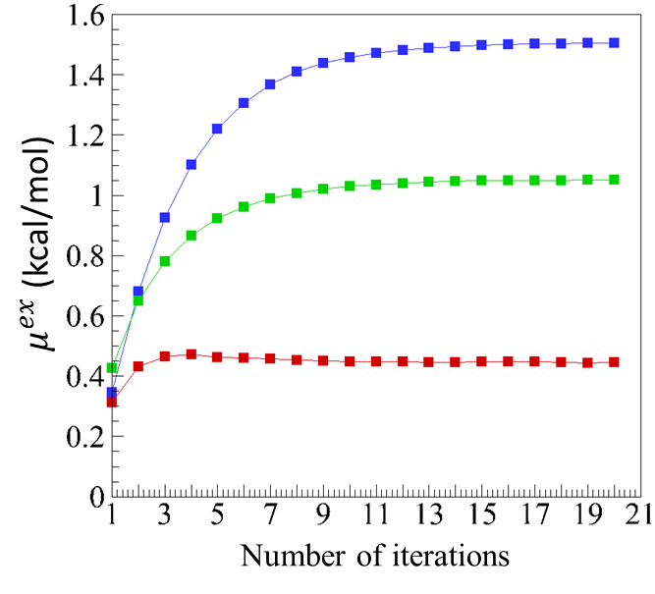

## Computing the average excess chemical potential and number of each particle type

The average excess chemical potential based on the last 5 iterations:

kcal/mol

kcal/mol, and

kcal/mol.

Average number of Na+ and Cl- ions = (the standard deviation per iteration ~ 4.5)

Average number of water molecules = 13650 (the standard deviation per iteration ~ 52.2)

## Ion-Ion and Ion-Water Radial Distribution Functions

Follow the same approach described in Example 1A to compute radial distribution functions. RDFs will be written out to files, rdfpair_Na_Na.out, rdfpair_Cl_Cl.out, rdfpair_Na_Cl.out, rdfpair_Water_Water.out, rdfpair_Na_Water.out, rdfpair_Cl_Water.out