Example 2: Calculating Excess Chemical Potential Using the Proportional Integral-Derivative (PID) Controller Approach

Contents

Example Folders 1

Example 2 A: Excess chemical potential calculation for 100 mM NaCl, using the Solvent Primitive Model (SPM) 2

Set the Parameters in the ./inputfiles/inputparameters.in File 2

Set the Parameters in the ./inputfiles/pid_init.in File 2

Set the Molar Masses of each Particle Type in the ./inputfiles/molar_mass.in File 2

Set the Hard Sphere Cut-Off Distances in ./inputfiles/hard_sphere_cutoffs.in File 3

Set the Types of Ion-Ion Interactions in the ./inputfiles/particle_pair_interactions.in File 3

Start Simulation 3

Plot Output 3

Compute the Average Excess Chemical Potential and Number of Ions and Water 4

# Example file folders

Uncompress the files listed in the table below, using the command

$ tar –zxvf {filename}.tar.gz

|  |  |
| --- | --- |
| Simulation Examples | Compressed files |
| Example 2 A: Excess chemical potential calculation for 100 mM NaCl, using the Solvent Primitive Model (SPM) | ./gibs/Simulation_Examples/excess_chempot_nacl_100mM_PID_SPM.tar.gz |

# Example 2 A: Excess chemical potential calculation for 100 mM NaCl, using the Solvent Primitive Model (SPM)

In this example, we calculate the excess chemical potential of Na+ and Cl- in 100 mM NaCl water with solvent packing fraction of 0.3 in a 100 Angstrom cube box, using the PID method and the solvent primitive model (SPM).

**Simulation run Directory**: ./gibs/Simulation_Examples/excess_chempot_nacl_100mM_PID_SPM

* Create inputfiles and outputfiles sub-directories
* Output files will be written out in the outputfiles folder
* Copy the input files from Example 1B to the inputfiles directory.

## Setting the parameters in the ./inputfiles/inputparameters.in file

Copy the input files from the first simulation of Example 1B to the inputfiles directory.

**Step 1:** Set the following parameters

USE_PID YES

NUM_ITER 1

NUM_STEPS 16000000

## 

In a 100 Angstrom cube box, a solvent packing fraction of 0.3 corresponds to 22.693 M concentration of water.

## Setting the parameters in ./inputfiles/pid_init.in file

PARTICLE_TYPE MU_EX BI EPSI

Na 0.0 1.0 0.01

Cl 0.0 1.0 0.01

Water 0.0 1.0 0.01

In the PID method, the initial guess values for the excess chemical potential are read from the 2nd column of the pid_init.in file, and not from the inputparameters.in file. The BI and EPSI are parameters used in the PID algorithm.

## Set the molar masses of each particle type in the ./inputfiles/molar_mass.in file

PARTICLE_TYPE MOLAR_MASS

Na 23.0

Rb 85.47

Sr 87.62

CoHex 160.93

Cl 35.45

Water 18.02

The molar mass is used for computing the target mass density, against which the PID method is used to calibrate the excess chemical potential.

## Setting the hard sphere cut-off distances in ./inputfiles/hard_sphere_cutoffs.in file

The hard sphere cut-off distances are set equal to the sum of the hard sphere radii of the particle types.

PARTICLE_TYPE PARTICLE_TYPE HARD_SPHERE_CUTOFF

Na Na 2.04

Cl Cl 3.62

Water Water 2.80

Na Cl 2.83

Na Water 2.42

Cl Water 3.21

## Setting the types of Interactions in the ./inputfiles/particle_pair_interactions.in file

In this example, ions interact via hard sphere repulsions and Coulomb potentials. Ions and water interact via hard sphere repulsions.

ParticleType ParticleType HARD_SPHERE_REPULSION COULOMB_POTENTIAL LENNARD_JONES_POTENTIAL SQUARE_WELL_POTENTIAL LOOKUP_TABLE

Na Na 1 1 0 0 0

Cl Cl 1 1 0 0 0

Water Water 1 0 0 0 0

Na Cl 1 1 0 0 0

Na Water 1 0 0 0 0

Cl Water 1 0 0 0 0

## Starting the simulation

To start the simulation in the simulation run folder (if executable file is located in the same folder), do

$ ./gibs.exe > run_2_13_2017_r1.out

The screen output is written out to run_2_13_2017_r1.out file.

## Checking convergence

In the PID method, the excess chemical potential values are written out in the 4th column of the particlecount_Na.out, particlecount_Cl.out, and particlecount_Water.out files.

The figure below shows the plot of the excess chemical potential ($μ^{ex}$) versus number of simulation steps for Na+ (red), Cl- (green), and water (blue) in 100 mM NaCl and water (solvent packing fraction is 0.3, equivalent to 22.693 M in 100 Angstrom cube box). On average, the values start to converge within the first $5×{10}^{6}$ steps. The plot shows the convergence in the excess chemical potential calculation based on the PID method.

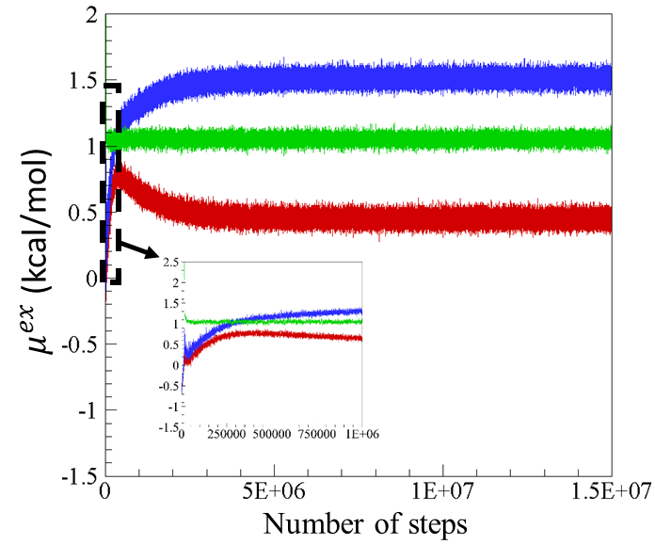

## Computing the average excess chemical potential and the number of ions and water molecules

Average excess chemical potential based on the last $8×{10}^{6}$ steps:

$μ_{Na}^{ex}=0.448±0.037$ kcal/mol

$μ_{Cl}^{ex}=1.509±0.041$ kcal/mol, and

$μ_{Water}^{ex}=1.052 ±0.028$ kcal/mol.

Number of Na+ and Cl- ions = $60.1±3.0$

Number of water molecules = $13665.8±13.7$