Example 6: Trivalent Ion Distributions around 25 bp Nucleic Acid Duplexes

Contents

Solute all-atom coordinate files and electrostatic potentials 1

Example file folders 2

Excess chemical potential calculation for 5mM CoHexCl3 2

Example 6A: Simulation with 25 bp poly(dA):poly(dT) DNA duplex in 5 mM CoHexCl3 , using the UPM model 3

Example 6B: Simulation with A-RNA duplex in 5 mM CoHexCl3, using the UPM model 4

Example 6C: Simulation with 25 bp mixed sequence DNA in 5 mM CoHexCl3, using the UPM model 5

Example 6D: Simulation with 25 bp DNA:RNA hybrid in 5 mM CoHexCl3, using the UPM model 6

# Solute all-atom coordinate files and electrostatic potentials

Uncompress the dna_rna_allatom_coordinates_potentials.tar.gz to extract the all-atom coordinate files (.pqr) and electrostatic potential maps (.dx) of four 25 base pair nucleic acid duplexes.

$ tar –zxvf dna_rna_allatom_coordinates_potentials.tar.gz

The folder names and files are listed in the table below. The PQR files were generated using PDB2PQR software, from PDB files provided by Alexey Onufriev and Igor Tolokh (from Virginia Tech). The electrostatic potentials (in .dx files) were approximated by solving the Poisson equation with the Adaptive Poisson Boltzman software (APBS) package. The input file used for the APBS calculations are also provided in the file folders.

|  |  |  |
| --- | --- | --- |
| File folder | 25 bp nucleic acid duplex | .pqr and .dx files |
| polyA_polyT_DNA_model | poly(dA):poly(dT) | polyAT25.pqr, pot_polyAT25_npbe_pdie2.dx |
| A-RNA_model | A-RNA | rGCAU25_cc.pqr, pot_rGCAU25_cc_npbe_pdie2.dx |
| mixed_sequence_DNA_model | Mixed sequence DNA | dGCAT25_cc.pqr, pot_dGCAT25_cc_npbe_pdie2.dx |
| DNA_RNA_hybrid_model | DNA:RNA hybrid | hyb_DNA_RNA_cc.pqr, pot_hyb_DNA_RNA_cc_npbe_pdie2.dx |

# Example file folders

Uncompress the files listed in the table below, using the command

$ tar –zxvf {filename}.tar.gz

|  |  |
| --- | --- |
| Simulation Examples | Compressed files |
| Excess potential calculation for 5 mM CoHexCl3 using the A-GCMC method | ./gibs/Simulation_Examples/excess_chempot_CoHexCl3_AGCMC_UPM.tar.gz |
| Example 6A: Simulation with 25 bp poly(dA):poly(dT) DNA duplex in 5 mM CoHexCl3 , using the UPM model | ./gibs/Simulation_Examples/CoHexCl3_UPM_PolyAT25.tar.gz |
| Example 6B: Simulation with 25 bp A-RNA duplex in 5 mM CoHexCl3, using the UPM model | ./gibs/Simulation_Examples/CoHexCl3_UPM_A_RNA.tar.gz |
| Example 6C: Simulation with 25 bp mixed sequence DNA in 5 mM CoHexCl3, using the UPM model | ./gibs/Simulation_Examples/CoHexCl3_UPM_Mixed_DNA_Sequence.tar.gz |
| Example 6D: Simulation with 25 bp DNA:RNA hybrid in 5 mM CoHexCl3, using the UPM model | ./gibs/Simulation_Examples/CoHexCl3_UPM_DNA_RNA_Hybrid.tar.gz |

Note: All input files are provided. Due to the large file sizes associated with the particle count and acceptance rates, only the RDF output files and final simulation states are provided. However, for the equilibration runs, all the output files are provided

# Excess chemical potential calculation for 5mM CoHexCl3

Results from the A-GCMC iterative simulations are provided below.

Excess chemical potential of CoHex3+ = -0.6876 kcal/mol

Excess chemical potential of Cl- = -0.09965 kcal/mol

**CoHex3+ ions (chempot_particletype_CoHex.out)**

iteration# avg_conc(M) avg_num mu_ex(kcal/mol) mu_old(kcal/mol) mu_new(kcal/mol) target_concentration(M)

0 0 0 -0.3 -2.07402 -2.07402 0.05

1 0.100585 60.5729 -0.713926 -2.07402 3.16784 0.05

2 0.0398857 24.0193 -1.25998 -3.16784 3.19646 0.05

3 0.0547647 32.9795 -1.47634 -3.19646 3.38781 0.05

4 0.0487568 29.3616 -1.59888 -3.38781 3.41616 0.05

5 0.0505398 30.4353 -1.64849 -3.41616 3.45285 0.05

6 0.0494534 29.7811 -1.67232 -3.45285 3.45317 0.05

7 0.0507587 30.5671 -1.68807 -3.45317 3.47437 0.05

8 0.0490768 29.5543 -1.68931 -3.47437 3.46462 0.05

9 0.0507404 30.5561 -1.6993 -3.46462 -3.47723 0.05

10 0.0496721 29.9127 -1.69931 -3.47723 3.46924 0.05

11 0.0502882 30.2838 -1.69862 -3.46924 -3.4755 0.05

12 0.0496221 29.8827 -1.69699 -3.4755 -3.46867 0.05

13 0.0502273 30.2471 -1.69733 -3.46867 3.47223 0.05

14 0.04997 30.0922 -1.69785 -3.47223 -3.47504 0.05

15 0.0495203 29.8213 -1.69531 -3.47504 3.46884 0.05

16 0.0509059 30.6557 -1.70545 -3.46884 3.48059 0.05

17 0.049652 29.9006 -1.70243 -3.48059 3.46896 0.05

18 0.0492187 29.6397 -1.68561 -3.46896 3.46169 0.05

19 0.0506394 30.4953 -1.69519 -3.46169 -3.4721 0.05

20 0.050272 30.274 -1.70129 -3.4721 -3.48116 0.05

**Cl- ions (chempot_particletype_Cl.out)**

iteration# avg_conc(M) avg_num mu_ex(kcal/mol) mu_old(kcal/mol) mu_new(kcal/mol) target_concentration(M)

0 0 0 -0.3 -2.78699 -2.78699 0.015

1 0.0131257 7.90434 -0.220955 -2.78699 2.64678 0.015

2 0.0149327 8.99255 -0.157124 -2.64678 -2.6155 0.015

3 0.0148882 8.96576 -0.124077 -2.6155 -2.59986 0.015

4 0.0149195 8.98458 -0.109679 -2.59986 2.59176 0.015

5 0.0149221 8.98618 -0.101682 -2.59176 2.58676 0.015

6 0.0151383 9.11637 -0.105204 -2.58676 2.59055 0.015

7 0.014791 8.90722 -0.0952493 -2.59055 2.58204 0.015

8 0.0151401 9.11745 -0.100549 -2.58204 2.58715 0.015

9 0.0149739 9.01734 -0.0991256 -2.58715 2.58644 0.015

10 0.0149788 9.02028 -0.0986108 -2.58644 2.58587 0.015

11 0.0152183 9.16453 -0.107427 -2.58587 2.59328 0.015

12 0.0147252 8.86757 -0.0953392 -2.59328 2.58299 0.015

13 0.0151474 9.12183 -0.101784 -2.58299 2.58801 0.015

14 0.0148979 8.97161 -0.0969743 -2.58801 -2.5852 0.015

15 0.0150706 9.07559 -0.100986 -2.5852 -2.58757 0.015

16 0.0148333 8.93266 -0.0939548 -2.58757 -2.5813 0.015

17 0.0152103 9.15971 -0.102551 -2.5813 -2.58723 0.015

18 0.0149233 8.98689 -0.0972043 -2.58723 2.58557 0.015

19 0.0150026 9.03465 -0.098679 -2.58557 2.58642 0.015

20 0.0150828 9.08291 -0.102683 -2.58642 -2.58984 0.015

The above results were obtained using the A-GCMC method from a previous version of GIBS, before the PID method was implemented.

Input files for the simulation are provided in the folder: ./gibs/Simulation_Examples/ excess_chempot_CoHexCl3_AGCMC_UPM

# Example 6A: Simulation with 25 bp poly(dA):poly(dT) DNA duplex in 5 mM CoHexCl3 , using the UPM model

Simulations are done as described previously for 100 mM NaCl (in Example 4A).

The input and output files are provided in the folder: ./gibs/Simulation_Examples/CoHexCl3_UPM_PolyAT25

First, run a GCMC simulation to equilibrate the system and to get the states to use as initial states for the productions. Results are provided in the folder, ./gibs/Simulation_Examples/CoHexCl3_UPM_PolyAT25/EQUILIBRATION_RUN

In this example, we perform four production runs (108 steps each). Results are provided in folders,

./gibs/Simulation_Examples/CoHexCl3_UPM_PolyAT25/PRODUCTION_RUN1

./gibs/Simulation_Examples/CoHexCl3_UPM_PolyAT25/PRODUCTION_RUN2

./gibs/Simulation_Examples/CoHexCl3_UPM_PolyAT25/PRODUCTION_RUN3

./gibs/Simulation_Examples/CoHexCl3_UPM_PolyAT25/PRODUCTION_RUN4

The final RDFs are calculated by averaging the RDFs from the four production runs. The results are shown in the plot below.

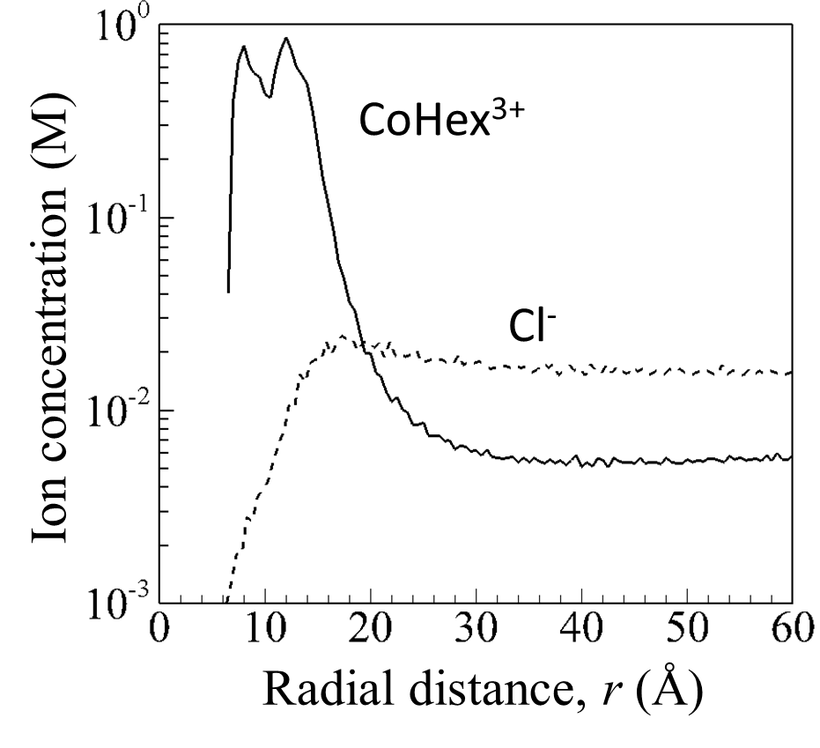

# Example 6B: Simulation with 25 bp A-RNA duplex in 5 mM CoHexCl3, using the UPM model

The input and output files are provided in the folder: ./gibs/Simulation_Examples/CoHexCl3_UPM_A_RNA

First, run a GCMC simulation to equilibrate the system and to get the states to use as initial states for the productions. Results are provided in the folder, ./gibs/Simulation_Examples/CoHexCl3_UPM_A_RNA/EQUILIBRATION_RUN

In this example, we perform four production runs (108 steps each). Results are provided in folders,

./gibs/Simulation_Examples/CoHexCl3_UPM_A_RNA/PRODUCTION_RUN1

./gibs/Simulation_Examples/CoHexCl3_UPM_A_RNA/PRODUCTION_RUN2

./gibs/Simulation_Examples/CoHexCl3_UPM_A_RNA/PRODUCTION_RUN3

./gibs/Simulation_Examples/CoHexCl3_UPM_A_RNA/PRODUCTION_RUN4

The final RDFs are calculated by averaging the RDFs from the four production runs. The results are shown in the plot below.

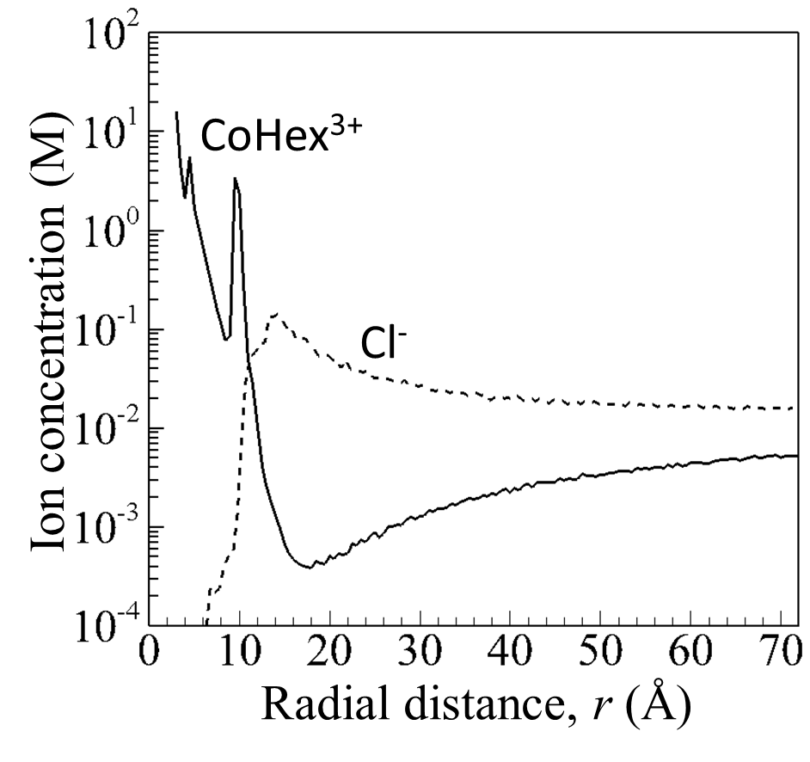

# Example 6C: Simulation with 25 bp mixed sequence DNA in 5 mM CoHexCl3, using the UPM model

The input and output files are provided in the folder: ./gibs/Simulation_Examples/CoHexCl3_UPM_Mixed_DNA_Sequence

First, run a GCMC simulation to equilibrate the system and to get the states to use as initial states for the productions. Results are provided in the folder, ./gibs/examples/ CoHexCl3_UPM_Mixed_DNA_Sequence/EQUILIBRATION_RUN

In this example, we perform four production runs (108 steps each). Results are provided in folders,

./gibs/Simulation_Examples/CoHexCl3_UPM_Mixed_DNA_Sequence/PRODUCTION_RUN1

./gibs/Simulation_Examples/CoHexCl3_UPM_Mixed_DNA_Sequence/PRODUCTION_RUN2

./gibs/Simulation_Examples/CoHexCl3_UPM_Mixed_DNA_Sequence/PRODUCTION_RUN3

./gibs/Simulation_Examples/CoHexCl3_UPM_Mixed_DNA_Sequence/PRODUCTION_RUN4

The final RDFs are calculated by averaging the RDFs from the four production runs. The results are shown in the plot below.

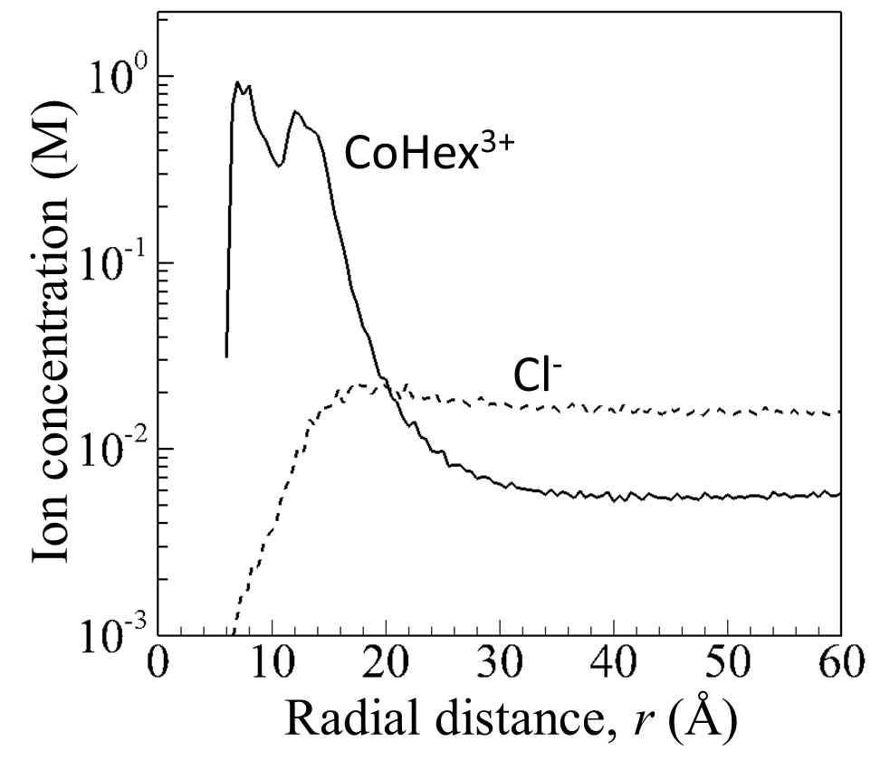

# Example 6D: Simulation with 25 bp DNA:RNA hybrid in 5 mM CoHexCl3, using the UPM model

The input and output files are provided in the folder: ./gibs/Simulation_Examples/CoHexCl3_UPM_DNA_RNA_Hybrid

First, run a GCMC simulation to equilibrate the system and to get the states to use as initial states for the productions. Results are provided in the folder, ./gibs/Simulation_Examples/ CoHexCl3_UPM_DNA_RNA_Hybrid/EQUILIBRATION_RUN

In this example, we perform four production runs (108 steps each). Results are provided in folders,

./gibs/Simulation_Examples/CoHexCl3_UPM_DNA_RNA_Hybrid/PRODUCTION_RUN1

./gibs/Simulation_Examples/CoHexCl3_UPM_DNA_RNA_Hybrid/PRODUCTION_RUN2

./gibs/Simulation_Examples/CoHexCl3_UPM_DNA_RNA_Hybrid/PRODUCTION_RUN3

./gibs/Simulation_Examples/CoHexCl3_UPM_DNA_RNA_Hybrid/PRODUCTION_RUN4

The final RDFs are calculated by averaging the RDFs from the four production runs. The results are shown in the plot below.

