PrintNet – Assignment #4 (Updated): User Stories & Design Diagrams
Updated: 2025-09-22 19:25

Design D0 — System Context
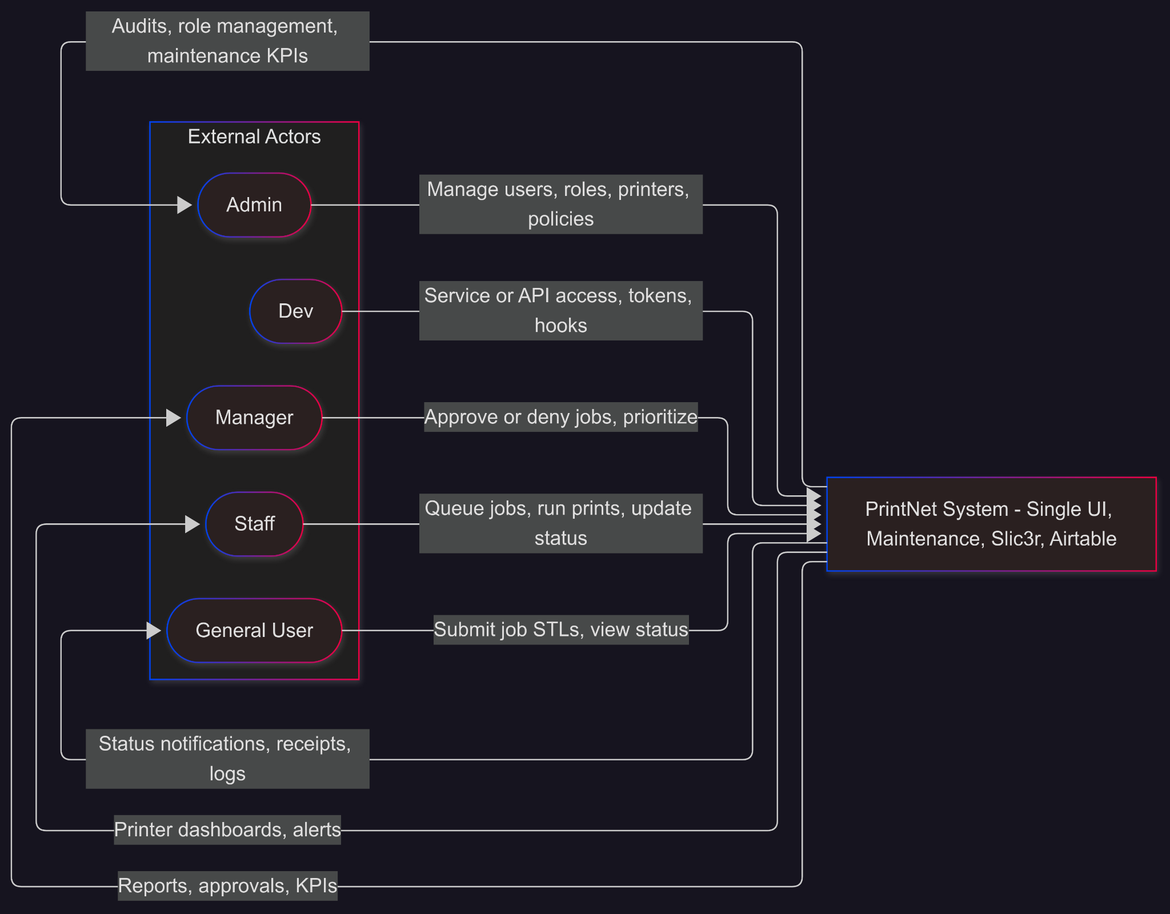
Figure 1. D0 – System Context for PrintNet.
What this shows: who sends inputs to PrintNet (submissions, approvals, admin changes) and what outputs they get back (statuses, dashboards, reports, audits).

Design D1 — Major Subsystems & Data Flow
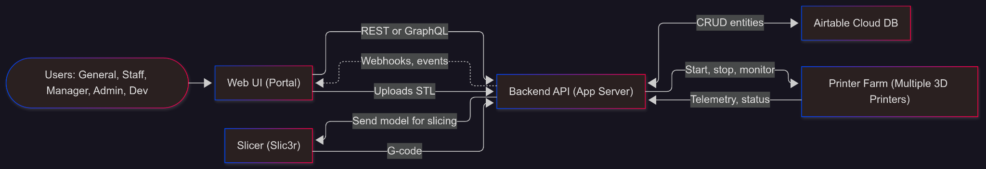
Figure 2. D1 – Major Subsystems and Data Flow.
Inputs/Outputs focus:
- UI ⇄ API: user actions and responses.
- API ⇄ DB: job/user/maintenance records (read/write).
- API ⇄ Slicer: model in → G-code out.
- API ⇄ Printers: commands out → telemetry/status in.
- API → UI (events): async notifications.

Design D2 — Detailed Internal Design
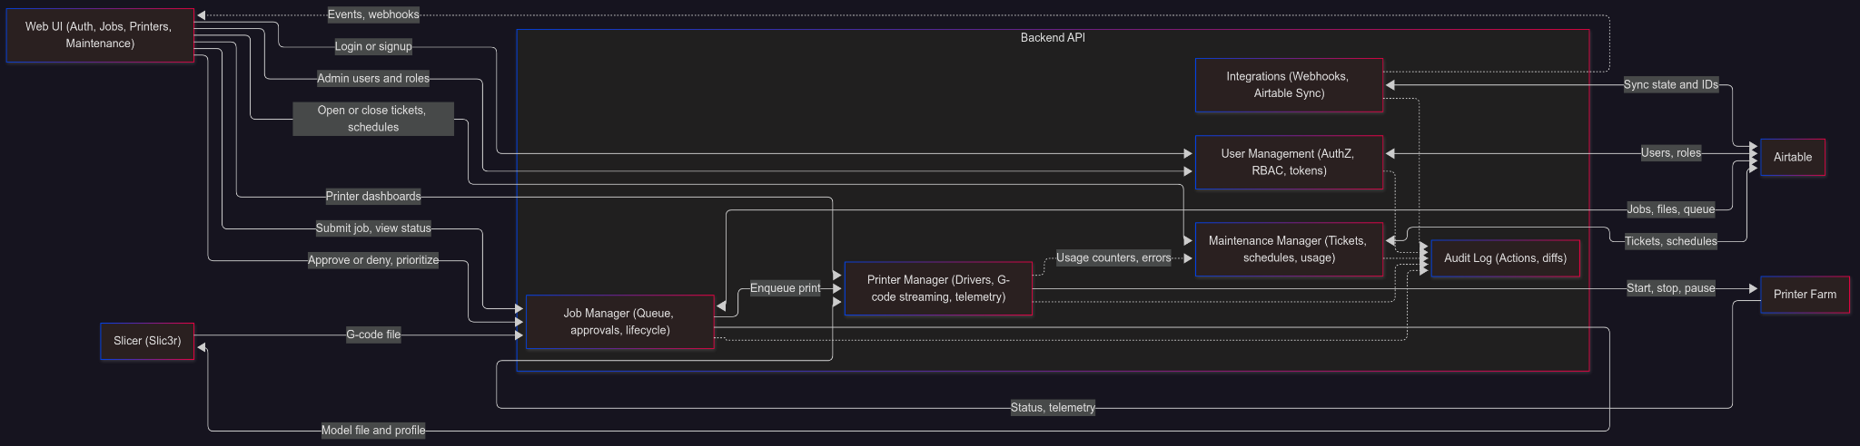
Figure 3. D2 – Detailed Backend and Integrations.
Inputs/Outputs focus:
- UM takes auth inputs from UI; outputs role-gated access; persists to DB; audits to AU.
- JM takes submissions/approvals; outputs queue state; persists to DB; sends model to SL (input) and gets G-code (output); enqueues to PM.
- PM outputs printer commands; inputs printer telemetry; forwards usage/errors to MM.
- MM inputs maintenance events; outputs tickets/schedule updates to DB.
- IN pushes events/webhooks to UI; syncs with Airtable.

ERD — Entities & Relationships
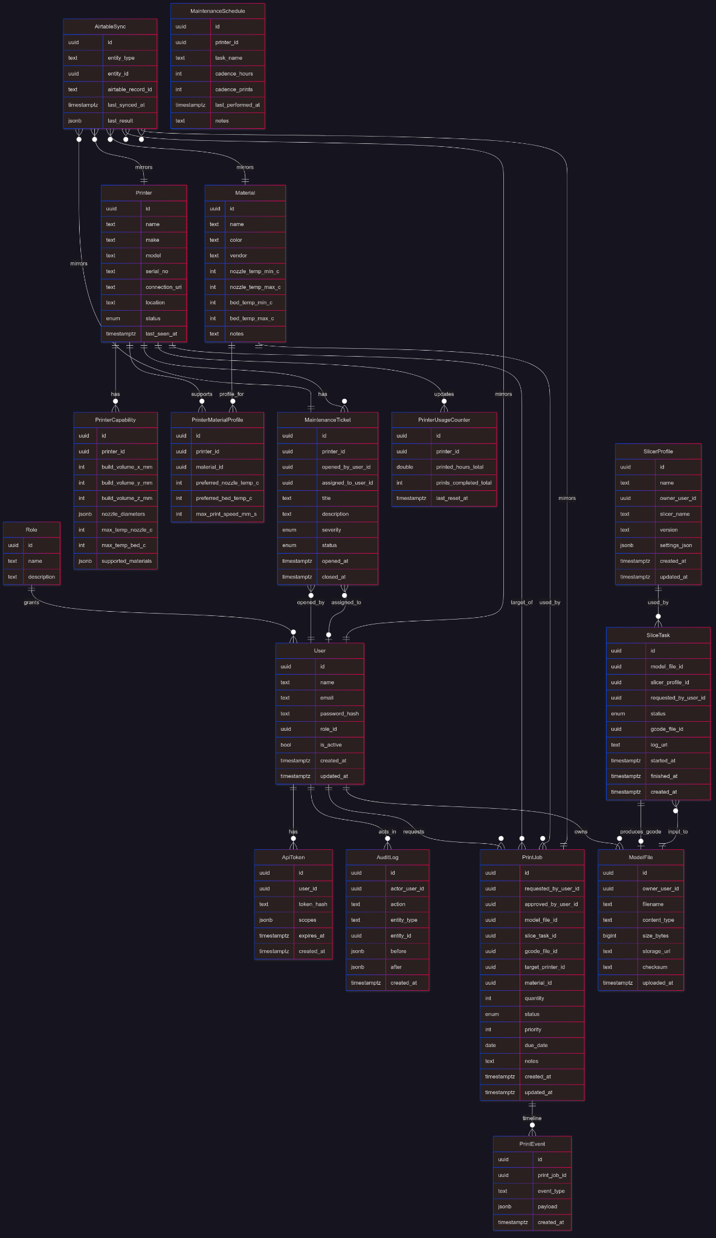
Figure 4. ERD – Data Model for PrintNet.

