PrintNet – Assignment #4: User Stories & Design Diagrams
Generated: 2025-09-18 17:25

Project Title & Goal
Project Title: PrintNet
Goal: Create an application that connects multiple 3D printers to one UI, with built-in maintenance features, Airtable integration, and a preferred Slic3r-based slicer.

User Stories
- As a general user, I want to submit a 3D print job (STL/3MF) through a web portal so that I can get parts printed without visiting the lab in person.
- As staff, I want to view the print queue and run jobs on specific printers so that I can manage throughput and keep machines busy.
- As a manager, I want to approve/deny and prioritize submitted jobs so that lab policy is enforced and critical prints are completed first.
- As an admin, I want to maintain users/roles, printers, and maintenance policies so that the lab remains secure, available, and in good working order.
- As a dev, I want API/token-based access and webhooks so that I can integrate PrintNet with other systems and automate workflows.

Design D0 — System Context
Diagram conventions: boxes indicate systems/components; arrows indicate data/control flows.
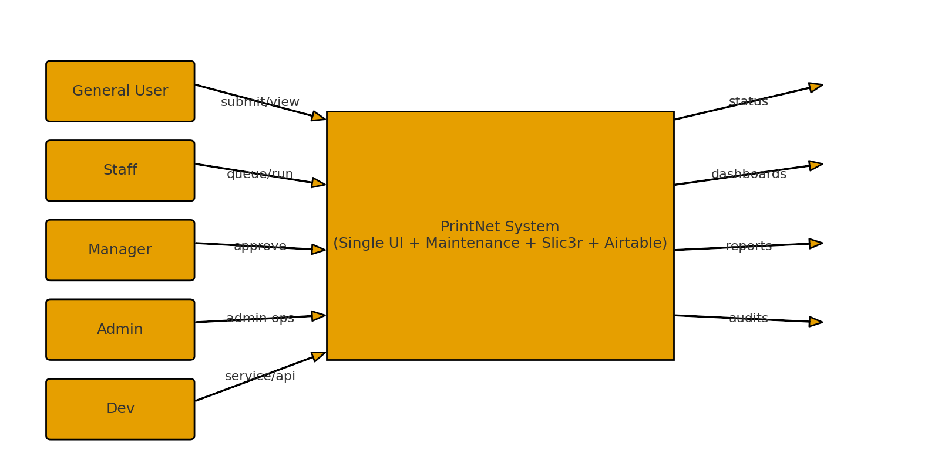
Mermaid source (for repository & renderers that support Mermaid):
```mermaid
flowchart LR
%% Diagram conventions:
%% - Rounded boxes = external actors/systems
%% - Rectangle = PrintNet system
%% - Arrows = data/control flow (inputs/outputs)
subgraph Actors["External Actors"]
U[("General User")]
S[("Staff")]
M[("Manager")]
A[("Admin")]
D[("Dev")]
end
P[[PrintNet System<br/>(Single UI + Maintenance + Slic3r + Airtable)]]
U -->|"Submit job (STL/3MF), view status"| P
S -->|"Queue jobs, run prints, update status"| P
M -->|"Approve/deny jobs, prioritize"| P
A -->|"Manage users/roles, printers, policies"| P
D -->|"Service/API access, tokens, hooks"| P
P -->|"Status notifications, receipts, logs"| U
P -->|"Printer dashboards, alerts"| S
P -->|"Reports, approvals, KPIs"| M
P -->|"Audits, role mgmt, maintenance KPIs"| A
```

Design D1 — Major Subsystems & Data Flow
Diagram conventions: boxes indicate systems/components; arrows indicate data/control flows.
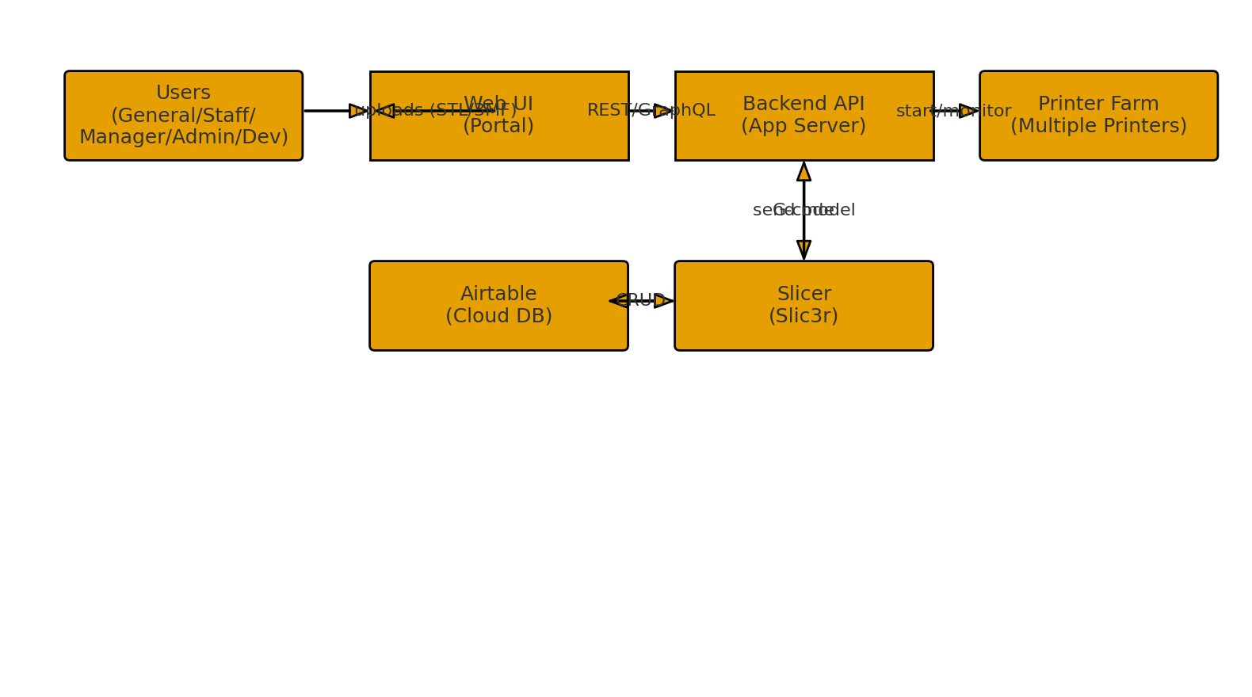
Mermaid source (for repository & renderers that support Mermaid):
```mermaid
flowchart LR
%% Conventions:
%% - Subgraphs = subsystems
%% - Solid arrows = primary request/response
%% - Dashed arrows = async events/webhooks
UI[Web UI<br/>(Portal)]
API[Backend API<br/>(App Server)]
DB[(Airtable<br/>Cloud DB)]
SL[Slicer<br/>(Slic3r)]
PF[Printer Farm<br/>(Multiple 3D Printers)]
U[("Users: General/Staff/Manager/Admin/Dev")] --> UI
UI -->|"REST/GraphQL"| API
API <-->|"CRUD entities"| DB
API -->|"send model for slicing"| SL
SL -->|"G-code"| API
API -->|"start/stop/monitor"| PF
PF -->|"telemetry/status"| API
API -.->|"webhooks/events"| UI
UI -->|"uploads (STL/3MF)"| API
```

Design D2 — Detailed Internal Design
Diagram conventions: boxes indicate systems/components; arrows indicate data/control flows.
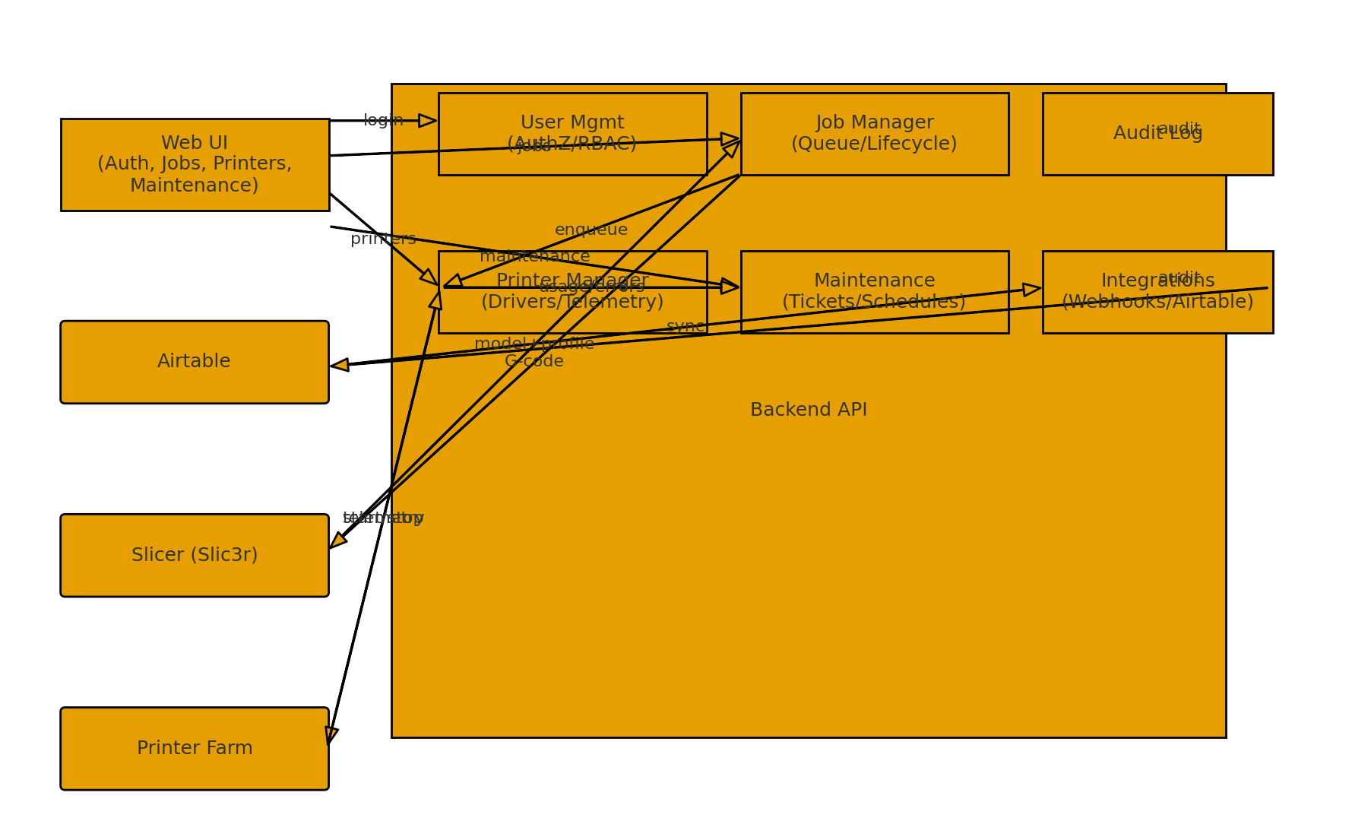
Mermaid source (for repository & renderers that support Mermaid):
```mermaid
flowchart LR
%% Conventions:
%% - Subgraph "Backend" contains internal modules
%% - Solid arrows = synchronous API/module calls
%% - Dotted arrows = internal events/side-effects
UI[Web UI<br/>(Auth, Jobs, Printers, Maintenance)]
DB[(Airtable)]
SL[Slicer (Slic3r)]
PRN[Printer Farm]
subgraph BE["Backend API"]
UM[User Management<br/>(AuthZ/RBAC, tokens)]
JM[Job Manager<br/>(Queue, approvals, lifecycle)]
PM[Printer Manager<br/>(Drivers, streaming G-code, telemetry)]
MM[Maintenance Manager<br/>(Tickets, schedules, usage)]
IN[Integrations<br/>(Webhooks, Airtable Sync)]
AU[Audit Log<br/>(Actions, diffs)]
end
%% UI routes
UI -->|"login/signup"| UM
UI -->|"submit job, view status"| JM
UI -->|"approve/deny, prioritize"| JM
UI -->|"printer dashboards"| PM
UI -->|"open/close tickets, schedules"| MM
UI -->|"admin: users/roles"| UM
%% Backend <-> DB
UM <-->|"users, roles"| DB
JM <-->|"jobs, files, queue"| DB
MM <-->|"tickets, schedules"| DB
IN <-->|"sync state/ids"| DB
%% Slicing path
JM -->|"model file + profile"| SL
SL -->|"G-code file"| JM
JM -->|"enqueue print"| PM
%% Printing path
PM -->|"start/stop/pause"| PRN
PRN -->|"status/telemetry"| PM
%% Maintenance signals
PM -.->|"usage counters, errors"| MM
%% Cross-cutting
UM -.-> AU
JM -.-> AU
PM -.-> AU
MM -.-> AU
IN -.-> AU
%% Notifications
IN -.->|"events/webhooks"| UI
```

ERD (Mermaid)
Use the Mermaid source below to render an ER diagram in GitHub/VS Code/Canvas (if supported):
```mermaid
erDiagram
%% Users & Access
User ||--o{ ApiToken : "has"
Role ||--o{ User : "grants"
User ||--o{ AuditLog : "acts_in"
%% Printers & Materials
Printer ||--o{ PrinterCapability : "has"
Printer ||--o{ PrinterMaterialProfile : "supports"
Printer ||--o{ PrintJob : "target_of"
Printer ||--o{ MaintenanceTicket : "has"
Printer ||--o{ PrinterUsageCounter : "updates"
Material ||--o{ PrinterMaterialProfile : "profile_for"
Material ||--o{ PrintJob : "used_by"
%% Files, Slicing, Jobs
User ||--o{ ModelFile : "owns"
ModelFile ||--o{ SliceTask : "input_to"
SlicerProfile ||--o{ SliceTask : "used_by"
SliceTask ||--o| ModelFile : "produces_gcode"
User ||--o{ PrintJob : "requests"
PrintJob ||--o{ PrintEvent : "timeline"
%% Maintenance
MaintenanceTicket }o--|| User : "opened_by"
MaintenanceTicket }o--o| User : "assigned_to"
%% Integrations
AirtableSync }o--|| User : "mirrors"
AirtableSync }o--|| Printer : "mirrors"
AirtableSync }o--|| PrintJob : "mirrors"
AirtableSync }o--|| MaintenanceTicket : "mirrors"
AirtableSync }o--|| Material : "mirrors"
%% Entities (attributes omitted in ERD for clarity)
User {
uuid id
text name
text email
text password_hash
uuid role_id
bool is_active
timestamptz created_at
timestamptz updated_at
}
Role {
uuid id
text name
text description
}
ApiToken {
uuid id
uuid user_id
text token_hash
jsonb scopes
timestamptz expires_at
timestamptz created_at
}
Printer {
uuid id
text name
text make
text model
text serial_no
text connection_uri
text location
enum status
timestamptz last_seen_at
}
PrinterCapability {
uuid id
uuid printer_id
int build_volume_x_mm
int build_volume_y_mm
int build_volume_z_mm
jsonb nozzle_diameters
int max_temp_nozzle_c
int max_temp_bed_c
jsonb supported_materials
}
Material {
uuid id
text name
text color
text vendor
int nozzle_temp_min_c
int nozzle_temp_max_c
int bed_temp_min_c
int bed_temp_max_c
text notes
}
PrinterMaterialProfile {
uuid id
uuid printer_id
uuid material_id
int preferred_nozzle_temp_c
int preferred_bed_temp_c
int max_print_speed_mm_s
}
ModelFile {
uuid id
uuid owner_user_id
text filename
text content_type
bigint size_bytes
text storage_url
text checksum
timestamptz uploaded_at
}
SlicerProfile {
uuid id
text name
uuid owner_user_id
text slicer_name
text version
jsonb settings_json
timestamptz created_at
timestamptz updated_at
}
SliceTask {
uuid id
uuid model_file_id
uuid slicer_profile_id
uuid requested_by_user_id
enum status
uuid gcode_file_id
text log_url
timestamptz started_at
timestamptz finished_at
timestamptz created_at
}
PrintJob {
uuid id
uuid requested_by_user_id
uuid approved_by_user_id
uuid model_file_id
uuid slice_task_id
uuid gcode_file_id
uuid target_printer_id
uuid material_id
int quantity
enum status
int priority
date due_date
text notes
timestamptz created_at
timestamptz updated_at
}
PrintEvent {
uuid id
uuid print_job_id
text event_type
jsonb payload
timestamptz created_at
}
MaintenanceTicket {
uuid id
uuid printer_id
uuid opened_by_user_id
uuid assigned_to_user_id
text title
text description
enum severity
enum status
timestamptz opened_at
timestamptz closed_at
}
MaintenanceSchedule {
uuid id
uuid printer_id
text task_name
int cadence_hours
int cadence_prints
timestamptz last_performed_at
text notes
}
PrinterUsageCounter {
uuid id
uuid printer_id
double printed_hours_total
int prints_completed_total
timestamptz last_reset_at
}
AirtableSync {
uuid id
text entity_type
uuid entity_id
text airtable_record_id
timestamptz last_synced_at
jsonb last_result
}
AuditLog {
uuid id
uuid actor_user_id
text action
text entity_type
uuid entity_id
jsonb before
jsonb after
timestamptz created_at
}
```

