Mitchell Koski 3/1/2026
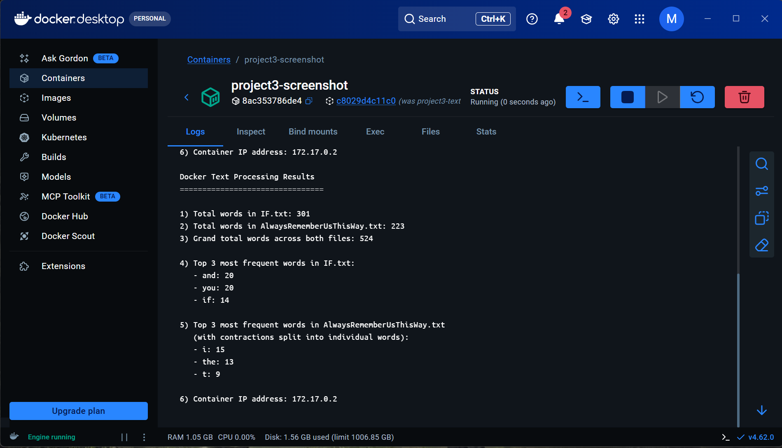
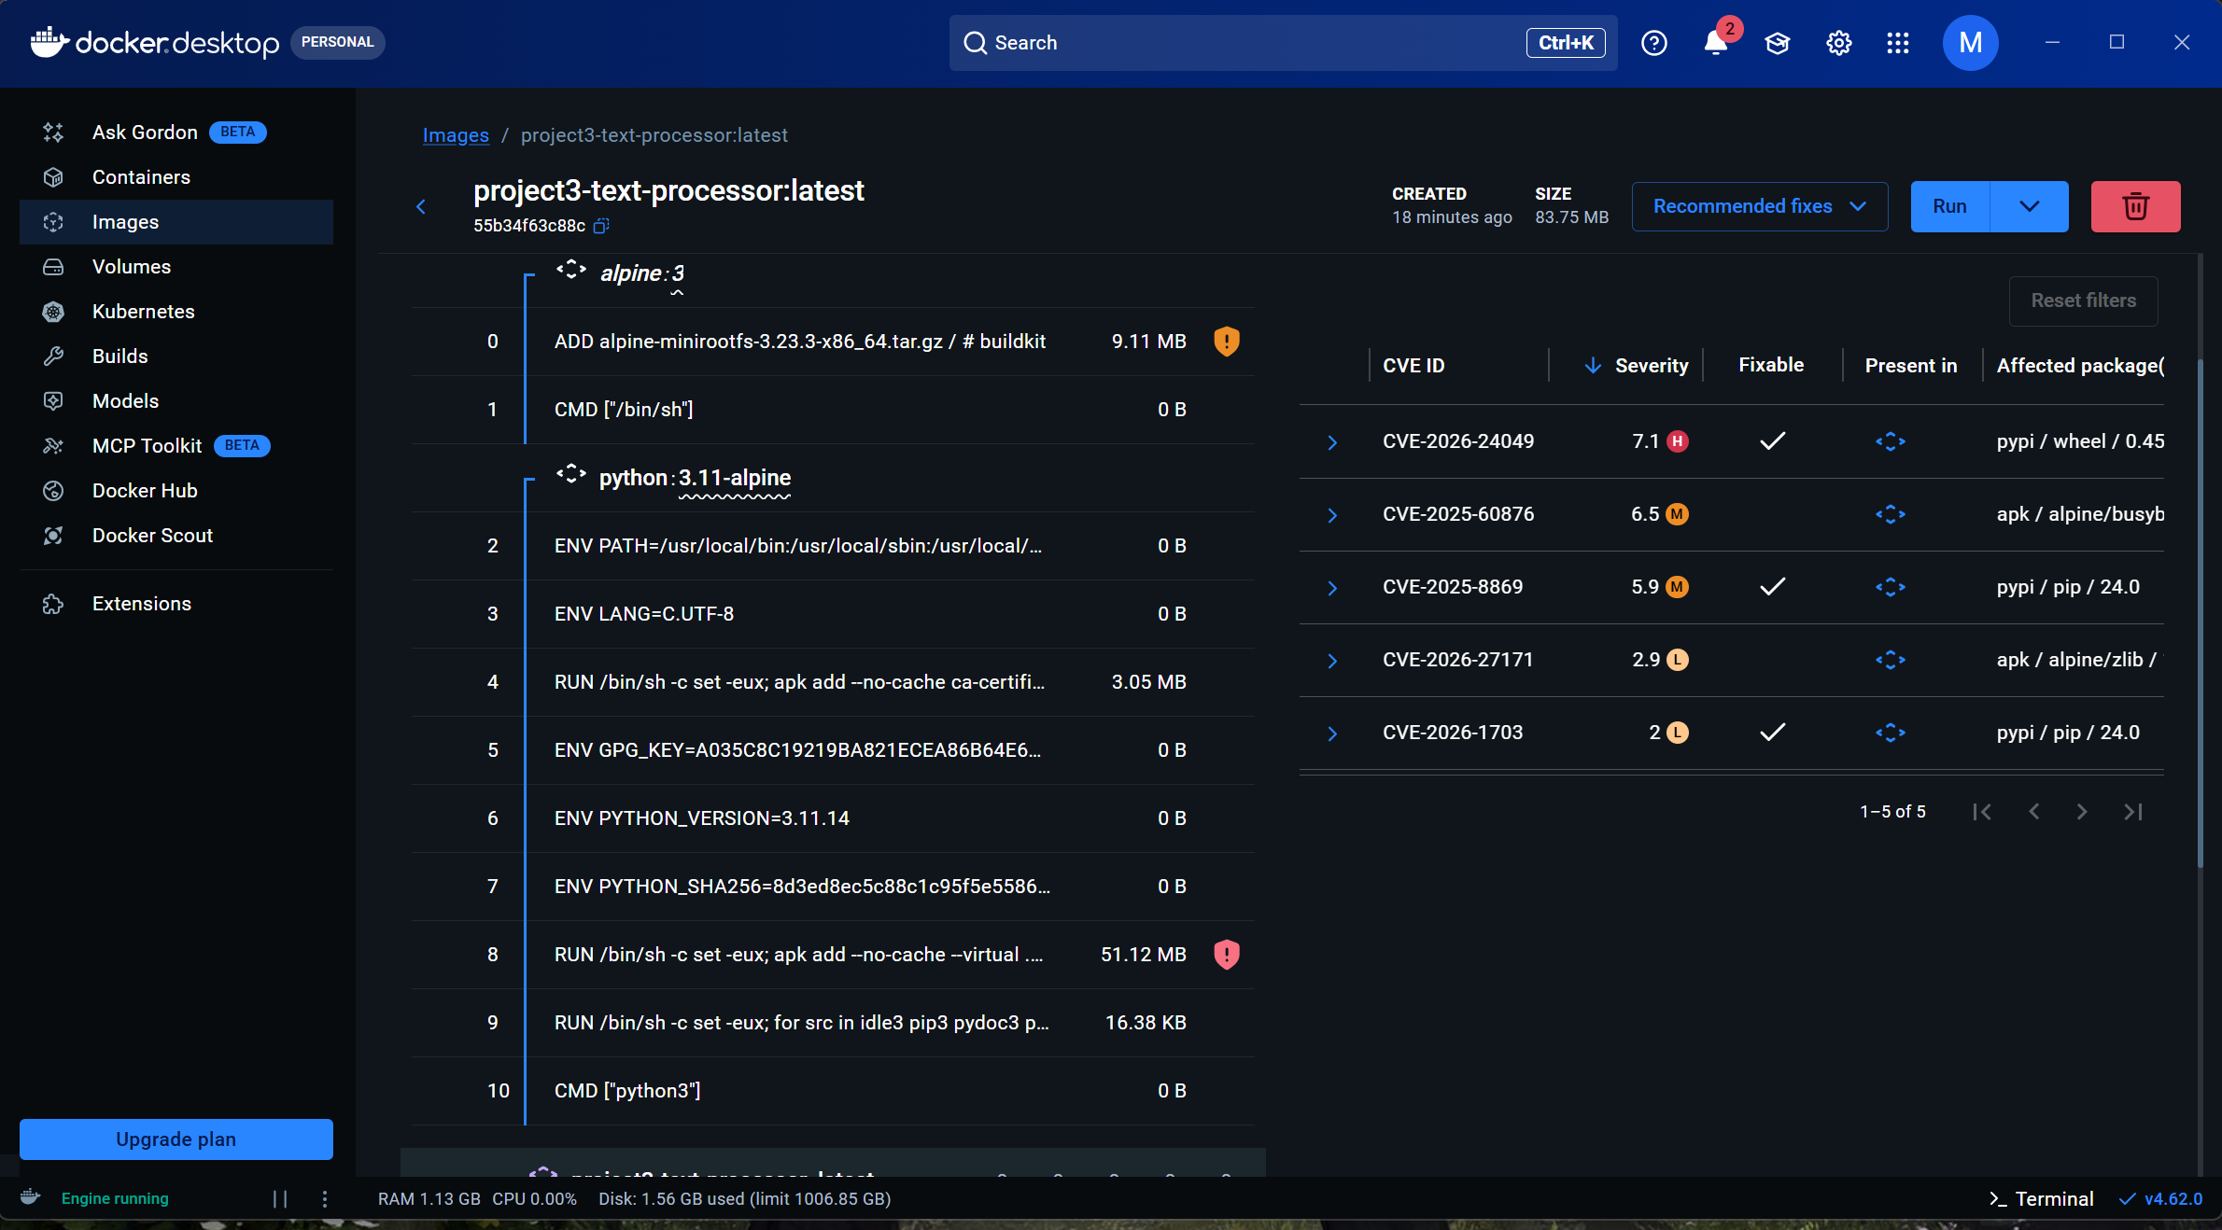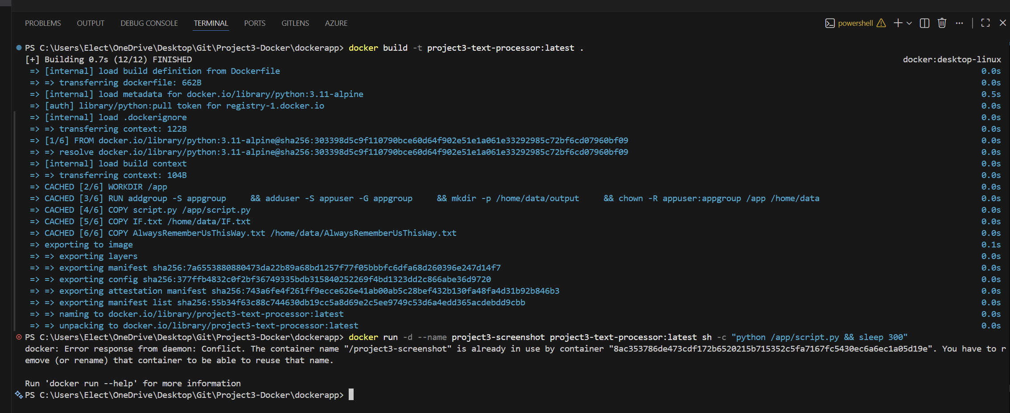
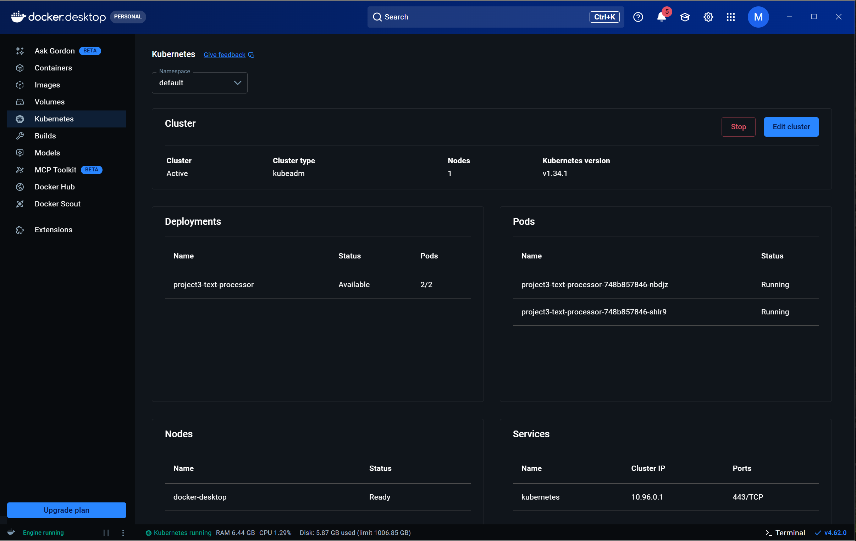
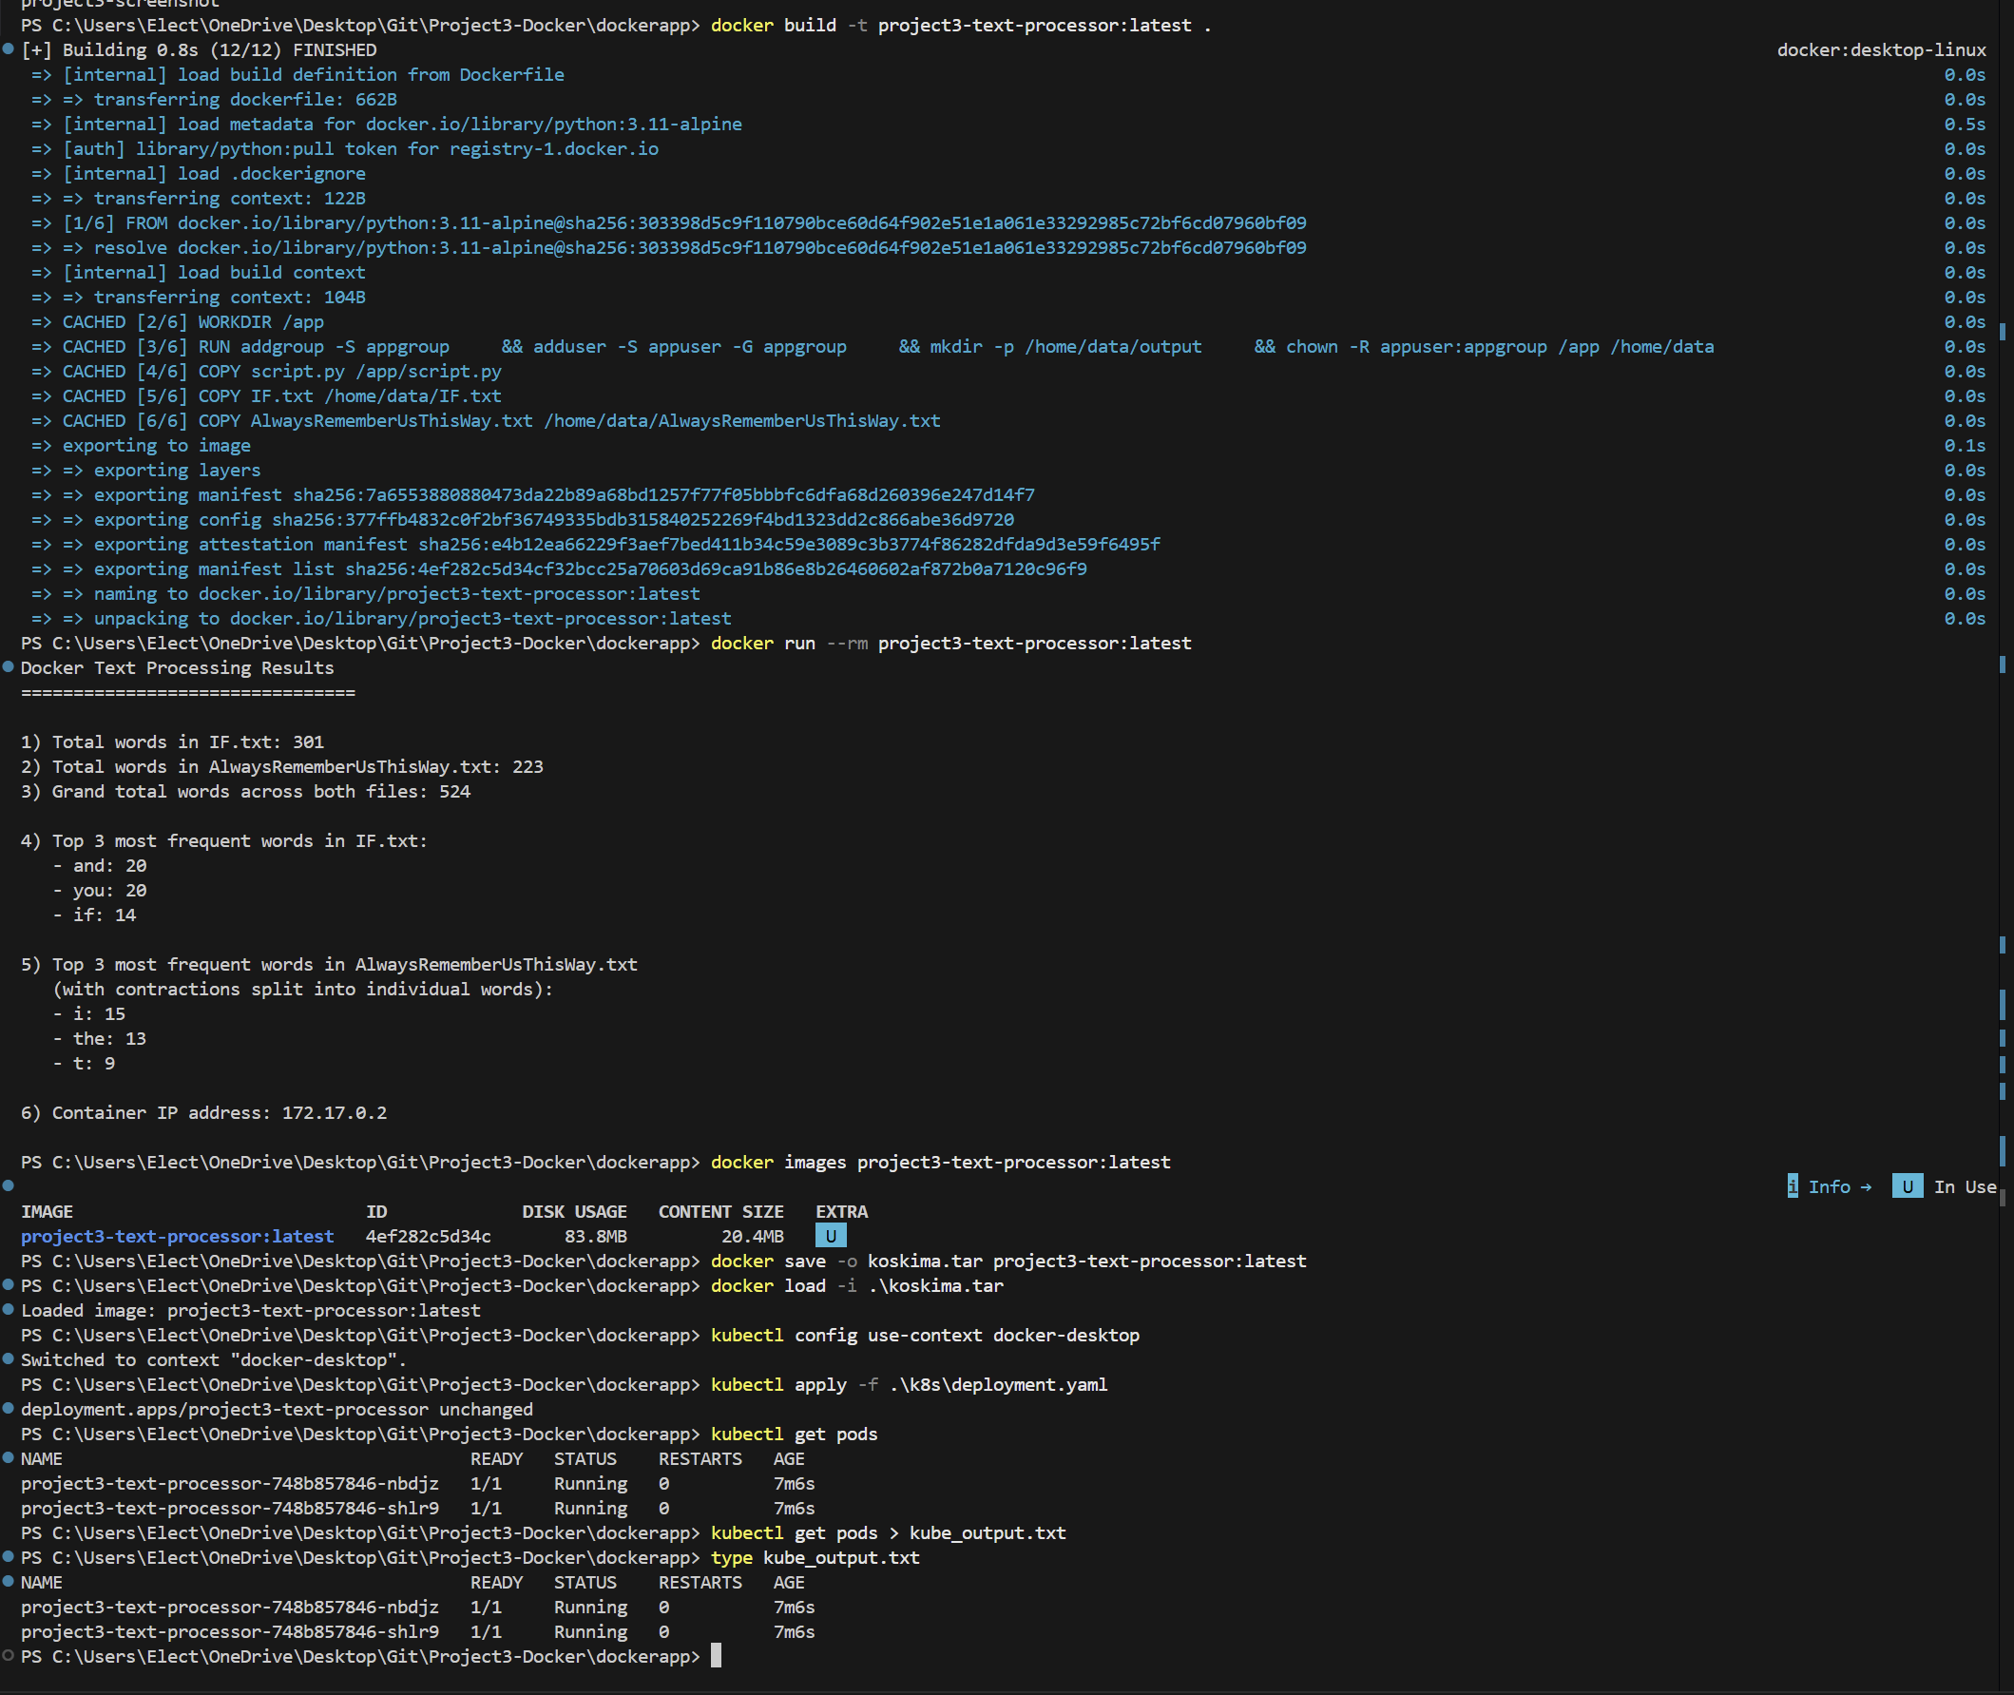
PS C:\Users\Elect\OneDrive\Desktop\Git\Project3-Docker\dockerapp> docker build -t project3-text-processor:latest .
[+] Building 0.8s (12/12) FINISHED docker:desktop-linux
=> [internal] load build definition from Dockerfile 0.0s
=> => transferring dockerfile: 662B 0.0s
=> [internal] load metadata for docker.io/library/python:3.11-alpine 0.5s
=> [auth] library/python:pull token for registry-1.docker.io 0.0s
=> [internal] load .dockerignore 0.0s
=> => transferring context: 122B 0.0s
=> [1/6] FROM docker.io/library/python:3.11-alpine@sha256:303398d5c9f110790bce60d64f902e51e1a061e33292985c72bf6cd07960bf09 0.0s
=> => resolve docker.io/library/python:3.11-alpine@sha256:303398d5c9f110790bce60d64f902e51e1a061e33292985c72bf6cd07960bf09 0.0s
=> [internal] load build context 0.0s
=> => transferring context: 104B 0.0s
=> CACHED [2/6] WORKDIR /app 0.0s
=> CACHED [3/6] RUN addgroup -S appgroup && adduser -S appuser -G appgroup && mkdir -p /home/data/output && chown -R appuser:appgroup /app /home/data 0.0s
=> CACHED [4/6] COPY script.py /app/script.py 0.0s
=> CACHED [5/6] COPY IF.txt /home/data/IF.txt 0.0s
=> CACHED [6/6] COPY AlwaysRememberUsThisWay.txt /home/data/AlwaysRememberUsThisWay.txt 0.0s
=> exporting to image 0.1s
=> => exporting layers 0.0s
=> => exporting manifest sha256:7a6553880880473da22b89a68bd1257f77f05bbbfc6dfa68d260396e247d14f7 0.0s
=> => exporting config sha256:377ffb4832c0f2bf36749335bdb315840252269f4bd1323dd2c866abe36d9720 0.0s
=> => exporting attestation manifest sha256:e4b12ea66229f3aef7bed411b34c59e3089c3b3774f86282dfda9d3e59f6495f 0.0s
=> => exporting manifest list sha256:4ef282c5d34cf32bcc25a70603d69ca91b86e8b26460602af872b0a7120c96f9 0.0s
=> => naming to docker.io/library/project3-text-processor:latest 0.0s
=> => unpacking to docker.io/library/project3-text-processor:latest 0.0s
PS C:\Users\Elect\OneDrive\Desktop\Git\Project3-Docker\dockerapp> docker run --rm project3-text-processor:latest
Docker Text Processing Results
================================

1) Total words in IF.txt: 301
2) Total words in AlwaysRememberUsThisWay.txt: 223
3) Grand total words across both files: 524

4) Top 3 most frequent words in IF.txt:
- and: 20
- you: 20
- if: 14

5) Top 3 most frequent words in AlwaysRememberUsThisWay.txt
(with contractions split into individual words):
- i: 15
- the: 13
- t: 9

6) Container IP address: 172.17.0.2

PS C:\Users\Elect\OneDrive\Desktop\Git\Project3-Docker\dockerapp> docker images project3-text-processor:latest
i Info → U In Use
IMAGE ID DISK USAGE CONTENT SIZE EXTRA
project3-text-processor:latest 4ef282c5d34c 83.8MB 20.4MB U
PS C:\Users\Elect\OneDrive\Desktop\Git\Project3-Docker\dockerapp> docker save -o koskima.tar project3-text-processor:latest
PS C:\Users\Elect\OneDrive\Desktop\Git\Project3-Docker\dockerapp> docker load -i .\koskima.tar
Loaded image: project3-text-processor:latest
PS C:\Users\Elect\OneDrive\Desktop\Git\Project3-Docker\dockerapp> kubectl config use-context docker-desktop
Switched to context "docker-desktop".
PS C:\Users\Elect\OneDrive\Desktop\Git\Project3-Docker\dockerapp> kubectl apply -f .\k8s\deployment.yaml
deployment.apps/project3-text-processor unchanged
PS C:\Users\Elect\OneDrive\Desktop\Git\Project3-Docker\dockerapp> kubectl get pods
NAME READY STATUS RESTARTS AGE
project3-text-processor-748b857846-nbdjz 1/1 Running 0 7m6s
project3-text-processor-748b857846-shlr9 1/1 Running 0 7m6s
PS C:\Users\Elect\OneDrive\Desktop\Git\Project3-Docker\dockerapp> kubectl get pods > kube_output.txt
PS C:\Users\Elect\OneDrive\Desktop\Git\Project3-Docker\dockerapp> type kube_output.txt
NAME READY STATUS RESTARTS AGE
project3-text-processor-748b857846-nbdjz 1/1 Running 0 7m6s
project3-text-processor-748b857846-shlr9 1/1 Running 0 7m6s
PS C:\Users\Elect\OneDrive\Desktop\Git\Project3-Docker\dockerapp>

