Report Due on Thursday, October 31.

Sensor Tile Lab 2 Report: Accelerometer Sensor Systems and Orientation and Event Detection

CEE-445 Embedded System, Fall 2019

Student Name: Jacob Hillebrand

**Introduction:**

In this lab, we will continue our exploration of the SensorTile board by looking into expanding the functionality of the Accelerometer and using the gyro sensor to determine the board’s orientation. This functionality can be useful when building an embedded system that needs to be aware of its orientation, such as an automated drone or robot. This lab should be of great use to the students planning to incorporate this type of design element into their final projects.

**Experimental Process and data:**

1. 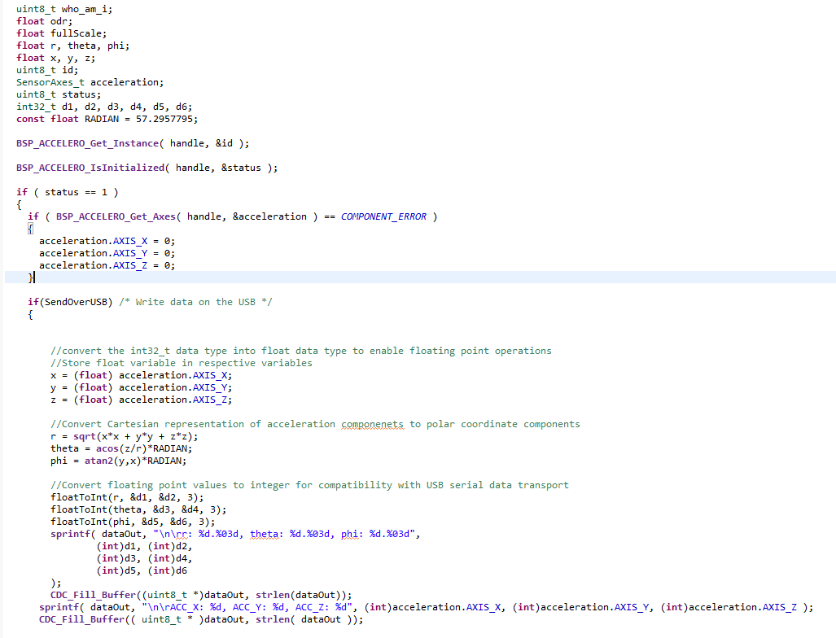Show your code that implements polar coordinate conversion to SensorTile system. See Accelero_Sensor_Handlerfunction (fig. 3 in the lab) and take a screen and add it to this report.
2. 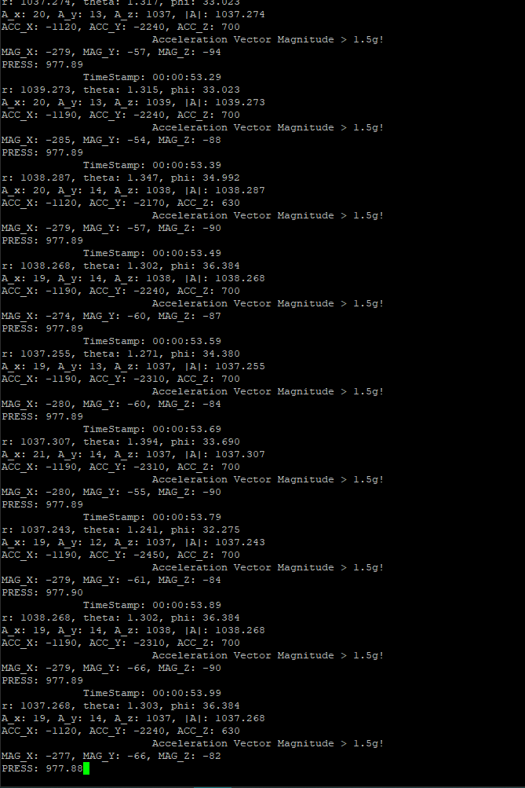Examine the data transmitted over the Serial USB connection to your personal computer. Take a screenshot and add it to this report.
3. Orient the SensorTile, such that the value for A_z is approximately +1000, and the two

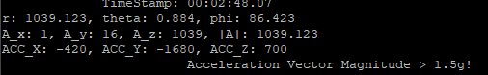other axes (A_x, A_y) are as close to 0 as possible. Record the values of r, phi and theta.

1. 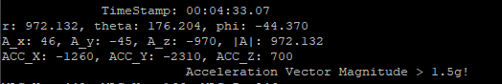Orient the SensorTile upside down such that the value for A_z is approximately -1000, and the two other axes (A_x, A_y) are as close to 0 as possible. Record the values of r, phi and theta.
2. Repeat steps 3 and 4 and fill in the following table.

|  |  |  |  |
| --- | --- | --- | --- |
|  | R (magnitude) | Phi (azimuth) | Theta (inclination) |
| 𝐴z ~ + 1000, 𝐴x~0, 𝐴y~0 | 1039.123 | 86.423 | 0.884 |
| 𝐴z ~ -1000, 𝐴x~0, 𝐴y~0 | 972.132 | -44.370 | 176.204 |
| 𝐴y ~ + 1000, 𝐴x~0, 𝐴z~0 | 982.004 | 89.883 | 89.883 |
| 𝐴y ~ -1000, 𝐴x~0, 𝐴z~0 | 1010.323 | -89.262 | 91.247 |
| 𝐴x ~ +1000, 𝐴z~0, 𝐴y~0 | 986.073 | 0.464 | 90.552 |
| 𝐴x ~ -1000, 𝐴z~0, 𝐴y~0 | 1011.024 | -179.716 | 90.283 |

1. Demonstration of Gesture Recognition Systems

Perform the steps required from the state machine in Figure 4 in this lab to make the “Flipping Gesture Detected!” appear on your personal computer. Take a screenshot of this message appearing and add it to this report.

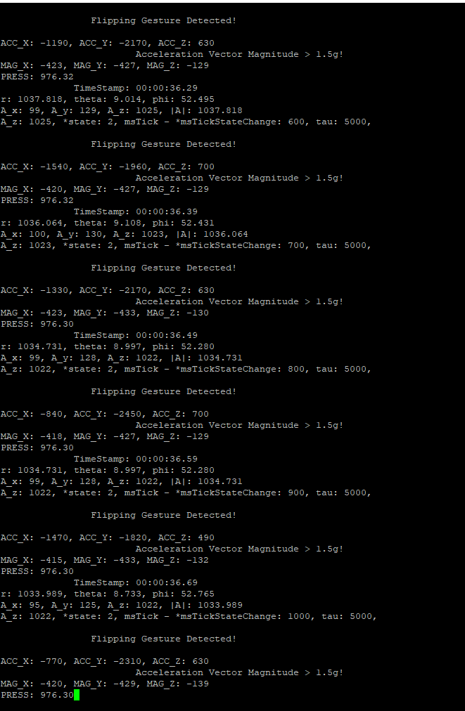

Conclusion:

//In this section, discuss how you can apply the Accelerometer Sensor Systems for Orientation and Event Detection to create real-world applications. Give an example.

Accelerometer sensor systems for orientation and event detection have a plethora of applications in the real world. They can be used for a wide range of detection systems and can feed data into an embedded system. For example, the remotes for the Nintendo Wii made use of orientation sensing to determine when a corresponding event had occurred. Thus, when the user would make a “bowling” action or swing their arm as if they were swinging a tennis racket, the corresponding event would be sent to the system, and the game could interpret the event as an in-game action. These kinds of sensors are what made games on the Nintendo Wii so fun and engaging, and the games would not be nearly as enthralling without them.