**Setting Up IP Address Pushing on Raspberry Pi**

# Introductory Notes

The intention of this document is to describe how to set up a script on the Raspberry Pi that, upon booting the Pi, the Pi’s current IP address will be pushed to the user’s Pushbullet account, allowing the user to quickly ssh into the Pi in a network environment where the Pi cannot retain a static IP address. There are, however, a few important limitations of this script to note. First and foremost, this script assumes that the Pi has already been properly configured to automatically connect to a network, and that the Pi can do so consistently with each boot. Secondly, this script was designed specifically for use with the UW-Stout network. On a NAT-enabled network, this script will not function as given, as it is designed to grab only the public-facing IP address of the Pi, which would not be the IP of the Pi on the NAT subnet[1]. And finally, this script is not intelligent. The script cannot detect if the Pi’s IP address changes during operation, and so if this scenario occurs, the entire Raspberry Pi must be rebooted to trigger the script. With these caveats out of the way, setting up the script is as follows.

# Setting Up Pushbullet

The first part of setting up the IP Pusher script is creating a Pushbullet account. If you already have an existing Pushbullet account, you may skip to Finding Your Pushbullet Authentication Token.

The most straightforward way to set up a Pushbullet account is to go to <https://www.pushbullet.com/>. You’ll be presented with the option to either sign in with a Google account or a Facebook account; choose whichever is most convenient for you.





Upon signing in, you’ll be greeted with the Pushbullet homepage. Pushbullet is a great messaging service and allows you to install it on nearly any device. For general usage, I recommend installing it on your favorite browser as a **browser extension**, and potentially on your smart phone as well (they have Android and iOS apps). You can send messages, pictures, and even small files between all your devices that have it installed and can even send messages through the app to other people with a Pushbullet account. But most importantly, Pushbullet has a fantastic API that allows you to write programs that can interact with your Pushbullet account. We will use this feature specifically in the next section.

# Finding Your Pushbullet Authentication Token

To set up the Raspberry Pi script, you will first need to grab the API token for your Pushbullet account. To do this, head to the Pushbullet homepage at <https://www.pushbullet.com/>, and get signed in. Next, go to the settings tab on the left-hand side of the page.

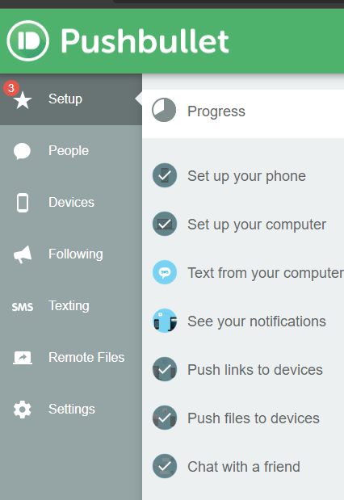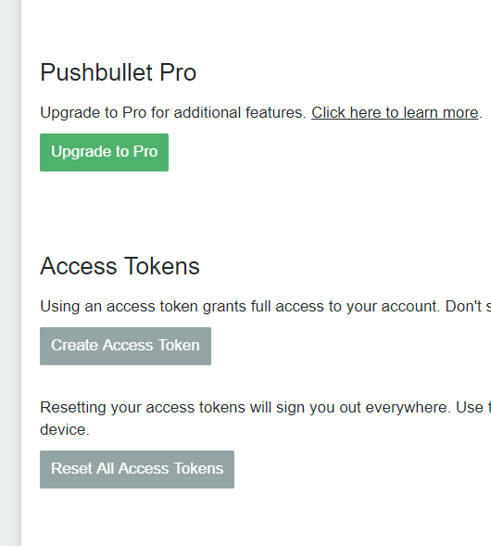

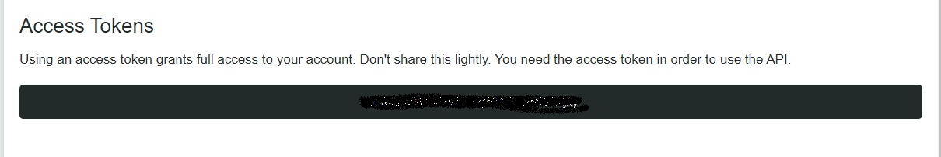Next, click the button that reads “Create Access Token”. This will generate an access token that can be used to make API calls to your account. DO NOT SHARE THIS, ANYONE WITH THIS CAN ACCESS YOUR PUSHBULLET ACCOUNT!

Once you have this token, be sure to copy it, and set it aside for now. We will need it in the next section.

# Setting Up the Python Script

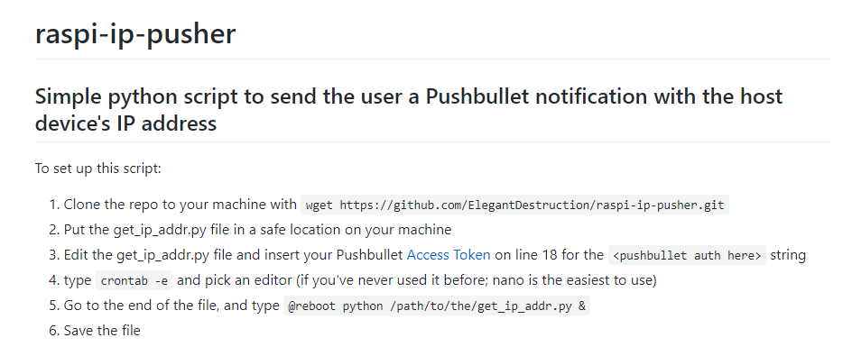 I have made the Python script publicly available at the website <https://github.com/ElegantDestruction/raspi-ip-pusher>. If you scroll to the bottom of the page, there are brief instructions on how to get the script set up. Note, when the instructions mention “machine”, in this context that should be taken to mean the Raspberry Pi[2].

# Usage

Once you have followed this guide, the steps to using this script are as follows:

1. Boot up the Raspberry Pi
2. Wait at least 45 seconds for the script to initialize.
3. Open your Pushbullet account on your preferred device. See if the script pushed the IP address of the Pi to your messages.
   1. If no IP appears after ~2 minutes, simply reboot the Pi and start again at Step 1.
   2. If this continues to occur, you will need to troubleshoot.
4. Use the IP address that was pushed to your Pushbullet account to connect to the Raspberry Pi over ssh

# Version History

|  |  |  |  |
| --- | --- | --- | --- |
| Date | Editor | Changes Made | Contact |
| 12/15/2019 | Jacob Hillebrand | Initial Doc Creation | hillebrandj3779@my.uwstout.edu |
|  |  |  |  |
|  |  |  |  |
|  |  |  |  |

1. This problem can be overcome by port-forwarding the ssh port of the Pi on the NAT router, which is NOT covered in the scope of this document
2. This script can be used on devices other than a Raspberry Pi, as long as they are running some form of GNU/Linux. Hence the terminology “machine” was chosen.