#MEGALED

revision 1

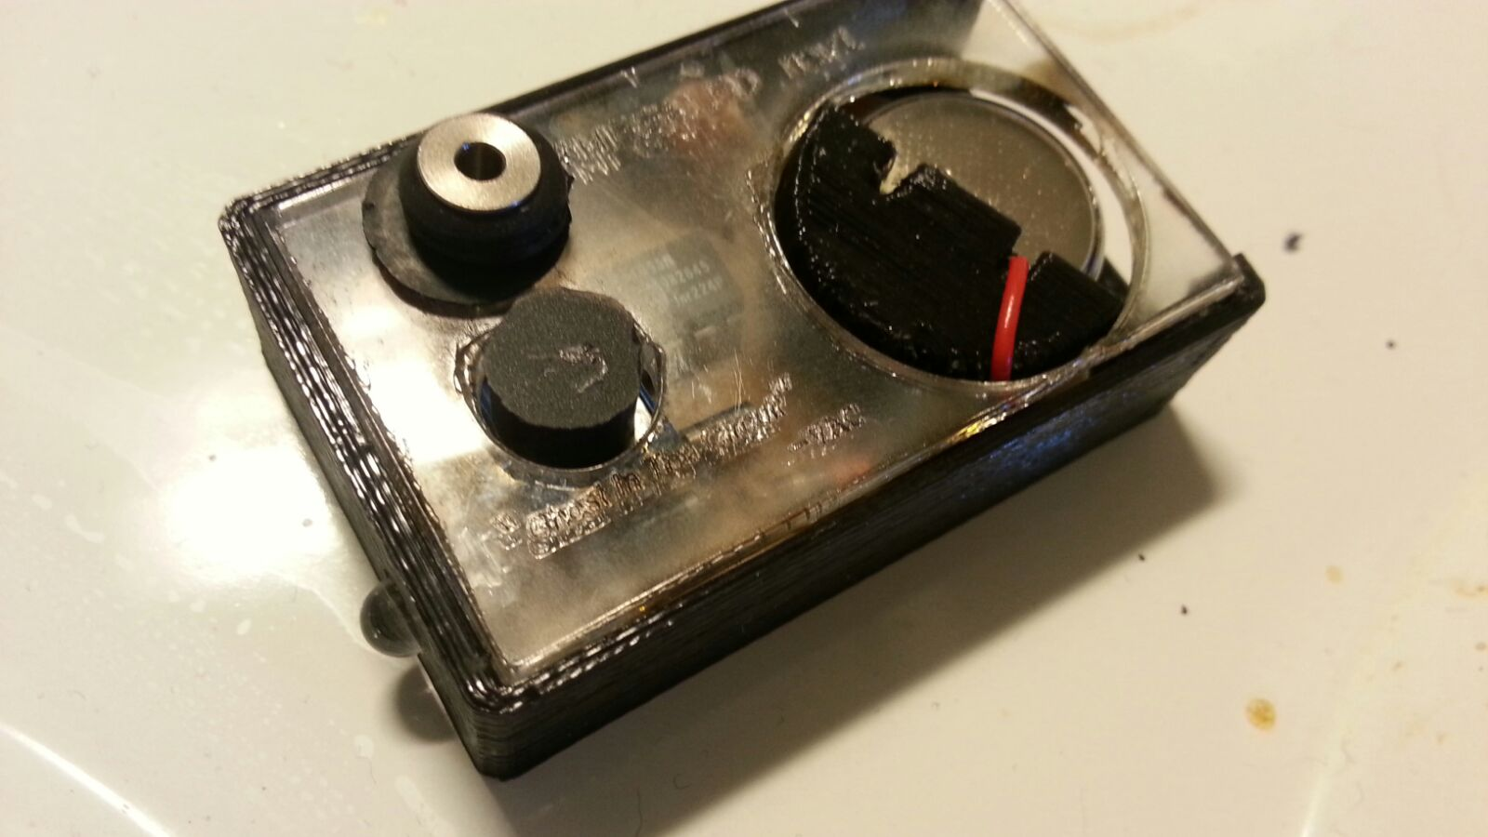

## Improvements for rev2

* Change diodes in schematic to be schottky diodes
* Change capacitor footprints to ones that are a bit wider
* Change resistor footprint into a longer one
* Finalize pcb design, minimize area
* Design own solution for battery holder that works with case template
* The case can be thinned a bit, especially bottom
* Add more design points towards template case, eg. pcb holder
* Design better buttons
* ~~Try to test with logaritmic trimmer for more linear brightness control~~ → Test brightness control with smaller and larger potentiometers!
* Reduce case size from 36 x 58,8 x 15,6 to approximately 30 x 57 x 11 (-43%)