Poseidon

# The project

We need to devolop a way to control light on terminal steder

# What are the requerements

## Outputs

There is a need for 9 outputs all relay

4 for controlling pumps

4 for controlling red/green lights

1 for reseting the E-stop

## Inputs

There is a need for 12 input all switch able

We need to connect to Uptime for controlling the in and outputs

So, we need to make our own protocol on how to communicate between uptime and the relay board

This system must run on its own like a second layer of security, so we will not be able to connect to existing Sapphire terminal.

# Thoughts on hardware

Outputs must be relays, and it must be able to switch 24V 1A

Inputs must have protection, so voltage spikes don’t destroy the board, preferable with opt cobles.

Board shall have a MCU onboard that we can control, an program ore own firmware into.

Communication must be via uart of some kind.

# Thoughts on connection to uptime

In the proto type we can use an existing Sapphire and connect the relay board to it via TTL logic or something like that.

In Sapphire there is a part of the software that are responsible for connecting to Uptime via Systic server. We can modify this part to parse command on to the MCU on the relay board.

In a later version we can make the MCU communicate directly to the server.

# Possible solution for prototype

We have found a relay board that can do most of the thing that we are looking for.

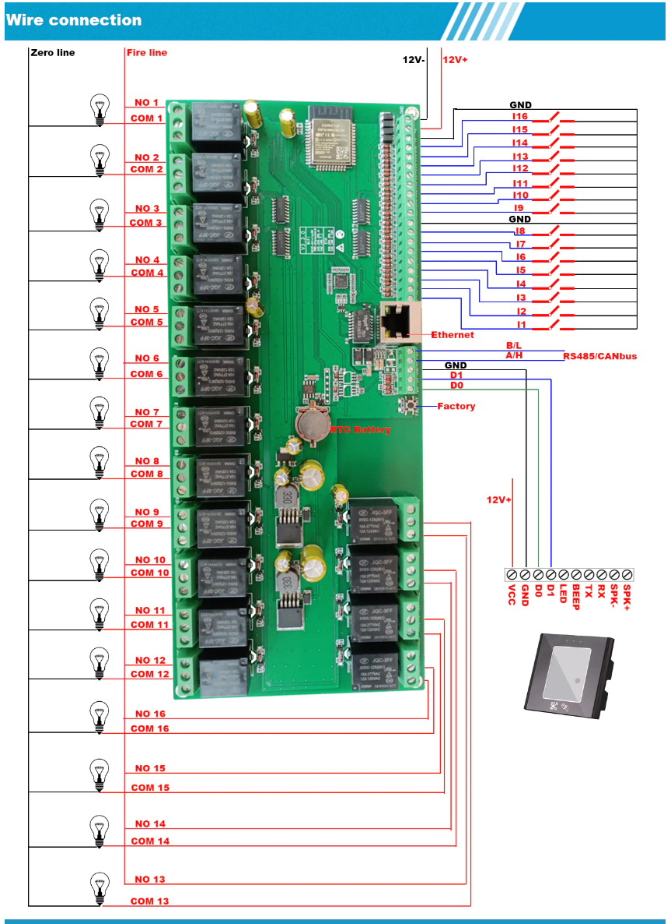

We suggest that we buy some of these boards for the prototype, because it will save us a loot of time on the prototype.

This board has a ESP32 MCU, some of us are already familiar with this MCU, and again time can be saved.

This board contains its own firmware, but we will recommend at we write our own, this to make it simpler, and to implement our protocol.

Price

The relay board cost 580dkk

18/8/2022

3 boards are on the way.

Question: do we want our own firmware?

Yes, I think so, we do not know what is in the provided firmware, and it might pose a threat to us.

An easy way to make it is by using Arduino ide, all of the setup that we need is taken care of for us in this ide. Easy and fast, and we don’t need low-level programming for this device.

The protocol will be something like

x

x

x

x

ICs

There is 2 74595 shift register that controls the relays

And there is 2 74165 shift register that measures the inputs

There are very easy to control

Pinout of the ESP32 wroom mcu

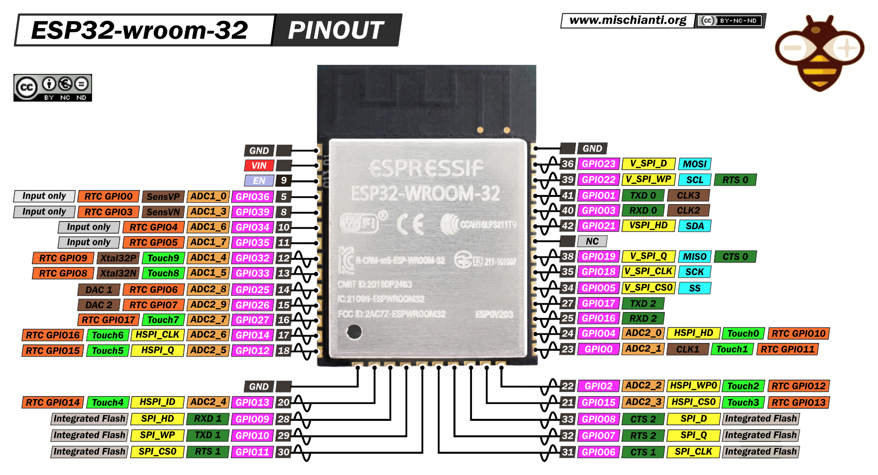

There is a connector were we can program this mcu

From left to right:

1. = 3.3V
2. = CLK1 = pin23
3. = EN = pin9
4. = TXD0 = pin41
5. = RXD0 = pin40
6. = GND

Pin10 is connected to button (Factory)

RS232 to TTL converter:

<https://www.digikey.dk/da/products/detail/advantech-corporation/BB-232LPTTL33/3770643>

Price 590dkk