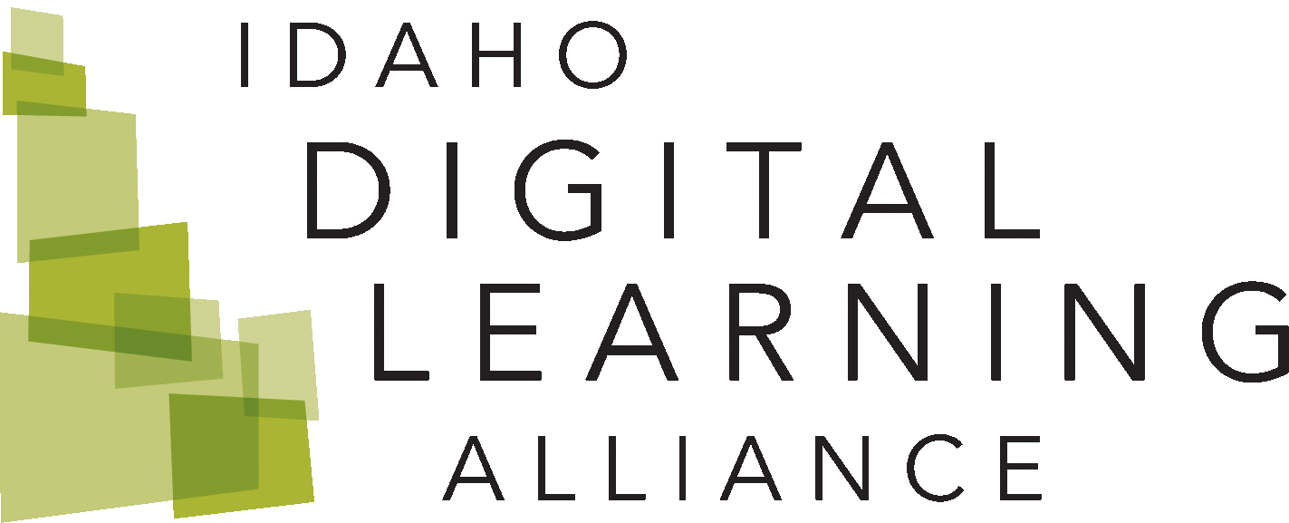

# Idaho Digital Learning Academic Honesty Contract

## Directions:

Idaho Digital Learning has a zero-tolerance policy toward academic dishonesty. All students are required to submit work that represents their original words, ideas, or products. At the beginning of **each** Idaho Digital Learning course you take, you will be asked to sign and submit this Academic Honesty Contract, pledging to avoid plagiarism and other forms of unacceptable practices. Please initial this contract where noted and submit your electronic signature on the contract before beginning your class.

## Violating the Academic Honesty Contract will result in one or more of the following consequences for regular assignments and exams:

1. A zero grade on the assignment, discussion, or assessment
2. Notification to your local school of the incident
3. Possible disciplinary action according to your local school’s policies
4. Other disciplinary action as seen fit by the Idaho Digital Learning instructor or online principal
5. Removal from the course and/or a failing grade

### **Initial here if you understand and agree to these statements:**

## If the local school and Idaho Digital Learning teacher agree that a student has violated the Academic Honesty Contract on a proctored exam a zero will be recorded for the final exam grade. A retake will not be allowed. Cheating on a final includes, but is not limited to:

1. The use of digital resources (except where allowed)
2. Help from other students
3. Study Aids
4. Unauthorized notes, etc.

*Note: Failing a dual credit class may have implications on future use of Advance Opportunity funds and/or the use of Federal Educational Grants.*

### **Initial here if you understand and agree to these statements:**

## Unacceptable academic practices include, but are not limited to, cheating. Various forms of cheating include:

1. Copying another student’s work or allowing your work to be copied
2. Allowing someone other than yourself to submit work in your name
3. Using unauthorized assistance on an assessment
4. Allowing someone other than yourself to take an assessment
5. Use of a translator in language classes
6. Submitting the same work for multiple courses
7. Giving answers to other students

### **Initial here if you understand and agree to these statements:**

## Unacceptable academic practices include, but are not limited to, plagiarism. Plagiarism is presenting other peoples’ ideas, writings, or products (written or electronic) by claiming them as one’s own and not giving credit to these sources. Forms of plagiarism include:

1. Submitting work that is not your own
2. Using “copy and paste” from any online source to complete an assignment, discussion, or test
3. Failing to properly cite words and ideas that are not your own
4. Using direct wording from another source (even a cited one) without quotation marks
5. Slightly re-wording phrases from another source and passing the phrases as your own

*See the Student Resources area for information on citations and paraphrasing.*

### **Initial here if you understand and agree to these statements:**

## Unacceptable academic practices include, but are not limited to, fabricating data. Fabricating data is making up data to complete an assignment that requires research and/or collecting data. Forms of data fabrication include:

1. Falsifying or manipulating data to achieve a desired experiment result
2. Reporting data for an experiment that was not conducted (dry-labbing)
3. Submitting written work with fabricated or falsified sources

### **Initial here if you understand and agree to these statements:**

## Unacceptable academic practices include, but are not limited to:

1. Academic sabotage: damaging another student’s work or grade on purpose
2. Falsifying information: lying to an instructor or site coordinator or parent (such as saying an assignment has been completed when it has not, or lying about your grade)

### **Initial here if you understand and agree to these statements:**

## I have enrolled in an online course with the full understanding that I will be working in an unsupervised environment during some of my class time. I agree to adhere to the following rules of online classroom conduct:

1. I will complete all of my own assignments.
2. I have read and understand the Idaho Digital Learning Academic Honesty Contract and agree to avoid unacceptable academic practices such as:
   1. Cheating
   2. Plagiarism
   3. Fabricating data
   4. Academic sabotage
   5. Falsifying information
3. I understand that my instructor has access to and will be using plagiarism-detection technologies to identify plagiarized content in my work. Comparisons can/will be made to online content, including work submitted by current and past Idaho Digital Learning students.
4. I will ask my instructor for clarification if I have any questions regarding the above Academic Honesty Contract.
5. I understand that if I violate the Academic Honesty Contract for this course, I will be subject to disciplinary action and may receive a zero for the assignment in question or removal from the course.

**To electronically sign this contract, type your name below. By signing this contract, you are agreeing not to engage in any form of academic dishonesty.**

### **Digital Signature:**