
XNDI& ëdON 3UDICIAL

Government of Kê*^ täkä
e-Stamp

Certlflcate No.
OflIlICá(O lssued Date JCCOUOt Ro!erence Un¡C|Lie Doc. Roíorenco Purchased by Doscription of Document Doscriptlon Conslderation Price (Rs.)
First Party
Second Party
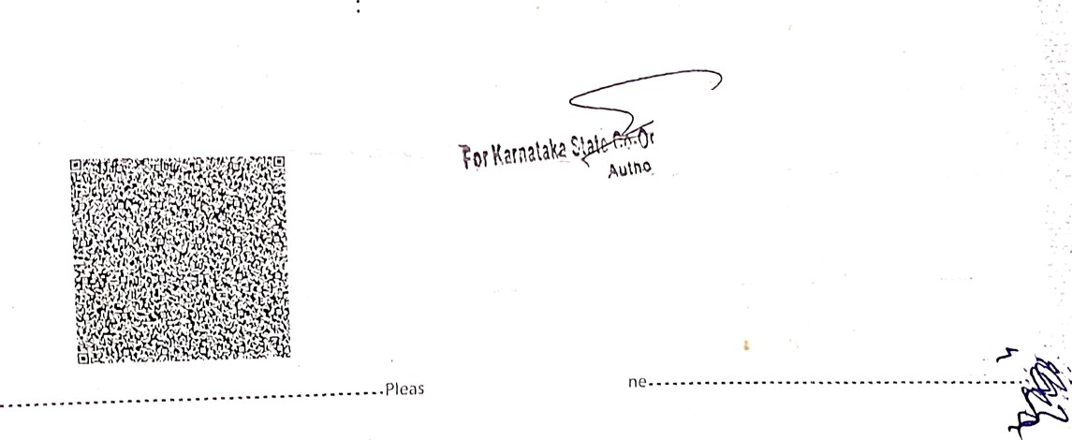

Stamp Duty Paid By
Stamp Duty Amount(Rs.)
100
(One Hundred only)
c \/Vrite oi’ type bclow tllis li
IN-KA56892416230B54O

01-Jun-2016 12:09 PM
NONACC (BK)/ kakscub00/ BANGAÎ-ORE1/ /‘ BA
SUBIN-KAKAKSCUB0863606276821222O C V SUSHEELA
Article 30 Lease of Immovcble ProP• v
RENTAL AGREEMENT 0
(Zero)
C V SUSHEELA RAMAKRISHNAN P V C V SUSHEELA







RamakriShn Ill P. . ag

ed about 45 years
Son of Mr.P.R.Venkit£t/£t all Oi i'lâ ^t
Tata .eIA Life f P ama rishnan

Insurance Compatly Limited and Mrs. JanakiRamakriSl21l•Il 9gi2d abollt= 6 y--lrS 'V1*--°
P.V. and Mr. P.R. Venkitaraman aged about 84 years
and having a permanent address at Door No.45/55, AdhitiyaPuram Spillage Palakkad 675 006 (hereinafter called the Lessee which expression shall include its successors) of the OTHER PART WITNESSETH:

THAT in consideration of the rents, covenants and conditions by the Lessee to be paid, observed and performed, the Lessor doth hereby grant upto the Lessee and the Less e hereby doth agree to take from the Lessor on Lease, the Flat No.NB2-34, in the Third floor , Vijaya Enclave, Vijaya Bank Layout, SRS Nagar, Bilekhalli Bangalore 560 076 GOIIlprisingof a hall, two bedrooms (one bedroom with attached toilet), one common bathroom cum toil-at and a
kitchen (hereinafter referred to as the premises ) for term of 11 months at . S.l4,s00.00 (Rupees fourteen thousand five hundred only) p•r month rent commencing from 24.05.2016 to and ending on 23.04.2017 when the lease expires. On expiry of the lease the Lessee will deliver vacated possession of the said premises to the owner .

That the LGase is renewable for a further period of 11 months at the option of the Lessor at the termination of Lease.

THE LESSEE DOTH hereby agree and undertake :-

- To pay the Lessor during the currency of the tenancy, rent at the rate aforesaid, month after month on or before the 4 of each month following the month for which the same shall have accrued due.

- To pay an advance rent of Rs. 1,00,000.00 ( Rupees One lakh only) bearing no interest by the Lessee to the Lessor refundable to the Lessee at the termination of that lease. The lessor and lessee shall have the option to terminate the lease before 11 months by giving one month notice on either side respectively.

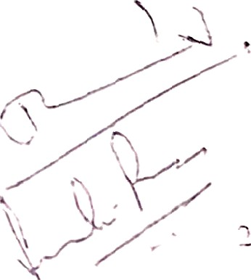
- To pay all charges for consumption of electric ener_{s}y to the electricity board as p• tire specified rates before the due da*er,.

w"W‘v^< ."\ “ ' “"’

To pay to Vijaya Enclave Apartment Owners' Assn. (Regd.) maintenance charges as specified by Vijaya Enclave Apartment Owners' Assn. (Regd.) from time to time before 5'^{h} of every month.

- To permit whenever necessary the LESSOR and his agent during reasonable hours in the day time with or without workmen to examine the state of repair and conditions of the premises.

- Without. the consent in writing of the Lessor first hand anñ obtained not to erect or place any additional building or erection or make any alteration or addition whatsoever to the premises or nailing on walls and wooden surface of the doors and windows, ventilators etc. hereby demised or any part thereof.

- To keep the premises with all fixtures, ( Ceiling Fans (4 Nos), Tube Lights (4 h'os), CFL (8 Nos), Geyser (1) ), electric installations, sanitary fittings etc. in the same condition as it was let out.

- To use the premises purely for residential purpose and at any time during the said term not
to carryout or permit to be carried out any trade habit or business in the said premises.

- All maintenance and repairs to the electrical and plumbing works to be carried out by the lessee at his own cost.

- On the termination of the period of the lease or earlier determination thereof as hereinafter provided, to quietly yield and deliver up possession of the said premises in the same condition with all fixtures which now or at any time hereinafter during the continuance of the lease may be put up or fastened or affixed thereto and yield the said premises in the original condition when it was let out.

- The Lessee hereby covenants with the Lessor not to Sale, let the premises leased to him. That the Lessee hereby further covenants with and assures the owner to use the light points for lisht, fan etc., only and further assures to the Lessor not to tamper »°it1i electrical
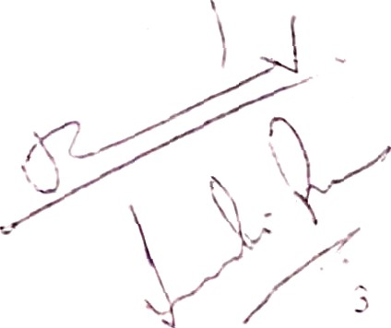
wiring or any other plant of s'ructuie of the said premises.

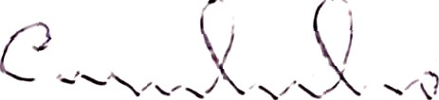
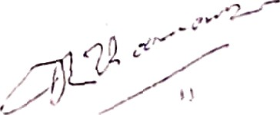

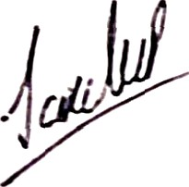

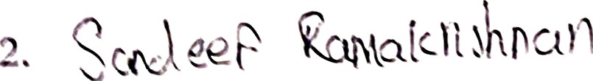
vfIE LESSOR doth hereby covenant with the Lessee:-

- To pay during the said term all existing and future rates arid taxa, assessments, charges and outgoings whatsoever for the time being payable in respect of the premises hereby agreed tO be leased except the charges mentioned in clause 3 above

- That iil CaSe the said premises or any part thereof shall at any time during the said terr:i be destroyed or damaged by fire (except when such damage or destruction has resulted from the negligence of the lessee),or other irresistible force has become unfit for occupation or
use the rent or rents reserved for the portion thereof according to the nature or extent of the damages sustained shall be suspended until the said premises shall be rendered fit for occupation and use.

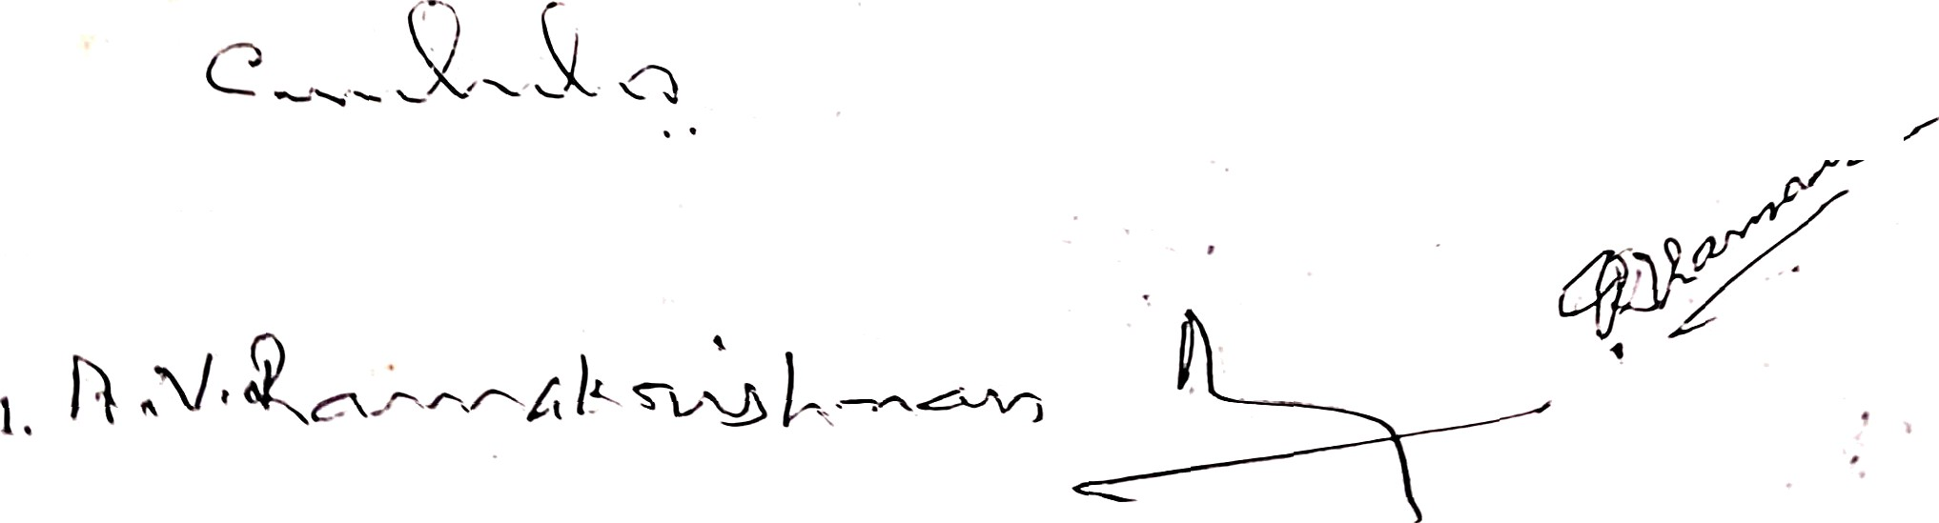


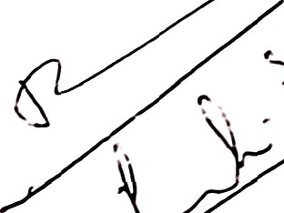
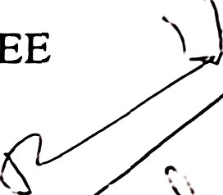
- The Lessor shall repay the advance of Rs.1,00,000.00 (Rupees One Lakh only) to the I csscc nt the expiry or sooner termination of the term of the lease agreed as above.
Signature of LESSOR
Signature of LESSEE
\V ITNESS

