Chizel – The Git We Need

Final Year Project Report
Computer Science
Section: English
Group: B01
Students:
- Student 1 – 60388 – Patrick Farah
- Student 2 – 61116 – Charbel Fares
- Student 3 – 61105 – Bilal Hammoud
- Student 4 – 61102 – Omar Hammoud
Supervisor: Dr. Bernadette Wakim

Table of Contents
Right-click and update fields to generate the Table of Contents automatically.
Abstract
Nowadays, technological projects require coordination, a key aspect to ensuring a stable workflow especially if the project’s being done by a group of developers, using remote repositories to be able to work efficiently and have the ease of pulling new content into your local machine, allowing users to work on separate details using branches, ect…
However recently, GitHub, the main platform used for these remote repositories, has been barraged by AI Slop, from their own owner no less, Microsoft, pushing the highly debated AI agenda onto the platform, with the full focus on making their AI Agent better, without thinking of the platform and the users themselves.
GitHub suffers from multiple things, one of them being the slowness of some features due to GitHub running some parts on what we call “Spaghetti Code”, a form of code that isn’t optimized as it should be.
We decided that we needed to do something, with Microsoft’s full focus on the unstable AI bubble, we proposed making a GitHub and Git alternative, called Chizel, acting as the replacement of Microsoft’s giant without all the AI and Corporate slop that big companies keep pushing.
To compete with such monster, we decided that it’s best to code the git-alternatives in the same language, C, the most efficient one we can use, prioritizing speed and efficiency for the best quality possible.
What we’ve achieved so far is…. (waiting)
Introduction
In recent years, software development has increasingly relied on collaborative platforms that enable version control, code sharing, and team coordination. Platforms such as GitHub have become the norm to modern development workflows, providing developers with tools to manage repositories, track issues, and collaborate efficiently. GitHub is the most widely used platform for such activities, however, due to it being owned by a single company, a mistake can be catastrophic, which is what's happening with Microsoft pushing AI and monetization onto this precious platform.
These recent updates brought out wishes among developers for simpler, more transparent alternatives that prioritize control and privacy. Many developers prefer environments that are free from intrusive AI assistance, unnecessary feature bloat, and corporate-driven design decisions. As a result, there is a need for a lightweight and developer-focused platform that retains the essential features of GitHub without the AI and corporate "slop" that's being pushed by Microsoft.
The problem addressed in this project is the lack of a minimal, clean, and independent alternative to GitHub. Existing platforms often impose limitations, introduce complex user interfaces, or integrate features that may not align with all developers’ preferences, particularly those who value simplicity and efficiency.
To address this issue, this project proposes Chizel, a GitHub clone designed to provide core repository management and collaboration features while remaining lightweight and free from unnecessary complexity. The main objective of Chizel is to offer a simple environment where developers can create repositories, manage version control operations, and collaborate with others without the influence of AI systems or excessive corporate features. The system focuses on remaining transparent with it's features by being Open-Sourced for everyone to see.
The key objectives of the project include:
- Designing a clean and simple user interface for repository management
- Implementing essential version control features such as commits, branches, and pull requests
- Enabling collaboration between users through repository sharing and contributions
- Ensuring smooth system performance
- Maintaining simplicity by avoiding unnecessary or intrusive features
The scope of the project is limited to the development of a web-based platform that supports core functionalities similar to those found in GitHub. This includes repository creation, version tracking, and basic collaboration tools. However, the system does not aim to replicate all advanced features of GitHub. Limitations of the project include the absence of free time, due to being overwhelmed by the sheer amount of work to be done, and sticking to our morals by not using any AI tools, and impending doom next door, we try to work as much as possible with the time we have available. Additionally, we lack the important resources to implement features beyond what our original scope offers.
This project is conducted as an academic initiative and is not affiliated with any company.
Bibliography
text
Analysis
The system should be able to:
- Allow users to register and log into accounts
- Allow users to make repositories, visit/view repositories and contribute to repositories
- Allow users to clone repositories
- Allow users to initialize a chz directory
- Allow users to upload and manage files directly to the remote directory
- Allow users to commit changes
- Allow users to create branches
- Allow users to push data/changes from local to remote, and pull commits from remote to local
- Allow users to create/manage pull requests
- Allow users to see commit/versions history (version control)
Also, the platform itself should:
- Have fast response time
- Be up to security standards
- Have clean and simple working UI
- Support multiple users
Here’s what the use case diagrams look like, alongside some scenarios (Scenarios.docx) :
~ 1.1: We categorize Chizel’s abilities into 4 parts. Repository features such as viewing repositories and logs, pulling from and pushing to repositories, creating and deleting repositories. Branch features such as creating, deleting, merging, viewing and renaming branches, staging and committing changes. Account features such as registration, log in and log out. Pull Request features such as creating, viewing, submitting, approving and denying pull requests to the repository.
~ 1.2: Here we divided the chz commands that will be available (hopefully) at release, containing the main branch and commit features, while also having some extra commands for the sake of not being lackluster.
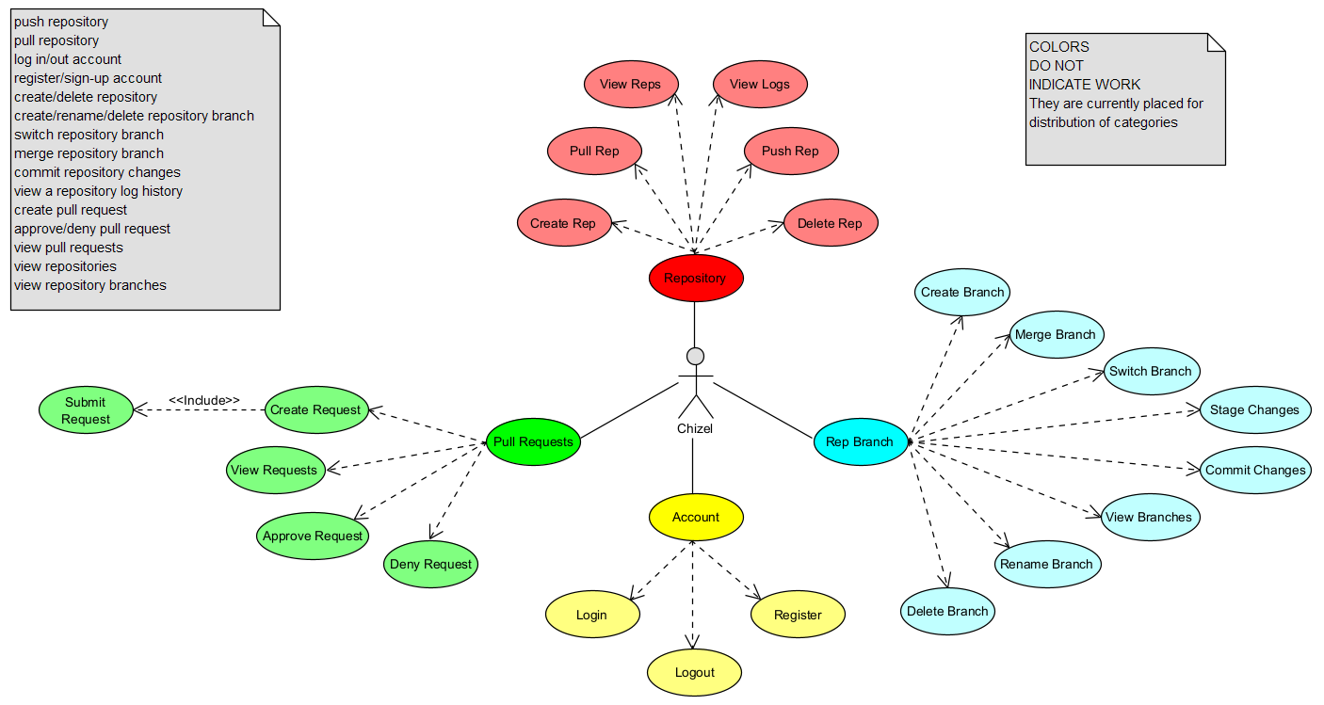
1.1: Chizel Use Cases.
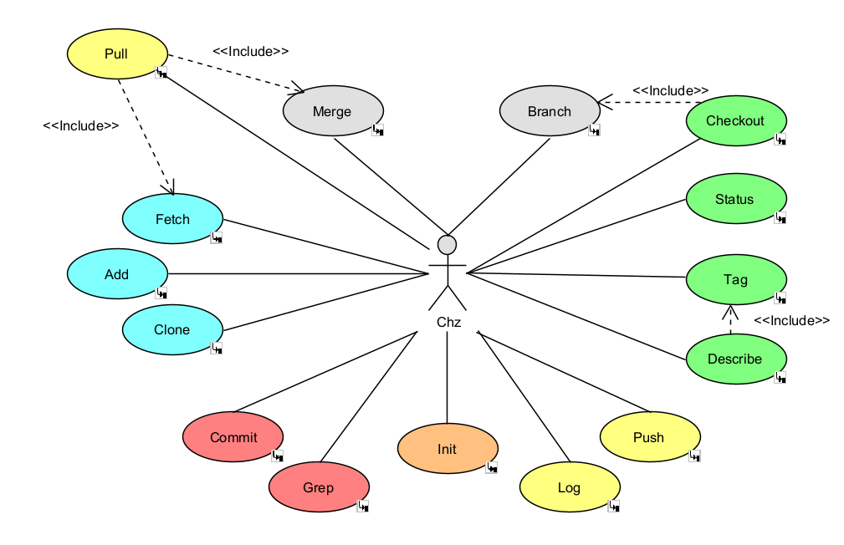
1.2: chz Use Cases.
Alongside our Use Case diagrams, we have come up with a Class Diagram:
[ EXPLAIN CLASS DIAGRAM ]
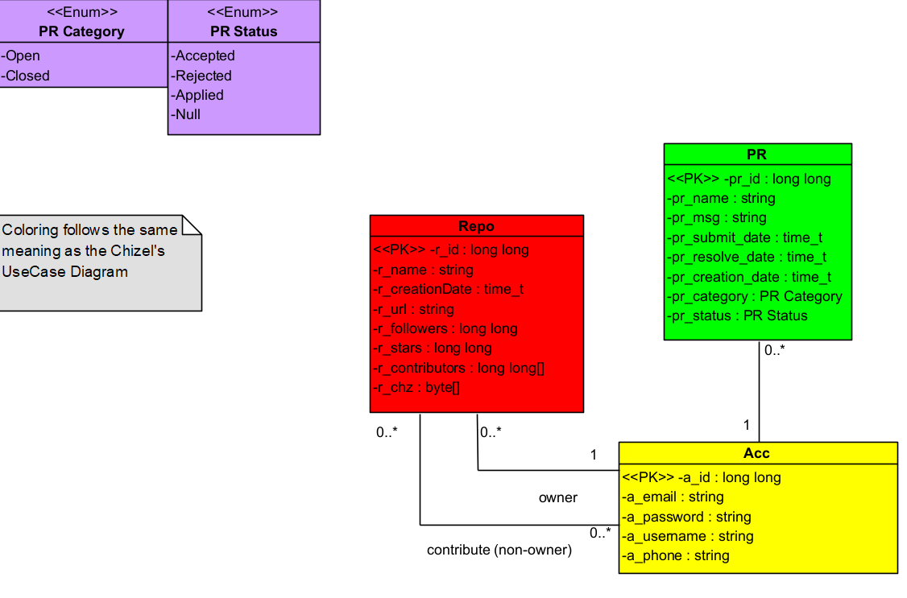
2.1: Current Class Diagram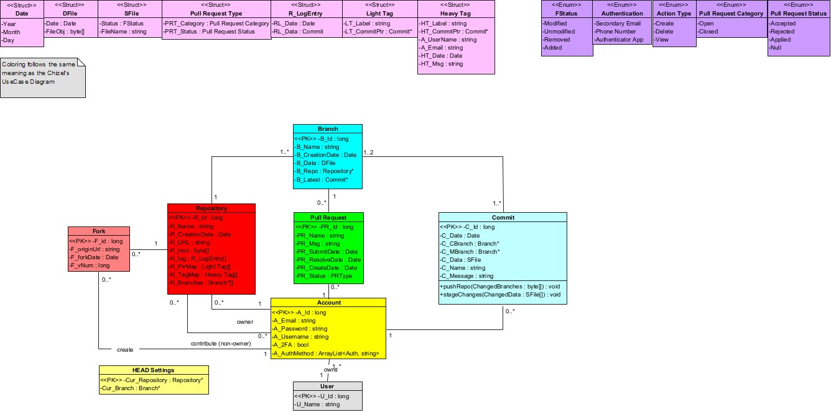
2.2: Old Class Diagram (Cluttered)
We’ve also made an Activity Diagram showcasing how <TOPIC> works:
[ EXPLAIN ACTIVITY DIAGRAM ]
[ PHOTO OF ACTIVITY DIAGRAM ]
Development
In order to make Chizel a competitor to GitHub, we have to one up it somehow, starting by using the same language for its commands, C, as it’s the most efficient and the fastest in this domain, alongside that, we’ve used TypeScript and React to make the interface, all thanks to Figma which made our work 10x easier, with the aid of numerous libraries such as zlib.h, postgresql, dirent.h, ctype.h <insert libs here>, we’ve also chosen Supabase as our database host, for it has proven reliable in multiple other projects, alongside it’s compatibility with C, we’re also ironically using GitHub for our remote repository for easy collaborative work, Visual Paradigm for UMLs, and of course IDEs for coding, starring Visual Studio Code for it’s Live Share Extension alongside an active Discord server for efficient communication.
Here is how the navigation system goes for our platform:
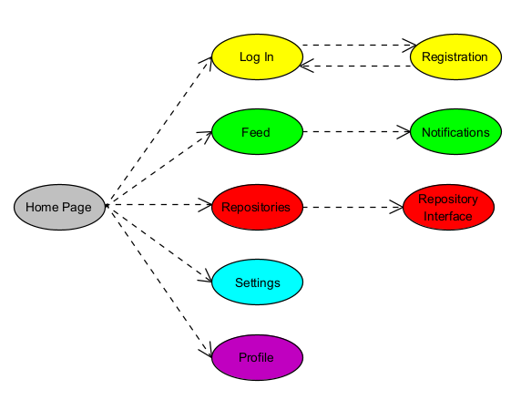
3.1: Navigation Structure
We’re able to access multiple other pages from the Home Page, we’re able to log into an account or register one if needed, access our feed which shows the activity of who the user follows, while also receiving notifications from his repositories, which the user can access from the repositories list, and going deeper into a repository, users can also access settings and profile pages for customization and security.
CHZ SCREENS
(do what I did and follow the order from the Tree Diagram by depth)
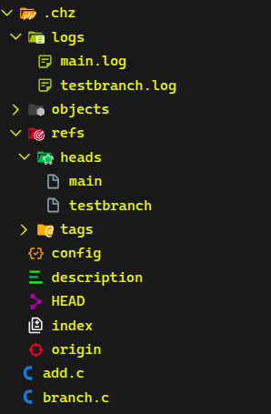
0.1: A small picture showing where and how branches are stored. The chz branch command allows creating, renaming and deleting branches. Upon creation, a reference head named after the branch is created in the hidden directory .chz/refs/heads, this reference head file houses the commit hash of the latest commit done to the HEAD branch (most cases, its main), this signals that the new branch wields the same data as the latest version of the HEAD on the date of creation, further commits to the HEAD branch will not alter the branch’s commit hash nor vise versa. Alongside the reference head, a new log file named after the branch is also created in .chz/logs, this stores the commit history of the branch EXCLUDING the initialization of said branch. Renaming/deleting a branch via “chz branch” will affect both reference head and log file. The command also prohibits any use of “main” as means of deletion, creation or manipulation. In case the current HEAD is a branch that gets renamed/deleted, the HEAD will point back to main in case of deletion, or to the renamed branch otherwise.
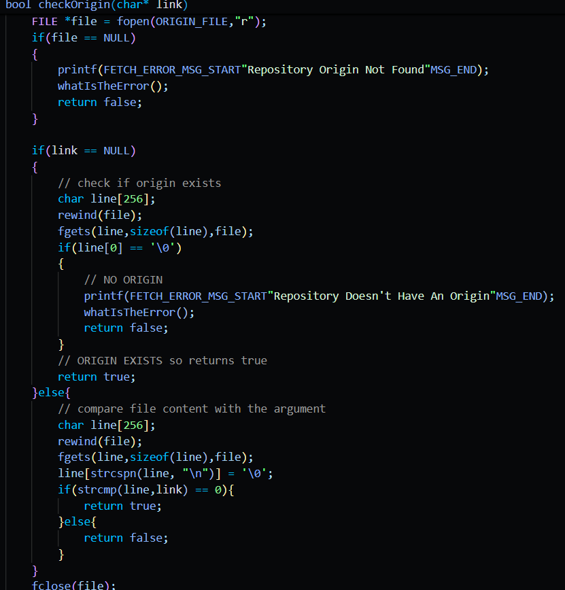
0.4: A snippet of code inside the chz fetch function, it has a terminal interface but isn’t shown here to being too basic, the snippet shows how the fetch function checks for the origin of the repository to fetch the data of the correct repository from the database. This function in of itself isn’t flashy, just works on fetching the data from the database and storing it in a specific folder. Supports “fetch <link>” and “fetch” commands.
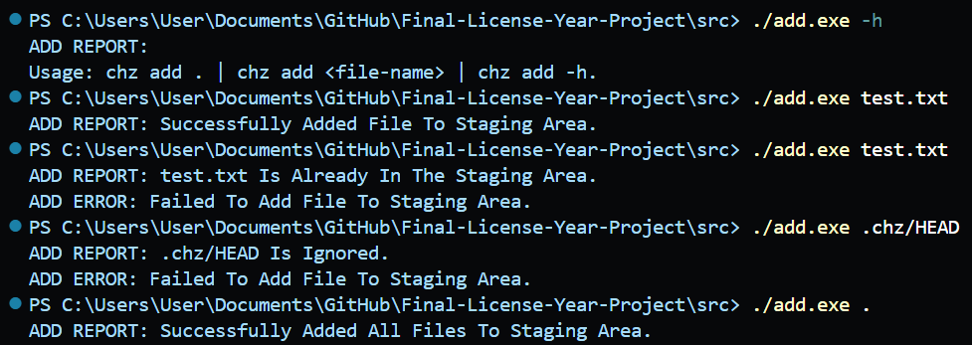
0.6: the add.c terminal with it’s functions, usable functions include the help function, adding a singular file while also not allowing for duplicates (writing relative path in INDEX file), checks for ignored files in the .chzignore file, works with directories, paths, file extensions and names, and an add all ( . ) function that adds all files that are changed and aren’t ignored to the staging area.
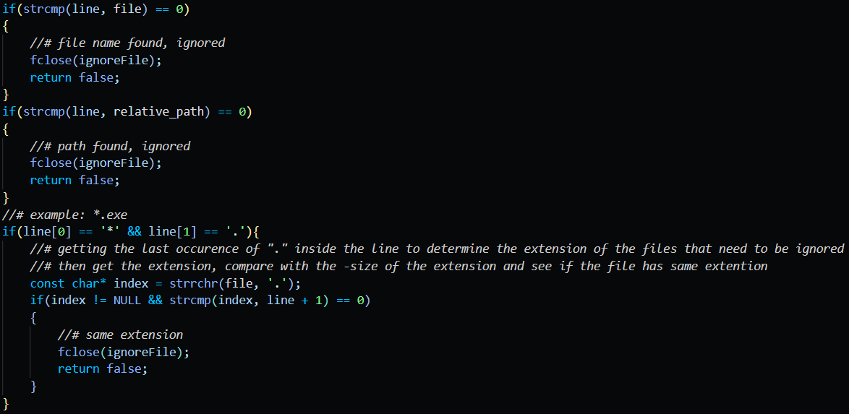
0.6a: a snippet of code showcasing how the ignore function checks the files to be added.
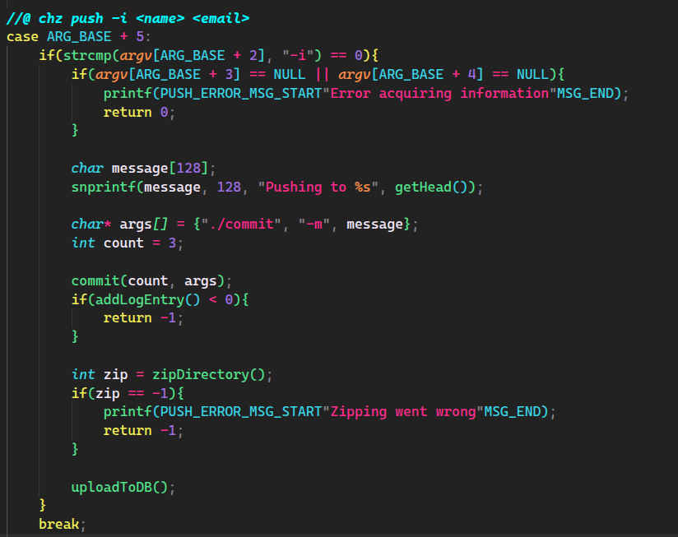
0.7: A code snippet that shows how chz push functions (calls). Firstly, chz push fabricates arguments and calls chz commit, which does its describe job whilst setting the commit message as “Pushing to <HEAD Branch>” then immediately makes a call to a function of chz log, known as addLogEntry(), which uses commit methods to add a new line to the HEAD branch’s log file with the specified commit information. Then the packing process starts, the zipDirectory() function, as well as the numerous others it uses, recursively reads & stores metadata of directories & files in the working directory, appending them all to a blob object called “blobs.pack” that resides in .chz/objects/compressed. Once everything is packed into this blob, the uploadToDB() function is called, which fills the necessary information by itself, like the repository’s URL & name, then uploads these 2 fields alongside the blobs.pack file to the database.
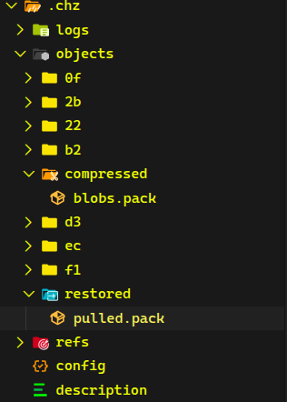
0.10: The image focuses on the objects folder of .chz, which holds the commit objects, push’s compressed blobs.pack and pull’s restored pack. The chz pull command calls chz fetch, which stores the data from the database in objects/restored as pulled.pack. After successful fetching of data, pull then calls chz merge which handles how data is inflated into the working directory.
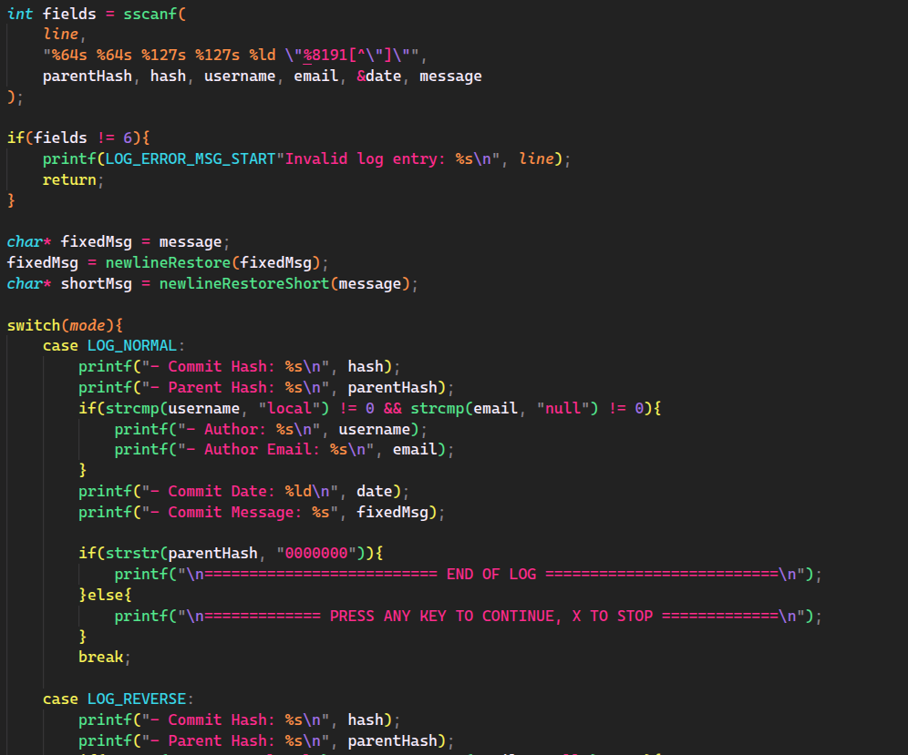
0.13: A code snippet showing how logs are printed to the terminal. The chz log command has various modes, showcased by the 4 different modes present in the printEntry() function (NORMAL, REVERSE, SHORT, NUMBERED). Each mode changes how and what the function prints. NORMAL and REVERSE both print the full entry details, and both await input from the user for continuation, or simply ends if the entirety of the logs have been printed, REVERSE reads the older commits first. NUMBERED does the same as NORMAL, but prints the user’s requested amount simultaneously without input. SHORT only prints the first 6 letters of both commit hash and parent hash and the first line (or title) of the commit, it has the same functional controls as NORMAL and REVERSE.
The tasks have been distributed evenly among the contributors, Patrick worked on parts of branch and merge, finished tag and is working on status and checkout. Charbel worked on commit, while also collaborating with Omar on making init, branch and merge, who is also working on push, pull and log. Bilal worked on fetch, clone and add.
For the interface, Bilal works primarily on the front-end, Omar works on the database whilst Patrick and Charbel work together on the back-end. (webapp work isn’t fixed and is flexible)
The project also has a remote repository on GitHub, and Dr. Bernadette has access to the repository.
Conclusion
We’ve done great so far, managing to complete the important commands in chz, them being init, branch, merge, fetch, add, commit, clone and tag. We’ve also set up the connections between the back-end and the front-end using <BULL ANSWER THIS>, and fully setting up our database using Supabase.
As stated before in this report, we’re limited to time and energy, for that we’re humans after all, and the burn out is hitting hard, the overwhelming amount of course work that we’re behind on because of the big number of projects to be done, we can’t pour the time and energy needed to make this project in its entirety, for that some features had to be scrapped, like grep and describe.
Hopefully in the future we can still continue on this project, with the help of the community who also share a similar goal to our objective, from making it better and faster to adding more and more features. Maybe one day, it’ll overthrow GitHub?
Appendix
Extra documentation, figures are explained under them.
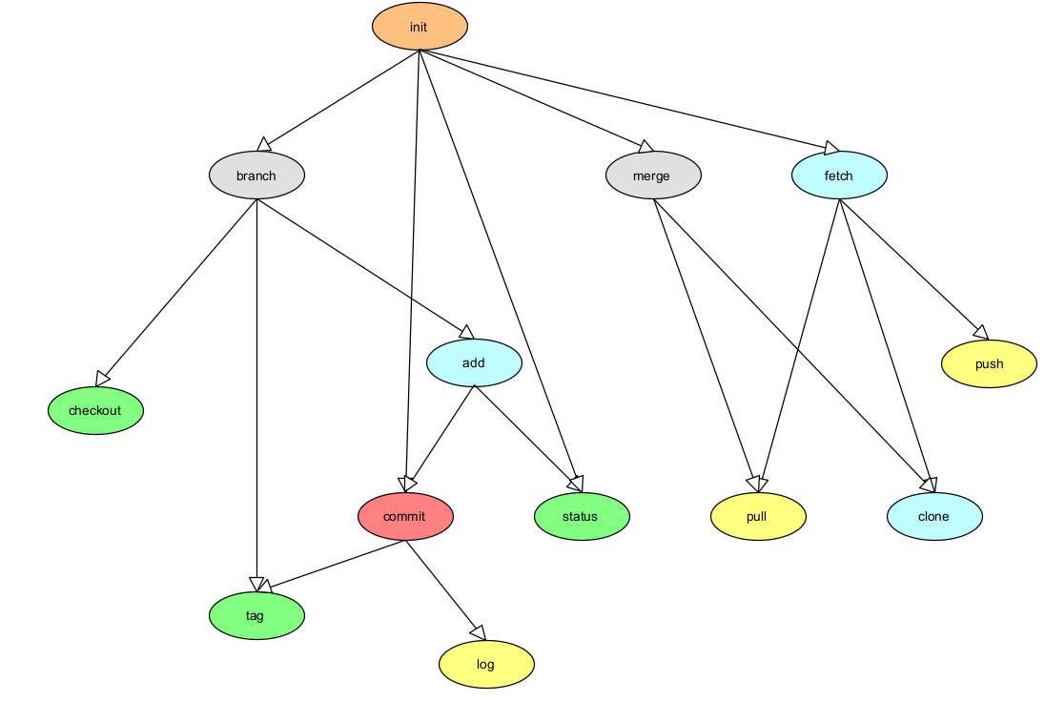
4.1: Tree Diagram showcasing the hierarchy and the road for the commands, higher levels means higher priority, as lower levels depend on them.
4.2: The database was a relatively exhausting system to implement, especially with the amount of times it has been redone from scratch. Initially, we decided on using MongoDB as our Query Language paired with MongoDB Atlas as our database, but that decision later stabbed us in the back with the newly imposed limits and the very slow execution speed that was apparent when the code fully implemented MongoDB uploading & restoration. After various efforts of trying to optimize and speed up the process, it proved inefficient for our course of action, so we moved to the good reliable SQL and Query Language, specifically PostgreSQL, as its features are what aligned most with our project, and its simplicity to implement proved superior than MySQL and OracleSQL. The database, including tables, data & code implementation, was recreated from scratch again after the big refactor, as initially, the database held redundant tables and the code was unnecessarily bloated. For the last time, the database aspect was also slightly refactored after we concluded that a blob pack was our current best option to store data. All database efforts have been single-handily done by Omar.

1. Abstract
Write a concise summary (maximum half a page) describing:
- The problem addressed
- The proposed solution
- The main technologies used
- The achieved results

2. Introduction
Introduce the project and its context. This section must include:
- Motivation and background
- Problem statement
- Project objectives
- Scope and limitations
- Brief presentation of the company (If the project is conducted within a company)
- Report roadmap
Maximum length: 2 pages.

3. Bibliography / State of the Art
Present existing tools, platforms, or solutions related to your project.
Discuss similarities, differences, and justify the relevance of your work.
All sources must be properly cited.

4. Analysis
This section analyzes the system from a functional point of view and defines what must be built.

4.1 Business Rules & Requirements
Describe how the system should behave.
Business rules define constraints and policies governing the system (e.g., validation rules, access conditions).
Clearly specify:
- Functional requirements (what the system must do)
- Non-functional requirements (performance, security, usability, scalability).

4.2 Use Case Diagram & Scenarios
Provide a Use Case Diagram defining actors and system boundaries.
Use cases describe what the system does from the user’s perspective. Each use case represents a functionality provided by the system.
Write structured scenarios for each use case.
At least one use case must be fully detailed (main flow and alternative flows).

4.3 Class Diagram
Provide a UML class diagram if your project involves domain modeling or a database.
Explain classes, relationships, and important design decisions.

4.4 Activity Diagram
Provide activity diagrams illustrating workflows.
Activity diagrams describe the sequence of actions and decisions in a process.
Focus on one or two core system operations.

5. Development
This section describes how the system was implemented.

5.1 Technical Environment
Describe the technical environment used:
- Programming languages and versions
- Frameworks and libraries
- Database system (if applicable)
- Development tools (IDE, version control).

5.2 Menus Tree / Navigation Structure
Describe the navigation structure of the system.
Use diagrams or trees to show the sequence of screens or modules.

5.3 Screens
Include representative screenshots of the system.
Each screen must be explained in the text:
- Purpose of the screen
- Main actions
- Validation rules if applicable.

5.4 Tasks Distribution
Clearly specify the tasks and modules developed by each group member.
The project must be hosted on GitHub (unless forbidden by the company):
- One shared repository per group
- Each student must contribute personally
- The supervisor must be granted access

6. Conclusion
Summarize what has been achieved.
Mention limitations and possible future improvements.

7. Appendix (Optional)
Include additional materials such as extended diagrams, database schemas, or documentation.

Important Rule for Figures and Diagrams
All figures, diagrams, and screenshots must be referenced and explained in the text.
A figure without explanation will not be considered.

Remarks
This template must be used unless otherwise approved by the supervisor.
The report must be written in clear academic English or French.
Font sizes and styles must be respected.
All group members must contribute equally to both development and report writing.
All project materials must be available during the final presentation.

