VISOKA ŠKOLA STRUKOVNIH STUDIJA ZA INFORMACIONE I KOMUNIKACIONE TEHNOLOGIJE



DOKUMENTACIJA
WEB PROGRAMIRANJE 1

Student:
Elena Milkovski 18/24

Sadržaj
Uvod 2
Korišćeni programski jezici 2
Opis fukcionalnosti 2
Template 2
Organizacija 2
Organizaciona šema 2
Mapa sajta 2
Slike stranica i opis funkcionalnosti 2
Kodovi 2
HTML 2
CSS 2
JS 2

Uvod

Korišćeni programski jezici
Za izradu sajta su korišćeni HTML,CSS,XML,JavaScript.
Radno okruženje:Visual Studio Code

Opis fukcionalnosti
- Dinamičko ispisivanje navigacije (zaglavlje i podnožje stranice pomoću niza objekata)
- Hamburger meni – navigacija za mobilne uređaje (toggleMenu)
- Dinamički prikaz statistike
- Interaktivni tabovi (ShowTab) – filtriranje sadržaja (Meditations, Courses, Tools)
- Smooth scroll – tečni prelaz između sekcija sajta
- Scroll spy – automatsko detektovanje aktivne sekcije tokom skrolovanja
- "Back to Top" dugme – dugme za povratak na vrh stranice
- Preloader (Loader Screen) – vizuelni efekat učitavanja stranice
- Reveal on Scroll– postepeno prikazivanje elemenata pri skrolovanju
- Validacija forme – provera unosa pomoću regularnih izraza (Regex) i ispisivanje poruka o greškama
- Dinamički ispis liste prednosti – generisanje stavki iz features niza
- Generisanje dekorativne pozadine – dinamičko kreiranje mrežnih linija i tačaka
- Dinamički datum – automatsko ispisivanje tekuće godine u podnožju

Template
Za izradu je korišćen: https://www.tooplate.com/live/2143_inner_peace

Organizacija

Organizaciona šema

autor.html
index.html

Mapa sajta

PITAJ IVU

Slike stranica i opis funkcionalnosti

Dinamički ispis je napravljen pomoću niya objekata,i funkcije koja kreira elemente tako što prima objekte iz niza jedan po jedan. Takodje je prilagođeno mobilnim telefonima i napravljen je hamburger meni.
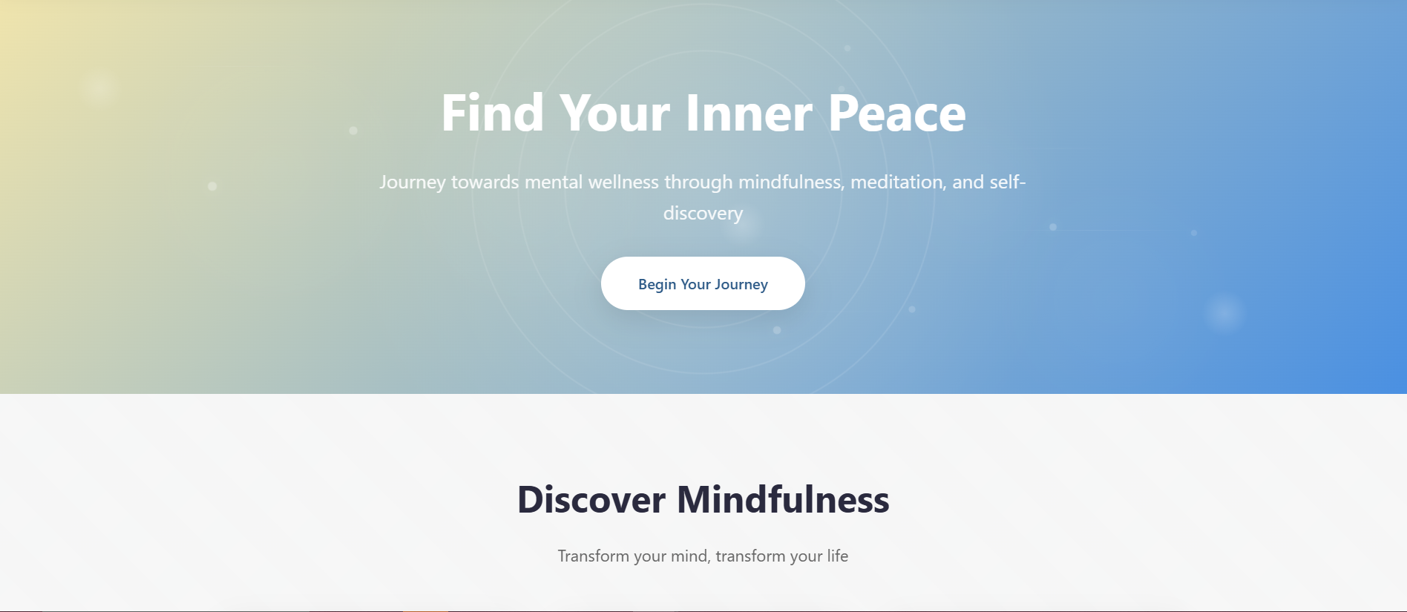
Generisanje dekorativne pozadine, pošto se previše ponavlja u HTML.
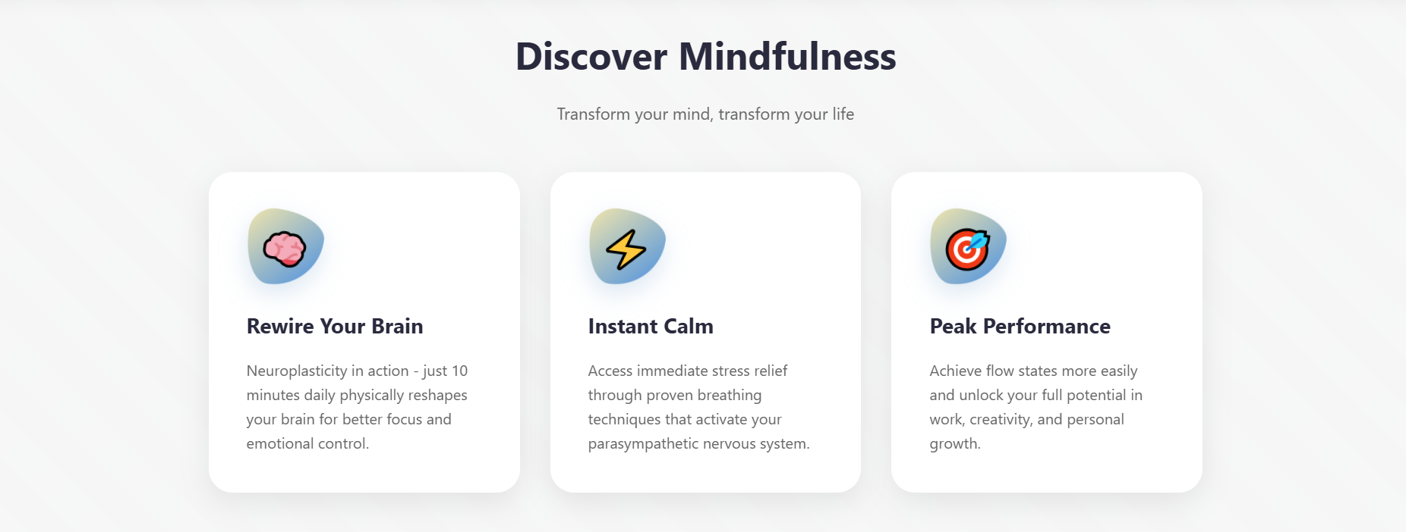
Na ovim karticama je postavljeno IntersectionObserver, detektuje elemente na ekranu i postiže se efekat fade in kada se oni pojave 30%.

Dinamički prikaz statistike, prolazi se kroz niz podataka i animira se brojač koj ide od nule do ciljane vrednosti.
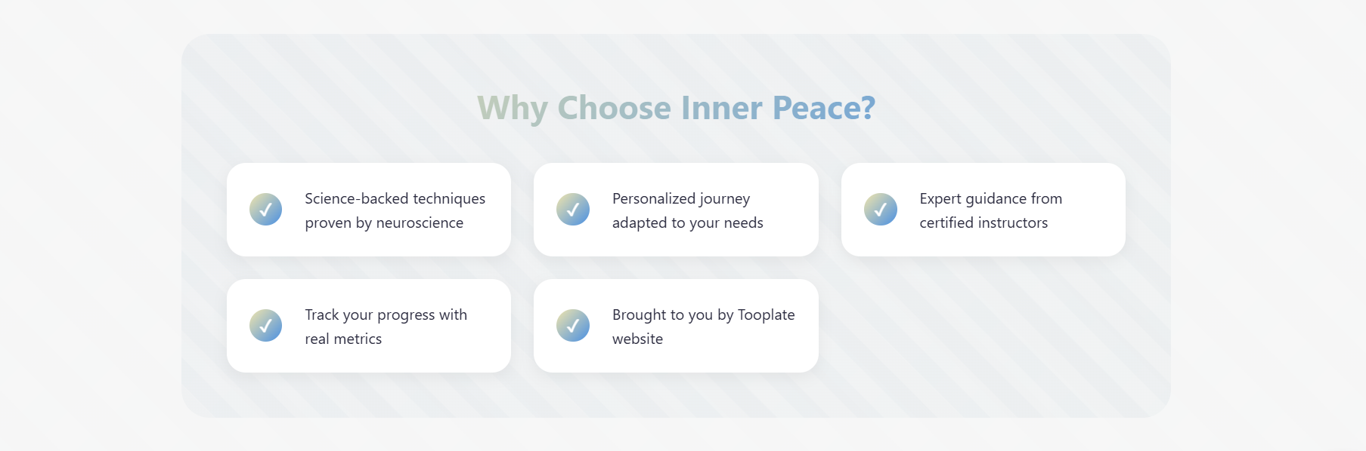
Dinamički ispis blokova
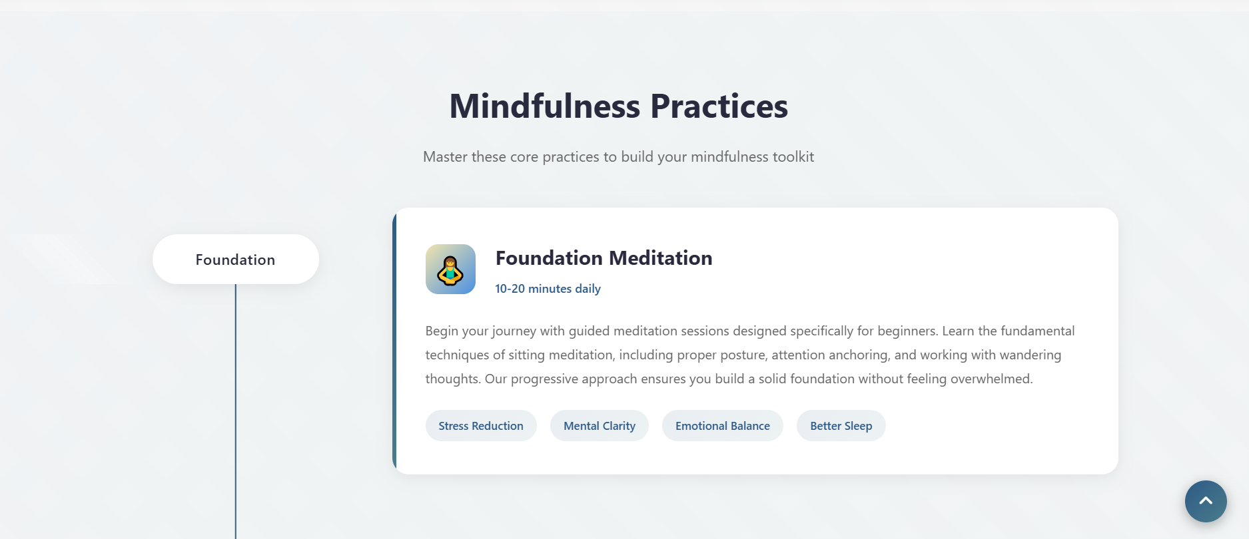
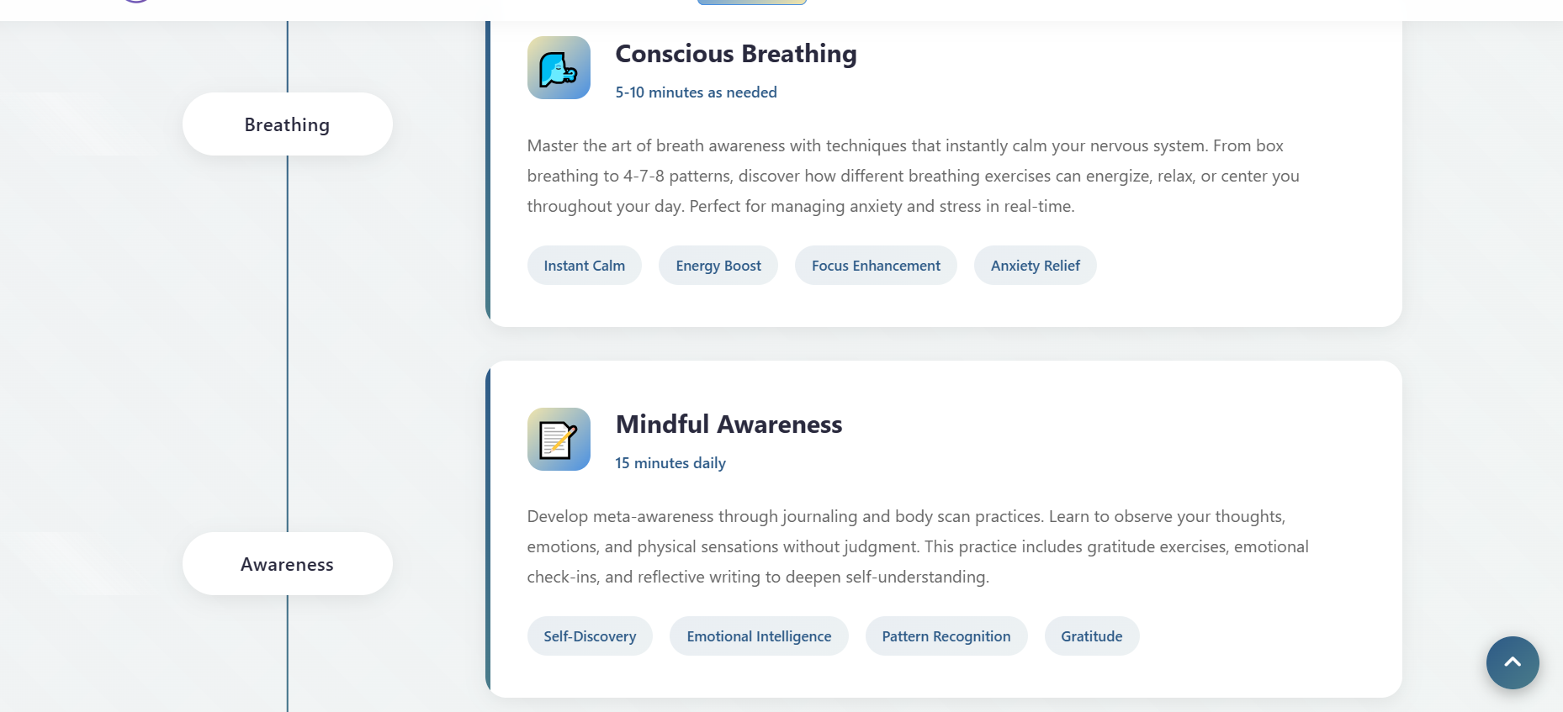
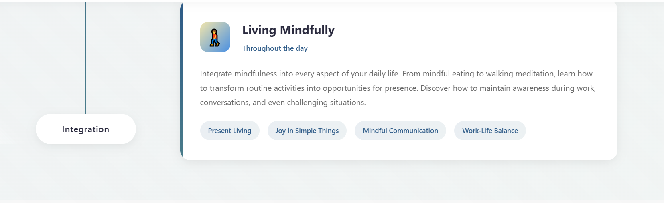
Ovde je stavljeno da se prikaze kad se skroluje do blokova(Reveal on Scroll)
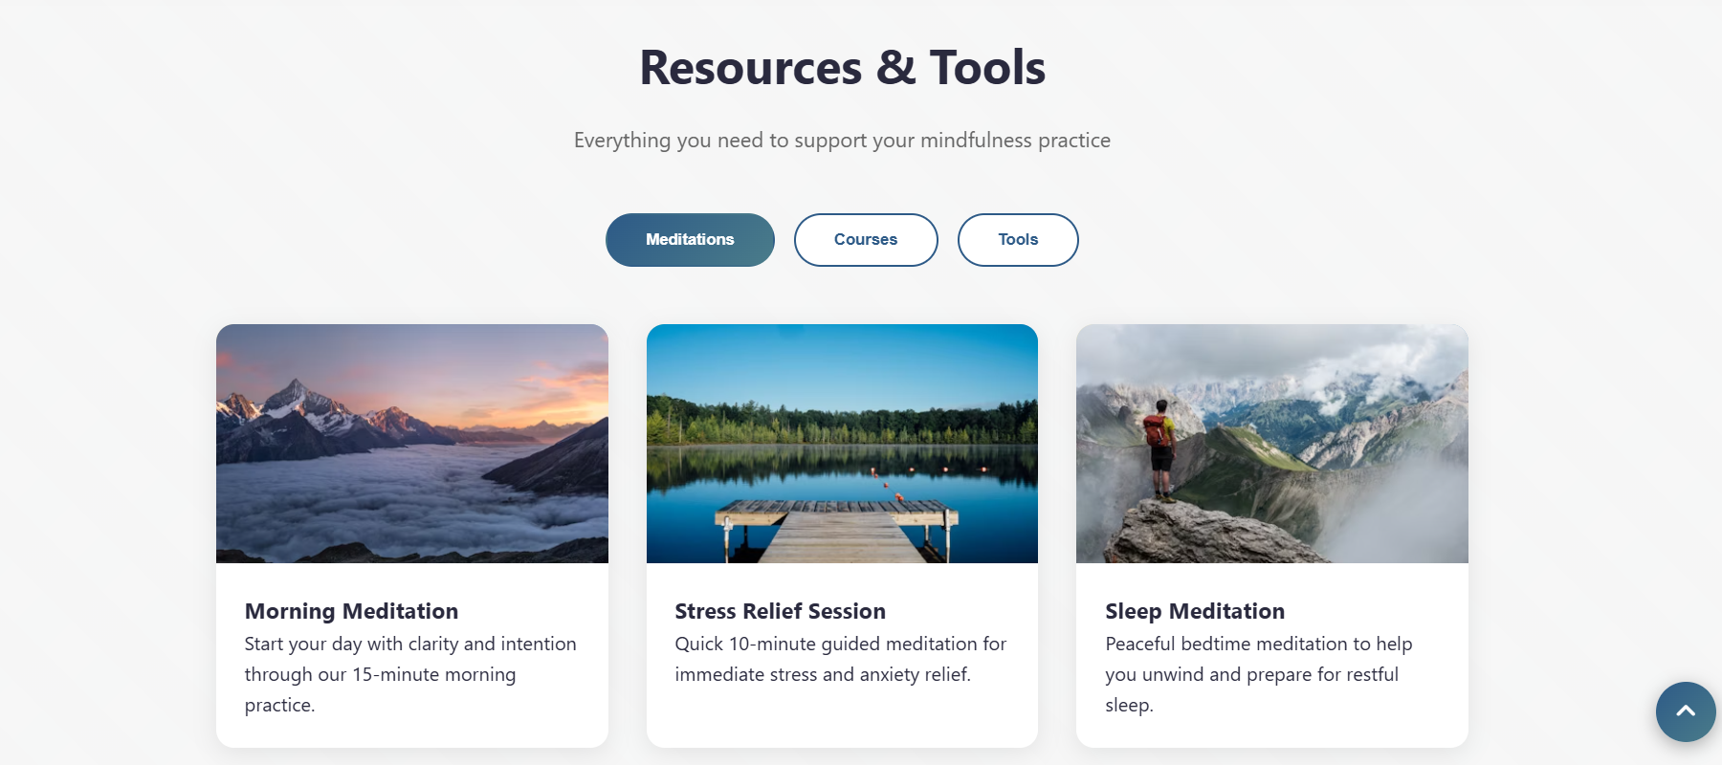
Interaktivni tabovi,kada se klikne na kategorije ove tri menja se prikaz sadržaja bez osvežavanja stranice.Oni koji nisu aktivni se samo ’sakriju’.
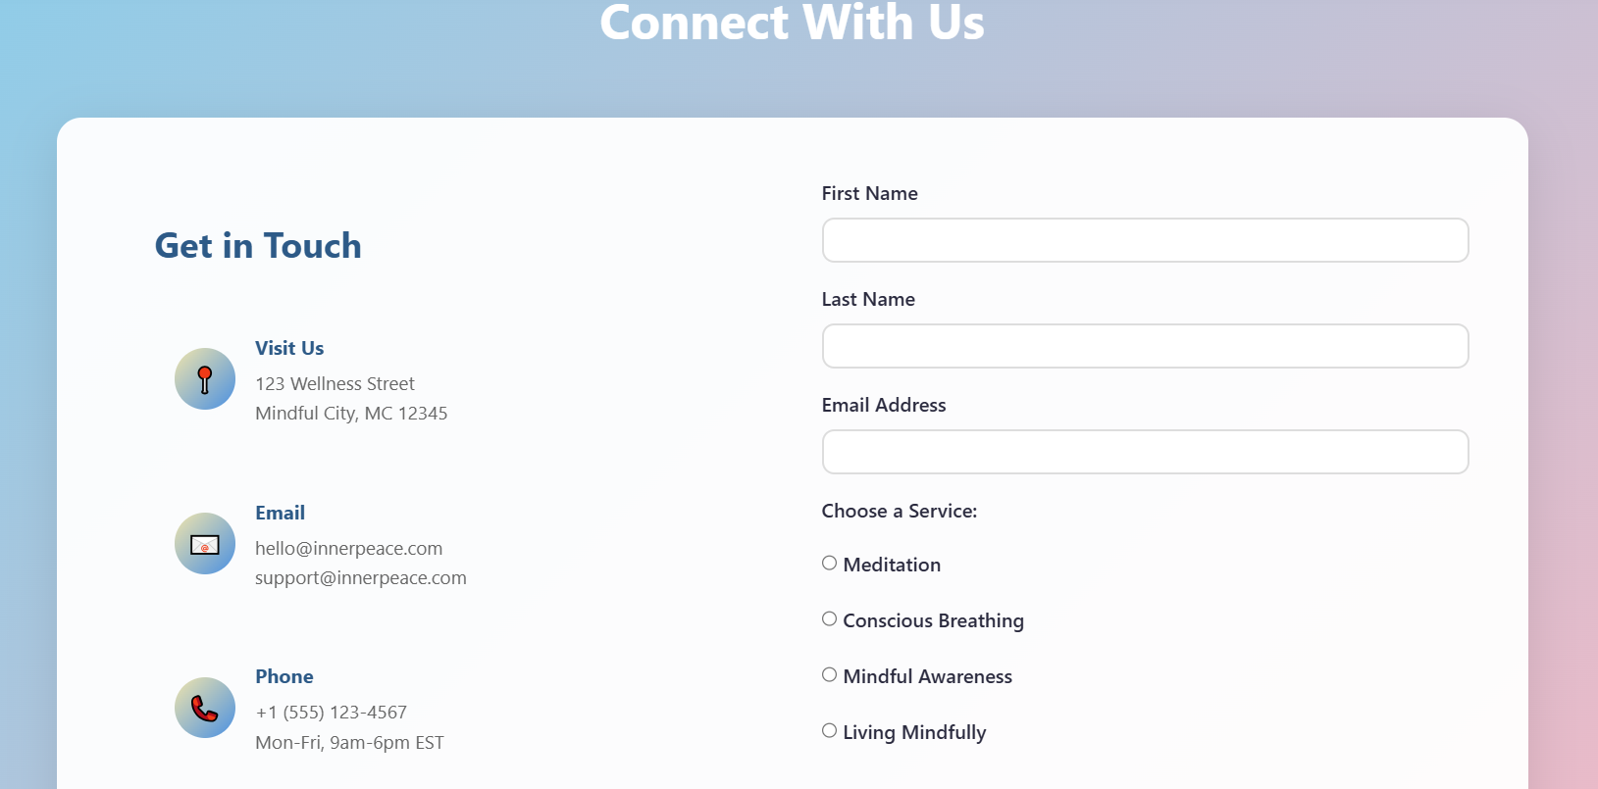
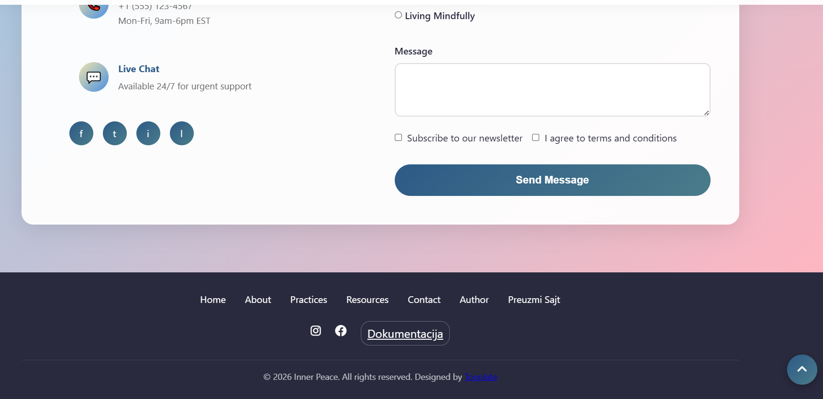
Ovde je postavljena validacija forme pomoću Regex-a. Vrši se provera i ako nešto nije dobro upisano izbacuje se greška, a ako je sve dobro onda izbacuje ovako...
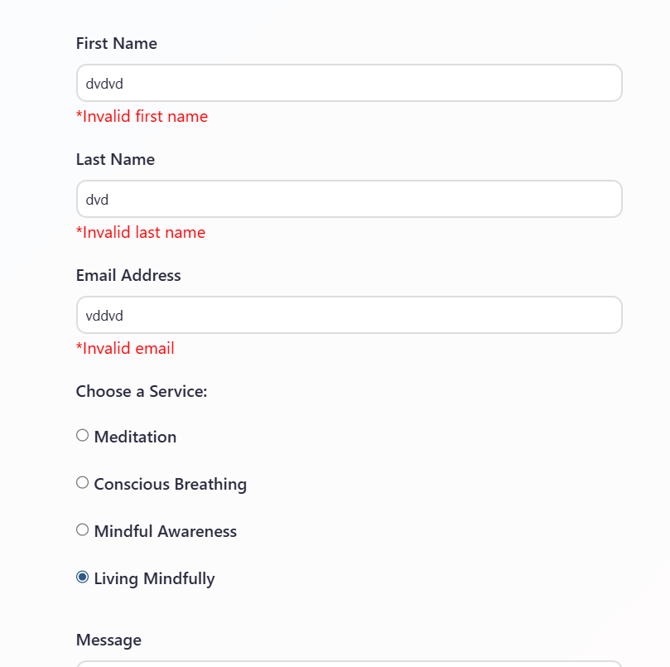
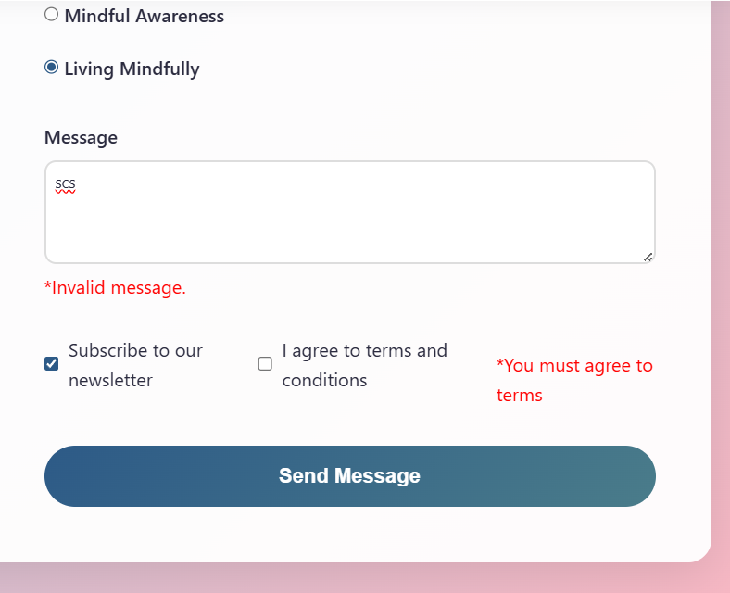


Dodatne funkcionalnosti:
Dinamički ispisan futer.
U podnožju je stavljeno da se uzima trenutna godina.
U desnom donjem uglu je stavljeno dugme koje vraća na početak.
Stavljen je Smooth Scroll, kada se klikne na neki link iy menija on se polako spusti do željenog dela.
Postavljen je i preloader, da se pokazuje load kružić dok se ne učita stranica.

Kodovi

HTML

Index.html
<!DOCTYPE html>
<html lang="en">

<head>
<meta charset="UTF-8">
<meta name="viewport" content="width=device-width, initial-scale=1.0">
<meta name="description"
content="Your guide to mindfulness, meditation, and mental wellness. Find your inner peace and transform your life.">
<meta name="keywords" content="mindfulness, meditation, peace, wellness, mind ,stress ,breath">
<meta name="author" content="Elena Milkovski">
<link rel="icon" type="image/png" href="images/peace.png">
<title>Inner Peace - Mindfulness & Mental Wellness</title>
<link href="tooplate-inner-peace.css" rel="stylesheet">
<link rel="stylesheet" href="https://cdnjs.cloudflare.com/ajax/libs/font-awesome/6.4.2/css/all.min.css">
</head>

<body>
<div id="preloader">
<div class="loader-content">
<div class="zen-spinner"></div>
</div>
</div>
<div class="geometric-bg"></div>
<!-- Header -->
<header>
<nav>
<a href="#hero" class="logo">
<svg viewBox="0 0 40 40" xmlns="http://www.w3.org/2000/svg">
<defs>
<linearGradient id="logoGradient" x1="0%" y1="0%" x2="100%" y2="100%">
<stop offset="0%" style="stop-color:#667eea;stop-opacity:1" />
<stop offset="100%" style="stop-color:#764ba2;stop-opacity:1" />
</linearGradient>
</defs>
<circle cx="20" cy="20" r="18" fill="none" stroke="url(#logoGradient)" stroke-width="2" />
<circle cx="20" cy="20" r="14" fill="none" stroke="url(#logoGradient)" stroke-width="1.5"
opacity="0.7" />
<circle cx="20" cy="20" r="10" fill="none" stroke="url(#logoGradient)" stroke-width="1"
opacity="0.5" />
<circle cx="20" cy="20" r="6" fill="none" stroke="url(#logoGradient)" stroke-width="0.5"
opacity="0.3" />
<circle cx="20" cy="20" r="3" fill="url(#logoGradient)" />
</svg>
<span class="logo-text">Inner Peace</span>
</a>

<div class="menu-toggle" id="mobile-menu" onclick="toggleMenu()">
<span></span>
<span></span>
<span></span>
</div>

<ul class="nav-links" id="glavni-meni"></ul>
</nav>
</header>

<!-- Hero Section with Enhanced Background -->
<section id="hero">
<!-- Network Background -->
<div class="network-bg" id="network-container">
</div>

<div class="peace-bg" id="peace-container">
</div>

<div class="floating-elements">
<div class="zen-stone"></div>
<div class="zen-stone"></div>
<div class="zen-stone"></div>
</div>
<div class="mandala-bg">
<div class="mandala-circle"></div>
<div class="mandala-circle"></div>
<div class="mandala-circle"></div>
</div>
<div class="hero-content">
<h1>Find Your Inner Peace</h1>
<p>Journey towards mental wellness through mindfulness, meditation, and self-discovery</p>
<a href="#about" class="cta-button">Begin Your Journey</a>
</div>
</section>

<!-- About Section - Complete Redesign -->
<section id="about">
<h2 class="section-title">Discover Mindfulness</h2>
<p class="section-subtitle">
Transform your mind, transform your life
</p>

<!-- Floating Cards Design -->
<div class="about-floating-cards">
<div class="floating-card sakriveno">
<div class="card-icon">
<div class="icon-wrapper">🧠</div>
</div>
<h3>Rewire Your Brain</h3>
<p>Neuroplasticity in action - just 10 minutes daily physically reshapes your brain for better focus and
emotional control.</p>
</div>

<div class="floating-card sakriveno">
<div class="card-icon">
<div class="icon-wrapper">⚡</div>
</div>
<h3>Instant Calm</h3>
<p>Access immediate stress relief through proven breathing techniques that activate your parasympathetic
nervous system.</p>
</div>

<div class="floating-card sakriveno">
<div class="card-icon">
<div class="icon-wrapper">🎯</div>
</div>
<h3>Peak Performance</h3>
<p>Achieve flow states more easily and unlock your full potential in work, creativity, and personal
growth.</p>
</div>
</div>

<!-- Stats Banner -->

<div class="stats-banner" id="facts">
</div>
<!-- Feature Showcase -->
<div class="feature-showcase">
<div class="showcase-content sakriveno">
<h3>Why Choose Inner Peace?</h3>
<ul class="feature-list" id="lista-prednosti">
</ul>
</div>
</div>
</section>

<!-- Practices Section - Enhanced Timeline Design -->
<section id="practices">
<div class="practices-container">
<h2 class="section-title">Mindfulness Practices</h2>
<p class="section-subtitle">Master these core practices to build your mindfulness toolkit</p>

<div class="practice-layout">
<!-- Futuristic Left Timeline -->
<div class="timeline-track">
<div class="timeline-progress"></div>
<div class="timeline-points">
<div class="timeline-point active">
<div class="futuristic-label">
<span class="label-text">Foundation</span>
</div>
<div class="timeline-indicator"></div>
</div>
<div class="timeline-point">
<div class="futuristic-label">
<span class="label-text">Breathing</span>
</div>
<div class="timeline-indicator"></div>
</div>
<div class="timeline-point">
<div class="futuristic-label">
<span class="label-text">Awareness</span>
</div>
<div class="timeline-indicator"></div>
</div>
<div class="timeline-point">
<div class="futuristic-label">
<span class="label-text">Integration</span>
</div>
<div class="timeline-indicator"></div>
</div>
</div>
</div>

<!-- Right Content Area -->
<div class="practice-content-area">
<div class="practice-card-new sakriveno">
<div class="practice-header">
<div class="practice-icon-new">🧘</div>
<div class="practice-info">
<h3>Foundation Meditation</h3>
<span class="practice-duration">10-20 minutes daily</span>
</div>
</div>
<p class="practice-description">
Begin your journey with guided meditation sessions designed specifically for beginners.
Learn the fundamental techniques of sitting meditation, including proper posture, attention
anchoring, and working with wandering thoughts. Our progressive approach ensures you build a
solid foundation without feeling overwhelmed.
</p>
<div class="practice-benefits">
<a href="#" class="benefit-tag">Stress Reduction</a>
<a href="#" class="benefit-tag">Mental Clarity</a>
<a href="#" class="benefit-tag">Emotional Balance</a>
<a href="#" class="benefit-tag">Better Sleep</a>
</div>
</div>

<div class="practice-card-new sakriveno">
<div class="practice-header">
<div class="practice-icon-new">🌬️</div>
<div class="practice-info">
<h3>Conscious Breathing</h3>
<span class="practice-duration">5-10 minutes as needed</span>
</div>
</div>
<p class="practice-description">
Master the art of breath awareness with techniques that instantly calm your nervous system.
From box breathing to 4-7-8 patterns, discover how different breathing exercises can
energize, relax, or center you throughout your day. Perfect for managing anxiety and stress
in real-time.
</p>
<div class="practice-benefits">
<a href="#" class="benefit-tag">Instant Calm</a>
<a href="#" class="benefit-tag">Energy Boost</a>
<a href="#" class="benefit-tag">Focus Enhancement</a>
<a href="#" class="benefit-tag">Anxiety Relief</a>
</div>
</div>

<div class="practice-card-new sakriveno">
<div class="practice-header">
<div class="practice-icon-new">📝</div>
<div class="practice-info">
<h3>Mindful Awareness</h3>
<span class="practice-duration">15 minutes daily</span>
</div>
</div>
<p class="practice-description">
Develop meta-awareness through journaling and body scan practices. Learn to observe your
thoughts, emotions, and physical sensations without judgment. This practice includes
gratitude exercises, emotional check-ins, and reflective writing to deepen
self-understanding.
</p>
<div class="practice-benefits">
<a href="#" class="benefit-tag">Self-Discovery</a>
<a href="#" class="benefit-tag">Emotional Intelligence</a>
<a href="#" class="benefit-tag">Pattern Recognition</a>
<a href="#" class="benefit-tag">Gratitude</a>
</div>
</div>

<div class="practice-card-new sakriveno">
<div class="practice-header">
<div class="practice-icon-new">🚶</div>
<div class="practice-info">
<h3>Living Mindfully</h3>
<span class="practice-duration">Throughout the day</span>
</div>
</div>
<p class="practice-description">
Integrate mindfulness into every aspect of your daily life. From mindful eating to walking
meditation, learn how to transform routine activities into opportunities for presence.
Discover how to maintain awareness during work, conversations, and even challenging
situations.
</p>
<div class="practice-benefits">
<a href="#" class="benefit-tag">Present Living</a>
<a href="#" class="benefit-tag">Joy in Simple Things</a>
<a href="#" class="benefit-tag">Mindful Communication</a>
<a href="#" class="benefit-tag">Work-Life Balance</a>
</div>
</div>
</div>
</div>
</div>
</section>

<!-- Resources Section - Tab Structure -->
<section id="resources">
<h2 class="section-title">Resources & Tools</h2>
<p class="section-subtitle">Everything you need to support your mindfulness practice</p>

<div class="resource-tabs sakriveno">
<button class="tab-btn active" onclick="showTab('meditations')">Meditations</button>
<button class="tab-btn" onclick="showTab('courses')">Courses</button>
<button class="tab-btn" onclick="showTab('tools')">Tools</button>
</div>

<div id="meditations" class="tab-content active sakriveno">
<div class="resource-list">
<div class="resource-card">
<div class="resource-image">
<div class="resource-thumbnail morning-meditation"></div>
</div>
<div class="resource-body">
<h3>Morning Meditation</h3>
<p>Start your day with clarity and intention through our 15-minute morning practice.</p>
</div>
</div>
<div class="resource-card">
<div class="resource-image">
<div class="resource-thumbnail stress-relief"></div>
</div>
<div class="resource-body">
<h3>Stress Relief Session</h3>
<p>Quick 10-minute guided meditation for immediate stress and anxiety relief.</p>
</div>
</div>
<div class="resource-card">
<div class="resource-image">
<div class="resource-thumbnail sleep-meditation"></div>
</div>
<div class="resource-body">
<h3>Sleep Meditation</h3>
<p>Peaceful bedtime meditation to help you unwind and prepare for restful sleep.</p>
</div>
</div>
</div>
</div>

<div id="courses" class="tab-content sakriveno">
<div class="resource-list">
<div class="resource-card">
<div class="resource-image">
<div class="resource-thumbnail mbsr-course"></div>
</div>
<div class="resource-body">
<h3>8-Week MBSR Program</h3>
<p>Comprehensive Mindfulness-Based Stress Reduction course with certified instructors.</p>
</div>
</div>
<div class="resource-card">
<div class="resource-image">
<div class="resource-thumbnail leadership-course"></div>
</div>
<div class="resource-body">
<h3>Mindful Leadership</h3>
<p>Develop presence and emotional intelligence for effective leadership.</p>
</div>
</div>
<div class="resource-card">
<div class="resource-image">
<div class="resource-thumbnail beginner-course"></div>
</div>
<div class="resource-body">
<h3>Beginner's Journey</h3>
<p>30-day introduction to mindfulness with daily lessons and practices.</p>
</div>
</div>
</div>
</div>

<div id="tools" class="tab-content sakriveno">
<div class="resource-list">
<div class="resource-card">
<div class="resource-image">
<div class="resource-thumbnail timer-tool"></div>
</div>
<div class="resource-body">
<h3>Meditation Timer</h3>
<p>Customizable timer with ambient sounds and interval bells for your practice.</p>
</div>
</div>
<div class="resource-card">
<div class="resource-image">
<div class="resource-thumbnail mood-tracker"></div>
</div>
<div class="resource-body">
<h3>Mood Tracker</h3>
<p>Monitor your emotional patterns and see how mindfulness impacts your well-being.</p>
</div>
</div>
<div class="resource-card">
<div class="resource-image">
<div class="resource-thumbnail breathing-tool"></div>
</div>
<div class="resource-body">
<h3>Breathing Exercises</h3>
<p>Interactive breathing patterns for different situations and energy levels.</p>
</div>
</div>
</div>
</div>
</section>

<!-- Contact Section - Two Columns -->
<section id="contact">
<div class="contact-container sakriveno">
<h2 class="section-title">Connect With Us</h2>

<div class="contact-wrapper">
<div class="contact-info">
<h3>Get in Touch</h3>

<div class="info-item">
<div class="info-icon">📍</div>
<div class="info-text">
<h4>Visit Us</h4>
<p>123 Wellness Street<br>Mindful City, MC 12345</p>
</div>
</div>

<div class="info-item">
<div class="info-icon">📧</div>
<div class="info-text">
<h4>Email</h4>
<p>hello@innerpeace.com<br>support@innerpeace.com</p>
</div>
</div>

<div class="info-item">
<div class="info-icon">📞</div>
<div class="info-text">
<h4>Phone</h4>
<p>+1 (555) 123-4567<br>Mon-Fri, 9am-6pm EST</p>
</div>
</div>

<div class="info-item">
<div class="info-icon">💬</div>
<div class="info-text">
<h4>Live Chat</h4>
<p>Available 24/7 for urgent support</p>
</div>
</div>

<div class="social-links">
<a href="#" class="social-link">f</a>
<a href="#" class="social-link">t</a>
<a href="#" class="social-link">i</a>
<a href="#" class="social-link">l</a>
</div>
</div>
<form id="contactForm">
<div class="form-group">
<label for="name">First Name</label>
<input type="text" id="name" name="name">
<span id="name-error" class="error-msg" style="color:red; display:none;">*Invalid first
name</span>
</div>

<div class="form-group">
<label for="lastName">Last Name</label>
<input type="text" id="lastName" name="lastName">
<span id="lastName-error" class="error-msg" style="color:red; display:none;">*Invalid last
name</span>
</div>

<div class="form-group">
<label for="email">Email Address</label>
<input type="email" id="email" name="email">
<span id="email-error" class="error-msg" style="color:red; display:none;">*Invalid email</span>
</div>

<div class="form-group">
<label>Choose a Service:</label>
<div class="radio-options">
<label class="radio-item">
<input type="radio" name="reason" value="meditation"> Meditation
</label>
<label class="radio-item">
<input type="radio" name="reason" value="breathing"> Conscious Breathing
</label>
<label class="radio-item">
<input type="radio" name="reason" value="mindful"> Mindful Awareness
</label>
<label class="radio-item">
<input type="radio" name="reason" value="living"> Living Mindfully
</label>
</div>
<span id="radio-error" class="error-msg" style="color:red; display:none;">*Please select a
service</span>
</div>

<div class="form-group">
<label for="message">Message</label>
<textarea id="message" name="message" rows="4" required></textarea>
<span id="message-error" style="display:none; color:red;">
*Invalid message.
</span>

</div>

<div class="form-group checkbox-group">

<input type="checkbox" id="newsletter" name="newsletter">
<label for="newsletter">Subscribe to our newsletter</label>
<br><input type="checkbox" id="terms" name="terms">
<label for="terms">I agree to terms and conditions</label>
<br>
<span id="terms-error" class="error-msg" style="color:red; display:none;"><br>*You must agree to
terms</span>
</div>

<div id="form-success" style="color:green; display:none; margin-top:10px; font-weight:bold;">Form
submitted successfully!</div>
<button type="submit" class="submit-btn">Send Message</button>
</form>
</section>

<!-- Footer -->
<footer>
<div class="footer-content">
<div class="footer-links"></div>

<div class="footer-social">
<a href="#"><i class="fa-brands fa-instagram"></i></a>
<a href="#"><i class="fa-brands fa-facebook"></i></a>
<a href="sitemap.xml"><i class="fa-solid fa-sitemap"></i></a>
<a href="dokumentacija.pdf" class="doc-link">Dokumentacija</a>
</div>

<div class="copyright">
<p>&copy; <span id="godina"></span> Inner Peace. All rights reserved.
Designed by <a href="https://www.tooplate.com" target="_blank">Tooplate</a></p>
</div>
</div>
</footer>

<button id="backToTop" onclick="skociNaVrh()" aria-label="Nazad na vrh">
<i class="fa-solid fa-angle-up"></i>
</button>

<script src="js.js"></script>
</body>

</html>

autor.html
<!DOCTYPE html>
<html lang="sr">
<head>
<meta charset="UTF-8">
<meta name="viewport" content="width=device-width, initial-scale=1.0">
<title>O Autoru | Inner Peace</title>
<link rel="icon" type="image/png" href="images/peace.png">
<link rel="stylesheet" href="style.css">
</head>
<body>

<div class="kartica">
<img src="images/slikaelena.jpg" alt="Slika autora">

<h2>Elena Milkovski</h2>
<p>Broj indeksa: 18/24</p>

<a href="index.html" class="dugme">Vrati se na početnu</a>
</div>

</body>
</html>

CSS

tooplate-inner-peace.css
/*

Tooplate 2143 Inner Peace

https://www.tooplate.com/view/2143-inner-peace

Free HTML CSS Template

*/

@charset "utf-8";
/* CSS Document */

* {
margin: 0;
padding: 0;
box-sizing: border-box;
}

:root {
--primary: #2D5A87;
--secondary: #4A7C8A;
--accent: #6B9B7A;
--light: #F7F7F7;
--dark: #2A2A3E;
--gradient-1: linear-gradient(135deg, #2D5A87 0%, #4A7C8A 100%);
--gradient-2: linear-gradient(135deg, rgb(241, 229, 172) 0%, #4a90e2 100%);
}

body {
font-family: 'Segoe UI', Tahoma, Geneva, Verdana, sans-serif;
line-height: 1.6;
color: var(--dark);
background: var(--light);
overflow-x: hidden;
}

/* Geometric Background Pattern */
.geometric-bg {
position: fixed;
top: 0;
left: 0;
width: 100%;
height: 100%;
z-index: -1;
opacity: 0.03;
background-image:
repeating-linear-gradient(45deg, transparent, transparent 35px, rgba(107, 91, 149, 0.1) 35px, rgba(107, 91, 149, 0.1) 70px),
repeating-linear-gradient(-45deg, transparent, transparent 35px, rgba(136, 176, 211, 0.1) 35px, rgba(136, 176, 211, 0.1) 70px);
}

/* Header */
header {
background: rgba(255, 255, 255, 0.95);
backdrop-filter: blur(10px);
box-shadow: 0 2px 20px rgba(0, 0, 0, 0.05);
position: fixed;
width: 100%;
top: 0;
z-index: 1000;
transition: all 0.3s ease;
}

nav {
display: flex;
justify-content: space-between;
align-items: center;
padding: 0.8rem 5%;
max-width: 1400px;
margin: 0 auto;
flex-wrap: wrap;
}

@media (max-width: 1000px) and (min-width: 769px) {
nav {
flex-direction: column;
gap: 1rem;
padding: 1rem 5%;
}

.nav-links {
width: 100%;
justify-content: center;
}

}

/* Logo SVG */
.logo {
display: flex;
align-items: center;
gap: 10px;
text-decoration: none;
transition: transform 0.3s ease;
}

.logo:hover {
transform: scale(1.05);
}

.logo svg {
width: 40px;
height: 40px;
}

.logo-text {
font-size: 1.8rem;
font-weight: bold;
background: var(--gradient-1);
-webkit-background-clip: text;
-webkit-text-fill-color: transparent;
background-clip: text;
}

.nav-links {
display: flex;
list-style: none;
gap: 2.5rem;
}

.nav-links a {
text-decoration: none;
color: var(--dark);
font-weight: 500;
font-size: 1rem;
transition: all 0.3s ease;
position: relative;
padding: 0.6rem 1.2rem;
border-radius: 6px;
border: 1px solid transparent;
}

.nav-links a:hover {
color: var(--primary);
background: rgba(45, 90, 135, 0.05);
border-color: rgba(45, 90, 135, 0.2);
}

.nav-links a.active {
color: white;
background: linear-gradient(135deg, #4a90e2 0%, #F1E5AC 100%);
border-color: #4a90e2;
}

.menu-toggle {
display: none;
flex-direction: column;
cursor: pointer;
gap: 4px;
}

.menu-toggle span {
width: 25px;
height: 3px;
background: var(--dark);
transition: all 0.3s ease;
border-radius: 3px;
}

.menu-toggle.active span:nth-child(1) {
transform: rotate(45deg) translate(5px, 5px);
}

.menu-toggle.active span:nth-child(2) {
opacity: 0;
}

.menu-toggle.active span:nth-child(3) {
transform: rotate(-45deg) translate(7px, -6px);
}

/* Hero Section with Enhanced Animated Background */
#hero {
min-height: 60vh;
display: flex;
align-items: center;
justify-content: center;
background: var(--gradient-2);
position: relative;
margin-top: 60px;
overflow: hidden;
}

/* Central Light Core */
#hero::before {
content: '';
position: absolute;
top: 50%;
left: 50%;
width: 800px;
height: 800px;
background: radial-gradient(circle, rgba(255, 255, 255, 0.15) 0%, transparent 70%);
transform: translate(-50%, -50%);
z-index: 0;
}

/* Connecting Lines and Dots Background */
.network-bg {
position: absolute;
width: 100%;
height: 100%;
top: 0;
left: 0;
opacity: 0.3;
}

.network-line {
position: absolute;
background: linear-gradient(90deg, transparent, rgba(255, 255, 255, 0.5), transparent);
height: 1px;
transform-origin: left center;
}

.network-line:nth-child(1) {
width: 200px;
top: 20%;
left: 10%;
transform: rotate(25deg);
animation: pulseLine 4s ease-in-out infinite;
}

.network-line:nth-child(2) {
width: 150px;
top: 40%;
right: 20%;
transform: rotate(-45deg);
animation: pulseLine 4s ease-in-out infinite 1s;
}

.network-line:nth-child(3) {
width: 180px;
bottom: 30%;
left: 30%;
transform: rotate(60deg);
animation: pulseLine 4s ease-in-out infinite 2s;
}

.network-line:nth-child(4) {
width: 220px;
top: 60%;
right: 15%;
transform: rotate(-20deg);
animation: pulseLine 4s ease-in-out infinite 3s;
}

.network-line:nth-child(5) {
width: 160px;
bottom: 20%;
right: 35%;
transform: rotate(40deg);
animation: pulseLine 4s ease-in-out infinite 1.5s;
}

@keyframes pulseLine {

0%,
100% {
opacity: 0.1;
transform: scaleX(0.8) rotate(var(--rotation));
}

50% {
opacity: 0.5;
transform: scaleX(1) rotate(var(--rotation));
}
}

.network-dot {
position: absolute;
width: 6px;
height: 6px;
background: white;
border-radius: 50%;
box-shadow: 0 0 10px rgba(255, 255, 255, 0.5);
}

.network-dot:nth-child(6) {
top: 20%;
left: 10%;
animation: dotPulse 3s ease-in-out infinite;
}

.network-dot:nth-child(7) {
top: 40%;
right: 20%;
animation: dotPulse 3s ease-in-out infinite 0.5s;
}

.network-dot:nth-child(8) {
bottom: 30%;
left: 30%;
animation: dotPulse 3s ease-in-out infinite 1s;
}

.network-dot:nth-child(9) {
top: 60%;
right: 15%;
animation: dotPulse 3s ease-in-out infinite 1.5s;
}

.network-dot:nth-child(10) {
bottom: 20%;
right: 35%;
animation: dotPulse 3s ease-in-out infinite 2s;
}

.network-dot:nth-child(11) {
top: 35%;
left: 25%;
animation: dotPulse 3s ease-in-out infinite 2.5s;
}

.network-dot:nth-child(12) {
bottom: 40%;
right: 25%;
animation: dotPulse 3s ease-in-out infinite 0.8s;
}

.network-dot:nth-child(13) {
top: 15%;
left: 60%;
animation: dotPulse 3s ease-in-out infinite 1.2s;
}

.network-dot:nth-child(14) {
bottom: 50%;
left: 15%;
animation: dotPulse 3s ease-in-out infinite 2.8s;
}

.network-dot:nth-child(15) {
top: 70%;
left: 45%;
animation: dotPulse 3s ease-in-out infinite 0.3s;
}

.network-dot:nth-child(16) {
top: 25%;
right: 40%;
animation: dotPulse 3s ease-in-out infinite 1.8s;
}

.network-dot:nth-child(17) {
bottom: 15%;
left: 55%;
animation: dotPulse 3s ease-in-out infinite 2.3s;
}

@keyframes dotPulse {

0%,
100% {
transform: scale(1);
opacity: 0.4;
}

50% {
transform: scale(1.5);
opacity: 1;
}
}

/* Inner Peace Animated Background */
.peace-bg {
position: absolute;
width: 100%;
height: 100%;
top: 0;
left: 0;
}

.breathing-circle {
position: absolute;
border-radius: 50%;
background: radial-gradient(circle, rgba(255, 255, 255, 0.1) 0%, transparent 70%);
animation: breathe 8s ease-in-out infinite;
}

.breathing-circle:nth-child(1) {
width: 300px;
height: 300px;
top: 10%;
left: 10%;
animation-delay: 0s;
}

.breathing-circle:nth-child(2) {
width: 200px;
height: 200px;
top: 60%;
right: 15%;
animation-delay: 2s;
}

.breathing-circle:nth-child(3) {
width: 250px;
height: 250px;
bottom: 20%;
left: 30%;
animation-delay: 4s;
}

.breathing-circle:nth-child(4) {
width: 180px;
height: 180px;
top: 30%;
right: 25%;
animation-delay: 6s;
}

@keyframes breathe {

0%,
100% {
transform: scale(1) translate(0, 0);
opacity: 0.3;
}

25% {
transform: scale(1.2) translate(-10px, -10px);
opacity: 0.5;
}

50% {
transform: scale(1.4) translate(10px, -20px);
opacity: 0.3;
}

75% {
transform: scale(1.1) translate(-5px, 10px);
opacity: 0.4;
}
}

.floating-elements {
position: absolute;
width: 100%;
height: 100%;
}

.zen-stone {
position: absolute;
width: 60px;
height: 60px;
background: radial-gradient(circle, rgba(255, 255, 255, 0.2) 0%, transparent 60%);
border-radius: 50%;
animation: float 15s ease-in-out infinite;
}

.zen-stone:nth-child(1) {
top: 20%;
left: 5%;
animation-delay: 0s;
}

.zen-stone:nth-child(2) {
top: 70%;
right: 10%;
animation-delay: 5s;
}

.zen-stone:nth-child(3) {
bottom: 30%;
left: 50%;
animation-delay: 10s;
}

@keyframes float {

0%,
100% {
transform: translateY(0) translateX(0) rotate(0deg);
}

33% {
transform: translateY(-30px) translateX(20px) rotate(120deg);
}

66% {
transform: translateY(20px) translateX(-20px) rotate(240deg);
}
}

.mandala-bg {
position: absolute;
width: 500px;
height: 500px;
top: 50%;
left: 50%;
transform: translate(-50%, -50%);
opacity: 0.1;
}

.mandala-circle {
position: absolute;
border: 2px solid white;
border-radius: 50%;
animation: rotate 60s linear infinite;
}

.mandala-circle:nth-child(1) {
width: 100%;
height: 100%;
animation-duration: 60s;
}

.mandala-circle:nth-child(2) {
width: 80%;
height: 80%;
top: 10%;
left: 10%;
animation-duration: 50s;
animation-direction: reverse;
}

.mandala-circle:nth-child(3) {
width: 60%;
height: 60%;
top: 20%;
left: 20%;
animation-duration: 40s;
}

@keyframes rotate {
from {
transform: rotate(0deg);
}

to {
transform: rotate(360deg);
}
}

.hero-content {
text-align: center;
z-index: 1;
padding: 2rem;
max-width: 800px;
position: relative;
}

.hero-content h1 {
font-size: 3.5rem;
color: white;
margin-bottom: 1rem;
animation: fadeInUp 1s ease;
text-align: center;
}

.hero-content p {
font-size: 1.3rem;
color: rgba(255, 255, 255, 0.9);
margin-bottom: 2rem;
animation: fadeInUp 1s ease 0.2s;
animation-fill-mode: both;
}

.hero-content p {
font-size: 1.3rem;
color: rgba(255, 255, 255, 0.9);
margin-bottom: 2rem;
animation: fadeInUp 1s ease 0.2s;
animation-fill-mode: both;
}

.cta-button {
display: inline-block;
padding: 1rem 2.5rem;
background: white;
color: var(--primary);
text-decoration: none;
border-radius: 50px;
font-weight: 600;
transition: all 0.3s ease;
animation: fadeInUp 1s ease 0.4s;
animation-fill-mode: both;
box-shadow: 0 10px 30px rgba(0, 0, 0, 0.1);
}

.cta-button:hover {
transform: translateY(-3px);
box-shadow: 0 15px 40px rgba(0, 0, 0, 0.15);
}

@keyframes fadeInUp {
from {
opacity: 0;
transform: translateY(30px);
}

to {
opacity: 1;
transform: translateY(0);
}
}

/* About Section - Complete Redesign */
#about {
padding: 5rem 5%;
max-width: 1200px;
margin: 0 auto;
}

.section-title {
text-align: center;
font-size: 2.5rem;
margin-bottom: 1rem;
position: relative;
color: var(--dark);
}

.section-subtitle {
text-align: center;
max-width: 800px;
margin: 0 auto 3rem;
color: #666;
font-size: 1.1rem;
}

/* Floating Cards Design */
.about-floating-cards {
display: grid;
grid-template-columns: repeat(auto-fit, minmax(280px, 1fr));
gap: 2rem;
margin-bottom: 4rem;
}

.floating-card {
background: white;
border-radius: 25px;
padding: 2.5rem;
position: relative;
overflow: hidden;
box-shadow: 0 10px 30px rgba(0, 0, 0, 0.08);
transition: all 0.4s cubic-bezier(0.175, 0.885, 0.32, 1.275);
}

.floating-card::before {
content: '';
position: absolute;
top: -50%;
right: -50%;
width: 200%;
height: 200%;
background: radial-gradient(circle, var(--accent) 0%, transparent 70%);
opacity: 0;
transition: opacity 0.4s ease;
}

.floating-card:hover {
transform: translateY(-10px) rotate(1deg);
box-shadow: 0 20px 40px rgba(0, 0, 0, 0.12);
}

.floating-card:hover::before {
opacity: 0.05;
}

.card-icon {
width: 80px;
height: 80px;
margin-bottom: 1.5rem;
position: relative;
}

.icon-wrapper {
width: 100%;
height: 100%;
background: var(--gradient-2);
border-radius: 30% 70% 70% 30% / 30% 30% 70% 70%;
display: flex;
align-items: center;
justify-content: center;
font-size: 2.5rem;
animation: morphShape 8s ease-in-out infinite;
box-shadow: 0 10px 25px rgba(136, 176, 211, 0.3);
}

@keyframes morphShape {

0%,
100% {
border-radius: 30% 70% 70% 30% / 30% 30% 70% 70%;
transform: rotate(0deg);
}

25% {
border-radius: 70% 30% 30% 70% / 70% 70% 30% 30%;
transform: rotate(90deg);
}

50% {
border-radius: 30% 70% 70% 30% / 70% 30% 30% 70%;
transform: rotate(180deg);
}

75% {
border-radius: 70% 30% 30% 70% / 30% 70% 70% 30%;
transform: rotate(270deg);
}
}

.floating-card h3 {
font-size: 1.4rem;
margin-bottom: 1rem;
color: var(--dark);
}

.floating-card p {
color: #666;
line-height: 1.6;
}

/* Stats Banner */
.stats-banner {
background: linear-gradient(135deg, #F1E5AC 0%, #4a90e2 100%);
border-radius: 30px;
padding: 3rem;
display: flex;
justify-content: space-around;
align-items: center;
flex-wrap: wrap;
gap: 2rem;
margin-bottom: 4rem;
position: relative;
overflow: hidden;
}

.stats-banner::before {
content: '';
position: absolute;
top: -50%;
left: -50%;
width: 200%;
height: 200%;
background: repeating-linear-gradient(45deg,
transparent,
transparent 10px,
rgba(255, 255, 255, 0.05) 10px,
rgba(255, 255, 255, 0.05) 20px);
animation: slidePattern 20s linear infinite;
}

@keyframes slidePattern {
0% {
transform: translate(0, 0);
}

100% {
transform: translate(50px, 50px);
}
}

.stat-block {
text-align: center;
position: relative;
z-index: 1;
}

.stat-value {
font-size: 3rem;
font-weight: bold;
color: white;
text-shadow: 0 4px 15px rgba(0, 0, 0, 0.1);
}

.stat-desc {
color: rgba(255, 255, 255, 0.9);
font-size: 1rem;
margin-top: 0.5rem;
}

/* Feature Showcase */
.feature-showcase {
display: grid;
grid-template-columns: 1fr;
gap: 2rem;
padding: 3rem;
background: linear-gradient(135deg, rgba(45, 90, 135, 0.03) 0%, rgba(74, 124, 138, 0.03) 100%);
border-radius: 30px;
position: relative;
overflow: hidden;
}

.feature-showcase::before {
content: '';
position: absolute;
top: -50%;
left: -50%;
width: 200%;
height: 200%;
background: repeating-linear-gradient(45deg,
transparent,
transparent 20px,
rgba(45, 90, 135, 0.02) 20px,
rgba(45, 90, 135, 0.02) 40px);
animation: slidePattern 30s linear infinite;
}

.showcase-content h3 {
font-size: 2.2rem;
margin-bottom: 2rem;
background: linear-gradient(135deg, #F1E5AC 0%, #4a90e2 100%);
-webkit-background-clip: text;
-webkit-text-fill-color: transparent;
background-clip: text;
text-align: center;
position: relative;
z-index: 1;
}

.feature-list {
list-style: none;
display: grid;
grid-template-columns: repeat(auto-fit, minmax(280px, 1fr));
gap: 1.5rem;
position: relative;
z-index: 1;
}

.feature-list li {
display: flex;
align-items: center;
gap: 1.5rem;
padding: 1.5rem;
background: white;
border-radius: 20px;
transition: all 0.4s ease;
box-shadow: 0 5px 15px rgba(0, 0, 0, 0.05);
position: relative;
overflow: hidden;
}

.feature-list li::before {
content: '';
position: absolute;
top: 0;
left: -100%;
width: 100%;
height: 100%;
background: linear-gradient(90deg, transparent, rgba(241, 229, 172, 0.2), transparent);
transition: left 0.5s ease;
}

.feature-list li:hover {
transform: translateY(-8px);
box-shadow: 0 15px 35px rgba(0, 0, 0, 0.12);
background: linear-gradient(135deg, rgba(241, 229, 172, 0.05) 0%, rgba(74, 144, 226, 0.05) 100%);
}

.feature-list li:hover::before {
left: 100%;
}

.feature-check {
width: 35px;
height: 35px;
background: linear-gradient(135deg, #F1E5AC 0%, #4a90e2 100%);
border-radius: 50%;
display: flex;
align-items: center;
justify-content: center;
color: white;
font-weight: bold;
flex-shrink: 0;
font-size: 1.1rem;
transition: all 0.3s ease;
}

.feature-list li:hover .feature-check {
transform: scale(1.1) rotate(360deg);
box-shadow: 0 5px 15px rgba(241, 229, 172, 0.4);
}

#practices {
background: linear-gradient(135deg, rgba(136, 176, 211, 0.05) 0%, rgba(152, 216, 200, 0.05) 100%);
padding: 5rem 5%;
}

.practices-container {
max-width: 1200px;
margin: 0 auto;
}

.practice-layout {
display: grid;
grid-template-columns: 280px 1fr;
gap: 3rem;
margin-top: 3rem;
}

.timeline-track {
position: relative;
padding: 2rem 0;
}

.timeline-progress {
position: absolute;
left: 50%;
top: 2rem;
bottom: 2rem;
width: 2px;
background: rgba(107, 91, 149, 0.1);
transform: translateX(-50%);
}

.timeline-progress::before {
content: '';
position: absolute;
top: 0;
left: 0;
width: 100%;
height: 0;
background: var(--gradient-1);
animation: fillTimeline 3s ease forwards;
}

@keyframes fillTimeline {
to {
height: 100%;
}
}

.timeline-points {
position: relative;
height: 100%;
display: flex;
flex-direction: column;
justify-content: space-between;
}

.timeline-point {
display: flex;
align-items: center;
justify-content: center;
cursor: pointer;
transition: all 0.3s ease;
position: relative;
}

.futuristic-label {
position: relative;
padding: 1rem 2rem;
background: white;
border-radius: 50px;
font-weight: 600;
color: var(--dark);
transition: all 0.3s ease;
box-shadow: 0 5px 20px rgba(0, 0, 0, 0.08);
z-index: 5;
min-width: 200px;
text-align: center;
}

.futuristic-label::before {
content: '';
position: absolute;
inset: -2px;
border-radius: 50px;
background: var(--gradient-1);
opacity: 0;
transition: opacity 0.3s ease;
z-index: -1;
}

.futuristic-label::after {
content: '';
position: absolute;
inset: 0;
border-radius: 50px;
background: linear-gradient(45deg, transparent 30%, rgba(255, 255, 255, 0.3) 50%, transparent 70%);
transform: translateX(-100%);
transition: transform 0.6s ease;
z-index: -1;
}

.timeline-point:hover .futuristic-label,
.timeline-point.active .futuristic-label {
animation: zoomPulse 0.6s ease-in-out;
}

@keyframes zoomPulse {
0% {
transform: scale(1);
}

50% {
transform: scale(1.05);
}

100% {
transform: scale(1);
}
}

.timeline-point:hover .timeline-indicator,
.timeline-point.active .timeline-indicator {
transform: translateX(-50%) scale(1.3);
background: var(--primary);
box-shadow: 0 0 15px rgba(45, 90, 135, 0.6);
}

.label-text {
position: relative;
z-index: 2;
font-size: 1.1rem;
letter-spacing: 0.5px;
}

/* Glowing dot indicator */
.timeline-indicator {
position: absolute;
left: 50%;
transform: translateX(-50%);
width: 12px;
height: 12px;
background: white;
border: 2px solid var(--primary);
border-radius: 50%;
z-index: 2;
}

.timeline-point.active .timeline-indicator {
background: var(--primary);
box-shadow: 0 0 20px rgba(107, 91, 149, 0.5);
}

.practice-content-area {
display: grid;
gap: 2rem;
}

.practice-card-new {
background: white;
padding: 2.5rem;
border-radius: 20px;
box-shadow: 0 5px 20px rgba(0, 0, 0, 0.08);
transition: all 0.3s ease;
position: relative;
overflow: hidden;
}

.practice-card-new::before {
content: '';
position: absolute;
top: 0;
left: 0;
width: 5px;
height: 100%;
background: var(--gradient-1);
}

.practice-card-new:hover {
transform: translateX(10px);
box-shadow: 0 10px 30px rgba(0, 0, 0, 0.12);
}

.practice-header {
display: flex;
align-items: center;
gap: 1.5rem;
margin-bottom: 1.5rem;
}

.practice-icon-new {
width: 60px;
height: 60px;
background: var(--gradient-2);
border-radius: 15px;
display: flex;
align-items: center;
justify-content: center;
font-size: 2rem;
}

.practice-info h3 {
font-size: 1.5rem;
color: var(--dark);
margin-bottom: 0.3rem;
}

.practice-duration {
font-size: 0.9rem;
color: var(--primary);
font-weight: 500;
}

.practice-description {
color: #666;
line-height: 1.8;
margin-bottom: 1.5rem;
}

.practice-benefits {
display: flex;
gap: 1rem;
flex-wrap: wrap;
}

.benefit-tag {
padding: 0.5rem 1rem;
background: linear-gradient(135deg, rgba(45, 90, 135, 0.1) 0%, rgba(74, 124, 138, 0.1) 100%);
border-radius: 20px;
font-size: 0.85rem;
color: var(--primary);
font-weight: 500;
cursor: pointer;
transition: all 0.3s ease;
text-decoration: none;
display: inline-block;
}

.benefit-tag:hover {
background: linear-gradient(135deg, #F1E5AC 0%, #4a90e2 100%);
color: white;
transform: translateY(-2px);
box-shadow: 0 5px 15px rgba(74, 144, 226, 0.3);
}

/* Resources Section - New Structure */
#resources {
padding: 5rem 5%;
max-width: 1200px;
margin: 0 auto;
}

.resource-tabs {
display: flex;
justify-content: center;
gap: 1rem;
margin-bottom: 3rem;
}

.tab-btn {
padding: 0.8rem 2rem;
background: white;
border: 2px solid var(--primary);
border-radius: 25px;
color: var(--primary);
font-weight: 600;
cursor: pointer;
transition: all 0.3s ease;
}

.tab-btn.active,
.tab-btn:hover {
background: var(--gradient-1);
color: white;
border-color: transparent;
}

.tab-content {
display: none;
}

.tab-content.active {
display: block;
animation: fadeIn 0.5s ease;
}

@keyframes fadeIn {
from {
opacity: 0;
}

to {
opacity: 1;
}
}

.resource-list {
display: grid;
grid-template-columns: repeat(auto-fit, minmax(300px, 1fr));
gap: 2rem;
}

.resource-card {
background: white;
border-radius: 15px;
overflow: hidden;
box-shadow: 0 5px 20px rgba(0, 0, 0, 0.08);
transition: all 0.3s ease;
}

.resource-card:hover {
transform: translateY(-5px);
box-shadow: 0 10px 30px rgba(0, 0, 0, 0.12);
}

.resource-image {
height: 200px;
background: var(--gradient-2);
position: relative;
overflow: hidden;
display: flex;
align-items: center;
justify-content: center;
}

.resource-thumbnail {
width: 100%;
height: 100%;
background-size: cover;
background-position: center;
background-repeat: no-repeat;
display: flex;
align-items: center;
justify-content: center;
font-size: 0;
color: transparent;
position: relative;
z-index: 1;
}

/* Real thumbnail images */
.morning-meditation {
background-image: url('images/unsplash-mountain-cloud.avif');
}

.stress-relief {
background-image: url('images/unsplash-blue-lakeside.avif');
}

.sleep-meditation {
background-image: url('images/unsplash-mountain-top.avif');
}

.mbsr-course {
background-image: url('images/unsplash-library-bookshelf.avif');
}

.leadership-course {
background-image: url('images/unsplash-people-meeting-room.avif');
}

.beginner-course {
background-image: url('images/unsplash-yoga-session.avif');
}

.timer-tool {
background-image: url('images/unsplash-meditation-timer.avif');
}

.mood-tracker {
background-image: url('images/unsplash-mood-tracker.avif');
}

.breathing-tool {
background-image: url('images/unsplash-breathing-exercise.avif');
}

.resource-image::before {
content: '';
position: absolute;
width: 200%;
height: 200%;
background: repeating-linear-gradient(45deg,
transparent,
transparent 10px,
rgba(255, 255, 255, 0.1) 10px,
rgba(255, 255, 255, 0.1) 20px);
animation: slide 20s linear infinite;
}

@keyframes slide {
0% {
transform: translate(-50%, -50%);
}

100% {
transform: translate(0, 0);
}
}

.resource-body {
padding: 1.5rem;
}

/* Contact Section - Two Columns */
#contact {
background: linear-gradient(135deg, #87ceeb 0%, #ffb6c1 100%);
padding: 5rem 5%;
color: white;
}

.contact-container {
max-width: 1200px;
margin: 0 auto;
}

.contact-container h2 {
color: white;
margin-bottom: 3rem;
}

.contact-wrapper {
display: grid;
grid-template-columns: 1fr 1fr;
gap: 3rem;
background: rgba(255, 255, 255, 0.95);
padding: 3rem;
border-radius: 20px;
box-shadow: 0 10px 40px rgba(0, 0, 0, 0.1);
}

.contact-info {
padding: 2rem;
}

.contact-info h3 {
color: var(--primary);
margin-bottom: 2rem;
font-size: 1.8rem;
}

.info-item {
display: flex;
align-items: center;
gap: 1rem;
margin-bottom: 1.5rem;
color: var(--dark);
padding: 1rem;
border-radius: 15px;
transition: all 0.3s ease;
cursor: pointer;
position: relative;
overflow: hidden;
}

.info-item::before {
content: '';
position: absolute;
top: 0;
left: -100%;
width: 100%;
height: 100%;
background: linear-gradient(90deg, transparent, rgba(45, 90, 135, 0.1), transparent);
transition: left 0.5s ease;
}

.info-item:hover {
background: linear-gradient(135deg, rgba(45, 90, 135, 0.05) 0%, rgba(74, 124, 138, 0.05) 100%);
transform: translateX(5px);
box-shadow: 0 5px 20px rgba(45, 90, 135, 0.1);
}

.info-item:hover::before {
left: 100%;
}

.info-item:hover .info-icon {
transform: scale(1.1) rotate(5deg);
box-shadow: 0 8px 25px rgba(45, 90, 135, 0.3);
}

.info-icon {
width: 50px;
height: 50px;
background: var(--gradient-2);
border-radius: 50%;
display: flex;
align-items: center;
justify-content: center;
font-size: 1.3rem;
transition: all 0.3s ease;
flex-shrink: 0;
}

.info-text h4 {
margin-bottom: 0.25rem;
color: var(--primary);
}

.info-text p {
color: #666;
font-size: 0.95rem;
}

.social-links {
display: flex;
gap: 1rem;
margin-top: 2rem;
}

.social-link {
width: 40px;
height: 40px;
background: var(--gradient-1);
border-radius: 50%;
display: flex;
align-items: center;
justify-content: center;
color: white;
text-decoration: none;
transition: transform 0.3s ease;
}

.social-link:hover {
transform: translateY(-3px);
}

.contact-form {
padding: 2px;
}

.form-group {
margin-bottom: 1rem;
}

.form-group label {
display: block;
margin-bottom: 0.5rem;
color: var(--dark);
font-weight: 500;
}

.form-group input,
.form-group textarea {
width: 100%;
padding: 8px;
border: 2px solid #ddd;
border-radius: 10px;
background: white;
transition: all 0.3s ease;
font-family: inherit;
color: var(--dark);
}

.form-group input:focus,
.form-group textarea:focus {
outline: none;
border-color: var(--primary);
background: white;
}

.submit-btn {
background: var(--gradient-1);
color: white;
padding: 1rem 3rem;
border: none;
border-radius: 50px;
font-size: 1.1rem;
font-weight: 600;
cursor: pointer;
transition: all 0.3s ease;
width: 100%;
}

.submit-btn:hover {
transform: translateY(-2px);
box-shadow: 0 10px 20px rgba(0, 0, 0, 0.2);
}

.form-group input[type="radio"],
.form-group input[type="checkbox"] {
width: auto;
padding: 0;
margin: 0;
height: auto;
cursor: pointer;
accent-color: var(--primary);
}
.radio-options {
display: flex;
flex-direction: column;
gap: 12px;
padding: 10px 0;
}
.radio-item, .checkbox-group {
display: flex;
align-items: center;
gap: 8px;
cursor: pointer;
}
.radio-item, .checkbox-group label {
display: inline-block;
margin-bottom: 0;
font-weight: 400;
color: var(--dark);
cursor: pointer;
}
.checkbox-group {
margin-top: 10px;
margin-bottom: 2rem;
}
footer {
background: var(--dark);
color: white;
padding: 2rem 5%;
text-align: center;
}

.footer-content {
max-width: 1200px;
margin: 0 auto;
}

.footer-links {
display: flex;
justify-content: center;
gap: 2rem;
margin-bottom: 1rem;
}

.footer-links a {
color: white;
text-decoration: none;
transition: color 0.3s ease;
}

.footer-links a:hover {
color: rgba(255, 185, 211);
}

.copyright {
margin-top: 1rem;
padding-top: 1rem;
border-top: 1px solid rgba(255, 255, 255, 0.1);
font-size: 0.9rem;
color: rgba(255, 255, 255, 0.7);
}
.footer-social {
margin: 1.5rem 0;
display: flex;
justify-content: center;
gap: 1.5rem;
}

.footer-social a {
color: white;
font-size: 1.2rem;
transition: transform 0.3s ease;
}

.footer-social a:hover {
transform: scale(1.2);
color: rgba(255, 185, 211);
}
.doc-link {
font-size: 0.8rem;
padding: 4px 10px;
border: 1px solid rgba(255, 255, 255, 0.3);
border-radius: 15px;
}

@media (max-width: 768px) {
.menu-toggle {
display: flex;
}

.nav-links {
position: fixed;
top: 80px;
right: -100%;
width: 100%;
height: calc(100vh - 80px);
background: rgba(255, 255, 255, 0.98);
flex-direction: column;
align-items: center;
justify-content: start;
padding-top: 3rem;
transition: right 0.3s ease;
gap: 1rem;
z-index: 999;
}

.nav-links.active {
right: 0;
}

.nav-links li {
width: 80%;
}

.nav-links a {
width: 100%;
text-align: center;
padding: 1rem;
margin: 0;
display: block;
box-sizing: border-box;
}

.hero-content h1 {
font-size: 2.5rem;
}

.hero-content p {
font-size: 1.1rem;
}

.mandala-bg {
width: 300px;
height: 300px;
}

.about-content,
.contact-wrapper {
grid-template-columns: 1fr;
}

.stats-counter {
grid-template-columns: repeat(2, 1fr);
}

.benefits-grid {
grid-template-columns: 1fr;
}

.journey-path {
flex-direction: column;
gap: 2rem;
}

.journey-path::before {
display: none;
}

.practice-layout {
grid-template-columns: 1fr;
}

.timeline-track {
display: none;
}

.practice-content-area {
gap: 1.5rem;
}

.section-title {
font-size: 2rem;
}

.footer-links {
flex-direction: column;
gap: 1rem;
}
}

@media (max-width: 480px) {
.hero-content h1 {
font-size: 2rem;
}

.stats-counter {
grid-template-columns: 1fr;
}

.stat-item::after {
display: none;
}

.benefits-grid {
grid-template-columns: 1fr;
}

.resource-tabs {
flex-direction: column;
}

.tab-btn {
width: 100%;
}
}
#backToTop {
display: none;
position: fixed;
bottom: 30px;
right: 30px;
width: 50px;
height: 50px;
border: none;
border-radius: 50%;
background: var(--gradient-1);
color: white;
font-size: 20px;
font-weight: bold;
cursor: pointer;
box-shadow: 0 4px 15px rgba(0, 0, 0, 0.3);
z-index: 1000;
transition: all 0.4s ease;
outline: none;
}
#backToTop:hover {
transform: translateY(-5px);
box-shadow: 0 6px 20px rgba(0, 0, 0, 0.4);
filter: brightness(1.1);
}
.strelica {
line-height: 50px;
display: block;
}
.sakriveno {
opacity: 0;
transform: translateY(30px);
transition: all 0.8s ease-out;
}
.prikazano {
opacity: 1;
transform: translateY(0);
}
#preloader {
position: fixed;
top: 0;
left: 0;
width: 100%;
height: 100vh;
background-color: var(--dark);
display: flex;
justify-content: center;
align-items: center;
z-index: 9999;
transition: opacity 0.6s ease;
}
.loader-content {
text-align: center;
color: white;
}
.zen-spinner {
width: 50px;
height: 50px;
border: 4px solid rgba(255, 255, 255, 0.1);
border-top: 4px solid var(--accent);
border-radius: 50%;
margin: 0 auto 15px;
animation: spin 1s linear infinite;
}

@keyframes spin {
0% { transform: rotate(0deg); }
100% { transform: rotate(360deg); }
}

.loader-hidden {
opacity: 0;
pointer-events: none;
}

style.css
body {
font-family: 'Segoe UI', Tahoma, Geneva, Verdana, sans-serif;
background: linear-gradient(135deg, rgb(241, 229, 172) 0%, #4a90e2 100%);
display: flex;
justify-content: center;
align-items: center;
height: 100vh;
margin: 0px;
color: #333;
}

.kartica {
text-align: center;
background: rgb(255, 255, 255);
padding: 30px;
border-radius: 15px;
box-shadow: 0 4px 10px rgba(0,0,0,0.1);
width: 400px;
height: 400px;
}

img {
width: 200px;
height: 200px;
border-radius: 50%;
object-fit: cover;
margin-bottom: 15px;
border: 3px solid #8fb6d9;
margin-top: 20px;
}

h2 { margin: 10px 0 5px 0; font-size: 22px; }
p { margin: 5px 0 20px 0; color: #666; }

.dugme {
display: inline-block;
text-decoration: none;
background-color: #8fb6d9;
color: white;
padding: 10px 20px;
border-radius: 20px;
font-weight: bold;
transition: 0.3s;
}

.dugme:hover {
background-color: #7aa5cc;
}

JS

Js.js
// Dinamicki prikaz statistike
var arrFacts = [
{ delay: '0.1s', header: '85', span: 'Stress Reduction', suffix: '%' },
{ delay: '0.3s', header: '3', span: 'Better Focus', suffix: 'X' },
{ delay: '0.5s', header: '10000', span: 'Happy Members', suffix: 'K+' },
{ delay: '0.7s', header: '4.9', span: 'User Rating', suffix: '★' }
];

var divFacts = document.getElementById('facts');

function createFact(objFact) {
let fact = `
<div class="stat-block" style="animation-delay: ${objFact.delay}">
<div class="stat-value" data-target="${objFact.header}">0</div>
<div class="stat-desc">${objFact.span}</div>
</div>`;
return fact;
}

if (divFacts) {
divFacts.innerHTML = "";
for (let objFact of arrFacts) {
divFacts.innerHTML += createFact(objFact);
}
}

function pokreniAnimaciju() {
const stavke = document.querySelectorAll('.stat-value');
stavke.forEach(stavka => {
const cilj = parseFloat(stavka.getAttribute('data-target'));
let trenutno = 0;
const korak = cilj / 50;

const updateCount = () => {
trenutno += korak;
const podatak = arrFacts.find(f => f.header == cilj);
const znak = podatak ? podatak.suffix : "";

if (trenutno < cilj) {
stavka.innerText = (cilj === 4.9 ? trenutno.toFixed(1) : Math.ceil(trenutno)) + znak;
setTimeout(updateCount, 30);
} else {
stavka.innerText = (cilj === 4.9 ? cilj : Math.ceil(cilj)) + znak;
}
};
updateCount();
});
}

// Dinamicki ispisan meni
let links = [
{ path: "#hero", text: "Home", isActive: true },
{ path: "#about", text: "About", isActive: false },
{ path: "#practices", text: "Practices", isActive: false },
{ path: "#resources", text: "Resources", isActive: false },
{ path: "#contact", text: "Contact", isActive: false },
{ path: "autor.html", text: "Author", isActive: false },
{ path: "sajt.zip", text: "Preuzmi Sajt", isZip: true }
];

function generisaniMeni() {
let meniSadrzaj = "";
for (let l of links) {
if (l.isZip) {
meniSadrzaj += `<li><a href="${l.path}" class="nav-link" download>${l.text}</a></li>`;
}
else {
meniSadrzaj += `<li><a href="${l.path}" class="nav-link">${l.text}</a></li>`;
}
}

let navMeni = document.querySelector("#glavni-meni");
if (navMeni) {
navMeni.innerHTML = meniSadrzaj;
}
}
function toggleMenu() {
let meni = document.querySelector("#glavni-meni");
let dugme = document.querySelector("#mobile-menu");
meni.classList.toggle("active");
dugme.classList.toggle("active");
}

// Smooth scroll
function mojSmoothScroll() {
let sviLinkovi = document.querySelectorAll(".nav-link");

for (let link of sviLinkovi) {
link.onclick = function (e) {
let href = this.getAttribute("href");
if (href && /^#/.test(href)) {
let sekcija = document.querySelector(href);
if (sekcija) {
e.preventDefault();
window.scrollTo({
top: sekcija.offsetTop - 70,
behavior: "smooth"
});
}
}
};
}
}

// Scroll spy
window.onscroll = function () {
let sekcije = document.querySelectorAll("section");
let linkovi = document.querySelectorAll(".nav-link");
let pozicija = window.scrollY + 100;

for (let s of sekcije) {
let id = s.getAttribute("id");
if (pozicija >= s.offsetTop && pozicija < s.offsetTop + s.offsetHeight) {
linkovi.forEach(l => {
l.classList.remove("active");
if (l.getAttribute("href") == "#" + id) l.classList.add("active");
});
}
}

// Dugme za vrh
let dugme = document.querySelector("#backToTop");
if (window.scrollY > 400) {
dugme.style.display = "block";
} else {
dugme.style.display = "none";
}
};

function skociNaVrh() {
window.scrollTo({ top: 0, behavior: "smooth" });
}

document.addEventListener("DOMContentLoaded", function () {
generisaniMeni();
mojSmoothScroll();

// Godina u futeru
let datum = new Date();
let godina = datum.getFullYear();
document.querySelector("#godina").innerHTML = godina;
window.dispatchEvent(new Event('scroll'));
});

// Prikaz i sakrivanje sadrzaja
window.showTab = function (imeTaba) {
let sviTabovi = document.querySelectorAll('.tab-content');
let sviDugmici = document.querySelectorAll('.tab-btn');

for (let t of sviTabovi) {
t.classList.remove('active');
}

for (let d of sviDugmici) {
d.classList.remove('active');
}

let nadjenTab = document.getElementById(imeTaba);
if (nadjenTab) {
nadjenTab.classList.add('active');
}

for (let d of sviDugmici) {
if (d.textContent.toLowerCase().includes(imeTaba.toLowerCase())) {
d.classList.add('active');
}
}
};

// Prikazivanje kad se dodje do bloka
function postaviOtkrivanje() {
let elementi = document.querySelectorAll('.sakriveno');

let gledanje = new IntersectionObserver(function (entries) {
for (let entry of entries) {
if (entry.isIntersecting) {
entry.target.classList.add('prikazano');
}
}
}, { threshold: 0.3 });

for (let el of elementi) {
gledanje.observe(el);
}
}

document.addEventListener("DOMContentLoaded", function () {

postaviOtkrivanje();
});

// Dinamicki ispis futera
function popuniFuter() {
let futerMeni = document.querySelector(".footer-links");
if (futerMeni) {
let ispis = "";
for (let l of links) {
ispis += `<a href="${l.path}">${l.text}</a>`;
}
futerMeni.innerHTML = ispis;
}

let god = document.querySelector("#godina");
if (god) {
god.innerHTML = new Date().getFullYear();
}
}

document.addEventListener("DOMContentLoaded", function () {
generisaniMeni();
popuniFuter();
});

// Ucitavanje
window.addEventListener("load", function () {
let loader = document.querySelector("#preloader");
loader.classList.add("loader-hidden");
setTimeout(() => {
loader.style.display = "none";
}, 600);
});

document.addEventListener("DOMContentLoaded", function () {
mojSmoothScroll();
pokreniAnimaciju();
postaviOtkrivanje();
popuniFuter();
window.dispatchEvent(new Event('scroll'));
});

// Forma
document.querySelector(".submit-btn").addEventListener("click", function (e) {
e.preventDefault();

const nameRegex = /^[A-ZŠĐŽČĆ][a-zšđžčć]{2,19}(\s[A-ZŠĐŽČĆ][a-zšđžčć]{2,19})?$/;
const emailRegex = /^[a-z]{3,}(\.)?[a-z\d]{1,}(\.[a-z0-9]{1,})*\@gmail\.com$/;
const messageRegex = /^[A-ZŠĐŽČĆ].{9,199}$/;

const firstName = document.getElementById("name");
const lastName = document.getElementById("lastName");
const email = document.getElementById("email");
const message = document.getElementById("message");
const terms = document.getElementById("terms");
const radioSelected = document.querySelector('input[name="reason"]:checked');

let errorsCount = 0;

function checkField(regex, element, errorId) {
if (!regex.test(element.value)) {
document.getElementById(errorId).style.display = "block";
errorsCount++;
} else {
document.getElementById(errorId).style.display = "none";
}
}

checkField(nameRegex, firstName, "name-error");
checkField(nameRegex, lastName, "lastName-error");
checkField(emailRegex, email, "email-error");
checkField(messageRegex, message, "message-error");

if (!radioSelected) {
document.getElementById("radio-error").style.display = "block";
errorsCount++;
} else {
document.getElementById("radio-error").style.display = "none";
}

if (!terms.checked) {
document.getElementById("terms-error").style.display = "block";
errorsCount++;
} else {
document.getElementById("terms-error").style.display = "none";
}

if (errorsCount === 0) {
document.getElementById("form-success").style.display = "block";
document.getElementById("contactForm").reset();
}
});

// Dinamicki ispis prednosti
const features = [
"Science-backed techniques proven by neuroscience",
"Personalized journey adapted to your needs",
"Expert guidance from certified instructors",
"Track your progress with real metrics",
"Brought to you by Tooplate website"
];

function popuniPrednosti() {
const lista = document.querySelector("#lista-prednosti");
if (lista) {
let ispis = "";
for (let f of features) {
ispis += `
<li>
<span class="feature-check">✓</span>
<span>${f}</span>
</li>`;
}
lista.innerHTML = ispis;
}
}
document.addEventListener("DOMContentLoaded", function () {

popuniPrednosti();
});

// Dekoracija koja se ponavlja
function generisiPozadinu() {
const networkContainer = document.querySelector("#network-container");
const peaceContainer = document.querySelector("#peace-container");

if (networkContainer) {
let networkHtml = "";
for (let i = 0; i < 8; i++) {
networkHtml += `<div class="network-line"></div>`;
}
for (let i = 0; i < 12; i++) {
networkHtml += `<div class="network-dot"></div>`;
}
networkContainer.innerHTML = networkHtml;
}

if (peaceContainer) {
let peaceHtml = "";
for (let i = 0; i < 4; i++) {
peaceHtml += `<div class="breathing-circle"></div>`;
}
peaceContainer.innerHTML = peaceHtml;
}
}

document.addEventListener("DOMContentLoaded", function () {
generisiPozadinu();
});

