这篇记录一下第一次成功自定义个RoCC加速器：

1、在chipyard/generator下 创建自己的Rocc加速器文件夹：

如例子LCMRoCCAccel

/home/yujiangnan/Desktop/chipyard/generators/LCMRoCCAccel

2、文件排布按照下面的格式，



build.sbt是为了遵循sbt构建工具规范写的

target文件是在chipyard/sims/vcs下make CONFIG= 该加速器配置名 时候自动生成的

src文件夹下面/main/scala文件下写自己的加速器

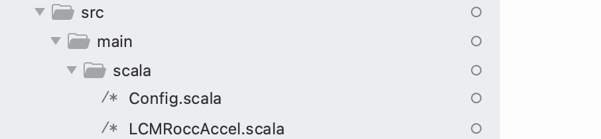

Config.scala

1. 加到系统配置



修改/home/yujiangnan/Desktop/chipyard/generators/chipyard/src/main/scala/config

下文件RocketConfig.scala

class LCMAccelRocketConfig extends Config(

new chipyard.iobinders.WithUARTAdapter ++

new chipyard.iobinders.WithTieOffInterrupts ++

new chipyard.iobinders.WithBlackBoxSimMem ++

new chipyard.iobinders.WithTiedOffDebug ++

new chipyard.iobinders.WithSimSerial ++

new testchipip.WithTSI ++

new chipyard.config.WithBootROM ++

new chipyard.config.WithUART ++

new chipyard.config.WithL2TLBs(1024) ++

**new LCMRoccAccel.WithLCMRoccAccel++**

new freechips.rocketchip.subsystem.WithNoMMIOPort ++

new freechips.rocketchip.subsystem.WithNoSlavePort ++

new freechips.rocketchip.subsystem.WithInclusiveCache ++

new freechips.rocketchip.subsystem.WithNExtTopInterrupts(0) ++

new freechips.rocketchip.subsystem.WithNBigCores(1) ++

new freechips.rocketchip.subsystem.WithCoherentBusTopology ++

new freechips.rocketchip.system.BaseConfig)